**MICRONCONTROLLERS AND ITS APPLICATIONS LAB**

## **NAME: Pratyush Raj**

## **REG.N0: 20BEC1273**

## **DATE: 17-01-2022**

# EXP-3 Assembly Programming with Program Control Instruction of 8051

# Lab Task 1

**Aim:**

To write a program to clear accumulator [A], then add 5 to the accumulator 20 times.

**Software used:**

Keil µvision 4 software

**Program:**

ORG 0000H

MOV A, #00

MOV R0, #20

LOOP: ADD A, #05

DJNZ R0, LOOP

MOV R5, A

END

**Output:**

**Result:**

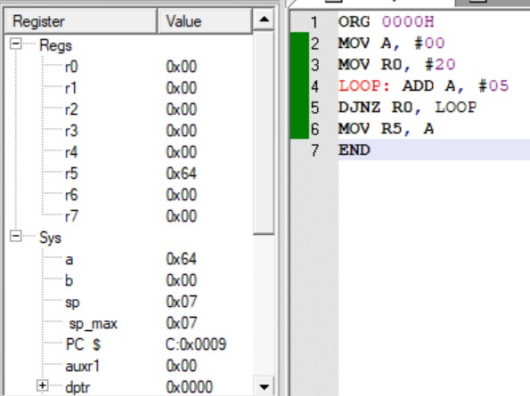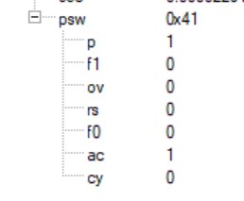

We have cleared the accumulator [A] and add 5 to the accumulator 20 times which gives the final value as **64**.

**-------------------------------------------------------------------------------------**

# Lab Task 2

**Aim:**

Write an 8051 ASM program to read a temperature value (T) from RAM location 55H. According to the test results, place the temperature value into the registers indicated below:

If T=30H then A=30H

If T<30H then R1=T

If T>30H then R2=T

**Software used:**

Keil µvision 4 software

**Program:**

ORG 0000H

MOV A, 55H

CJNE A, #30H, OVER

SJMP EXIT

OVER: JNC NEXT

MOV R1, A

SJMP EXIT

NEXT: MOV R2, A

EXIT: NOP

END **Output:**

For T>30:

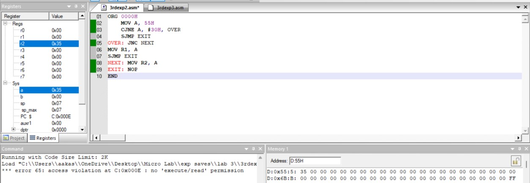

For T=30:

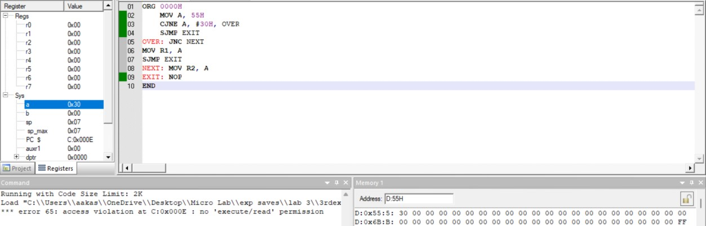

For T<30:

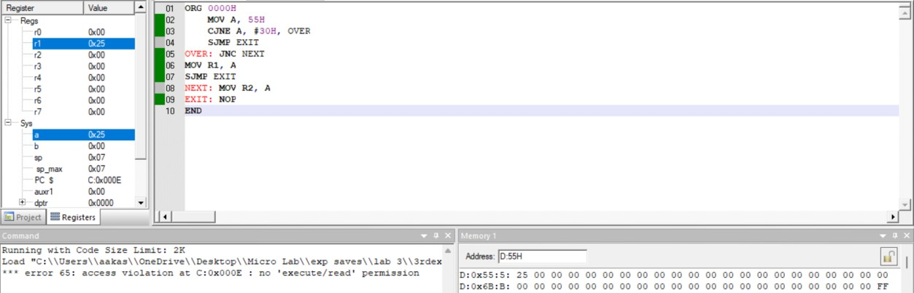

**Result:**

We have read the value of temperature from the address D:55H and depending on the temperature value, we placed it into the different registers as mentioned in the question.

**-------------------------------------------------------------------------------------**

# Lab Task 3

**Aim:**

Write a program to move a block of FIVE data starting from RAM 40H to external ROM memory 3000H onwards and perform complement operation before storing to ROM.

**Software used:**

Keil µvision 4 software

**Program:**

ORG 0000H

MOV R0, #40H

MOV DPTR, #3000H

MOV R2, #05H

LOOP: MOV A,@R0

CPL A

MOVX @DPTR,A

INC R0

INC DPTR

DJNZ R2, LOOP

END

**Output:**

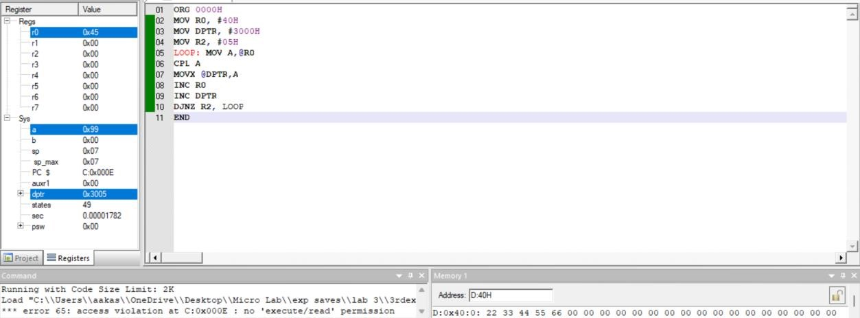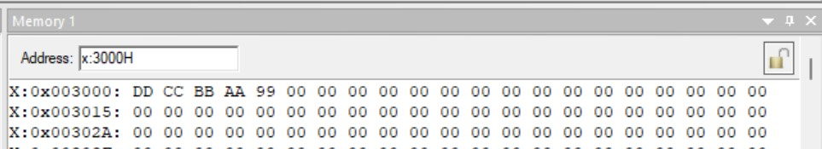

**Result:**

We moved a block of FIVE data starting from RAM 40H to external ROM memory 3000H onwards and perform complement operation before storing to ROM.

**-------------------------------------------------------------------------------------**

# Challenging Task 1

**Aim:**

To write an 8051 ASM program to add the first 15 natural numbers.

**Software used:**

Keil µvision 4 software

**Program:**

ORG 0000H

MOV R0, #15H

MOV A, #00H

MOV R1, #01H

LOOP:ADD A, R1

INC R1

DJNZ R0, LOOP

MOV R4, A

END

**Output:**

**Result:**

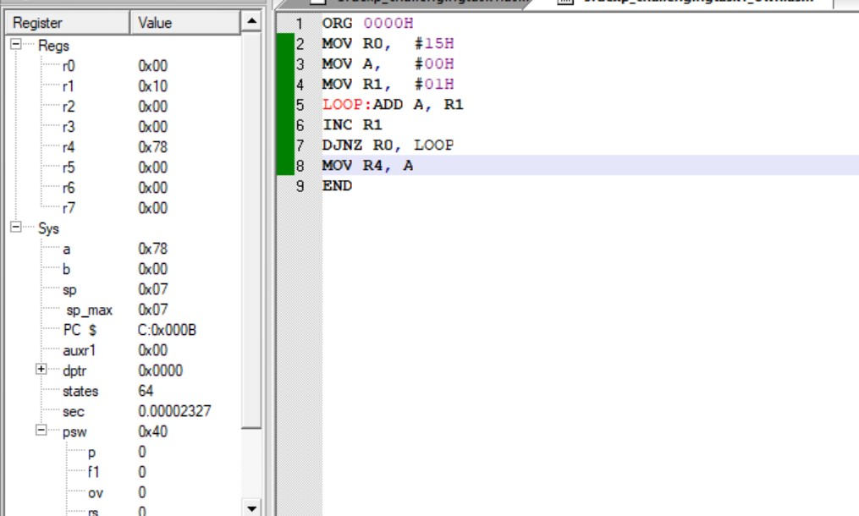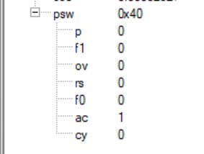

We have calculated the sum of the 1st fifteen natural numbers and it is stored in R4 register.

**-------------------------------------------------------------------------------------**

# Challenging Task 2

**Aim:**

Write an 8051 ASM program to move a block of five data using conditional statements from 50H RAM to External ROM memory 4000H to do addition and store the result in 5000H (High Byte) and 5001H (Lower Byte).

**Software used:**

Keil µvision 4 software

**Program:**

ORG 0000H

MOV R0,#50H

MOV R1,#05H

MOV DPTR,#4000H

MOVE: MOV A,@R0

MOVX @DPTR,A

INC R0

INC DPTR

DJNZ R1,MOVE

MOV R1,#05H

MOV DPTR,#4000H

MOVX A,@DPTR

ADDR: MOV R0,A

INC DPTR

MOVX A,@DPTR

ADDC A,R0

JNC NEXT

INC R2

NEXT: DJNZ R1,ADDR

MOV A,R0

MOV DPTR,#5001H

MOVX @DPTR,A

MOV A,R2

MOV DPTR,#5000H

MOVX @DPTR,A

NOP

END

**Output:**

Input values in 50h lo

cation:

Printing values in

4000

H

:

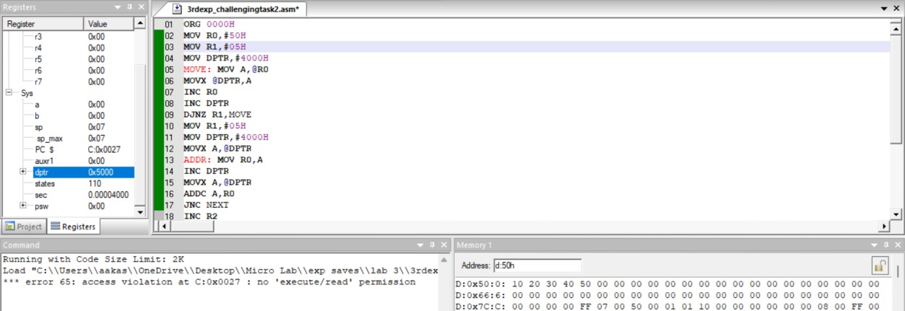

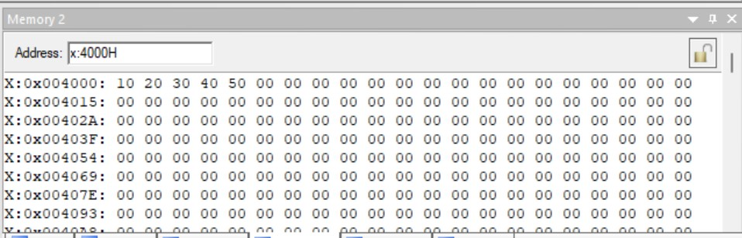

Placing the sum in 5000H and 50001H:

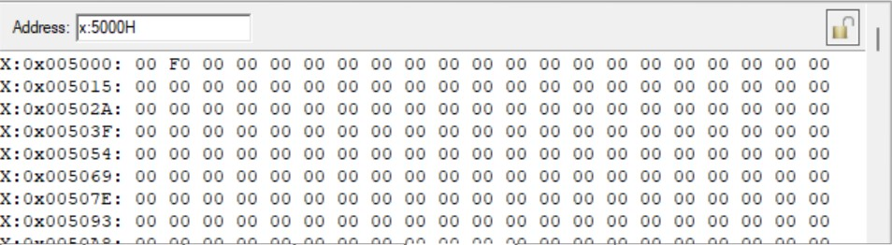

**Result:**

We have transferred 5 blocks of data to external ROM 4000H and did addition and stored the result in 5000H (High Byte) and 5001H (Lower Byte).

---------------------------------------------------------------------------------------------------------------------------