**MICRONCONTROLLERS AND ITS APPLICATIONS LAB**

## **NAME: Pratyush Raj**

## **REG.N0: 20BEC1273**

## **DATE: 06-03-2022**

**EXP – 6 Assembly programming with Timers/Counters of 8051**

**LAB TASK – 1**

**AIM:** Write an 8051-assembly language program using timers to generate a square wave of frequency 2kHz on pin port pin P2.7. Assume the crystal frequency as 11.0592 MHz.

**SOFTWARE USED:** Keil µVision4

**PROGRAM:**

ORG 0000H

MOV TMOD, #01H

BACK:MOV TL0, #01AH

MOV TH0, #0FFH

SETB TR0

WAIT: JNB TF0, WAIT

CLR TR0

CLR TF0

CPL P2.7

SJMP BACK

END**OUTPUT:**

**Port 2 and timer:**

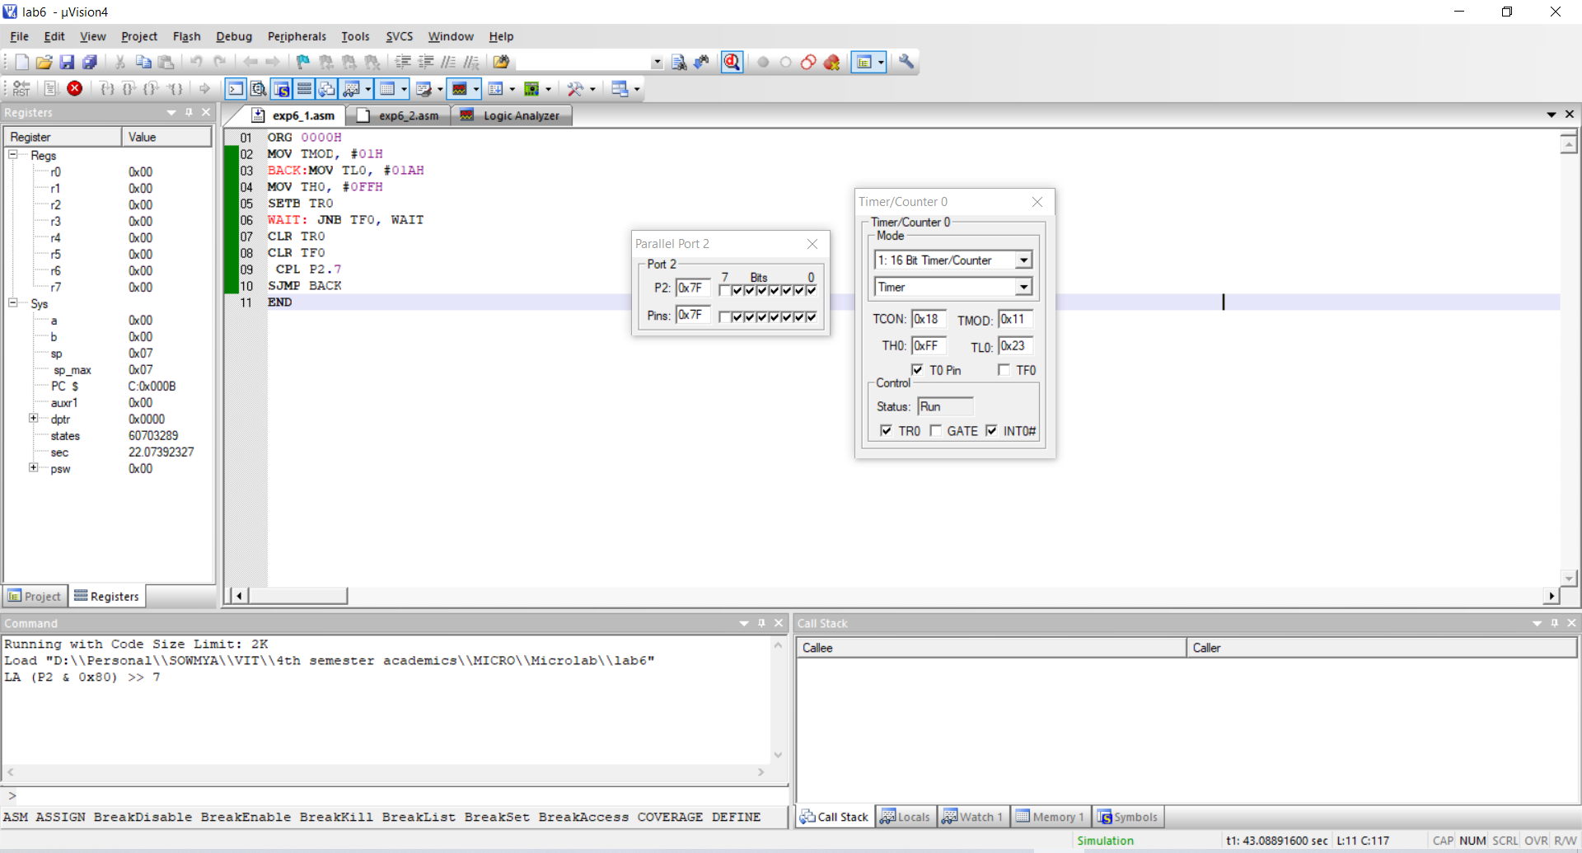

**Square wave of frequency 2kHz**

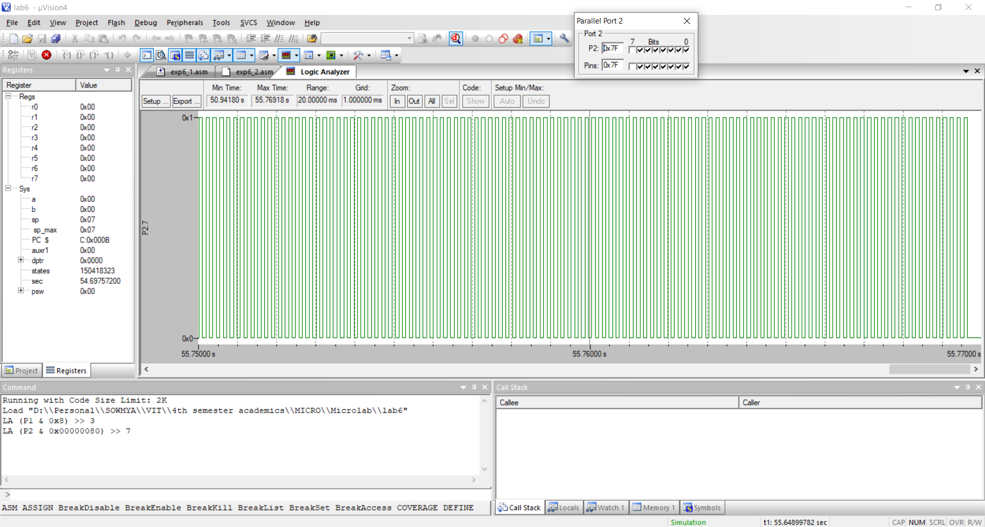

**RESULT:** 8051 asm program to perform Lab task 1 has successfully written and executed.

**LAB TASK 2**

**AIM:** Assuming that clock pulses are fed into pin T1 (P3.5), write an 8051-assembly language program for counter 1 in mode 2 to count the pulses and display the state of the TL1 count on P2, which connects to 8 LEDs.

**SOFTWARE USED:** Keil µVision4

**PROGRAM:**

ORG 000H

REPEAT: MOV TMOD, #60H

MOV TH1, #0

SETB P3.5

AGAIN: SETB TR1

BACK:MOV A, TL1

MOV P2, A

JNB TF1, BACK

CLR TR1

CLR TF1

SJMP REPEAT

END

**OUTPUT:**

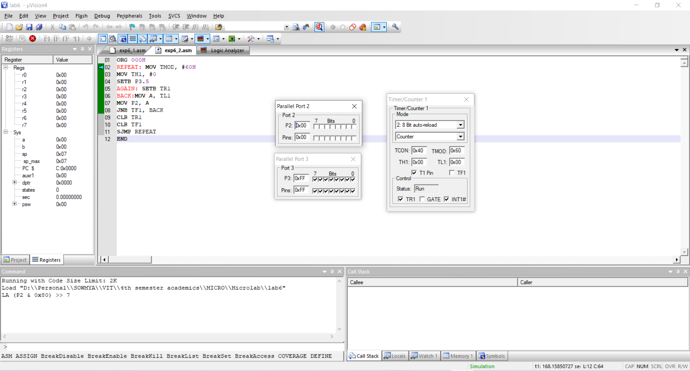

**RESULT:** 8051 asm program to perform Lab task 2 has been successfully written and executed.

**CHALLENGING TASK 1**

**AIM:** Write an 8051-assembly language program using timers to generate a frequency of 10kHz on pin port pin P2.7. Assume the crystal frequency as 11.0592 MHz.

**SOFTWARE USED:** Keil µVision4

**PROGRAM:**

ORG 0000H

MOV TMOD,#01H

BACK: MOV TL0,#0D1H

MOV TH0,#0FFH

SETB TR0

AGAIN: JNB TF0, AGAIN

CLR TR0

CPL P2.7

CLR TF0

SJMP BACK

END

**OUTPUT:**

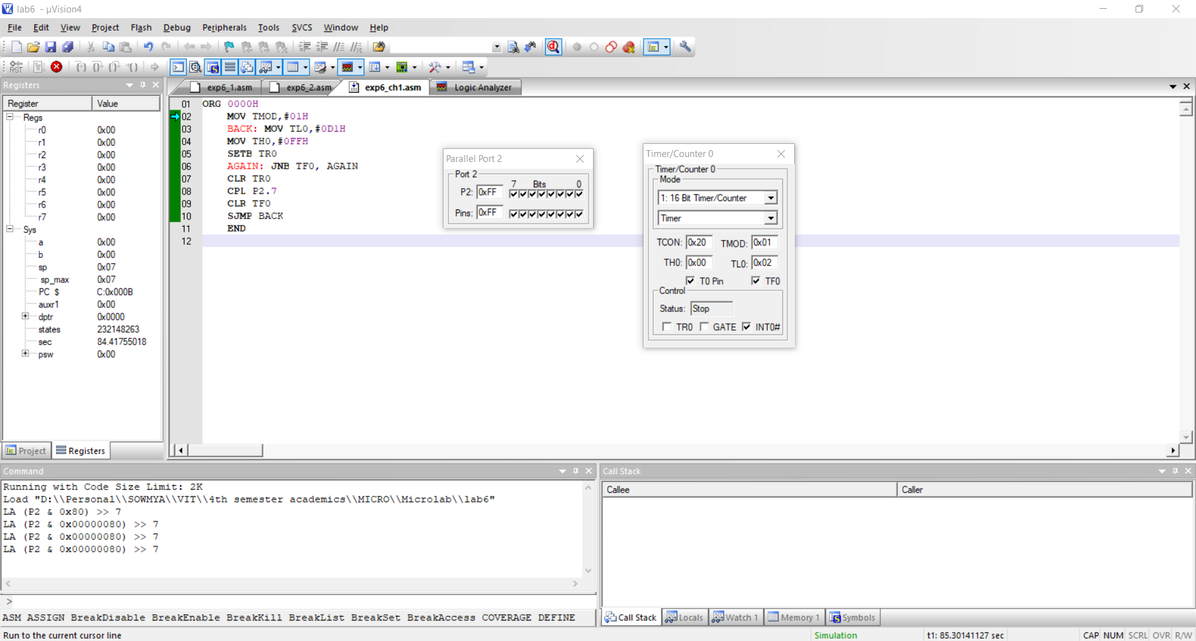

**Frequency of 10KHz:**

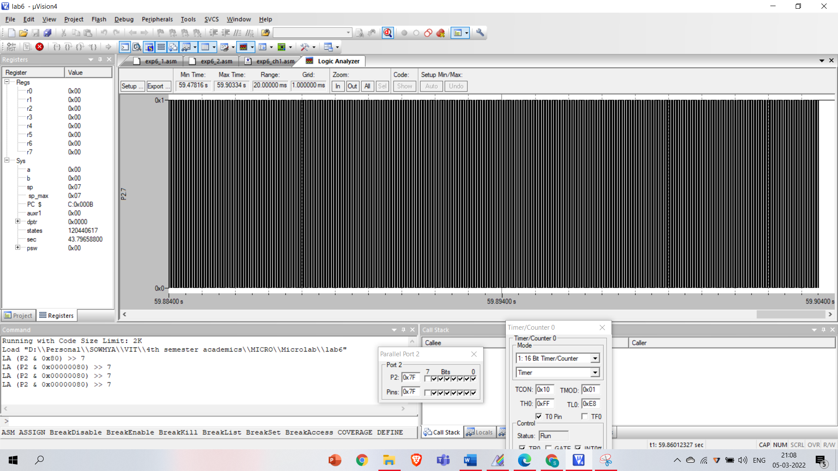

**RESULT:** 8051 asm program to perform challenging task 1 has been successfully written and executed.

**CHALLENGING TASK 2**

**AIM:** Write an 8051 assembly language program to implement a counter for counting pulses of an input signals. Assume the crystal frequency as 11.0592 MHz. Configure TIMER 1 to generate a clock pulse for every one seconds and TIMER 0 as a counter which receives input pulses at P3.4 from P3.5 Display final count values in port P1 (TL0) & P2(TH0).

**SOFTWARE USED:** Keil µVision4

**PROGRAM:**

**OUTPUT:**

**RESULT**: 8051 asm program to perform Challenging task 2 has been successfully written and executed.

------------------------------------------------------------------------------------------------------------