**MICRONCONTROLLERS AND ITS APPLICATIONS LAB**

## NAME: Pratyush Raj

## REG.N0: 20BEC1273

## DATE: 17-03-2022

EXP– 7 Interrupt Programming in 8051

# LAB TASK-1

**AIM:** To write a timer interrupt program that continuously gets 8-bit data from P0 and sends it to P1 while simultaneously creating a square wave of 200 μs period on pin P2.1. Use timer 0 to create the square wave. Assume that XTAL = 11.0592 MHz

# SOFTWARE USED: Keil software PROGRAM:

We will use timer 0 in mode 2 (auto reload). TH0 = 100/1.085 us = 92.

//Go to main ORG 0000h

LJMP main

// ISR for Timer 0 to generate a square wave ORG 000Bh

CPL P2.1 RETI

main: MOV TMOD,#02H MOV P0,#0FFH

MOV TH0,#0A4H MOV IE,#82H SETB TR0

Back: MOV A, P0 MOV P1,A

SJMP Back END

**OUTPUT: Screenshot taken from Keil software**

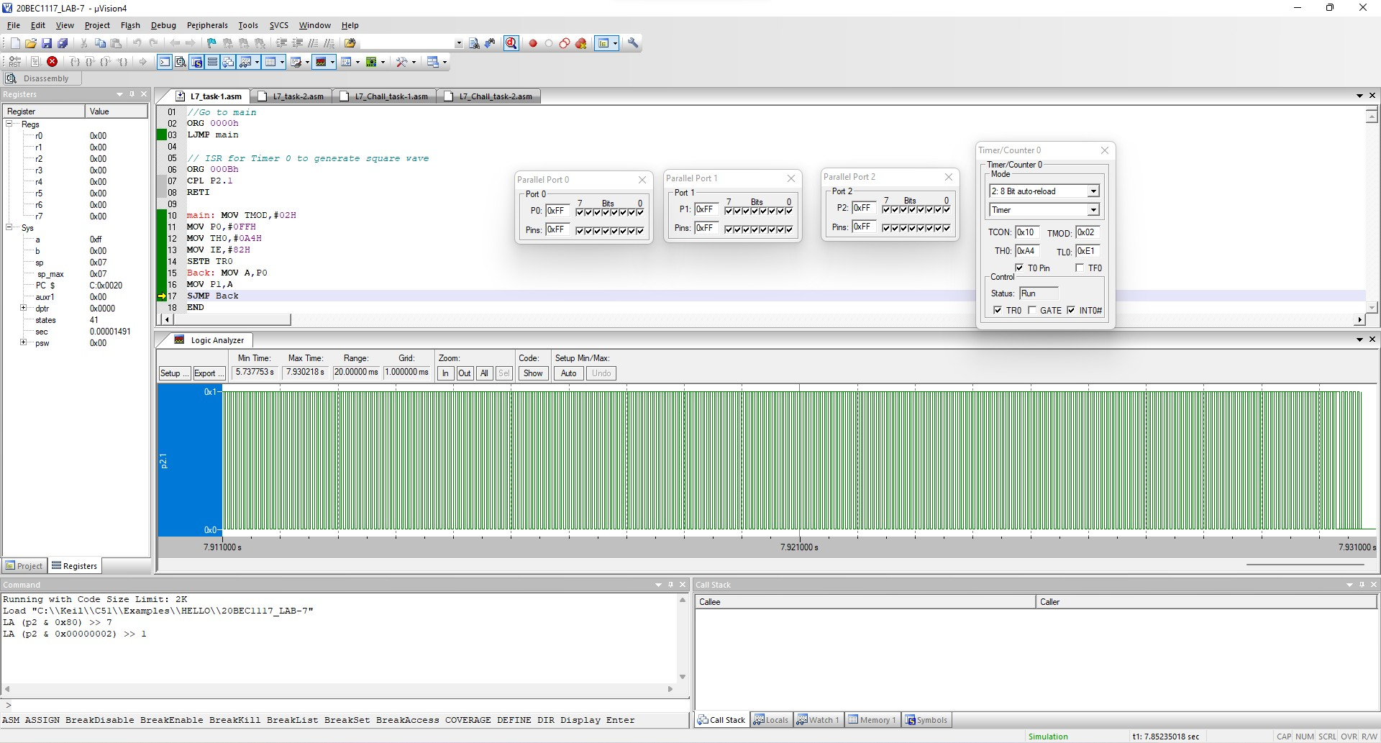

**RESULT:** We have successfully got the square wave at pin P2.1 with a period of 200us.

**LAB TASK 2**

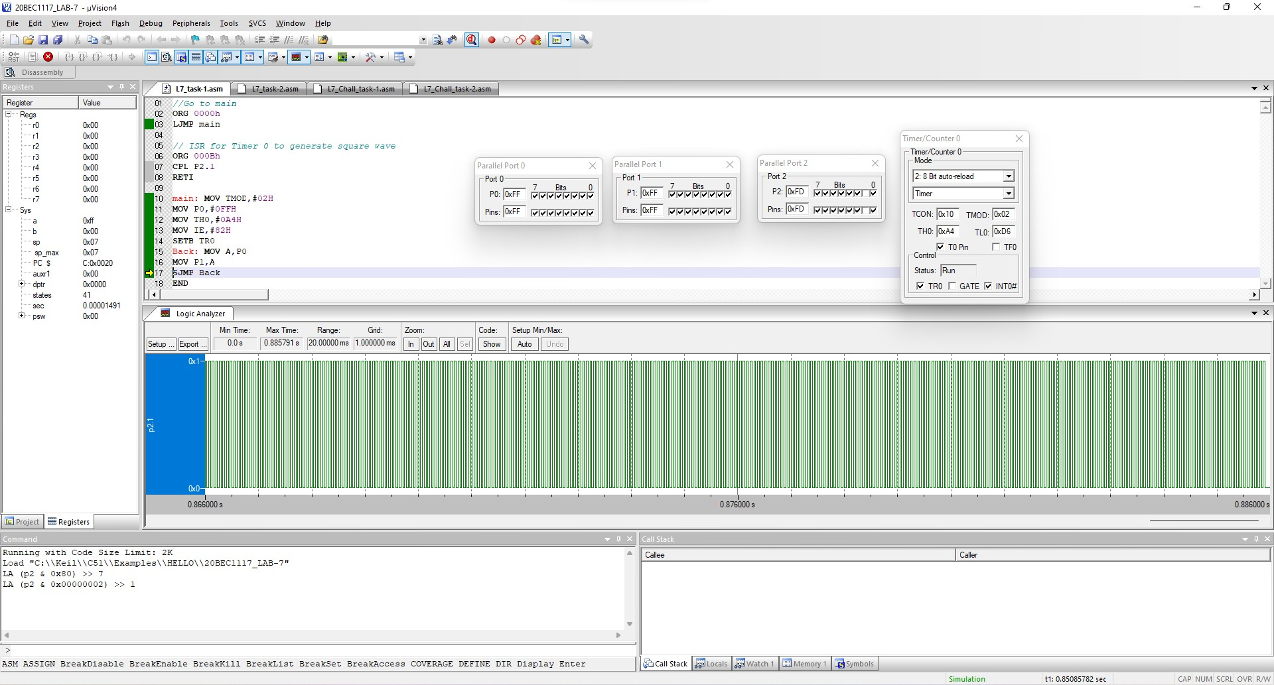**AIM:** Assume that the INT1 pin is connected to a normally high switch. Whenever it goes low, it should turn on an LED. The LED is connected to P1.3 and is normally off. As long as the switch is pressed low, the LED should stay on.

# SOFTWARE USED: Kiel software PROGRAM:

ORG 0000H

LJMP main

//ISR for INT1 to turn on the LED ORG 0013H

SETB P1.3 MOV R3,#255

Back: DJNZ R3, Back CLR P1.3

RETI

//Main program ORG 30H

main: MOV IE,#10000100B

Here: SJMP Here END

**OUTPUT: Screenshot taken from Keil software**

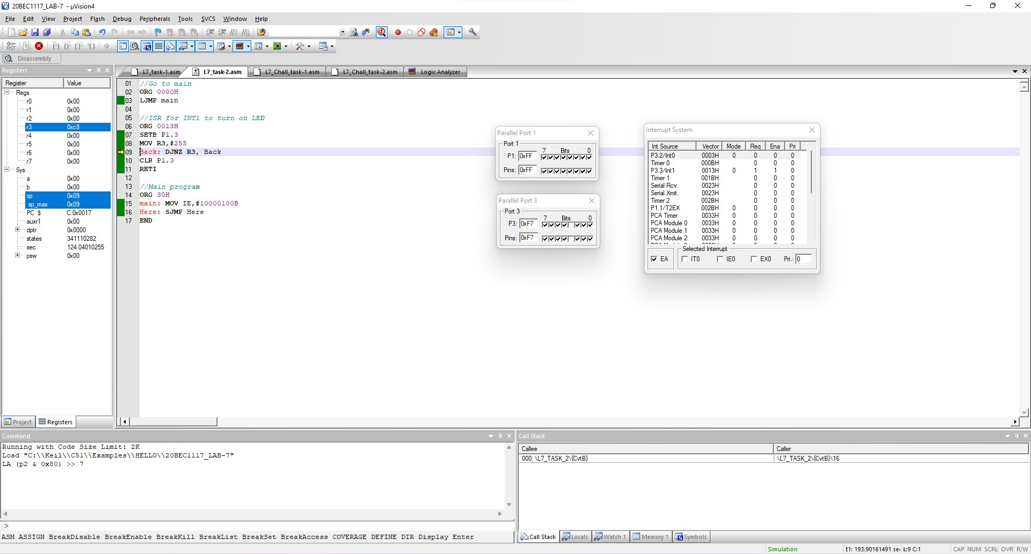

Port 1 P1 will get toggled and we get 0xFF to 0xF7.

**RESULT:** We have successfully turned on and off the LED which is connected to P1.3.

# CHALLENGING TASK-1

**AIM:** To write an ALP for the generation of the square pulse of 50% duty cycle with on time of 10 ms using timer 0 and simultaneously send ‘Y’ and ‘N’ to port 0 and port 1 respectively. Assume that XTAL = 11.0592 MHz.

# SOFTWARE USED: Keil software PROGRAM:

We use timer 0, TH0 = 5ms/1.085us = 4608

ORG 0000H

ACALL MAIN LJMP BACK

ORG 150H BACK:MOV A, #'Y'

MOV P0, A MOV A, #'N' MOV P1, A

SJMP BACK

// ISR for Timer 0 to generate square wave ORG 000BH

CPL P2.7 ACALL MAIN RETI

ORG 100H MAIN:MOV TMOD, #0001

MOV P0, #00FFH MOV TH0, #0FCH MOV TL0, #66H MOV IE, #82H SETB TR0

RET

**ENDOUTPUT: Screenshot taken from Keil software**

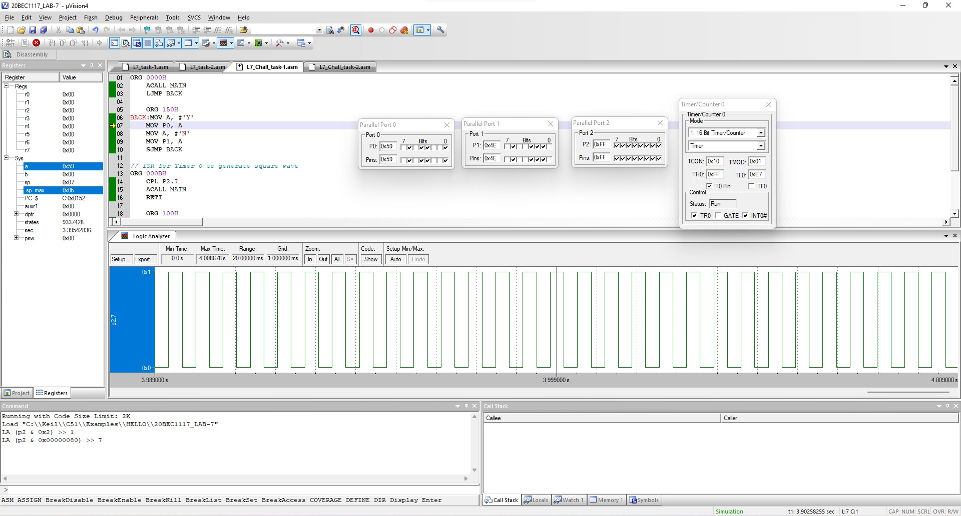

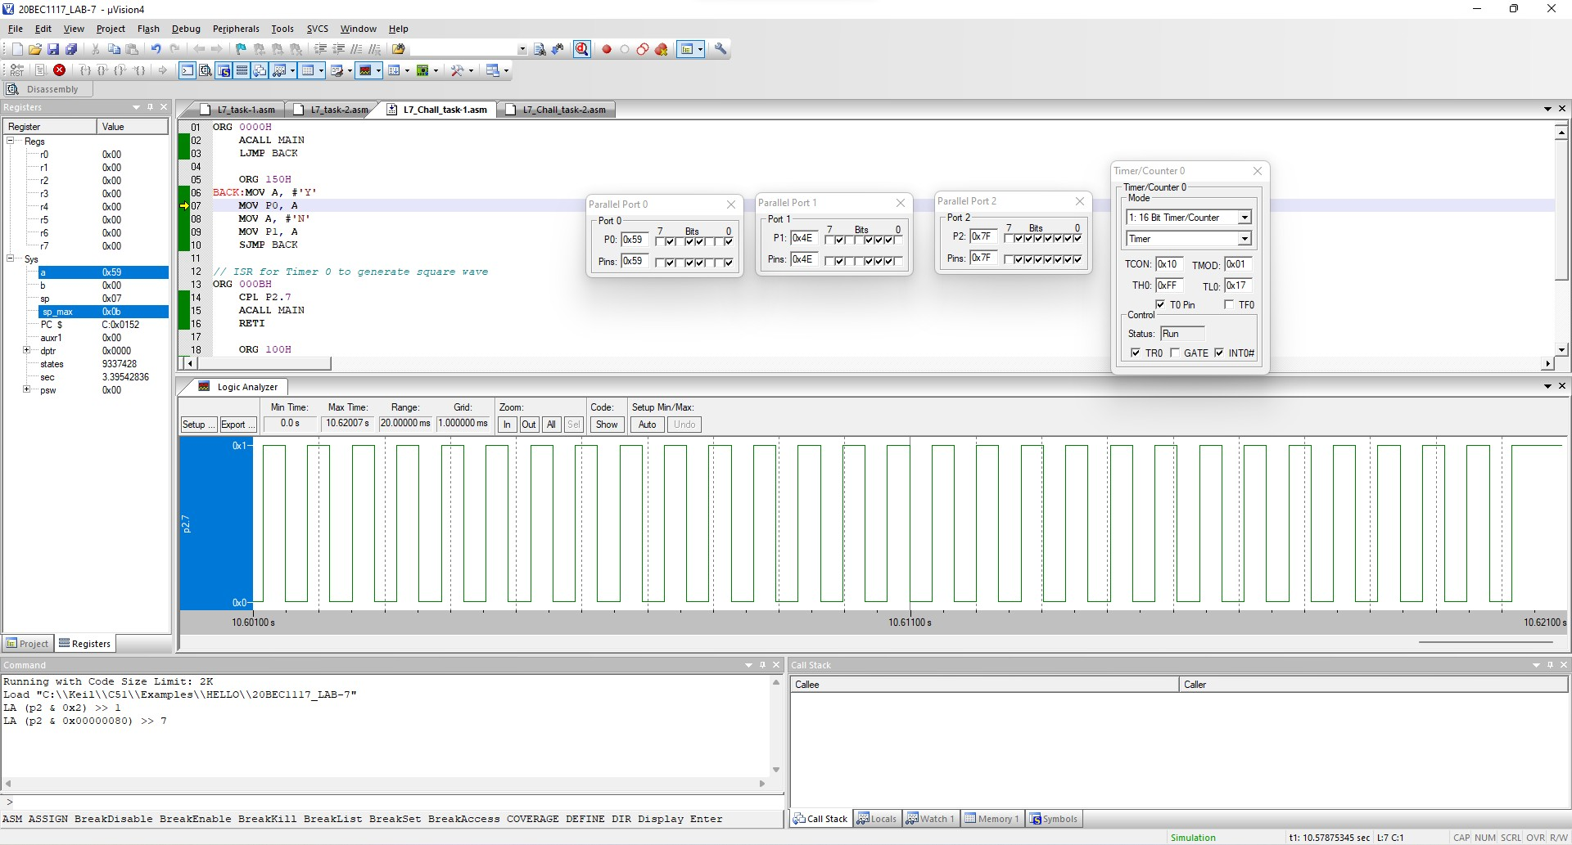

**RESULT:** We have successfully generated the square pulse of 50% duty cycle with on time of 10 ms using timer 0 and simultaneously send ‘Y’ and ‘N’ to port 0 and port 1 respectively.

# CHALLENGING TASK-2

**AIM:** Assume that pin 3.3 (INT1) is connected to a pulse generator, write a program in which the falling edge of the pulse will send a high to P1.3, which is connected to a buzzer. In other words, the buzzer is turned on and off at the same rate as the pulses are applied to the INT1 pin.

**SOFTWARE USED: Keil software**

# PROGRAM:

//Go to main ORG 000H LJMP MAIN

//ISR for INT1 to turn on BUZZER ORG 013H

SETB P1.3 MOV R3,#255

BACK: DJNZ R3, BACK CLR P1.3

RETI

//Main program ORG 30H

MAIN: SETB TCON.2 MOV IE,#10000100B HERE: SJMP HERE END

**OUTPUT: Screenshot taken from Keil software**

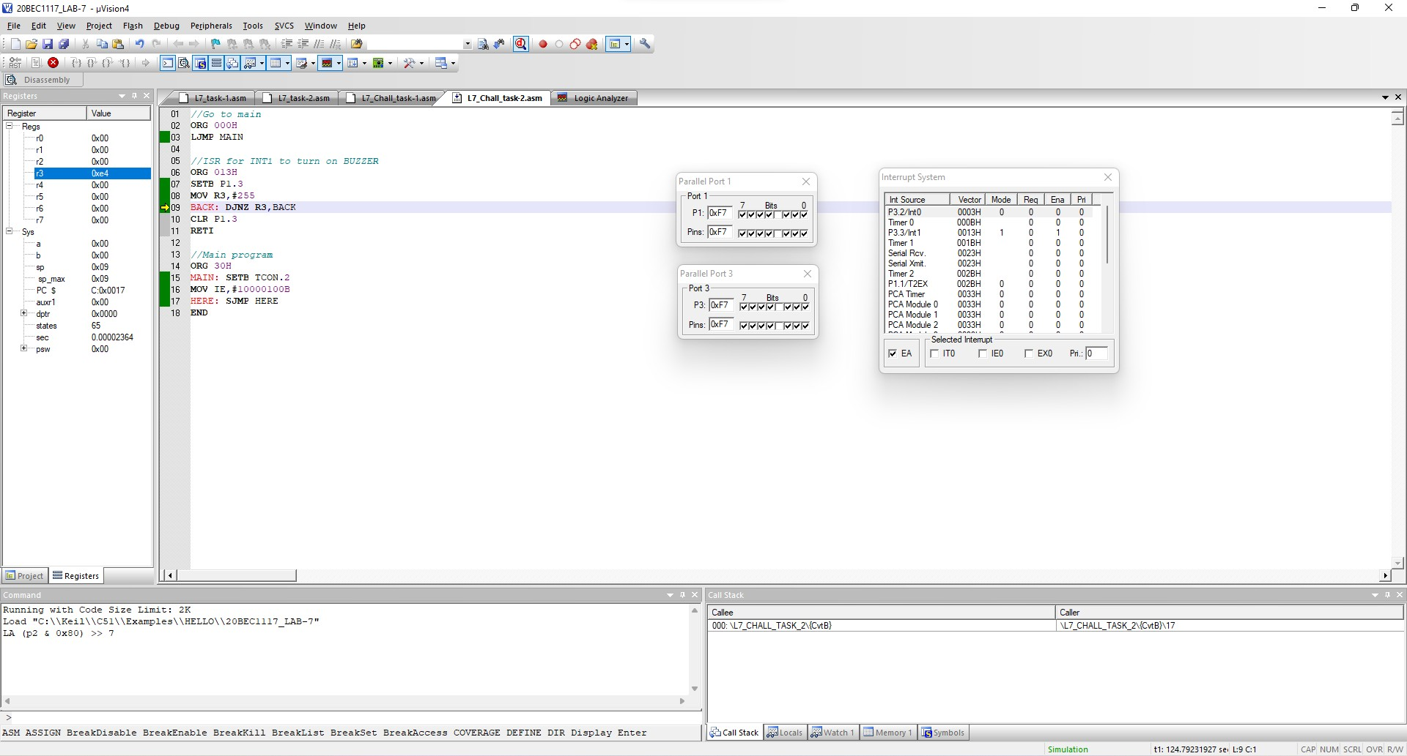

**RESULT:** We have successfully connected the buzzer; it is turned on and off at the same rate as the pulses are applied to the INT1 pin.

**----------------------------------------------------------------------------------------------------------------------**