**MICRONCONTROLLERS AND ITS APPLICATIONS LAB**

## NAME: Pratyush Raj

## REG.N0: 20BEC1273

## DATE: 19-03-2022

**EXP – 8 Interrupt programming in 8051**

**LAB TASK – 1**

**AIM:** Write a program for the 8051 to transfer “VIT” serially at 9600 baud, 8-bit data, 1 stop bit, do this continuously.

**SOFTWARE USED:** Keil µVision4

**PROGRAM:**

MOV TMOD,#20H ;timer1,mode 2(auto reload)

MOV TH1,#0FDH ;9600 baud rate

MOV SCON,#50H ;8-bit, 1 stop, REN enabled

SETB TR1 ;start timer 1

AGAIN: MOV A,#'V' ;transfer “V”

ACALL TRANS

MOV A,#'I' ;transfer “I”

ACALL TRANS

MOV A,#'T' ;transfer “T”

ACALL TRANS

MOV A,#' '

;transfer “ ”

ACALL TRANS

SJMP AGAIN ;keep doing it

;serial data transfer subroutine

TRANS: MOV SBUF,A ;load SBUF

HERE: JNB TI,HERE ;wait for the last bit

CLR TI ;get ready for next byte

RET

END

**OUTPUT:**

**Serial window UART 1:**

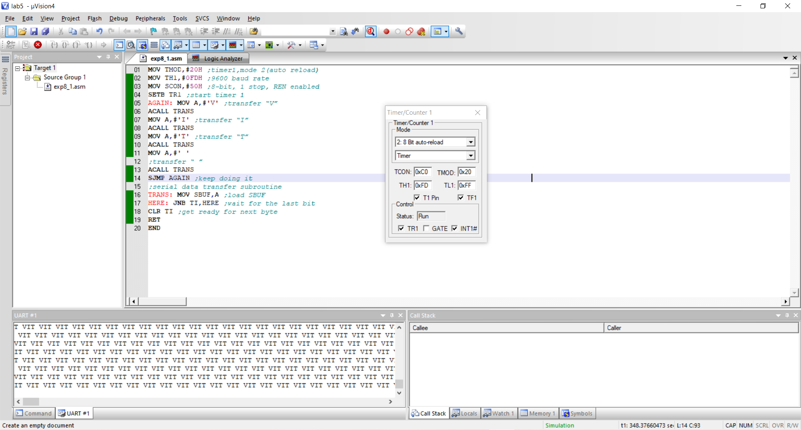

**RESULT:** 8051 asm program to perform Lab task 1 has successfully written and executed.

**LAB TASK 2**

**AIM:** Write a program for the 8051 to receive bytes of data serially, and put them in P1, set the baud rate at 4800, 8-bit data, 1 start and 1 stop bit.

**SOFTWARE USED:** Keil µVision4

MOV TMOD,#20H ;timer1,mode 2(auto reload)

MOV TH1,#0FAH ;4800 baud rate

MOV SCON,#50H ;8-bit, 1 stop, REN enabled

SETB TR1 ;start timer 1

HERE: JNB RI,HERE ;wait for char to come in

MOV A,SBUF ;saving incoming byte in A

MOV P1,A ;send to port 1

CLR RI ;getready to receive next ;byte

SJMP HERE ;keep getting data

END

**OUTPUT:**

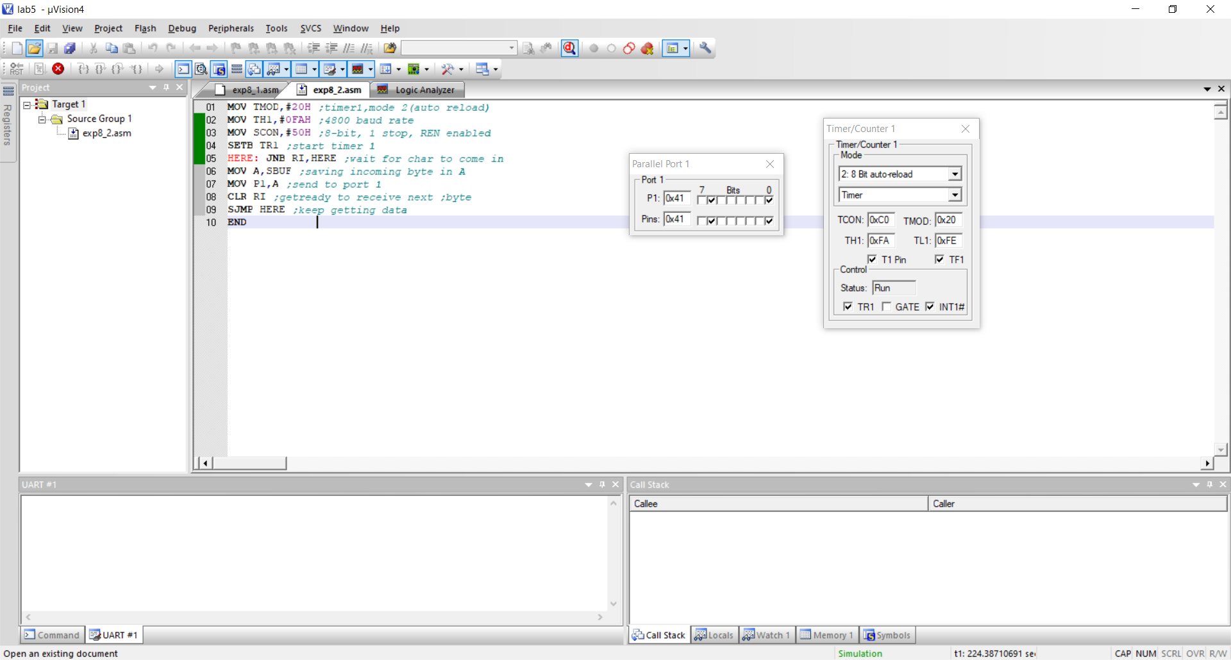

**RESULT:** 8051 asm program to perform Lab task 2 has been successfully written and executed.

**CHALLENGING TASK 1**

**AIM:** Assume a switch is connected to a port pin P1.3. Monitor this port pin continuously, whenever P1.3 is HIGH perform the transmission of “Hello” message to the serial port. When P1.3 LOW, perform the receive operation on serial port and display it in port P2.

**SOFTWARE USED:** Keil µVision4

**PROGRAM:**

ORG 0000H

MOV P1,#0FFH

MOV TMOD,#20H

MOV TH1,#0FDH

MOV SCON,#50H

SETB TR1

AGAIN: MOV C,P1.3

JNC LOW1

MOV A,#'H'

ACALL TRANS

MOV A,#'E'

ACALL TRANS

MOV A,#'L'

ACALL TRANS

MOV A,#'L'

ACALL TRANS

MOV A,#'O'

ACALL TRANS

MOV A,#' '

ACALL TRANS

SJMP AGAIN

LOW1: JNB RI,LOW1

MOV A,SBUF

MOV P2,A

CLR RI

SJMP AGAIN

TRANS: MOV SBUF,A

HERE:JNB TI,HERE

CLR TI

RET

END

**OUTPUT:**

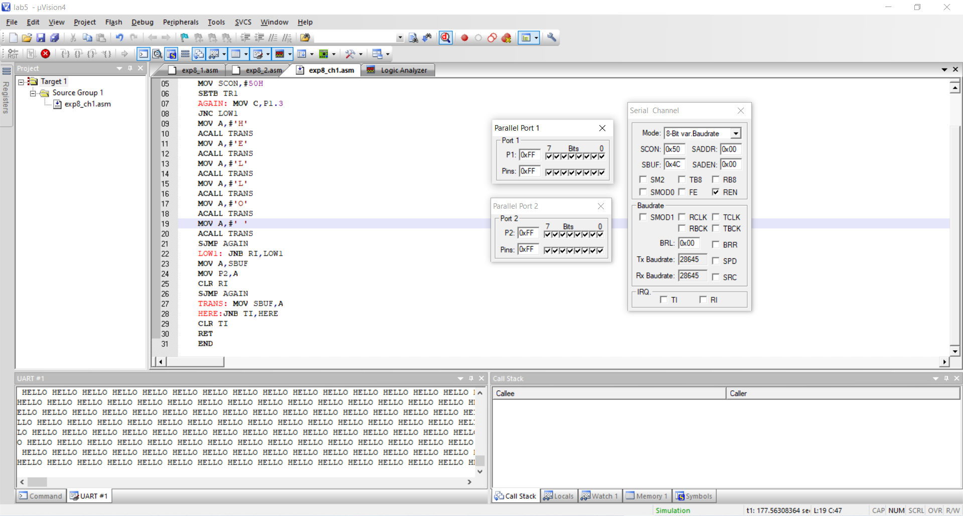

**RESULT:** 8051 asm program to perform challenging task 1 has been successfully written and executed.

--------------------------------------------------------------------------------------------------------------------------------------