**MICRONCONTROLLERS AND ITS APPLICATIONS LAB**

## NAME: Pratyush Raj

## REG.N0: 20BEC1273

## DATE: 03-04-2022

**Exp-9: Assembly programming with I/O Ports of 8051**

**(HARDWARE)**

**Task1**

**AIM:**

Write an 8051 assembly language program to toggle all the bits of P1 for every 500ms (0.5 Seconds). Assume the crystal frequency as 11.0592 MHz. Verify the output using ESA 8051 Microcontroller kit.

**SOFTWARE USED:**

Keil microvision

**PROGRAM:**

ORG 0000H

MOV P1, #00H

BACK: MOV A,#55H

MOV P1, A

ACALL DELAY

MOV A,#0AAH

MOV P1, A

ACALL DELAY

SJMP BACK

DELAY: MOV R2,#04H ;LOAD R2 WITH 04 HEX

HERE3: MOV R1,#0FFH ;LOAD R1 WITH 0FF HEX

HERE2: MOV R0,#0FFH ;LOAD R2 WITH 0FF HEX

HERE1: DJNZ R0,HERE1 ;DECREMENT R0

DJNZ R1,HERE2 ;DECREMENT R1 DJNZ R2,HERE3 ;DECREMENT R2

RET ;RETURN

END

**OUTPUT:**

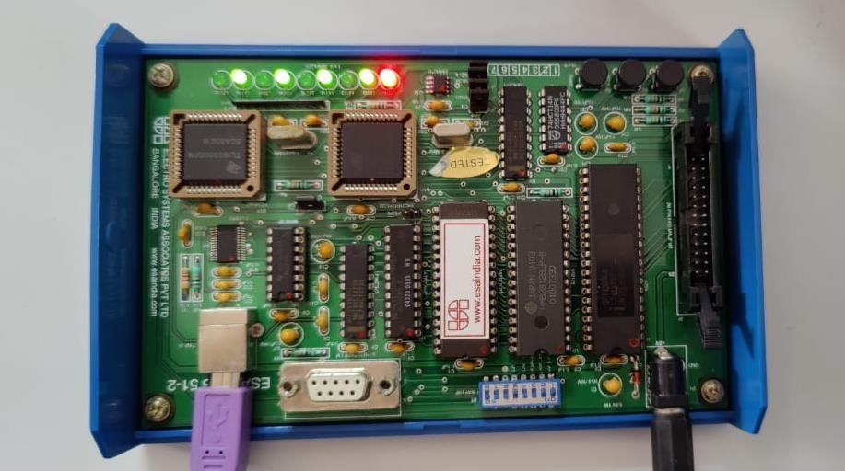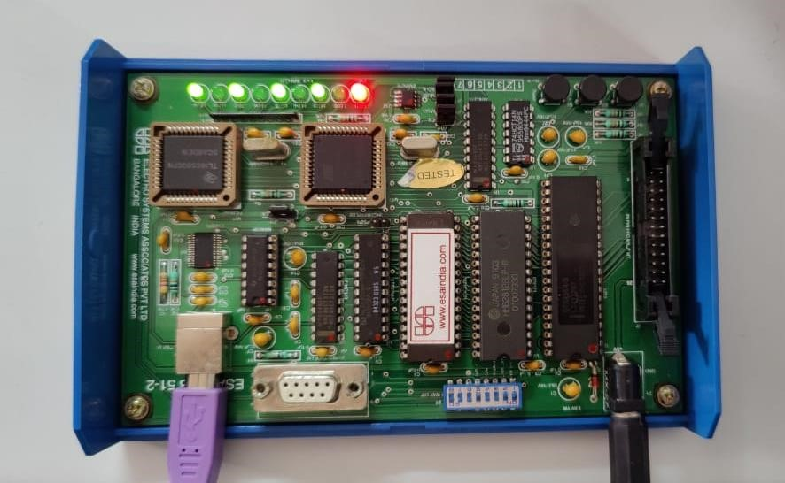

**RESULT:**

The given task is performed and the output is obtained in hardware and LED is toggled for every 500ms.

**---------------------------------------------------------------------------------------------------------------------**

**TASK2**

**AIM:**

Write an 8051 assembly language program to glow the LEDs connected on PORT1 one at a time in a serial fashion (from LSB to MSB) continuously with 0.5 seconds delay for each . Verify the output using ESA 8051 Microcontroller kit.

**SOFTWARE USED:**

Keil

**PROGRAM:**

ORG 0000H

MOV P1,#00H

MOV A,#01H

AGAIN: MOV P1,A

ACALL DELAY

RL A

SJMP AGAIN

DELAY: MOV R2,#04H ;LOAD R2 WITH 07 HEX

HERE3: MOV R1,#0FFH ;LOAD R1 WITH 0FF HEX

HERE2: MOV R0,#0FFH ;LOAD R2 WITH 0FF HEX

HERE1: DJNZ R0,HERE1 ;DECREMENT R0

DJNZ R1,HERE2 ;DECREMENT R1 DJNZ R2,HERE3 ;DECREMENT R2

RET ;RETURN

END

**OUTPUT:**

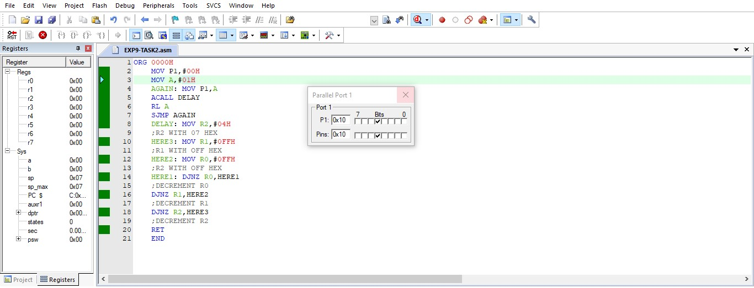

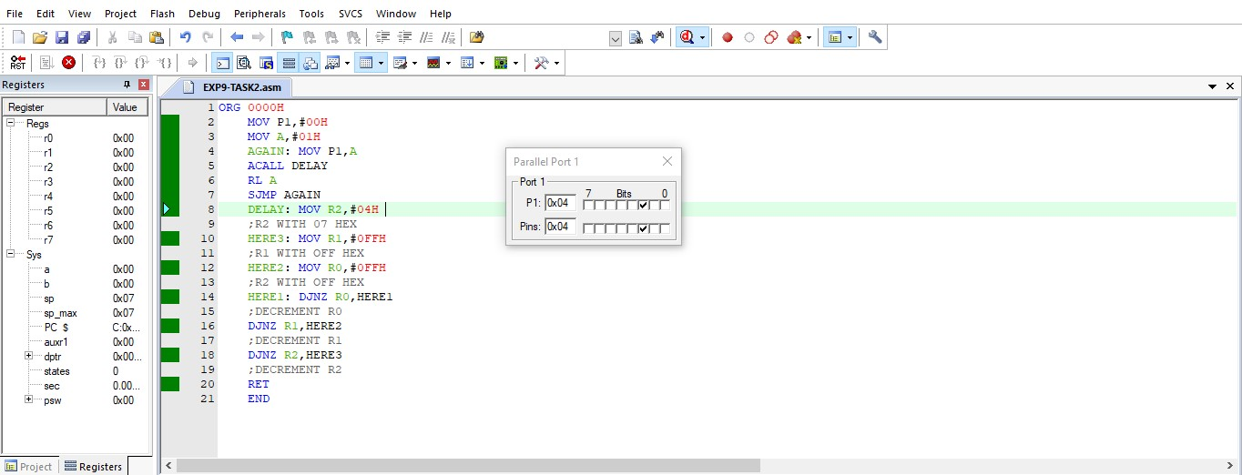

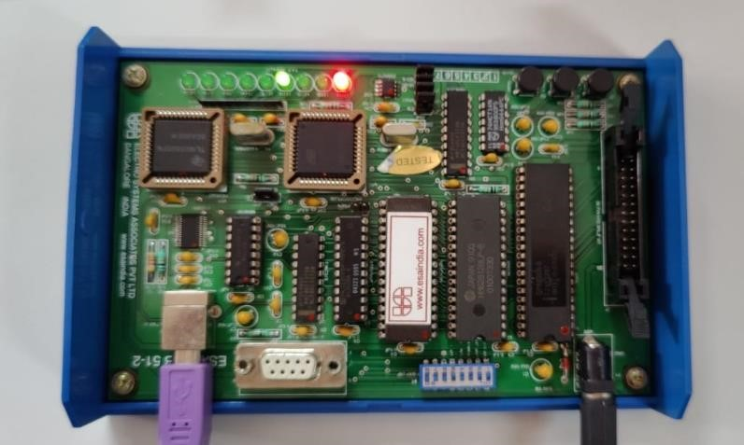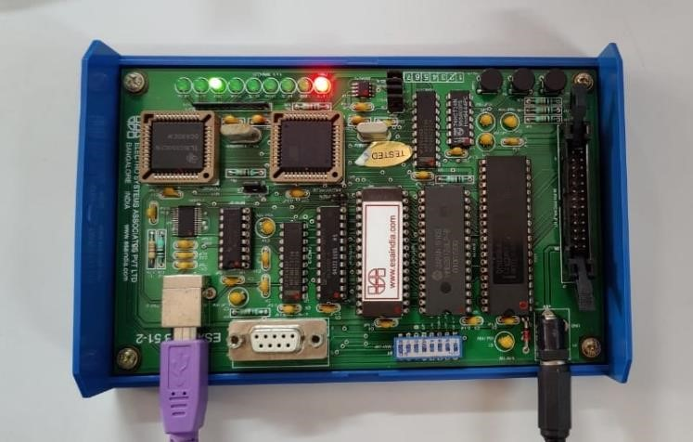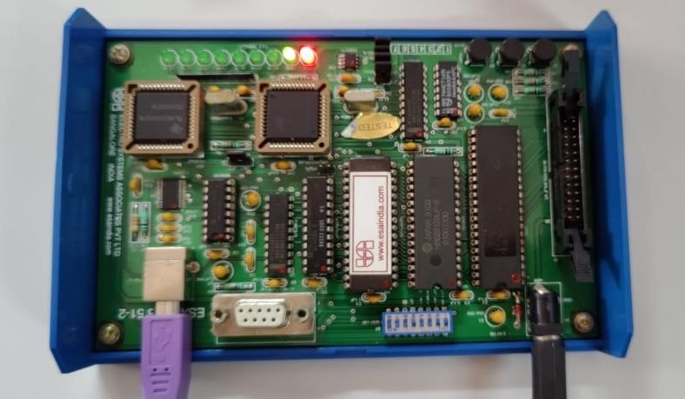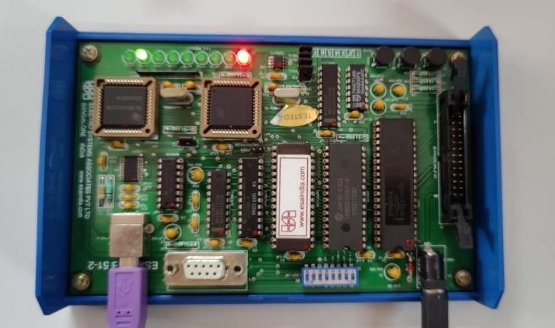

**RESULT:**

The given task is performed and the output is obtained in hardware and LED is displayed at a serial fashion.

--------------------------------------------------------------------------------------------------------------------------------