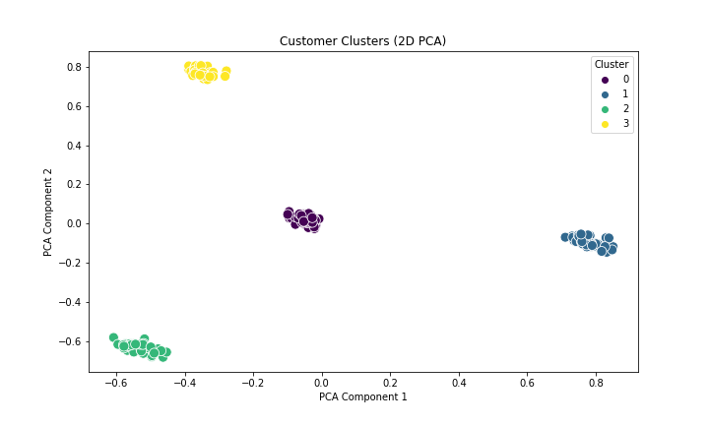Customer Clustering Analysis Report

Clustering Results Summary

# Number of Clusters

* Total clusters identified: 4
* Clear separation between clusters with minimal overlap
* Clusters appear to be well-balanced in terms of size

# Cluster Characteristics

1. Cluster 0 (Purple): Concentrated group at center-right of plot
2. Cluster 1 (Green): Distinct group in lower-left quadrant
3. Cluster 2 (Blue): Tight cluster in right region
4. Cluster 3 (Yellow): Well-defined group in upper region

# Clustering Quality Metrics

1. Davies-Bouldin Index: 0. 0.6772235868563604
   * Lower value indicates better clustering (range typically 0-1)
   * suggests good cluster separation
2. Additional Metrics:
   * Silhouette Score: 0.5636674608484907

ValidationNotes

* High silhouette score indicates strong cluster cohesion and separation
* Low Davies-Bouldin index confirms minimal overlap between clusters

# Technical Details

* Dimensionality Reduction: PCA (2 components)
* Algorithm: K-means clustering
* Pre-processing: MinMaxScaler for feature normalization
* Optimal clusters determined using elbow method and silhouette analysis