

**Fall Semester 2025-26**

**Lab Assignment – 2**

**Slot:** L13+L14

**Class:** VL2025260105679

**Branch:** B.tech CSBS

**Course code & title:** CBS3005

Cloud, Microservices and Applications

**Faculty name:** Nithya K

**DA by:**

Kartikey Gupta

22BBS0105

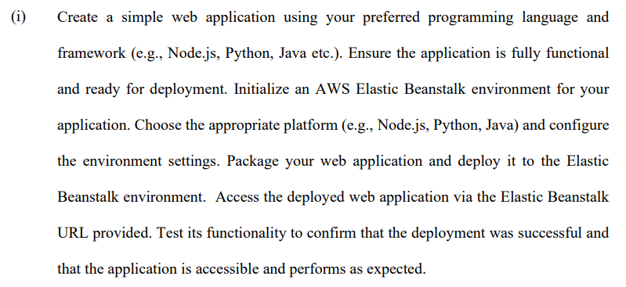

**Step 1: Create a Simple Spring Boot Application**

1. Open in your IDE IntelliJ, or VS Code.
2. Create new springboot project
   * Project: **Maven**
   * Language: **Java**
   * Spring Boot: latest stable version
   * Dependencies: **Spring Web**
3. Group: com.cloud, Artifact: LA2

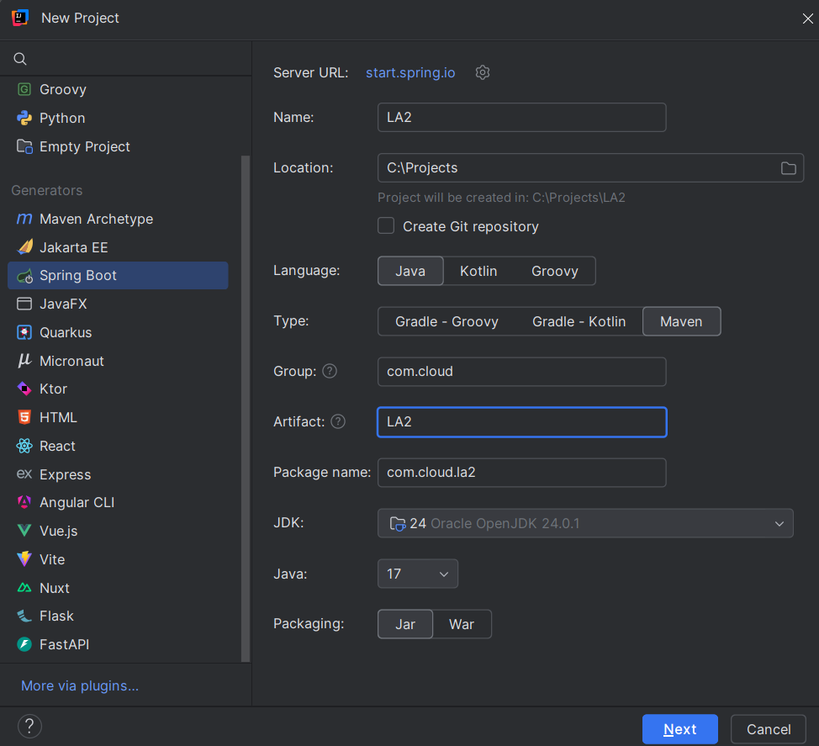

1. Edit src/main/java/com/cloud/la2/La2Application.java to create a simple REST endpoint:

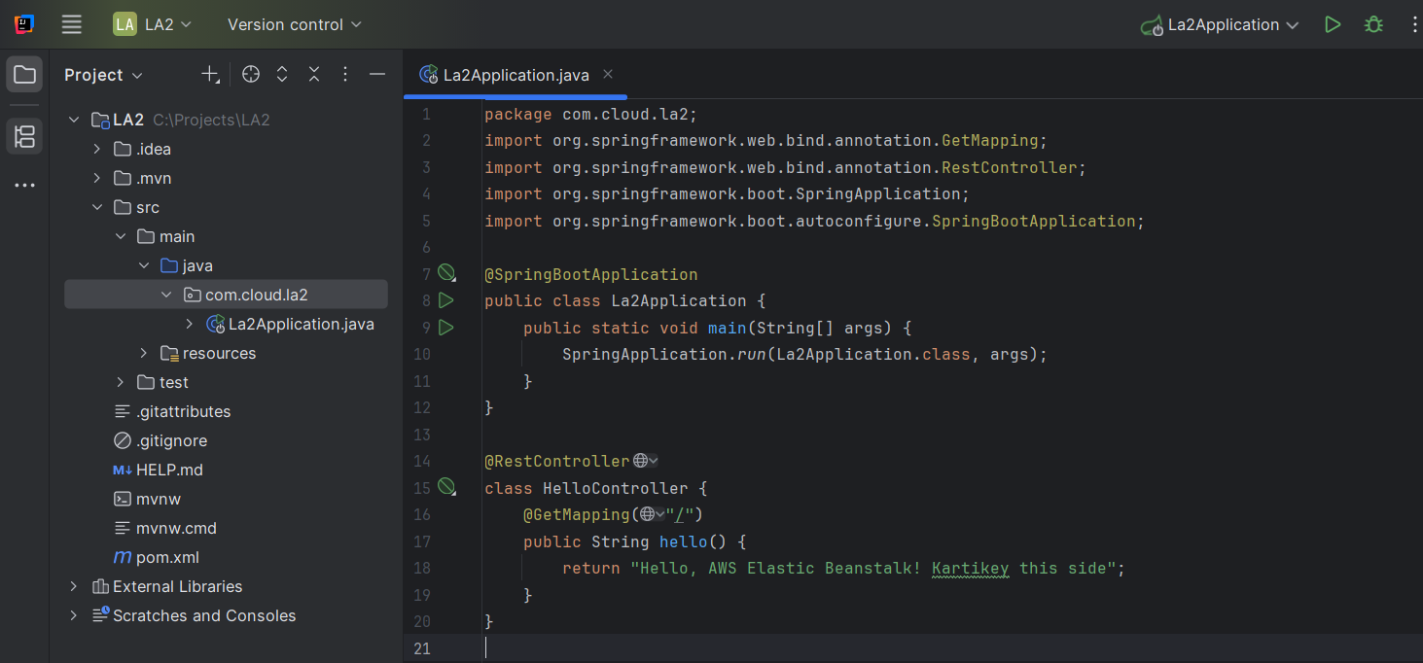

1. Clean the project using mvn clean package
2. Build success and Jar file created

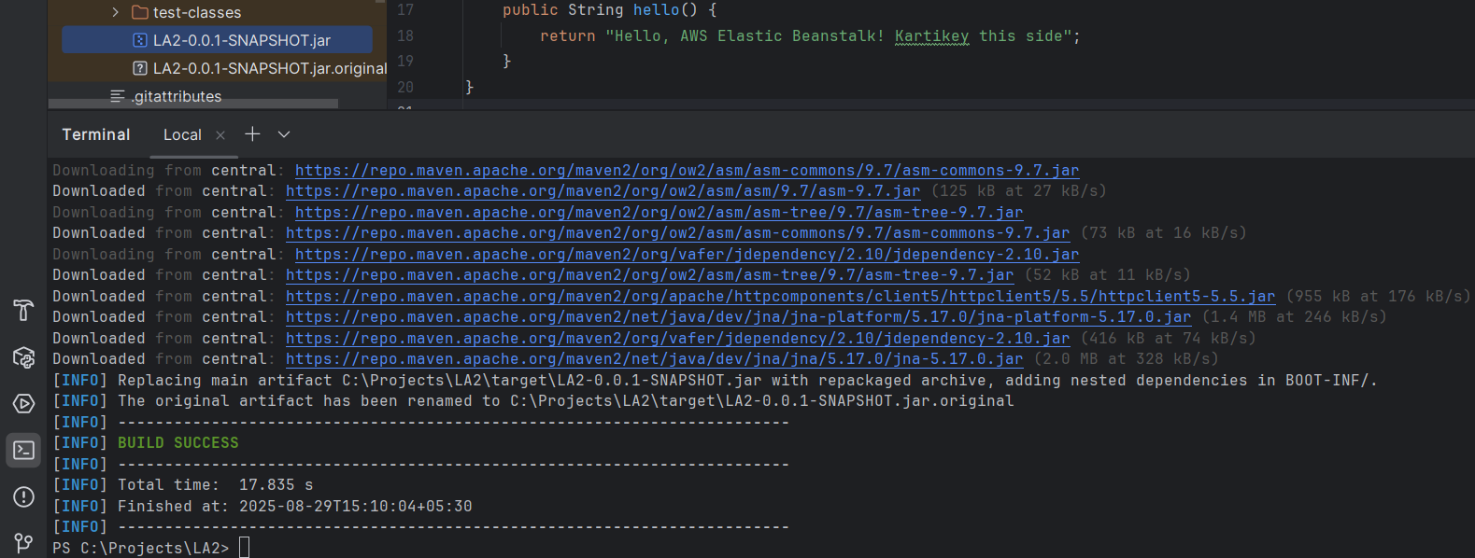

**Step 2: Log in to AWS Management Console**

1. Go to AWS Console.
2. Log in with your AWS account.
3. Navigate to **Elastic Beanstalk**

**Step 3: Create a New Application**

1. Click **Create application**.
2. Enter **Application name**: La2JavaApp.
3. Add an optional description: Sample Spring Boot app.
4. Click **Create application**

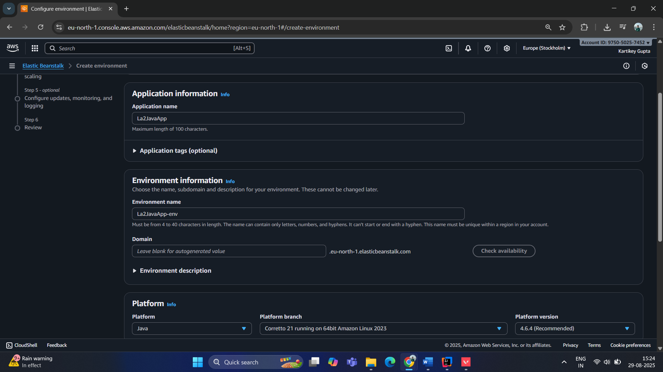

**Step 5: Configure Environment and Platform**

1. **Environment name**: La2JavaApp-env
2. **Platform**: Choose **Java**
   * For Spring Boot JAR: choose **Corretto 17** (or latest Java 17+)
3. **Platform branch**: Keep the default

**Step 6: Upload Your Application**

1. Under **Application code**, choose **Upload your code**.
2. Click **Choose file** and select your **JAR file** from target/.

**Step 7: Optional Environment Settings**

1. **Instance type**: For testing, choose t2.micro (free tier eligible).
2. **Capacity**: Keep single instance.

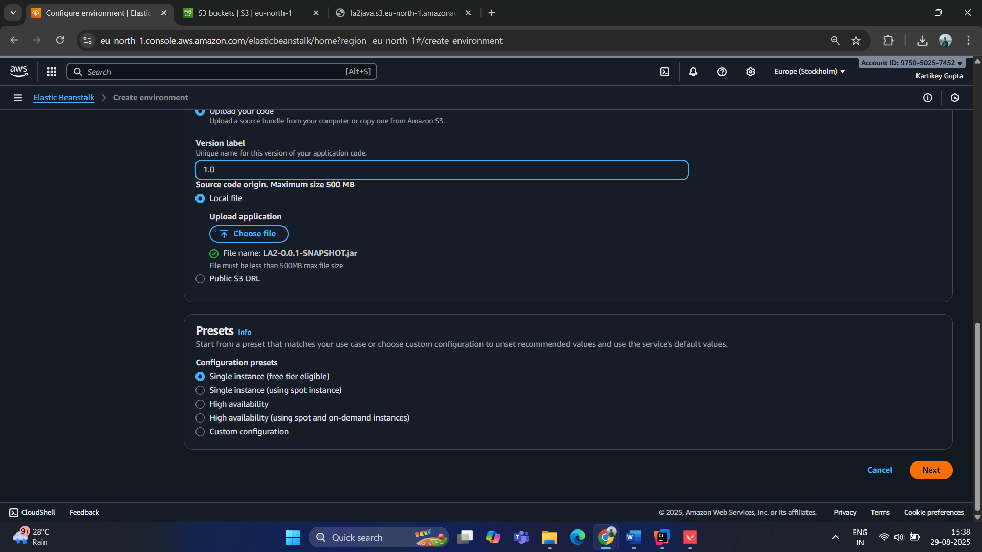

Uploading JAR file:

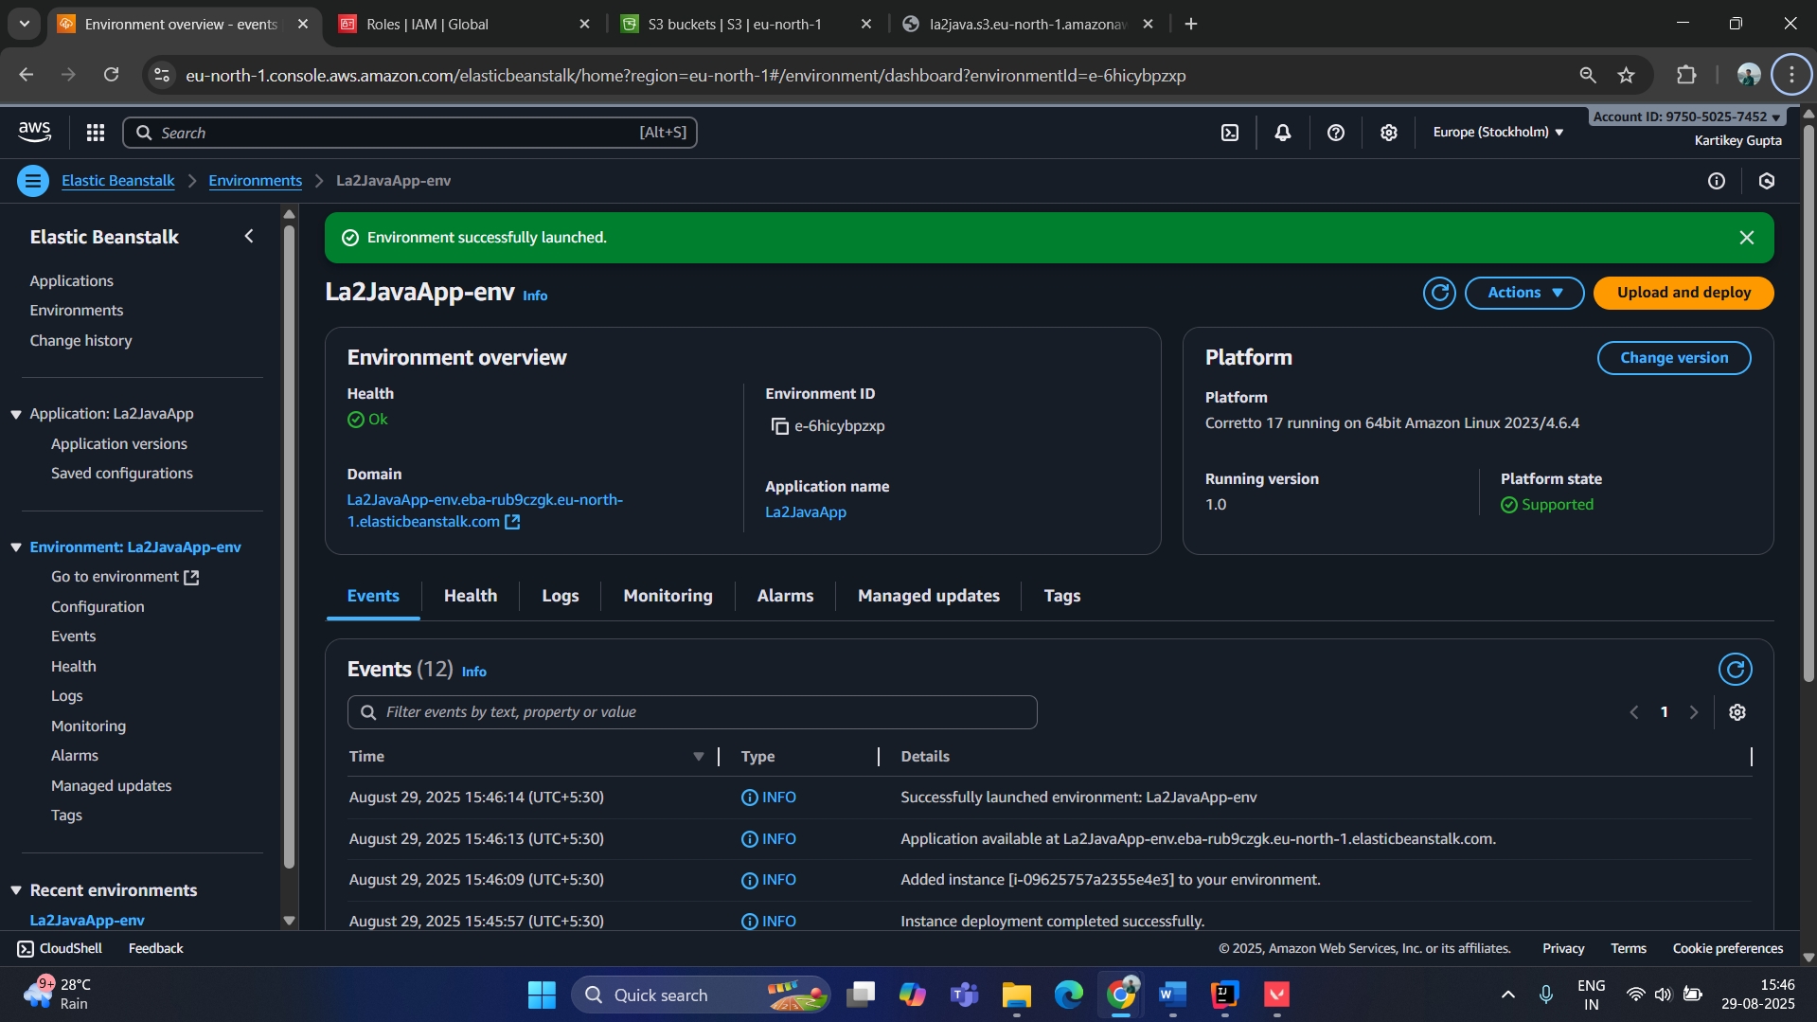

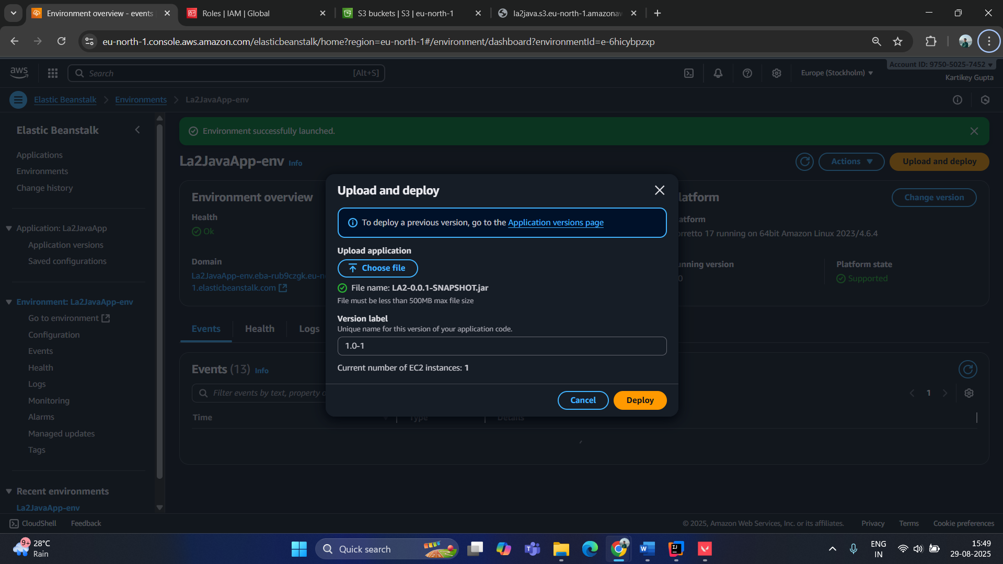

**Environment created successfully**

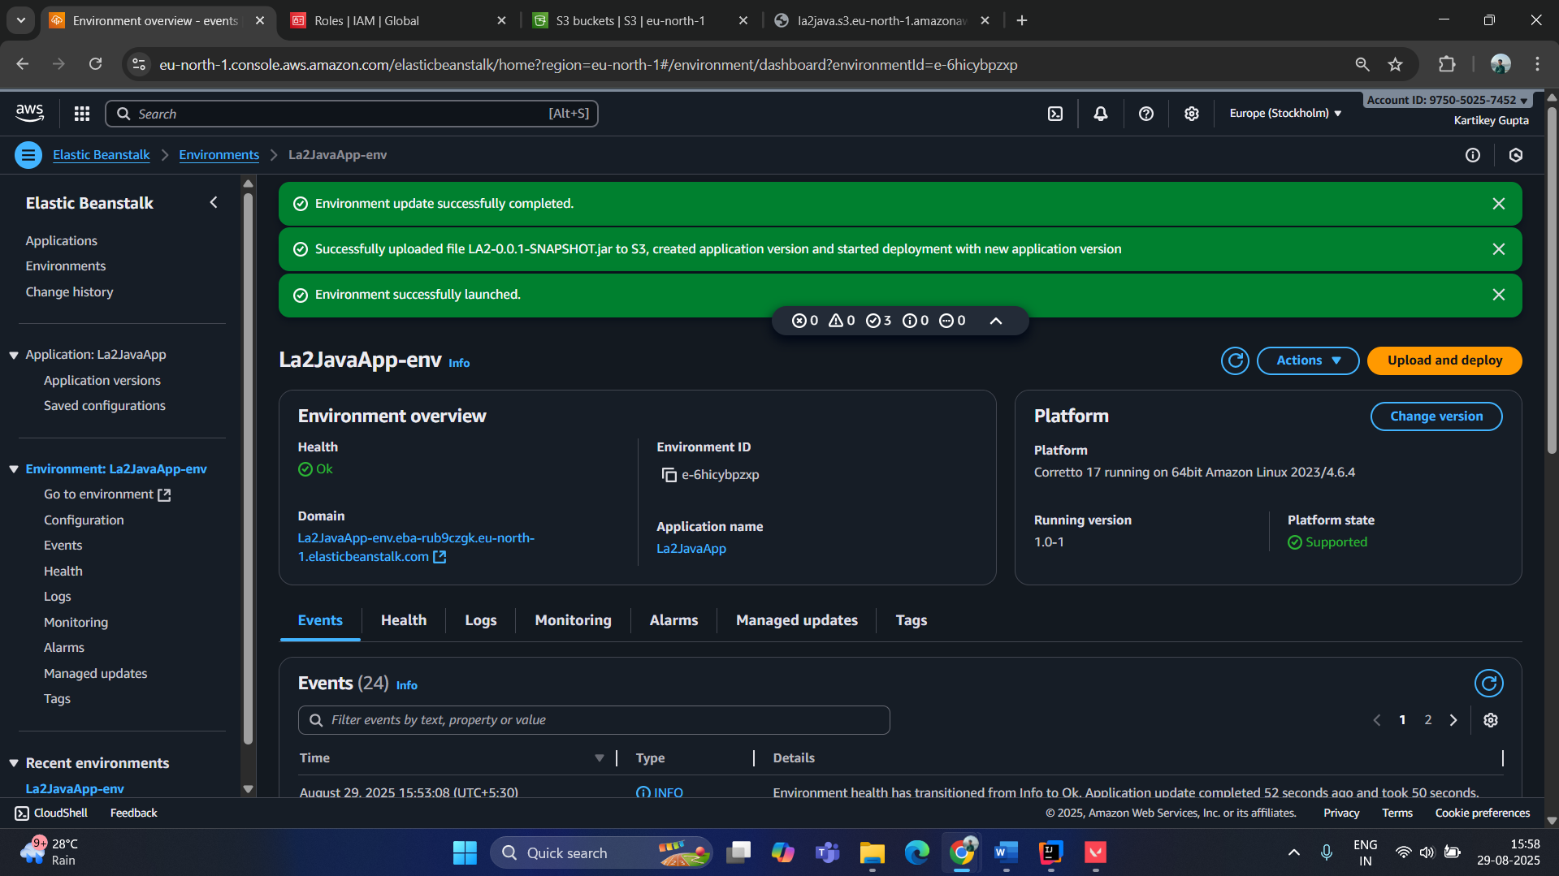

Accessing using the link: (will disable later due to incurring charges)

<http://la2javaapp-env.eba-rub9czgk.eu-north-1.elasticbeanstalk.com/>

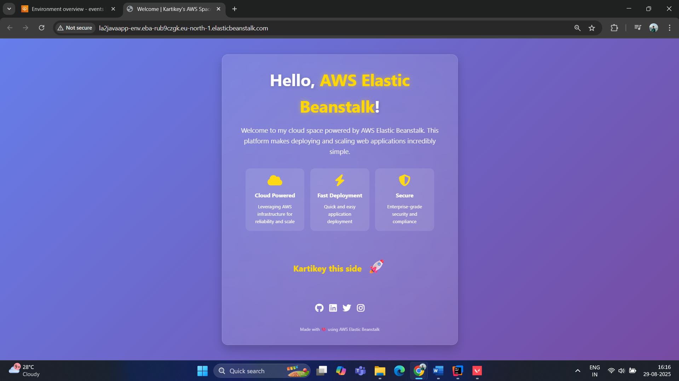

**Deployed web application successfully via the AWS Elastic Beanstalk!!**