

**Fall Semester 2025-26**

**Lab Assignment – 1**

**Slot:** L13+L14

**Class:** VL2025260105679

**Branch:** B.tech CSBS

**Course code & title:** CBS3005

Cloud, Microservices and Applications

**Faculty name:** Nithya K

**DA by:**

Kartikey Gupta

22BBS0105

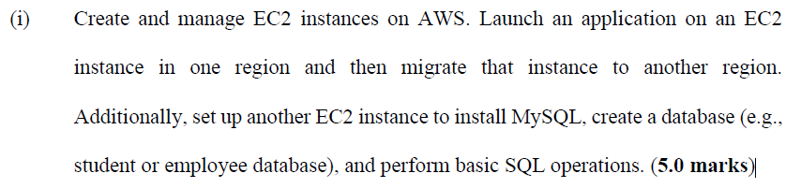

**Part 1: Launch EC2 Instance for Static HTML App**

**1. Log in to AWS Console**

* Go to EC2 Dashboard

**2. Launch EC2 Instance**

* Click **Launch instance**

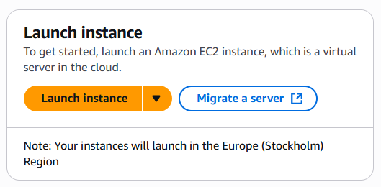

* **Name**: 22BBS0105_LA1
* **AMI**: Amazon Linux 2023 kernel-6.1
* **Instance type**: t3.micro

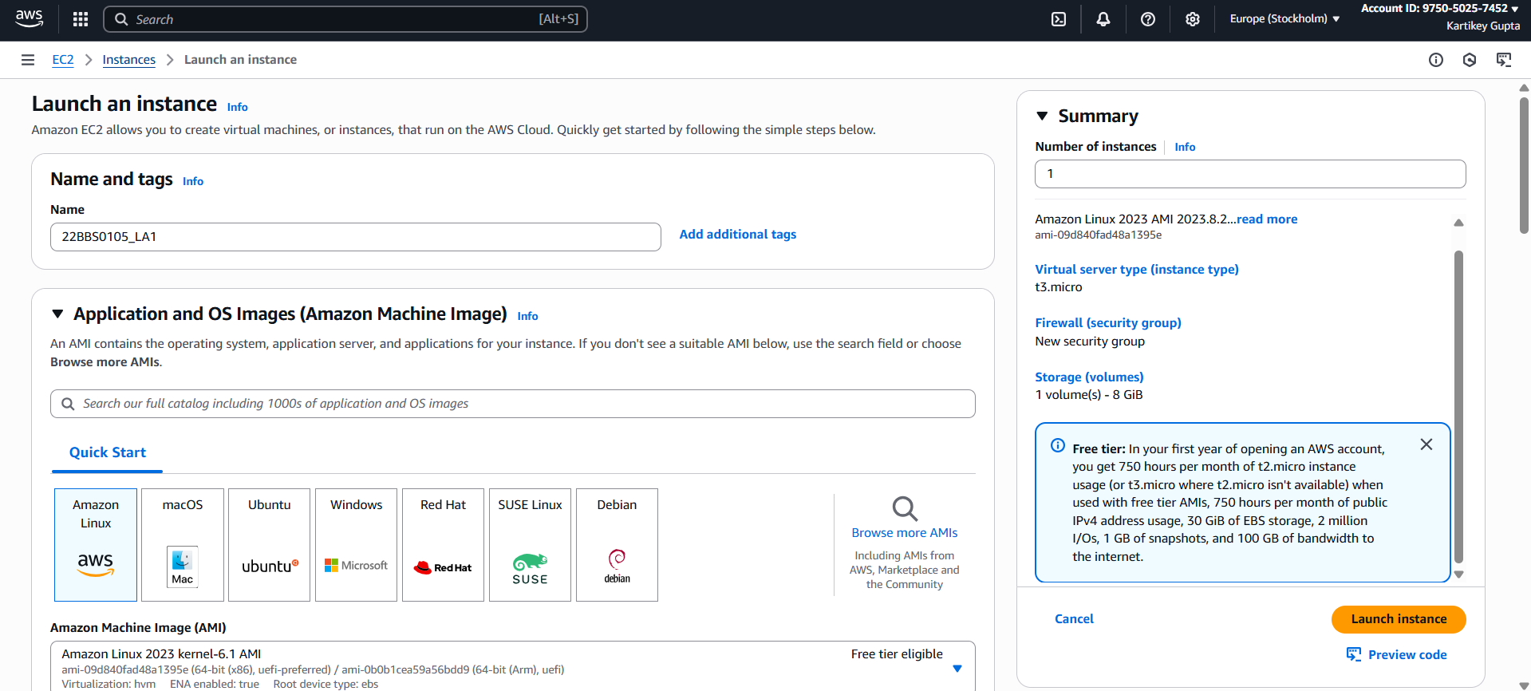

* **Key pair**: Create or select existing key
* **Network settings**:
  + Click **Edit**
  + Allow **SSH (port 22)** and **HTTP (port 80)**

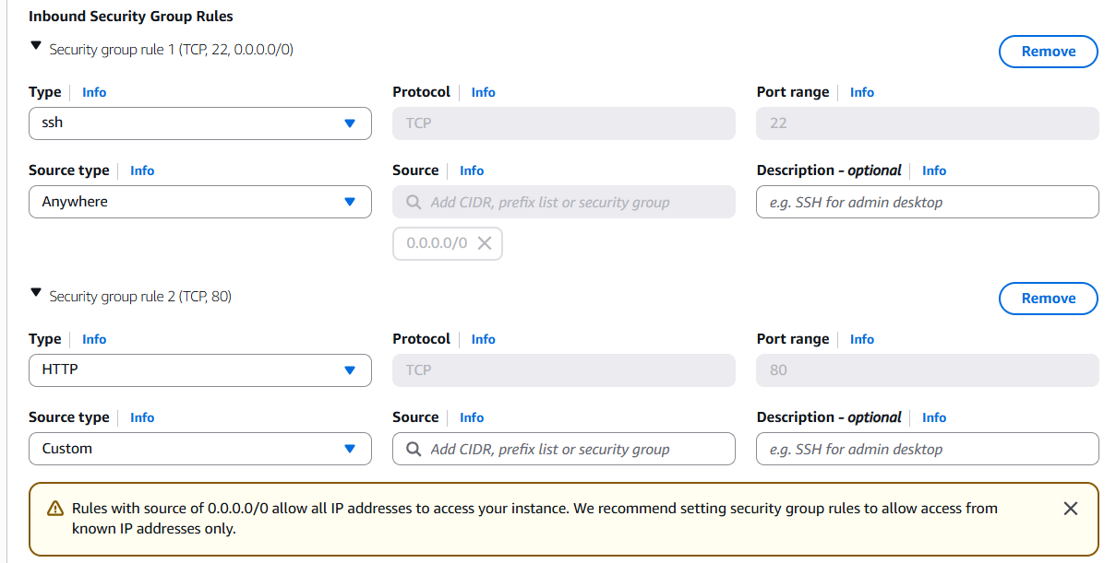

* Click **Launch**

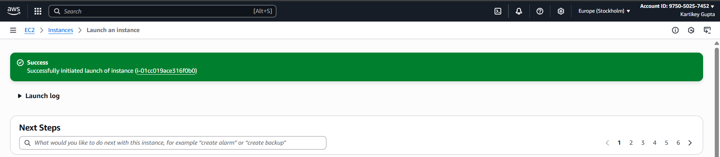

**Step 2: Connecting to ec2 instance**

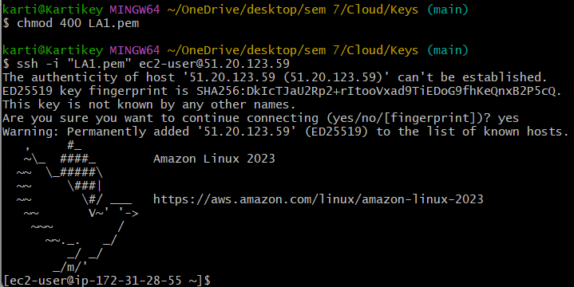

**Step 3: Installing Apache**

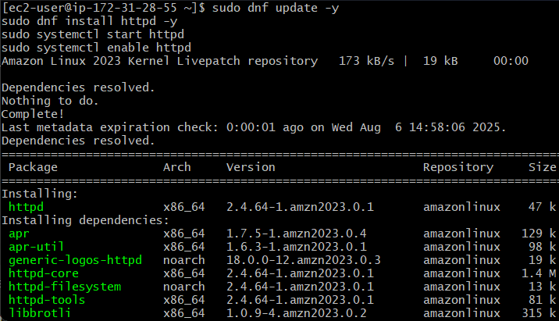

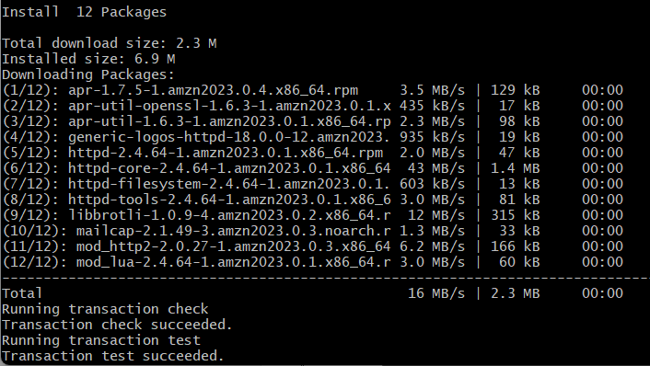

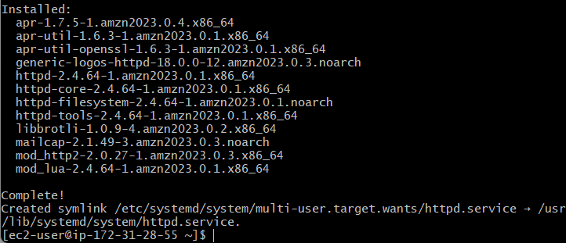

Checking if server is up and running

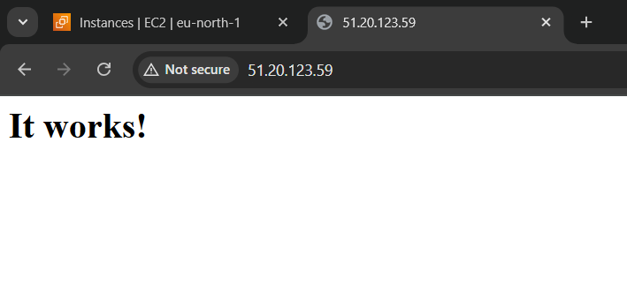

Working!!

**Part 2: Migrate the Instance to Another Region**

AWS doesn't allow direct region change, so we will copy the AMI.

**1. Create Image (AMI)**

* Go to EC2 → Instances → Select instance → Actions → Image → Create Image

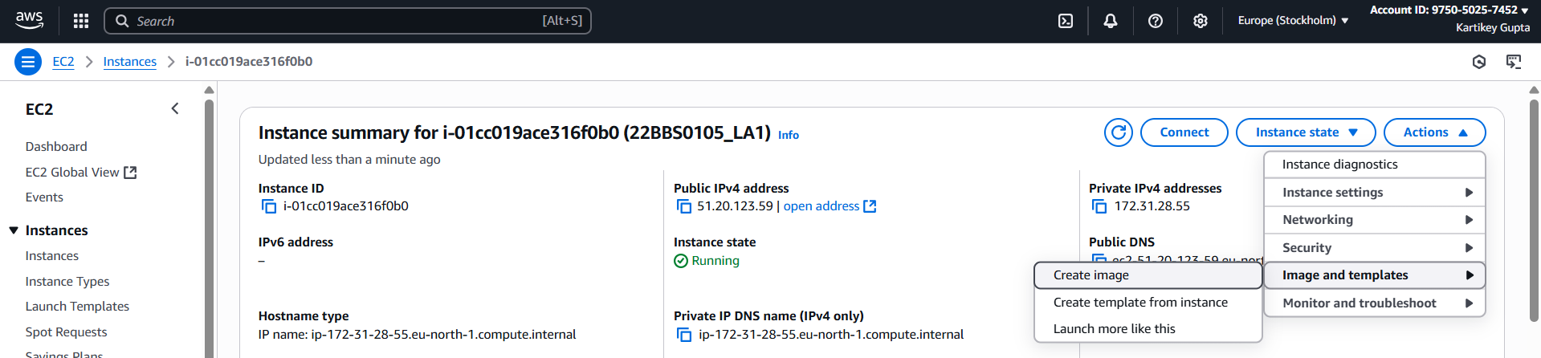

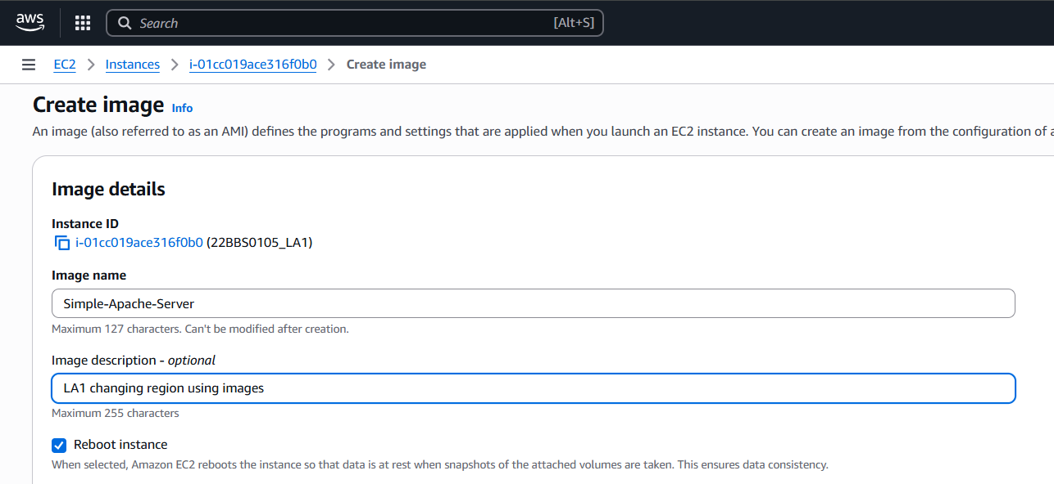

* Give a name and click **Create**

**2. Copy AMI to Another Region**

* Go to EC2 → AMIs
* Select your AMI → Actions → Copy AMI

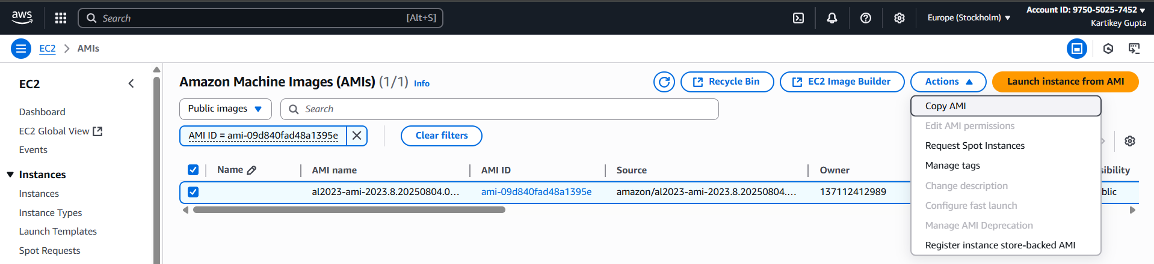

* Choose **destination region** (Asia Pacific Mumbai)

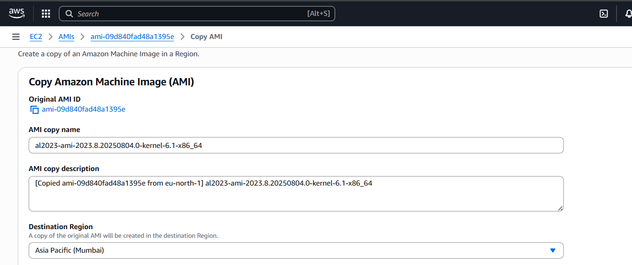

* Click **Copy**



**3. Launch New EC2 in Another Region**

* Switch region to Mumbai
* Go to AMIs → Select copied AMI → Launch instance

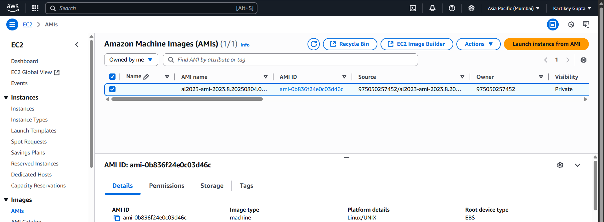

* Now app runs in the new region.

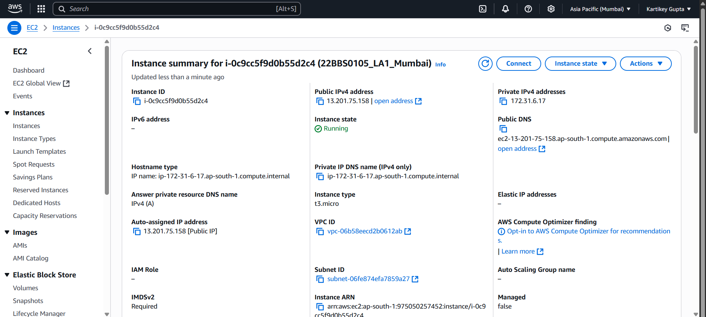

**Part 3: Setup Database**

Launch new instance with name DBServer following same steps above

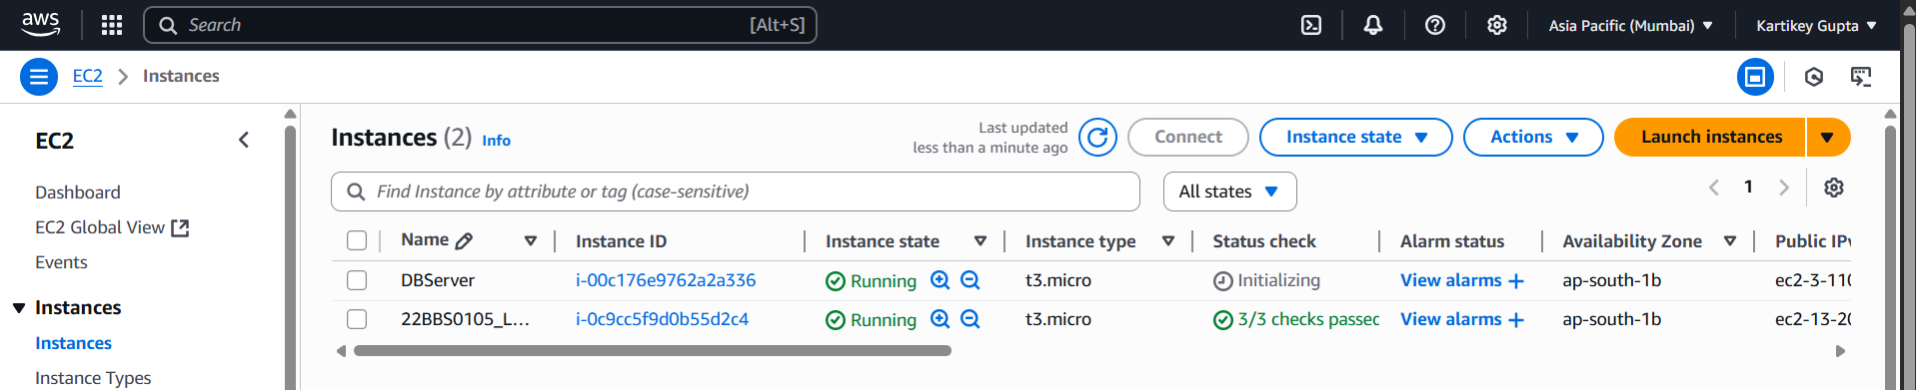

**Step 1:** Connecting to DBServer

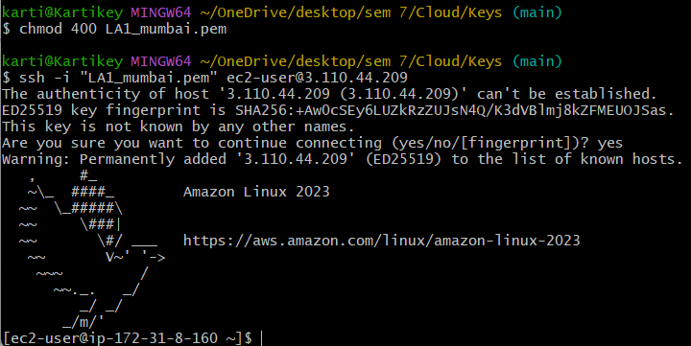

**Step 2:** Installing MySql

* sudo dnf update -y
* sudo dnf install mariadb105-server -y

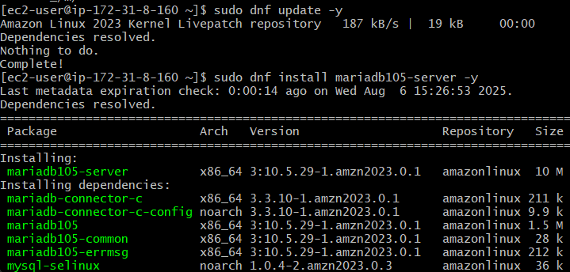

Start and enable MySQL:

* sudo systemctl start mariadb
* sudo systemctl enable mariadb

**Step 3:** Log in to MySQL CLI

sudo mysql -u root -p

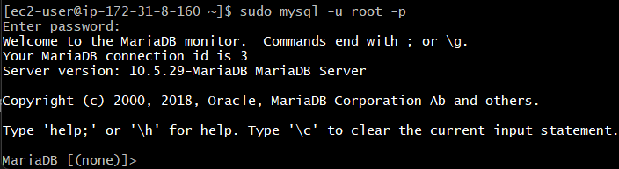

**Step 4:** Create Database and Table

CREATE DATABASE student;

USE student;

CREATE TABLE students (

id INT AUTO_INCREMENT PRIMARY KEY,

name VARCHAR(50),

age INT

);

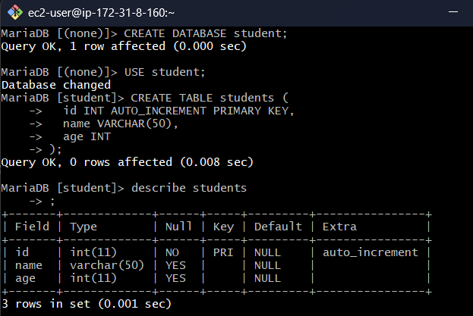

**Step 5:** Insert in table and display

INSERT INTO students (name, age) VALUES ('Aman', 20), ('Priya', 21), ('Ravi', 22);

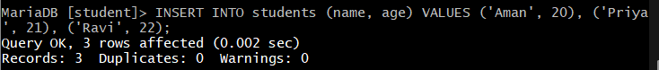

SELECT * FROM students;

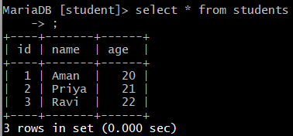

Closing connections

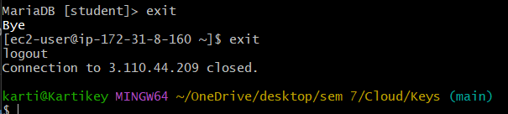

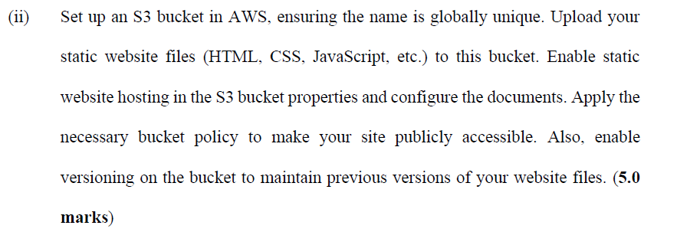

**Step 1: Create an S3 Bucket**

1. Go to S3 Console: https://s3.console.aws.amazon.com/s3/home
2. Click “Create bucket”

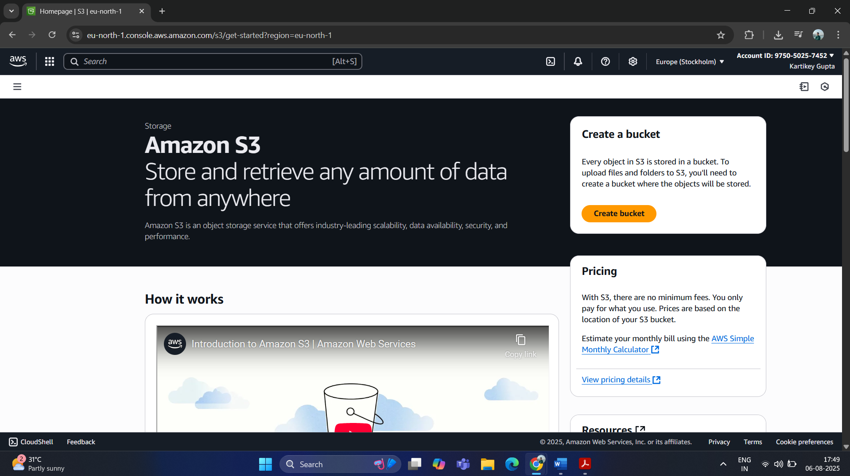

1. Enter a globally unique bucket name, 22bbs0105-kartikey-la1

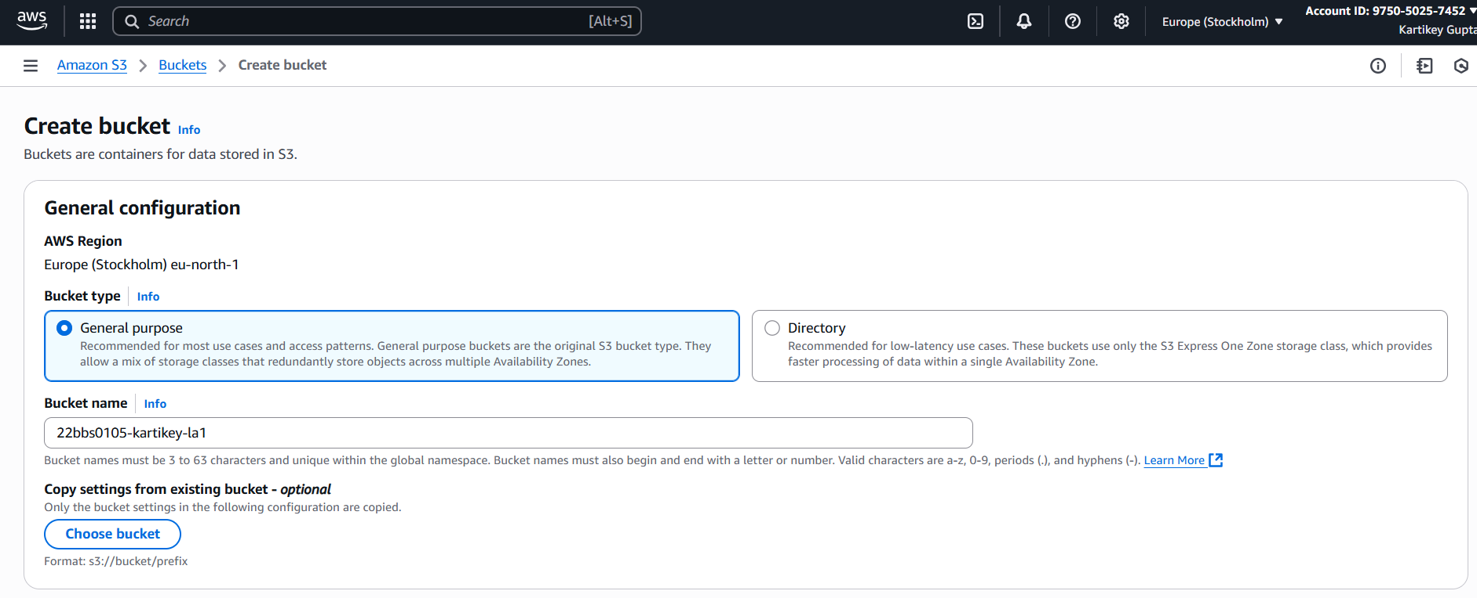

1. Uncheck “Block all public access” and “Enable bucket versioning”

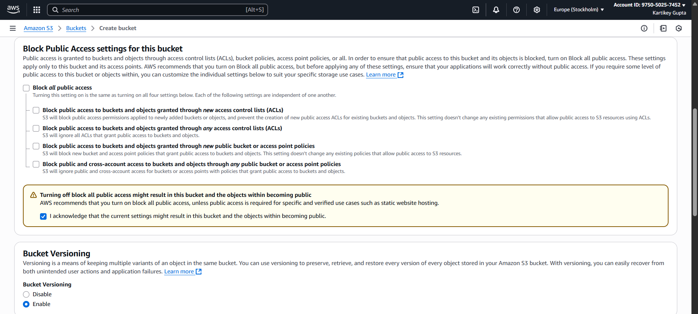

1. Click “Create bucket”

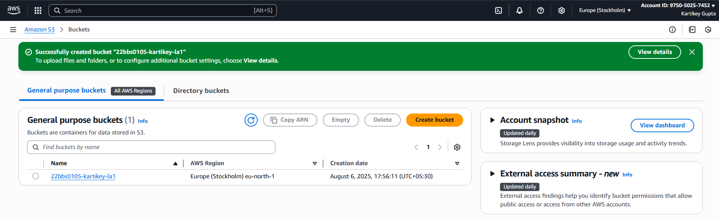

**Step 2: Enable Static Website Hosting**

1. Go to the created bucket
2. Click “Properties”

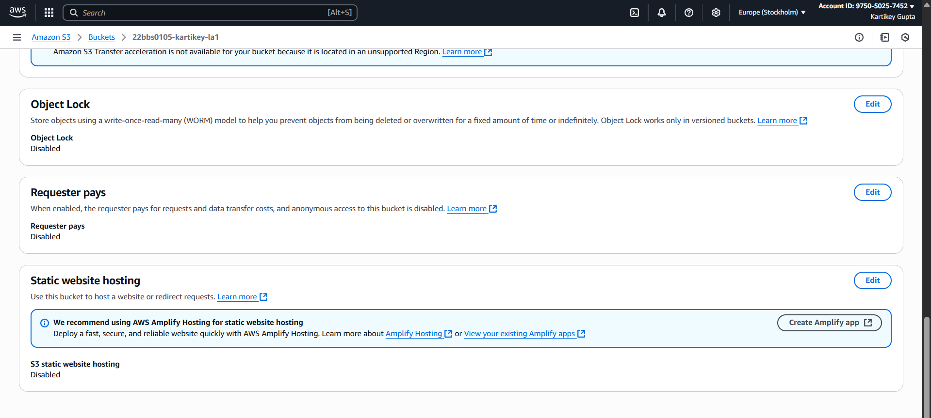

1. Scroll to “Static website hosting” and enable it
2. Select “Host a static website”
3. Set:
   * Index document: index.html

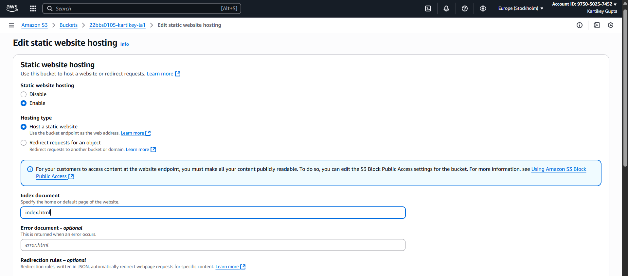

1. Save changes

**Step 3: Upload Website Files**

1. Go to the “Objects” tab in your bucket
2. Click “Upload”
3. Add index.html, style.css, script.js.

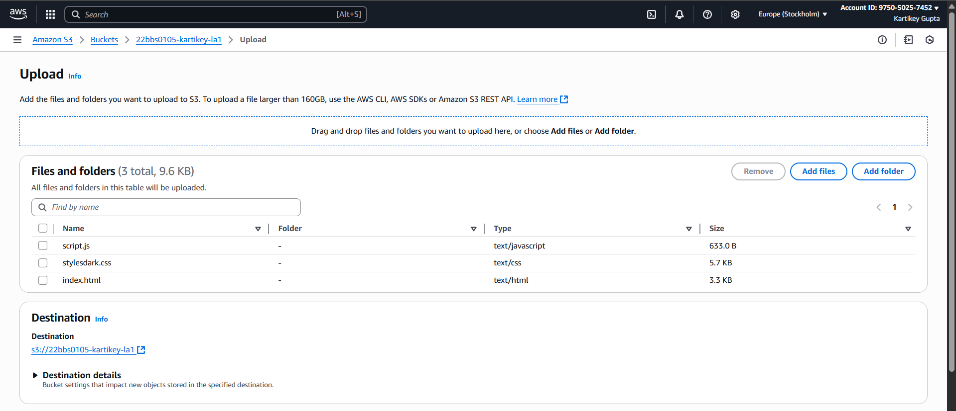

1. Click “Upload”

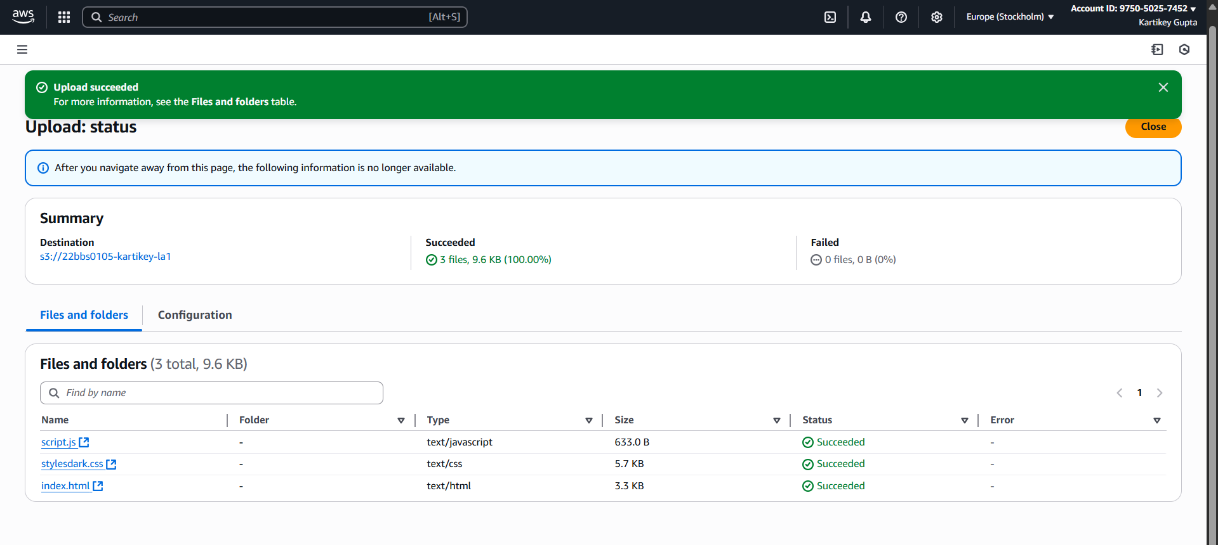

Permission Denied now

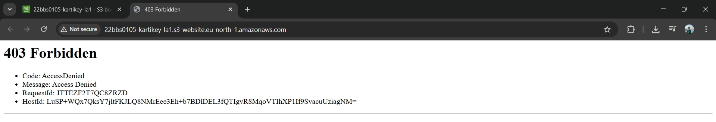

**Step 4: Make Files Public (Bucket Policy)**

1. Go to “Permissions” tab
2. Scroll to Bucket Policy

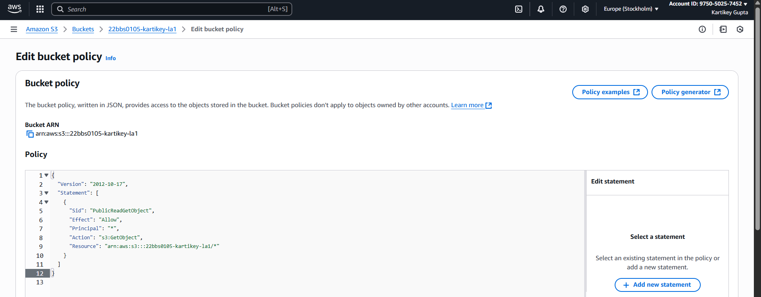

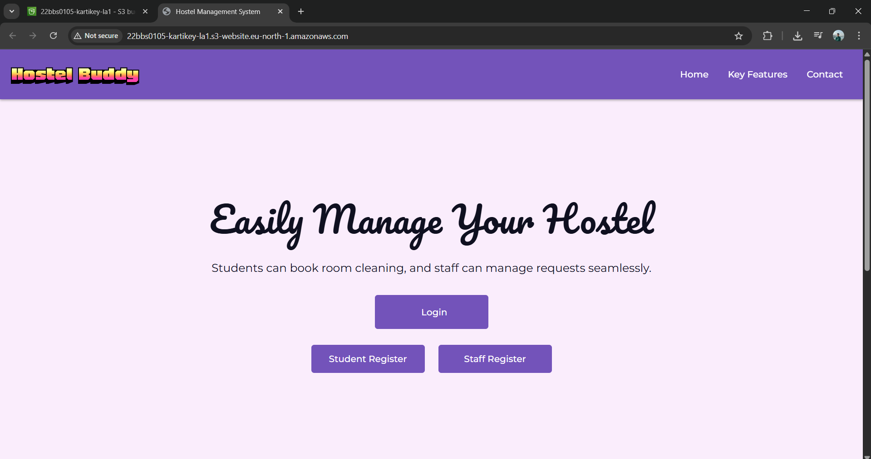

Website hosted successfully

Link: <http://22bbs0105-kartikey-la1.s3-website.eu-north-1.amazonaws.com/>