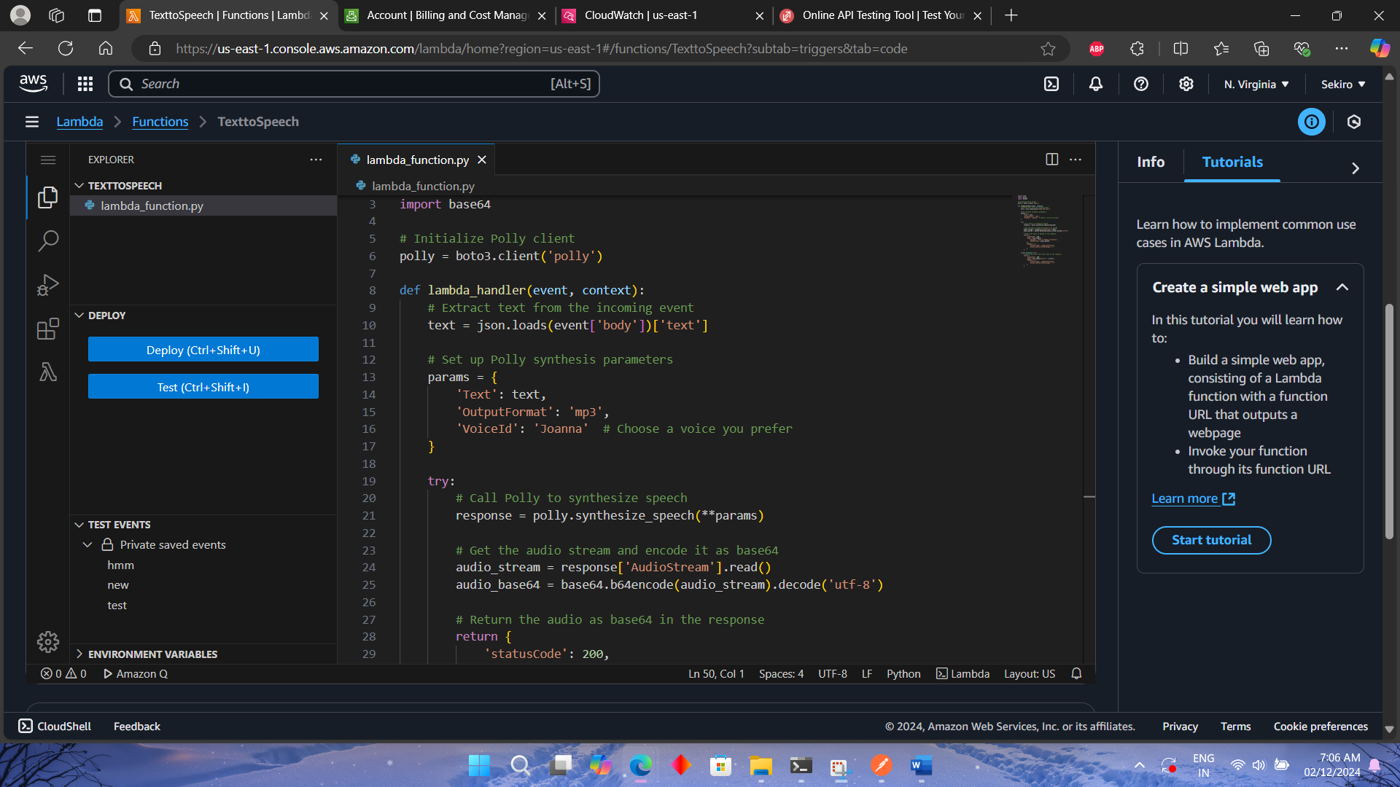

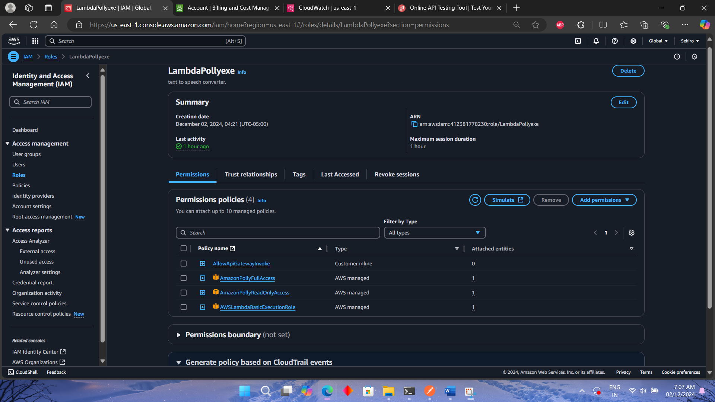

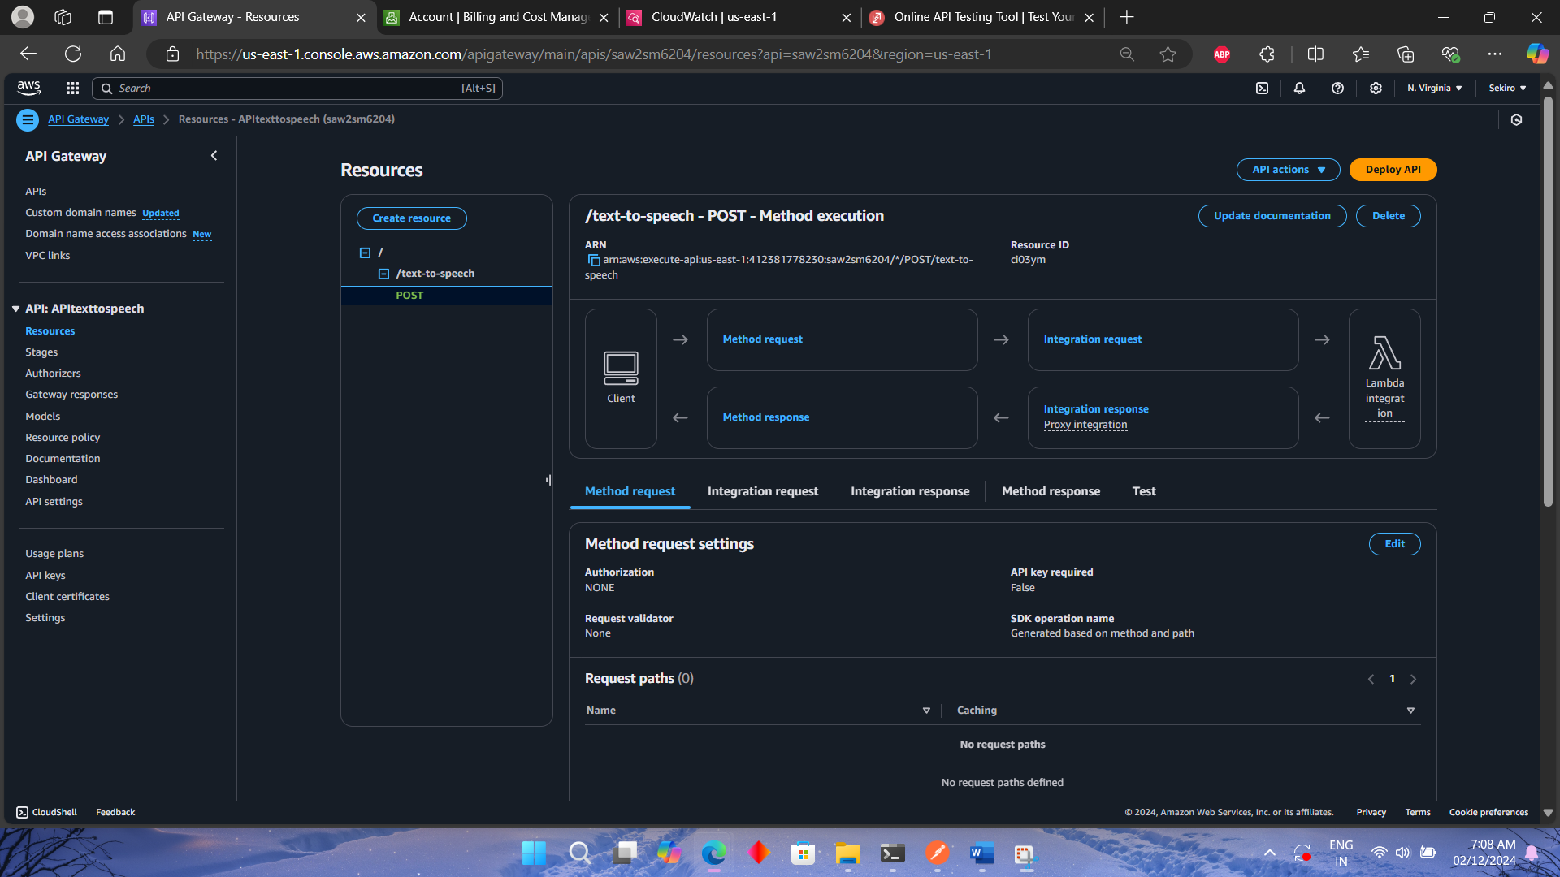

**Project Overview:**

**I developed a text-to-speech service using AWS Lambda, Amazon Polly, and S3. The project enables users to input text, which is then converted into an audio file stored in an S3 bucket, providing a link for easy access.**

**Setting Up AWS Lambda:**

**• Created a Lambda function in the AWS Management Console using Python.**

**• Configured the function to call Amazon Polly’s synthesizeSpeech API to convert text into speech.**

**• Utilized the audio stream returned by Polly and saved it as an MP3 file in an S3 bucket.**

**S3 Integration:**

**• Uploaded the audio file to an S3 bucket and configured permissions for public access.**

**• Generated a public URL for the stored audio file, which can be shared with users for download.**

**API Gateway Setup:**

**• Set up an API Gateway to trigger the Lambda function via a POST request.**

**• Configured the endpoint to accept dynamic text in the request body and return the generated audio file's S3 URL in the response.**

**• Ensured that CORS and authorization were correctly configured to allow API access.**

**Testing & Debugging:**

**• Initially tested the Lambda function using the built-in test feature in the AWS Lambda console.**

**• Performed end-to-end testing using Postman to ensure the API worked as expected, with accurate audio file generation.**

**Deployment:**

**• Deployed the API on a stage in API Gateway and ensured the Lambda function was linked correctly.**

**• Published the API and tested it with real input to verify that the text-to-speech functionality was working as expected.**