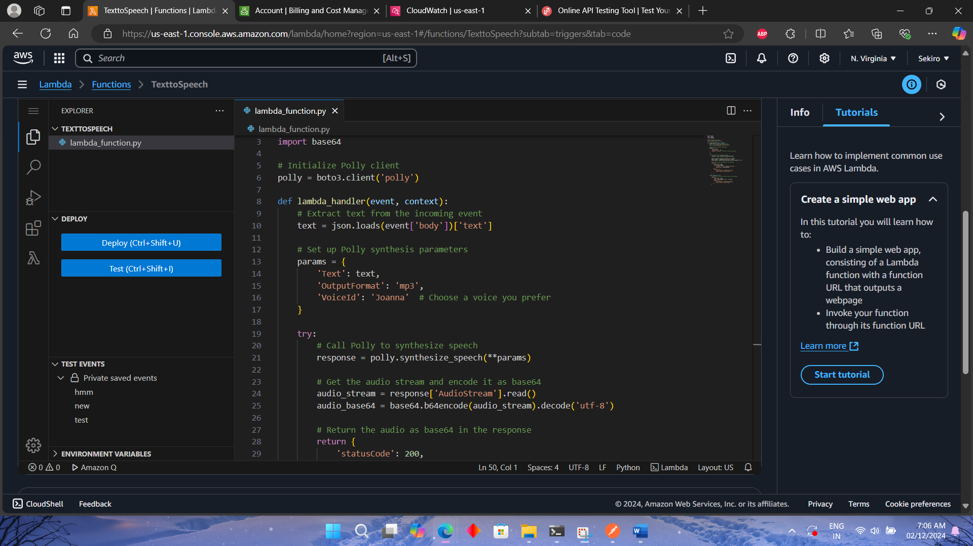

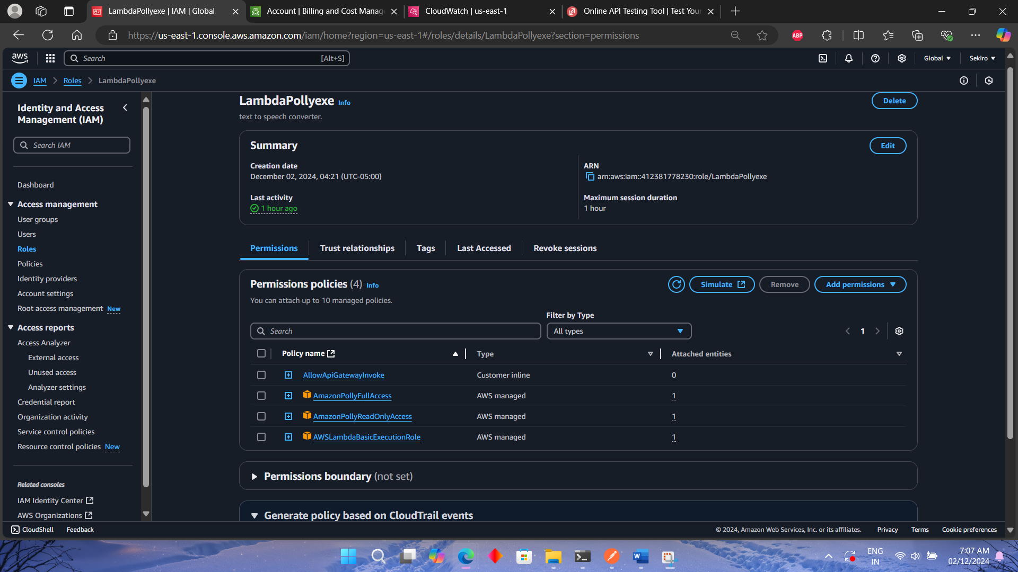

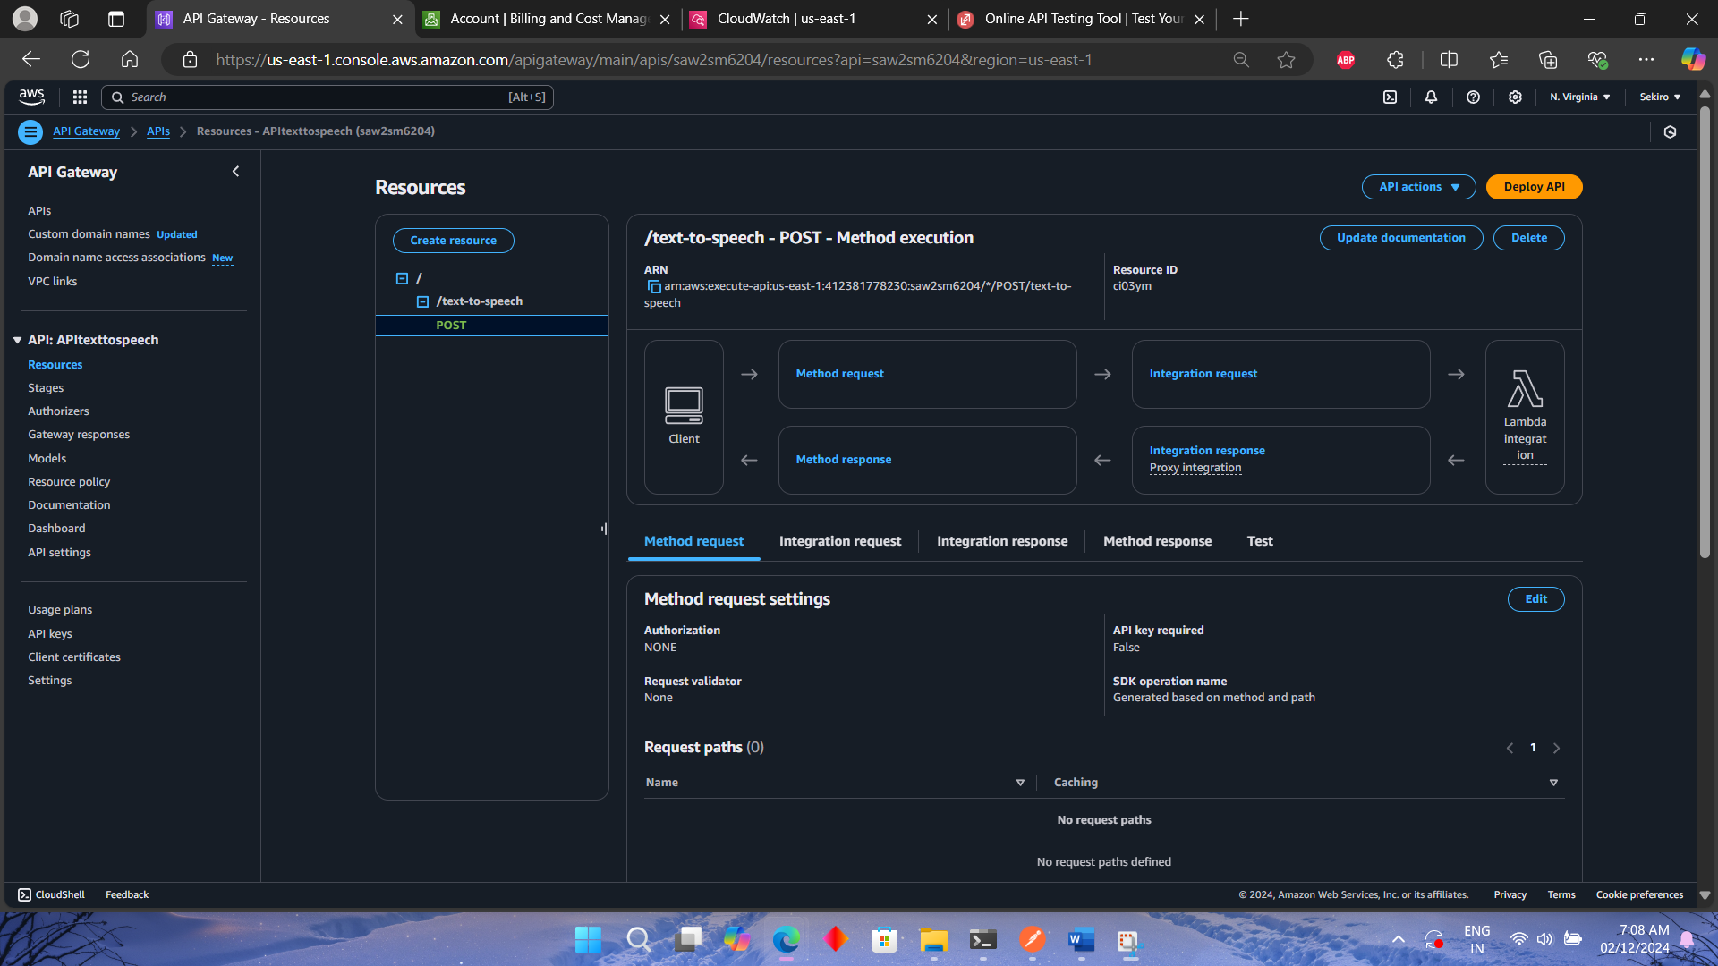

**Project Overview**: I developed a text-to-speech converter using AWS Lambda and Polly. The goal was to create a service where users could submit text, and the system would return an audio file in response.

**Setting Up AWS Lambda**:

* Created a Lambda function in the AWS Management Console using Python.
* Configured the function to call Amazon Polly's synthesizeSpeech API to convert text into speech.
* Used base64 encoding to return the audio stream as a response.

**API Gateway Setup**:

* Set up an API Gateway to trigger the Lambda function via a POST request.
* Configured the endpoint to accept text in the request body and return the audio file in base64 format.
* Ensured that CORS and authorization were correctly configured to allow access to the API.

**Testing & Debugging**:

* Initially tested the Lambda function using the built-in test feature in the AWS Lambda console.
* Used Postman(it’s a tool for API testing) for end-to-end testing, ensuring the system worked as expected.

**Deployment**:

* Deployed the API on a stage in API Gateway and ensured the Lambda function was linked correctly to the API.
* Published the API and tested it with real input to verify functionality.

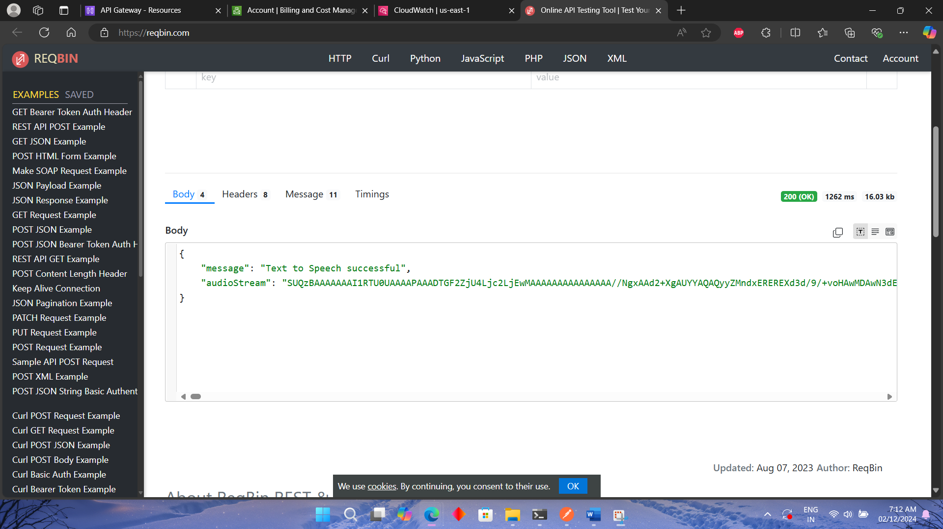

We can now convert the base64 format in mp3 using online tool or code.