**LAB1**

**Submitted by:**

**Pratyush Bakshi.**

**Student ID: 22055453**

**Submitted to:**

**Professor: Nawaz Chowdhury**

**Subject: Programming Concepts 2**

**Course code: CSD214**

Honesty Statement: “I declare that this submission is my own work in compliance with Sault College Academic Policies.”

CALCULATOR-

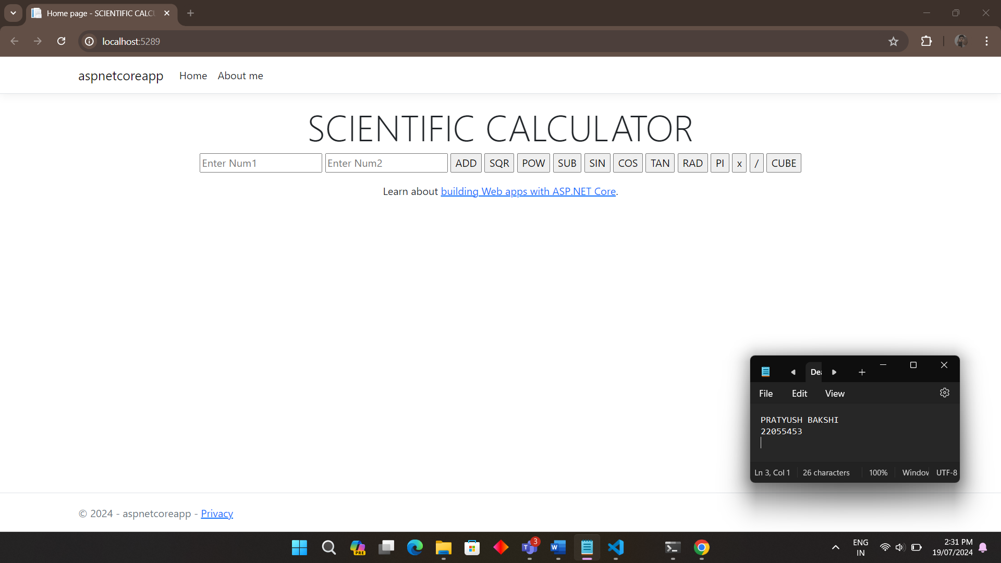

Write a program using tail recursion that will find the product of all the elements of a list.

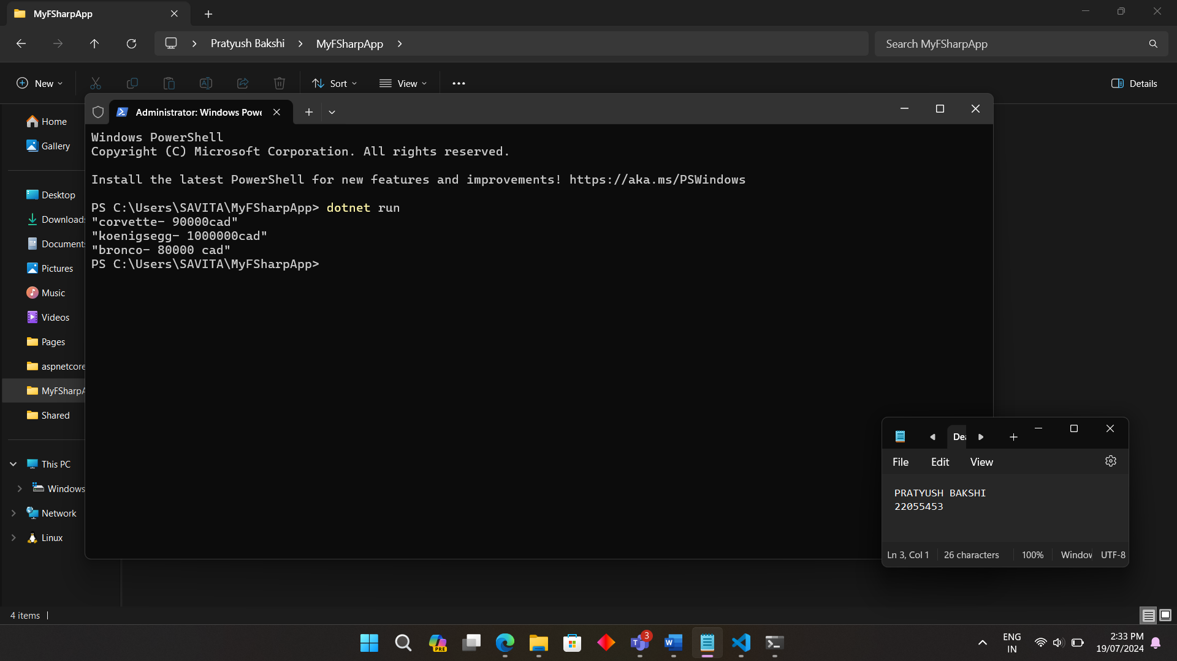

Write a program using tail recursion that will calculate the product of all odd numbers from a given number to 1. Assume that we pass only an odd number to this function. No validation is needed.  
Example: If the parameter is 11, then the result of the function should be 11x9x7x5x3x1 = 10395.

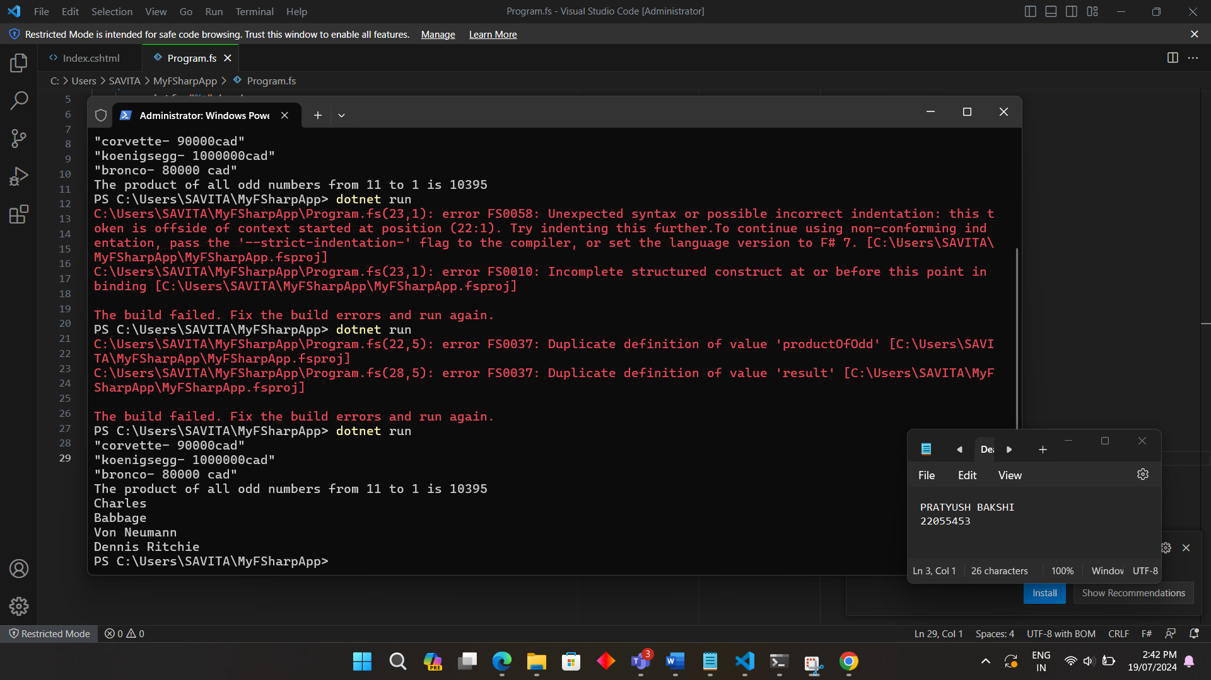

Using Map Function with a Collection:

* 1. Use the following list of strings.  
       
     [" Charles"; "Babbage  "; "  Von Neumann  "; "  Dennis Ritchie  "]  
       
     Using the map function, trim all the empty spaces before and after each element. You can use the String.Trim() function to achieve this.  
       
     Usage:  
     let name="  Untrimmed  "  
     let newName  = name.trim()



Using Filter and Reduce with a Collection:

* 1. Create a sequence of the first 700 positive integers.
  2. Convert the sequence into a list using the Seq.ToList function.
  3. Filter out those elements that are multiples of both 7 and 5.
  4. Finally, sum all the filtered numbers using a reduce or the fold function.

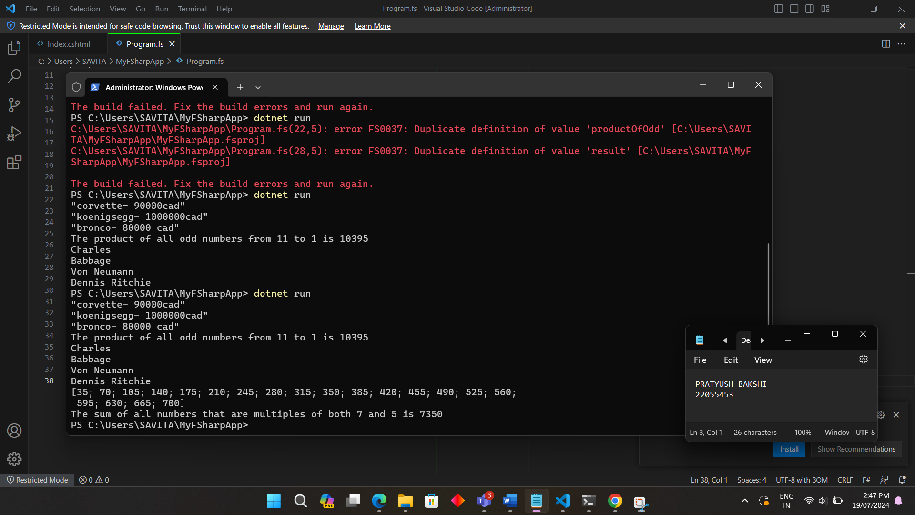

1. Using Filter and Reduce with Collection of Strings:
   1. Use the following list of strings:  
      ["James";"Robert";"John";"William";"Michael";"David";Richard"]
   2. Filter all the elements that have the letter "I,"' and use the reduce/fold function to concatenate all the resulting names.

