**TEST**

**Submitted by:**

**Pratyush Bakshi.**

**Student ID: 22055453**

**Submitted to:**

**Professor: Nawaz Chowdhury**

**Subject: Web Development 2**

**Course code: CSD213**

Honesty Statement: “I declare that this submission is my own work in compliance with Sault College Academic Policies.”

**Due date: 08 May 2024**

**Table of Content**

**Assignment Steps** 3

**Assignment Steps-1** 3

**Assignment Step-2** 4

# 

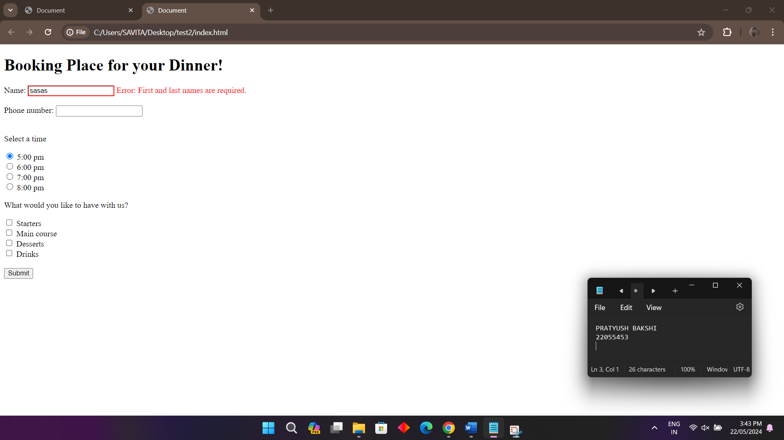

**Error first and last name required.**

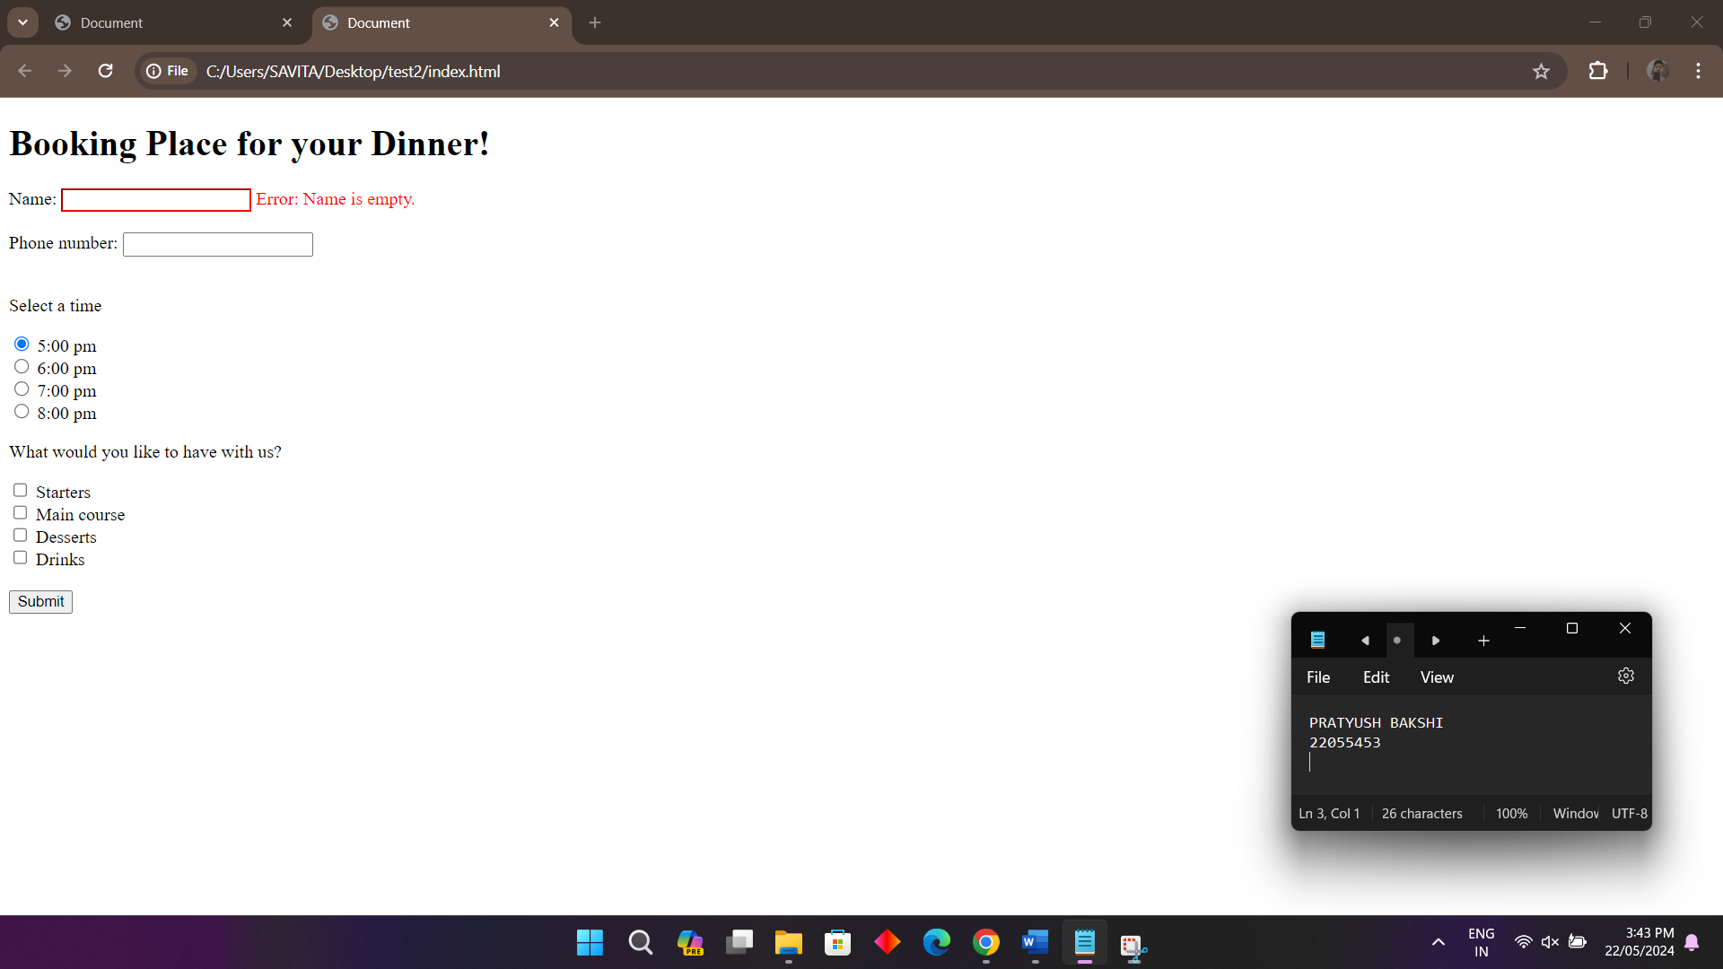

**Error name is empty!**

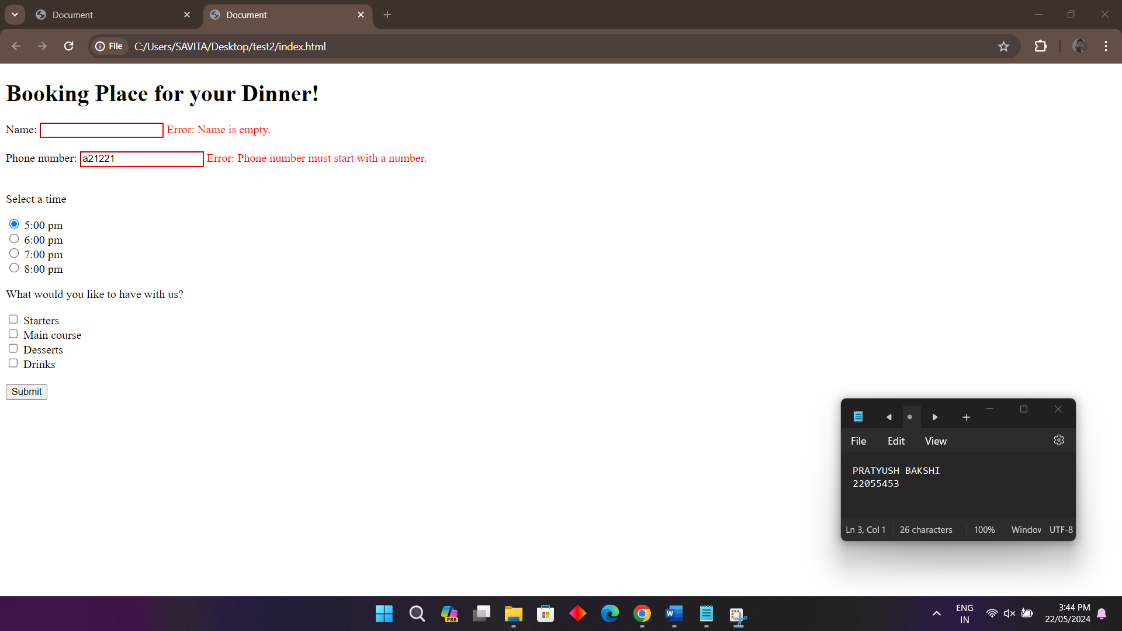

**Phone number must start with number.**

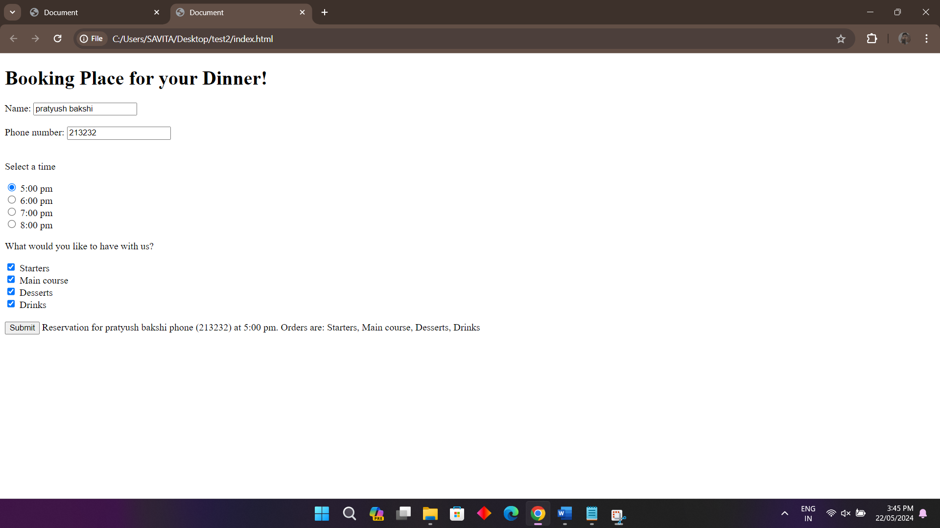

**Submitted form.**