**Q1. Advance Java:**

A)Write a java program to display IP Address and Name of client machine. [15 M]

B)Write a JSP script to accept username, store it into the session, compare it with password in another jsp file, if username matches with password then display appropriate message in html file. [15 M ]

**Q2. Node JS:**

A)Create a Node.js file that will convert the output "Hello World!" into upper-case letters. [25 M]

**OR**

**Advance PHP:**

A)Write a PHP script to create student.xml file which contains student roll no, name address, college and course. Print student details of specific course in tabular format after accepting course as input. [25 M]

**Q3. Android:**

A)Create an Android application to demonstrate Progress Dialog Box using

AsyncTask. [25 M]

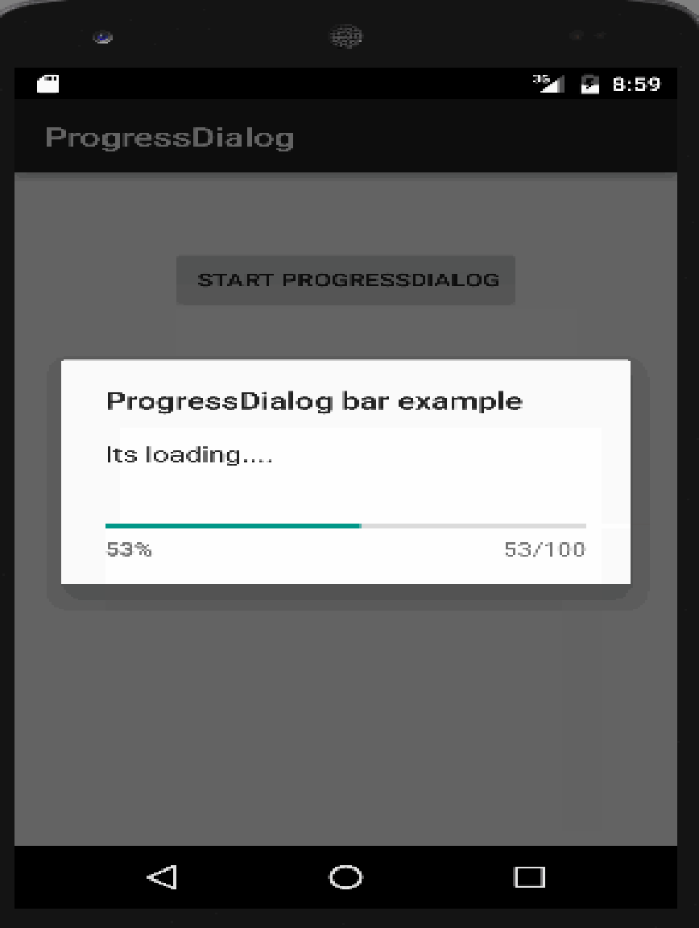

Q.4 Viva [10 M]

Q.5 Lab Book [10 M]

**Q.1.Advance Java:**

A)Write a multithreading program in java to display all vowels from a given String. [15 M ]

B)Write a SERVLET program which counts how many times a user has visited a web page. If user is visiting the page for the first time, display a welcome message. If the user is revisiting the page, display the number of times visited. (Use cookies) [15 M ]

**Q2. Node JS:**

A)Create a Nodejs Application that uses user defined Module to return the factorial of given number. [25 M]

**OR**

**Advance PHP:**

A)Write a PHP script to solve following questions(use student.xml file) [25 M]

i) Create a DOM Document object and load this XML file.

ii)Get the output of this Document to the browser.

iii)Save this [.XML] document in another format i.e. in [.doc]

Write a XML Script to print the names of the student present in “Student.xml” file

**Q.3 Android:**

A)Create a Simple Application Which Send ―Hello‖ message from one activity to

another with help of Button (Use Intent). [25 M]

Q.4 Viva [10 M]

Q.5 Lab Book [10 M]

Q.1. **Advance Java:**

A) Write a JDBC program to displays the details of employees (eno, ename, department, sal) whose department is “Computer Science”. [15 M]

B) Write a java program to simulate traffic signal using multithreading. [15 M]

**Q2. Node JS:**

A) Create a Nodc.js Application that uses user defined module circle.js which exports the functions area () and circumference () and display the details on console. [25 M]

**OR**

**Advance** **PHP:**

A)Write a script to create “cricket.xml” file with multiple elements as shown below. [25 M]

<CricketTeam>

<Team country=”Australia”>

<Player> </Player>

<runs> </runs>

<wicket> </wicket>

</Team>

</CricketTeam>

**Q.3 Android:**

A)Create an Android Application that Demonstrate DatePicker and DatePickerDailog. [25 M]

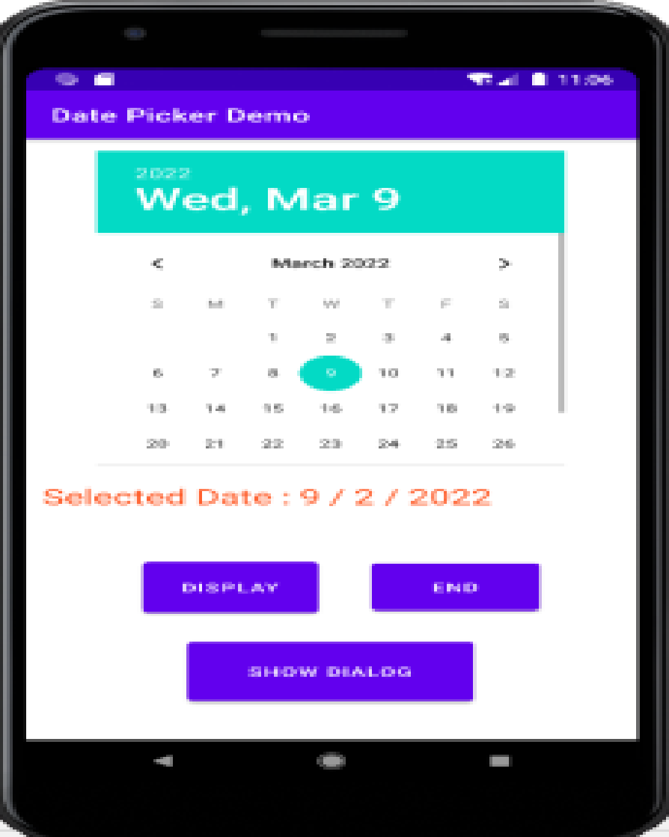

Q.4 Viva [10 M]

Q.5 Lab Book [10 M]

**Q.1. Advance Java:**

A)Write a java program to display “Hello Java” message n times on the screen. (Use Runnable Interface). [15 M]

B) Write a JSP program to create an online shopping mall. User must be allowed to do purchase from two pages. Each page should have a page total. The third page should display a bill, which consists of a page total of whatever the purchase has been done and print the total. (Use Session) [15 M]

**Q2. Node JS:**

A) a) Create a Node.js Application that accepts first name, last name and date of birth of a Person and define a Module that concatenate firstName and lastName and also calculate the age of the Person. [25 M]

**OR**

**PHP:**

A)Create an xml file which should comprise the following : [25 M]

<cricket>

<player>Sachin Tendulkar </player>

<runs>2000 </runs>

<wickets>100 </wickets>

<noofnotout>20</noofnotout>

</cricket>

For atleast 5 players.

Write a PHP script to display the details of players who have scored more than 1200 runs andat least 50 wickets.

**Q.3 Android:**

A)Create a Simple Application, which read a positive number from the user and

display its factorial value in another activity. [25 M]

Q.4 Viva [10 M]

Q.5 Lab Book [10 M]

Q.1. **Advance Java:**

A) Write a java program to create Teacher table(TNo.TName, Sal, Desg) and insert a record in it. [15 M]

B)Write a MultiThreading program in java using Runnable interface to draw a horizontally rolling ball on an applet container. [15 M]

**Q2. Node JS:**

A) Create a Node.js Application that performs following operations on Buffer data.

a. Concat

b. Compare

c. Copy [25 M]

**OR**

**Advance** **PHP:**

A)Create student table as follows [15 M]

Student(sno, sname,standard,Marks, per).

Write AJAX script to select the student name and print the students details of particular standard. [25 M]

**Q.3 Android:**

A)Create an Android App, it reads the Students Details (Name, Surname, Class,

Gender, Hobbies, Marks) and Display the all information in another activity in

table format on click of Submit button [25 M]

Q.4 Viva [10 M]

Q.5 Lab Book [10 M]

Q.1. **Advance Java**

A)Write a JDBC program to accept the details of customer (CID, CName, Address, Ph_No) and store it into the database (Use PreparedStatement interface) [15 M]

B)Write a SOCKET program in java to check whether given file is present on server or not, If it is present then display its content on the server’s machine otherwise display error message. [15 M]

**Q2. Node JS:**

A) a) Create a Node.js file that opens the requested file and returns the content to the client. If anything goes wrong, throw a 404 error. [25 M]

**OR**

**Advance PHP**

A)Create employee table as follows EMP(eno,ename, designation,salary).Write a AJAX program to select the employees name and print the selected employee’s details [25 M]

**Q.3 Android:**

A)Create an Android Application to display satellite view of current location using

Google Map. [25 M]

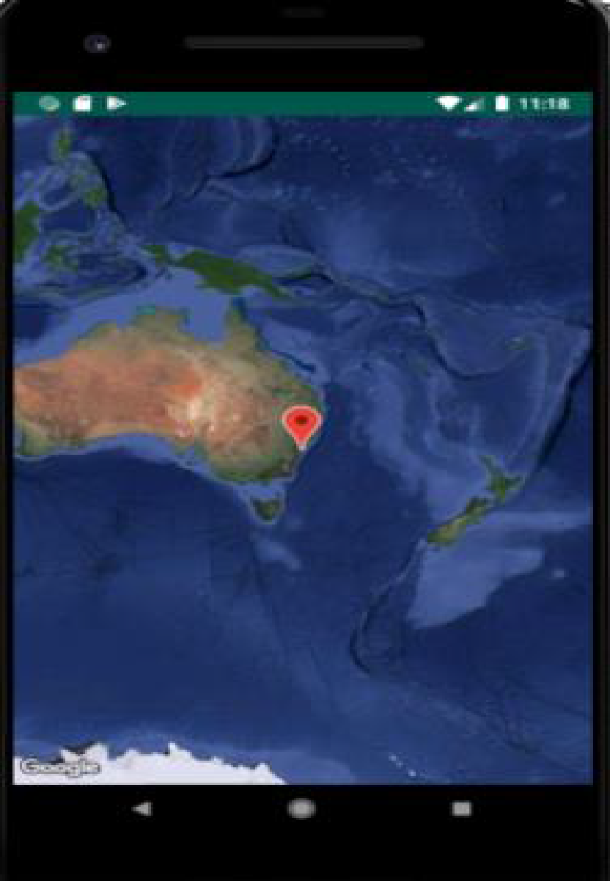

Q.4 Viva [10 M]

Q.5 Lab Book [10 M]

Q.1. **Advance Java**

A)Write a JSP program to calculate sum of first and last digit of a given number. Display sum in Red Color with font size 18. [15 M]

B)Write a Multithreading program in java for Racing Car. [15 M]

**Q2. Node JS:**

A) Using Node.js create a web page to read two file names from user and append contents of first file into second file. [25 M]

**OR**

**Advance PHP**

A) Consider the following relational database [25 M]

Project(P_Group,Project_Title)

Student(Seat_no,Name, Class, P_Group_No)

Write an AJAX Script to accept project title and display the list of students who are working in a particular project.

**Q.3 Android:**

A)Create an Android Application that will change color of the College Name on click

of Push Button and change the font size, font style of text view using xml. [25 M]

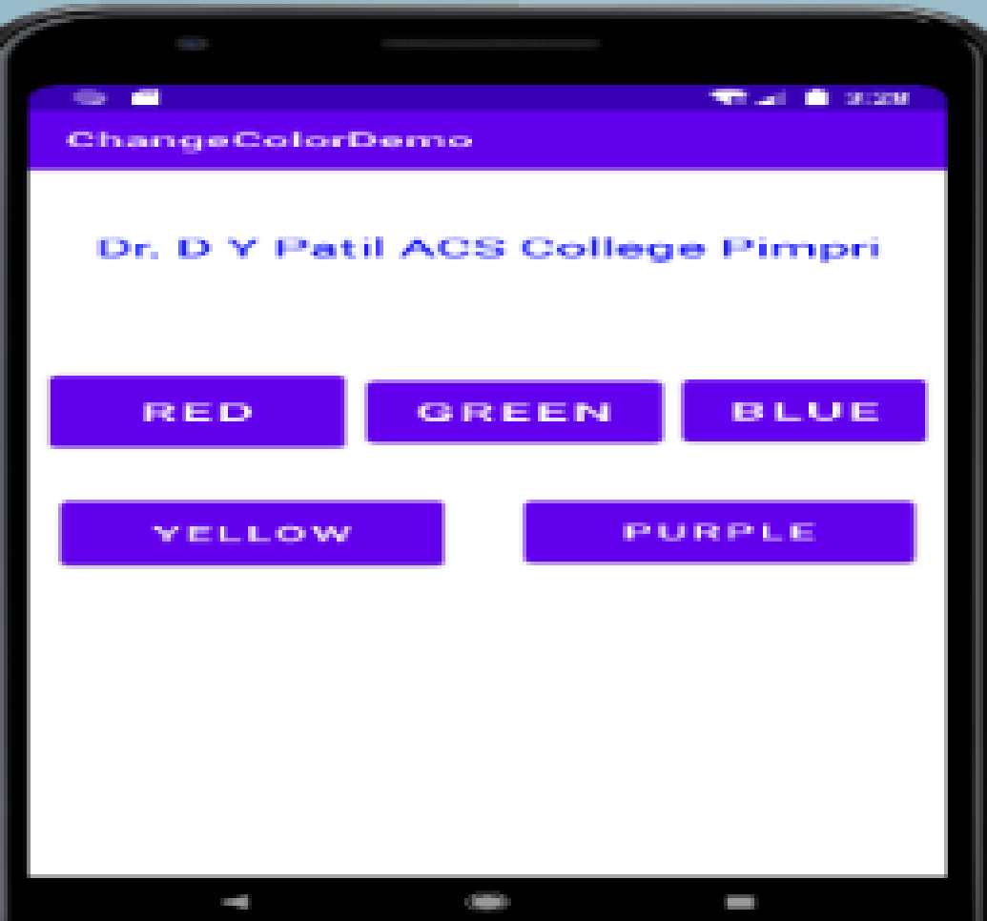

Q.4 Viva [10 M]

Q.5 Lab Book [10 M]

Q.1. **Advance Java**

A)Write a Multithreading program using Runnable interface to blink Text on the frame. [15 M]

B)Write a SERVLET application to accept username and password, search them into database, if found then display appropriate message on the browser otherwise display error message. [15 M]

**Q2. Node JS:**

A)Using Node.js create a web page to read two file names from user and combine in third file with all content in Upper case. [25 M]

**OR**

**Advance PHP**

A)Write a AJAX script to get player details from XML file when the user select player name. Create XML file o store details of player(name, country,wickets and runs) [25 M]

**Q.3 Android:**

A)Create an Android Application to find the factorial of a number and Display the

Result on Alert Box. [25 M]

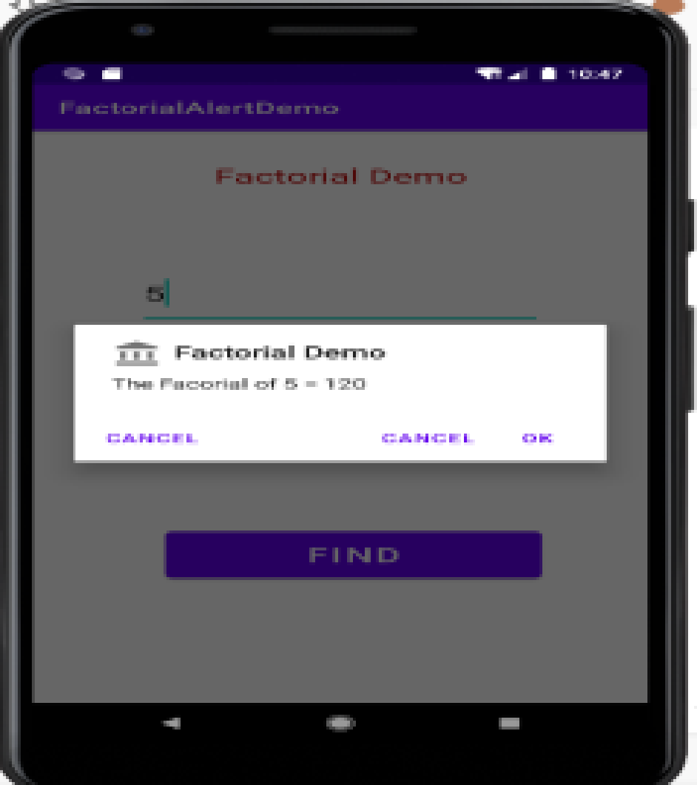

Q.4 Viva [10 M]

Q.5 Lab Book [10 M]

Q.1. **Advance Java**

A) Write a JDBC program to delete the records of employees whose names are starting with ‘A’ character. [15 M]

B)Write a Multithreading program in java using Runnable interface to display a bouncing ball on an Applet. [15 M]

**Q2. Node JS:**

A)Create a Node.js file that writes an HTML form, with an upload field [25 M]

**OR**

**Advance PHP**

A)Consider he following entities and their relationships. [25M]

Movie(movie_no, movie_name,release_year)

Actor(actor_no,name)

Relationship between actor and movie is many to many with attribute rate in Rs. Create a RDB in 3NF. With using three radio buttons (accept, insert, update)

Write an AJAX script to accept actor name and display names of movies in which he has selected.

**Q.3 Android:**

A)Create an Android Application to find the factorial of a number and Display the

Result on Alert Box. [25 M]

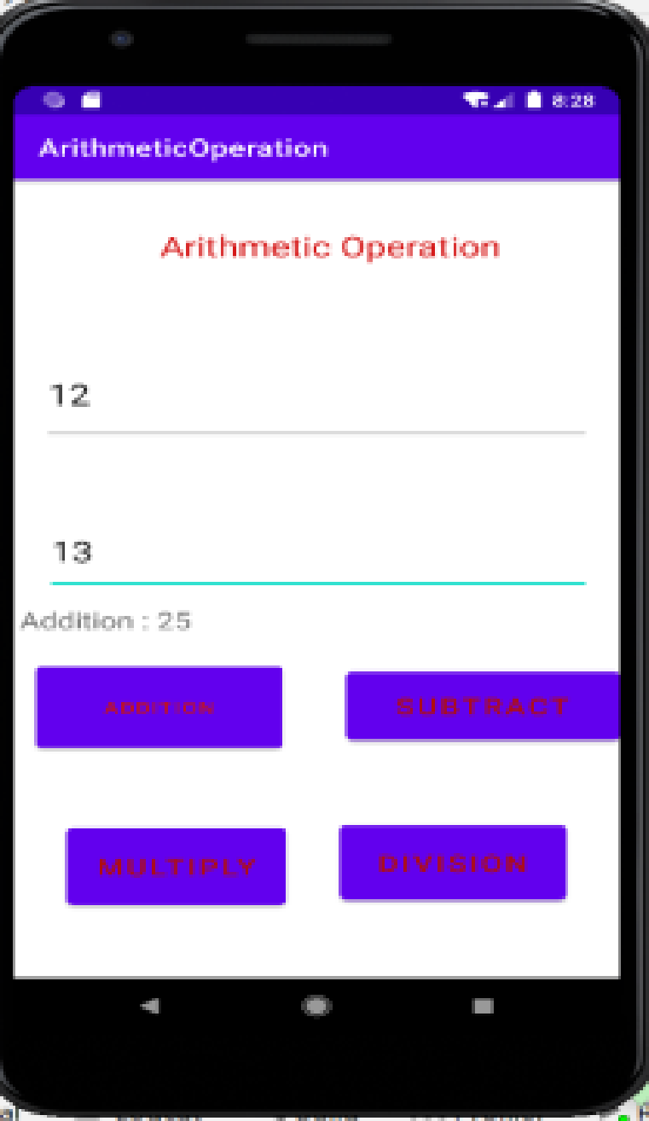

Q.4 Viva [10 M]

Q.5 Lab Book [10 M]

Q.1.**Advance Java**

A) Write a JDBC program to count the number of records in table. (Without using standard method) [15 M]

B) Write a Multithreading program in java for bouncing ball. For each bounce change the color of ball randomly. [15 M]

**Q2. Node JS:**

A)Create a Node.js Application to download jpg image from the Server. [25 M]

**OR**

**Advance PHP**

A) Create student registration form. Accept the student details and display details in the next page. (Use sticky form concept). [25 M]

**Q.3 Android:**

A)Create an Android Application to accept two numbers and find power and Average.

Display the result on the next activity on Button click. [25 M]

Q.4 Viva [10 M]

Q.5 Lab Book [10 M]

Q.1. **Advance Java**

A)Write a JDBC program to remove “percentage” column from student (rno, sname, percentage) table. [15 M]

B)Write a SERVLET program to display addition of two numbers. [15 M]

**Q2. Node JS:**

A)Create a Simple Web Server using Node.js that shows the college information. [25 M]

**OR**

**Advance PHP**

A)Write an Ajax code to print the content of “MyFile.dat” on clicking on fetch button. The data fetches from the server using Ajax Technique. [25 M]

**Q.3 Android:**

A)Create Android Application for performing the following operation on the table

Customer (id, name, address, phno). (use SQLite database or other)

i) Insert New Customer Details.

ii) Show All the Customer Details on Toast Message. [25 M]

Q.4 Viva [10 M]

Q.5 Lab Book [10 M]

Q.1. **Advance Java**

A)Write a Multithreading program in java to display the number’s between 1 to 100 continuously in a TextField by clicking on button.(use Runnable Interface). [15 M]

B)Write a JSP program to accept the details of Account (ANo, Type, Bal) and store it into database and display it in tabular form. (Use PreparedStatement interface) [15 M]

**Q2. Node JS:**

A)Using Node.js create a User Login System. [25 M]

**OR**

**Advance PHP**

A)Write AJAX script to read contact.dat file and print the content of a file in tabular form when the user clicks on print button. Contact.dat file contains srno, name, residence no, mobile no.(Enter at least 3 records in contact.dat file) [25 M]

**Q.3 Android:**

A)Develop an Android application that create custom Alert Dialog containing Friends Name and onClick of Friend Name Button greet accordingly. [25 M]

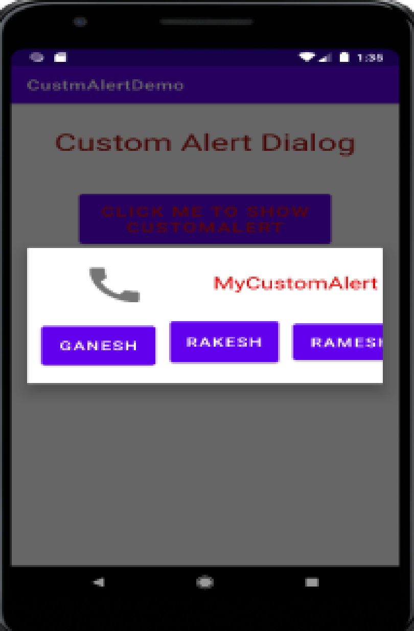

Q.4 Viva [10 M]

Q.5 Lab Book [10 M]

Q.1. **Advance Java**

A) Write a JDBC program to create a Mobile (Model_No, Company_Name, Price, Color) table and insert a record in it. [15 M]

B) Write a Socket program in java for simple stand alone chatting application. [15 M]

**Q2. Node JS:**

A)Create a Node.js file that demonstrate create database student DB and student table (Rno, Sname, Percentage ) in MySQL. [25 M]

**OR**

**Advance PHP**

A)Create a web application that contains Voters details and check proper validation for (name, age and nationality) as Name should be in uppercase only, age should not be less than 18 years and Nationality should be Indian.(use HTML-AJAX-PHP) [25 M]

**Q.3 Android:**

A) Design Following Screens using Table Layout. Display the entered text using Toast. [25 M]

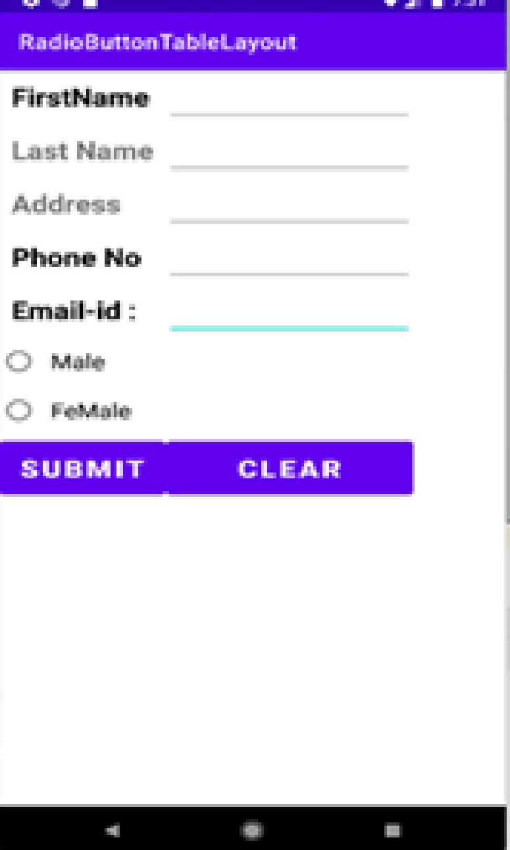

Q.4 Viva [10 M]

Q.5 Lab Book [10 M]

**Q.1. Advance Java**

A)Write a Socket program in java which displays the server machine’s date and time on the client machine. [15 M]

B)Write a JDBC program in java to display details of Book_Sales(SalesID, Date, Amount) of selected month in JTable. Book_sales table is already created. (Use JCombo component for Month selection) [15 M]

**Q2. Node JS:**

A)Create a Node.js Application that contain the Employee Registration details and write a JavaScript to validate DOB, Joining Date, and Salary. [25 M]

**OR**

**Advance PHP**

A)Write PHP script using AJAX concept to check if username and password are valid or invalid. (Use database to store username and password) [25 M]

**Q.3 Android:**

A) Create an Android Application to perform Zoom In, Zoom Out operation and display Satellite view, on Google Map. [25 M]

Q.4 Viva [10 M]

Q.5 Lab Book [10 M]

**Q.1. Advance Java**

A) Write a JDBC program in java to update an address of given customer(cid,cname,address) and display updated details. [15 M]

B) Write a SERVLET program in java to accept details of student (SeatNo, Stud_Name, Class, Total_Marks). Calculate percentage and grade obtained and display details on page. [15 M]

**Q2. Node JS:**

A)Using Nodejs create a S Y BBA(CA) Teachers Profile System. [25 M]

**OR**

**Advance PHP**

A)Write PHP program to select list of subjects from list box and display the selected subject information on next page. (Use sticky multivalued parameters) [25 M]

**Q.3 Android:**

A) Create an Android Application that Demonstrate Radio Button [25 M]

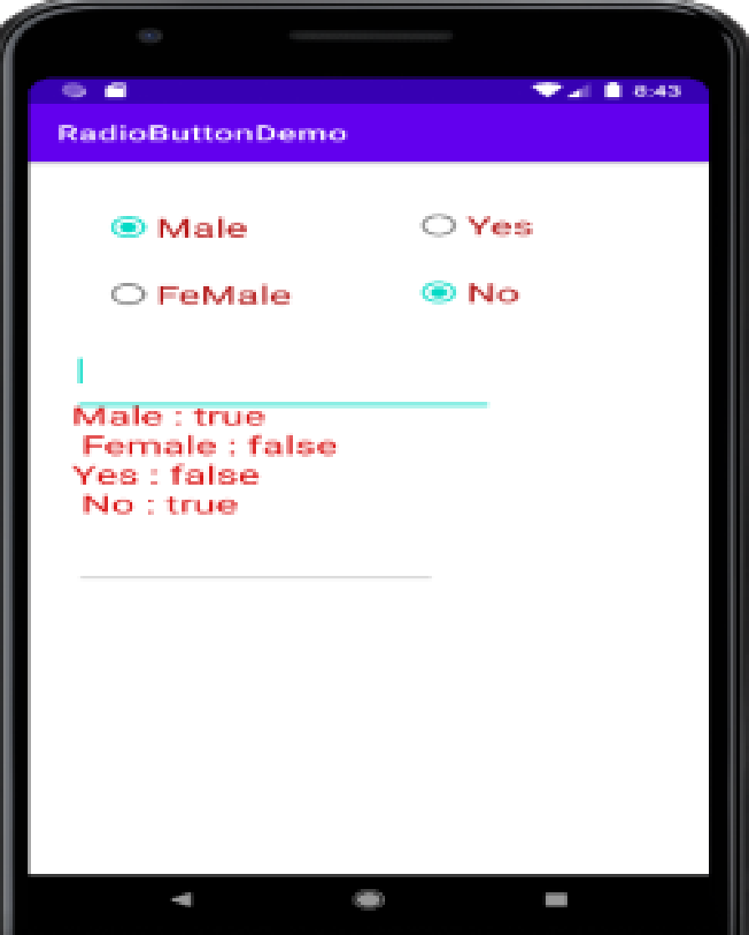

Q.4 Viva [10 M]

Q.5 Lab Book [10 M]

**Q.1. Advance Java**

A) Write a JSP program which accept UserName in a TextBox and greets the user according to the time on server machine. [15 M]

B) Write a program in java which will show lifecycle (creation, sleep, and dead) of a thread. Program should print randomly the name of thread and value of sleep time. The name of the thread should be hard coded through constructor. The sleep time of a thread will be a random integer in the range 0 to 4999. [15 M]

**Q2. Node JS:**

A)Create a Node.js file that Select all records from the "Employee" table, and Update the salary of the given Eno. [25 M]

**OR**

**Advance PHP**

A)Write a PHP program to accept two strings from the user and check whether the entered strings are matching or not. Use the AJAX concept. [25 M]

**Q.3 Android:**

A) Create an Android Application that Demonstrate ListView and Onclick of List Display the Toast. [25 M]

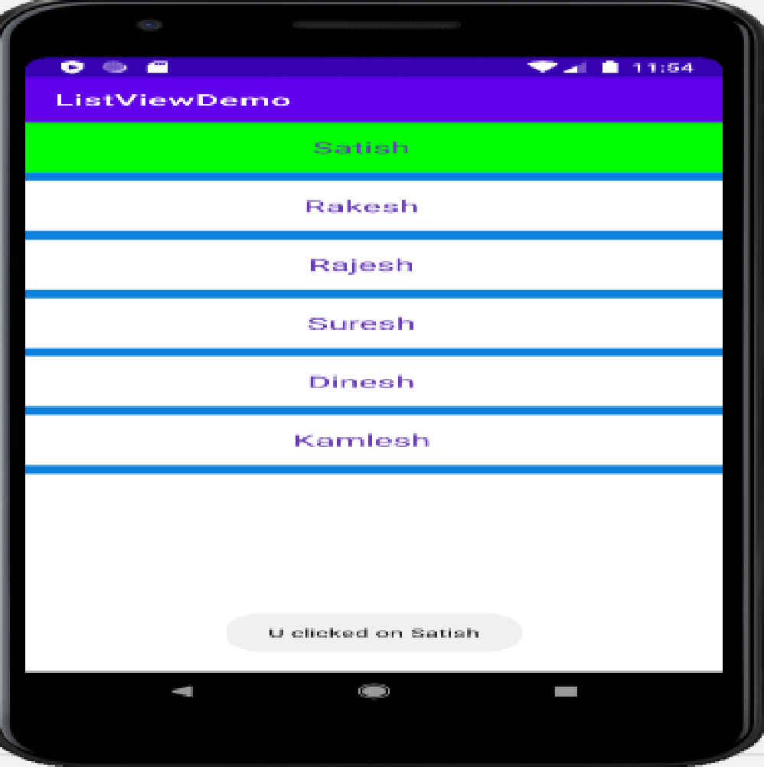

Q.4 Viva [10 M]

Q.5 Lab Book [10 M]

**Q.1. Advance Java:**

A)Write a java program which will display name and priority of current thread. Change name of Thread to MyThread and priority to 2. Display the details of Thread. [15 M]

Q2. Write a JDBC application using swing for the following: [15 M]

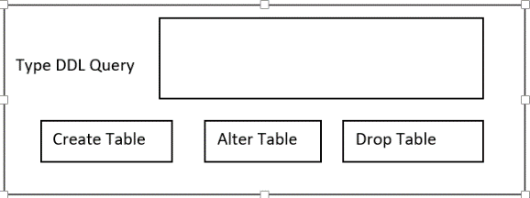

**Q2. Node JS:**

A)Using Node.js display the Employee details order by salary in Table format. [25 M]

**OR**

**Advance PHP**

A)Write a script to create a XML file “University.xml” The elements details of the university.xml file are as follows. [25 M]

<Univ>

<UName>----</UName?

<City>---</City>

<Rank>---</Rank>

</Univ>

1)Store the details of atleast 3 universities.

2)Link the “University.xml” file to css and get well formatted output as follows.

i)UName : Color :black

Font-family : copperplate Gothic Light;

Font-size : 16;

Font : Bold;

ii)City and Rank : Color :Yellow

Font-family : arial;

Font-size : 12;

Font : Bold;

**Q.3 Android:**

A) Write a program to search a specific location on Google Map. [25 M]

Q.4 Viva [10 M]

Q.5 Lab Book [10 M]

Q.1. **Advance Java:**

A) Write a java program using multithreading to execute the threads sequentially.

(Use Synchronized Method) [15 M]

B) Write a SERVLET program that provides information about a HTTP request from a client, such as IP address and browser type. The servlet also provides information about the server on which the servlet is running, such as the operating system type, and the names of currently loaded servlets.

**Q2. Node JS:**

A)Create Node.js application using user defined Rectangle module to find area of rectangle and display the details on console. [25 M]

**OR**

Q.2 **Advance PHP:**

A)Write a PHP script to generate an XML in the following format [25 M]

<?xml version = “1.0”?>

<BookStore>

<Books>

<PHP>----</PHP>

<title>Programming PHP</title>

<publication>O’Relly</publication>

<price>800</price>

</PHP>

<PHP>----</PHP>

<title>Beginners PHP</title>

<publication>WROX</publication>

<price>900</price>

</PHP>

</Books>

</BookStore>

Add more than 5 books details. Display details of book by selecting publication of book from user.

**Q.3 Android:**

A Create an Android App with Login Screen. On successful login, gives message go to next Activity (Without Using Database& use Table Layout). [25 M]

Q.4 Viva [10 M]

Q.5 Lab Book [10 M]

**Q.1. Advance Java:**

A) Create a JSP page to accept a number from an user and display it in words:

Example: 123 – One Two Three. The output should be in red color. [15 M]

B) Write a Multithreading program in java to convert smile face into the crying face after 5 seconds. [15 M]

**Q2. Node JS:**

A)Using Node.js clone the "Hacker News" website. [25 M]

**OR**

**Advance PHP:**

A)Write a PHP program to read the XML document “Stock_list.xml” (fruits and vegetables) which creates XML document and parse the XML data into an array. [25 M]

**Q.3 Android:**

A) Create Android application to send email with attachment. [25 M]

Q.4 Viva [10 M]

Q.5 Lab Book [10 M]

Q.1. **Advance Java:**

A) Write a JSP program to display the details of Hospital (HNo, HName, Address) in tabular form on browser. [15 M]

B) Write a Socket program in java for chatting application. (~~Use AWT)~~ [15 M]

**Q2. Node JS:**

A)Write Node.js application containing an event handler to open and read the contents of a file. [25 M]

**OR**

**Q.2 Advance** **PHP:**

A)Create a xml file which gives details of movies available in “Venus CD Store” fro following categories. a.Classical b.Action c.Horror

Elements in each category are in following format [15 M]

<Category>

<Movie Name>---</ Movie Name >

<ReleaseYear>---</ReleaseYear>

<ActorName>---</ActorName>

</Category>

Save the file with the name “movies.xml”

**Q.3 Android:**

A) Design following-add a border to an Android Layout [25 M]

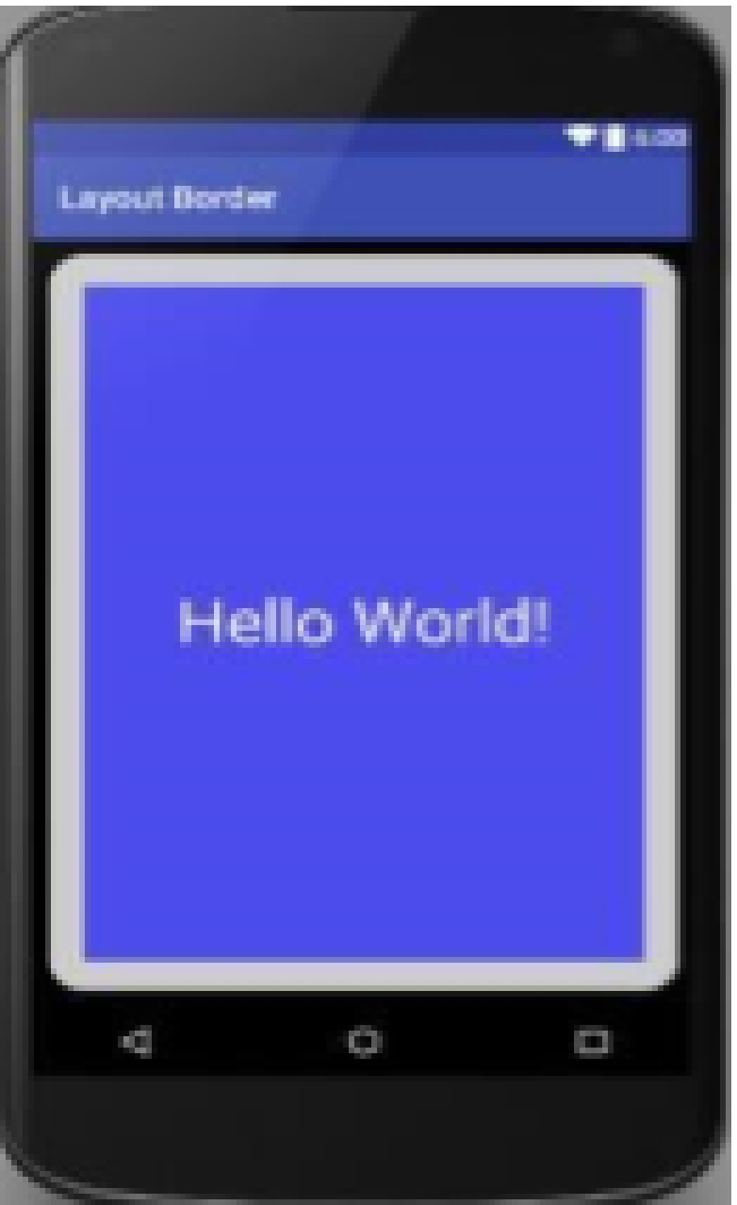

Q.4 Viva [10 M]

Q.5 Lab Book [10 M]

Q.1. **Advance Java:**

A) Write a JDBC Program to display the names of Employees starting with ‘S’ character. [15 M]

B) Write a SERVLET program to Design an HTML page containing 4 option buttons (Painting, Drawing, Singing and swimming) and 2 buttons reset and submit. When the user clicks submit, the server responds by adding cookie containing the selected hobby and sends the HTML page to the client. ~~Program should not allow duplicate cookies to be written~~. [15 M]

**Q2. Node JS:**

A)Using Node.js create an application that shows S Y BBA(CA) course structure. [25 M]

**OR**

**Q.2 Advance PHP:**

A)Write a script to create a XML file named “Course.xml” [25 M]

<Course>

<Computer Science>

<Student name>---</Student name>

<Class name>--- </Class name>

<percentage>--- </percentage>

</Computer Science>

</Course>

Store the details of 5 students who are in SYBBA(CA)

**Q.3 Android:**

A) Create following Vertical Scroll View Creation in Android. [25 M]

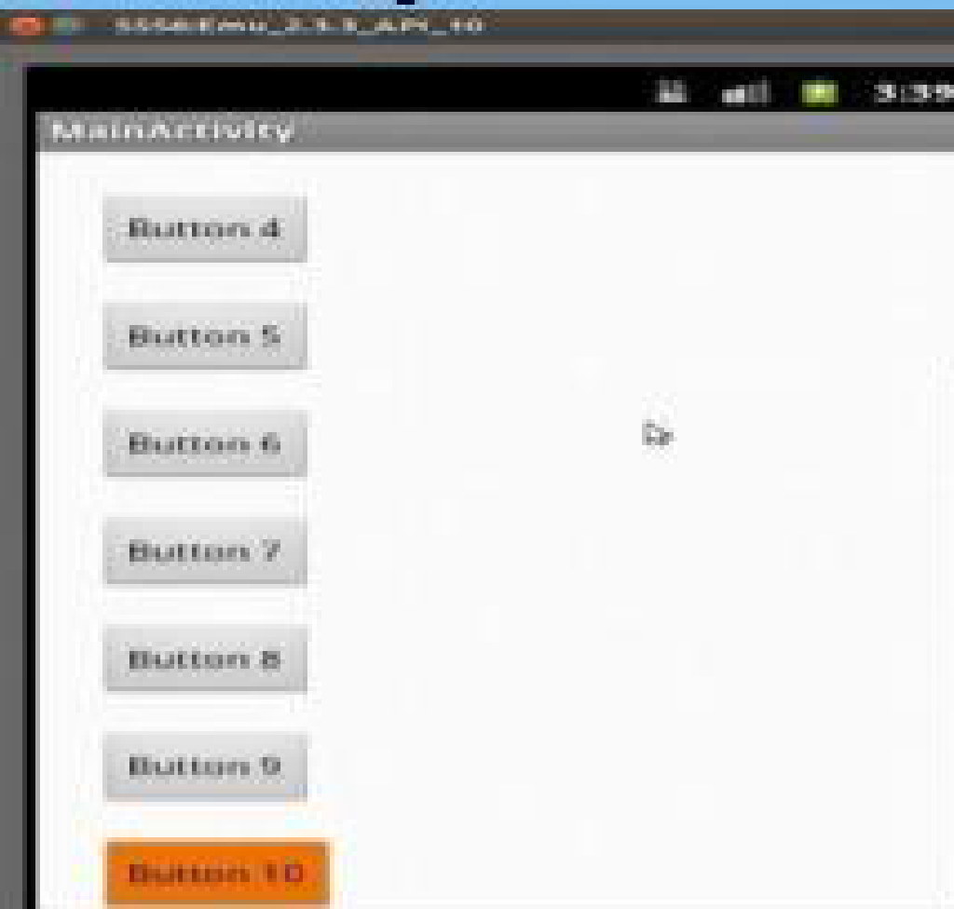

Q.4 Viva [10 M]

Q.5 Lab Book [10 M]Q.1. **Advance Java:**

A) Write a Socket program in java in which client accept a number, send it to the server, server calculates its factorial and sends result to the client. [15 M]

B) Write a java program to create a student table with field’s rno, name and per. Insert values in the table. Display all the details of the student on screen. (Use PreparedStatement Interface) [15 M]

**Q2. Node JS:**

A) Create a Node.js Application to count number of lines in a file and display the count on console. [25 M]

**OR**

**Advance PHP:**

A)Create a XML file which gives details of books available in “Pragati Bookstore” from following categories. [25 M]

1)Yoga 2)Story 3)Technical

Elements in each category are in following format

<Book>

<BookTitle>----</BookTitle>

<BookAuthor>---</BookAuthor>

<BookPrice>---</BookPrice>

</Book>

Save the file as “Bookcategory.xml”

**Q.3 Android:**

A) Create an Android Application to Construct image switcher using setFactory(). [25 M]

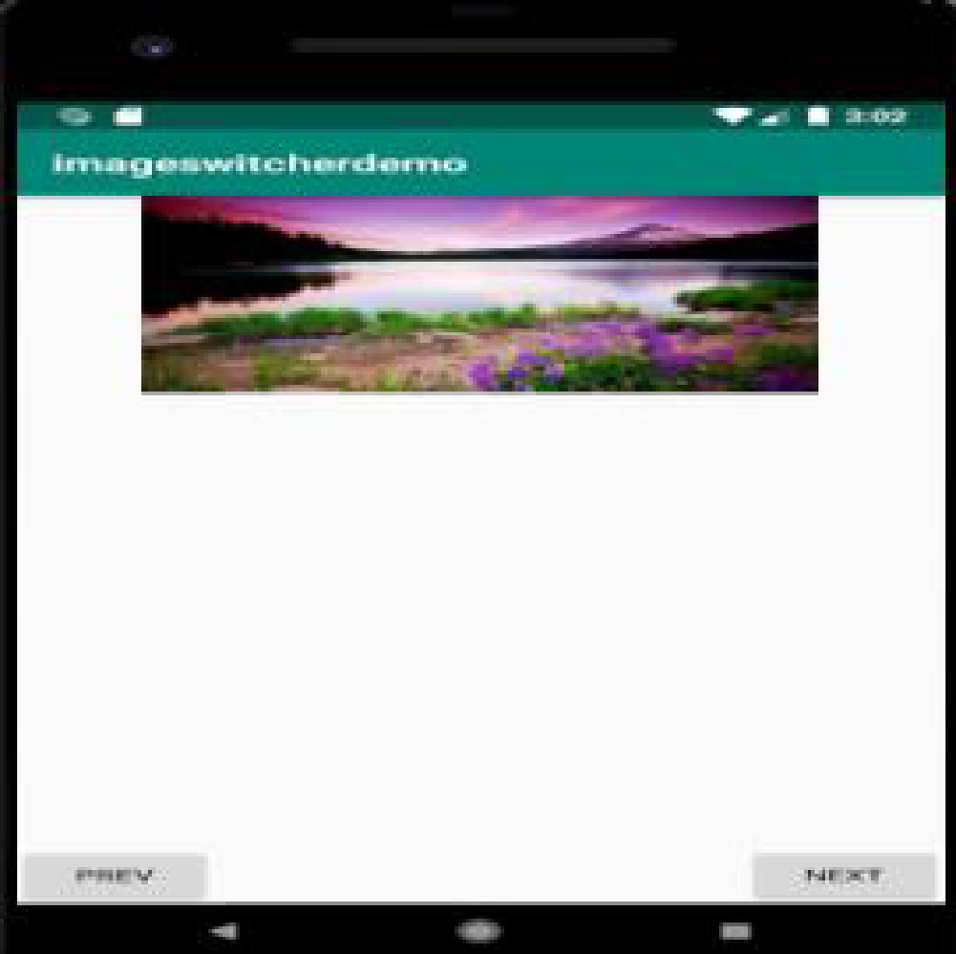

Q.4 Viva [10 M]

Q.5 Lab Book [10 M]

Q.1. **Advance Java:**

A) Write a JSP script to accept the details of Student (RNo, SName, Gender, Computer_ Knowledge , Class) and display it on the browser. Use appropriate controls for accepting data. [15 M]

B) Write a Java Program to Read, Update and Delete any record from “Elements” table. The table has following fields (Atomic_weight , Name (primary key), Chemical_Symbol). The input should be provided through Command Line Arguments along with the appropriate data. The operations are: R : Read, U: Update, D: Delete.

[15 M]

**Q2. Node JS:**

A)Create a Node.js Application to search a particular word in a file and replace all occurrences of that word with another word and bold all. [25 M]

**OR**

**Advance PHP:**

A)Write an application that reads “Sports.xml” file into simple XML object. Display attributes and elements. (Hint Use simple_xml_load_file() function) [15 M]

**Q.3 Android:**

A) Write an Android application to accept two numbers from the user, and displays

them, but reject input if both numbers are greater than 10 and asks for two new

numbers. [25 M]

Q.4 Viva [10 M]

Q.5 Lab Book [10 M]

**Q.1. Advance Java:**

A) Write a JSP script to check whether given mail ID is valid or not. (Mail ID should contain one @ symbol) [15 M]

B) Write a java program to accept the details of college (CID, CName, Address, year) and store it into database (Use Swing and PreparedStatement interface) [15 M]

**Q2. Node JS:**

A)Using Node.js create a Historical place portal. [25 M]

**OR**

**Advance PHP:**

A)Write a script to create XML file named “college.xml” [15 M]

The element details of college.xml are:

<College>

<Cname>---</Cname>

<City>---</City>

<Rank>---</Rank>

</College>

Display at least 3 college Information

**Q.3 Android:**

A) Write an Android code to merge given two Array/List [25 M]

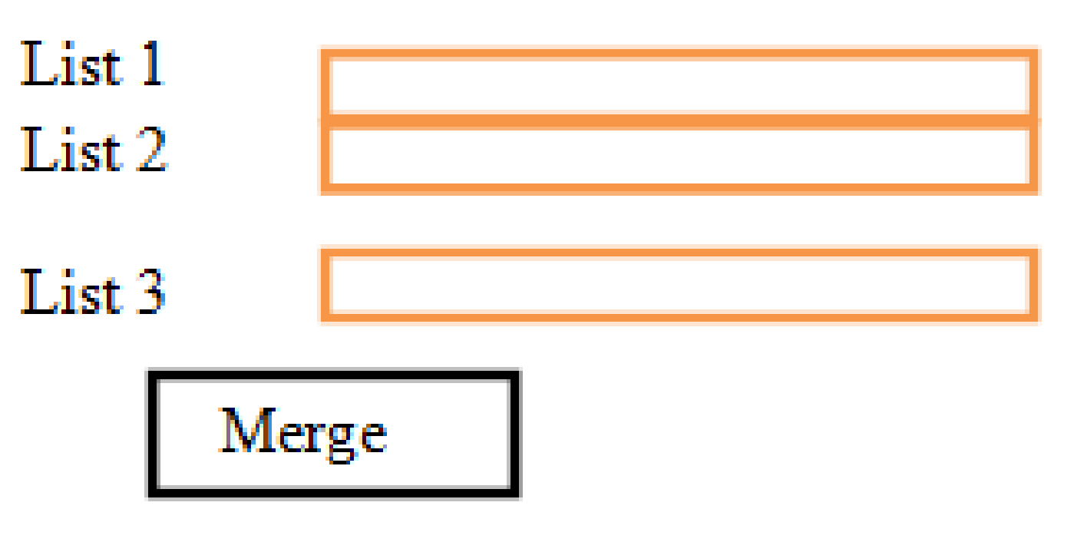

Q.4 Viva [10M]

Q.5 Lab Book [10 M]

Q.1. **Advance Java:**

Q1. Write a JSP script to accept UserName and his NickName through html page and then displays username when visit count to page is odd and displays nickname when the visit count to the page is even. [15 M]

Q2. Write a java program for implementation scrollable ResultSet. Consider Emp table (eno ename, sal) . Provide the operations moveFirst, moveNext, movePrevious and moveLast on the database. [15 M]

**Q2. Node JS:**

A)Using Node.js create an application that shows the events of the day.[25 M]

**OR**

**Q.2 Advance PHP:**

A).Write a script to create “vehicle.xml” file with multiple element as given below.

<Vehicle>

<Type = Two Wheeler>

<Vehicle Name>---</Vehicle Name>

<Company>---</Company>

<Color>---</Color>

<Average>---</Average>

</Type>

</Vehicle>

Also add type=”Four Wheeler” and its elements.

**Q.3 Android:**

A) Create a Simple calculator. (Use Linear Layout) [25 M]

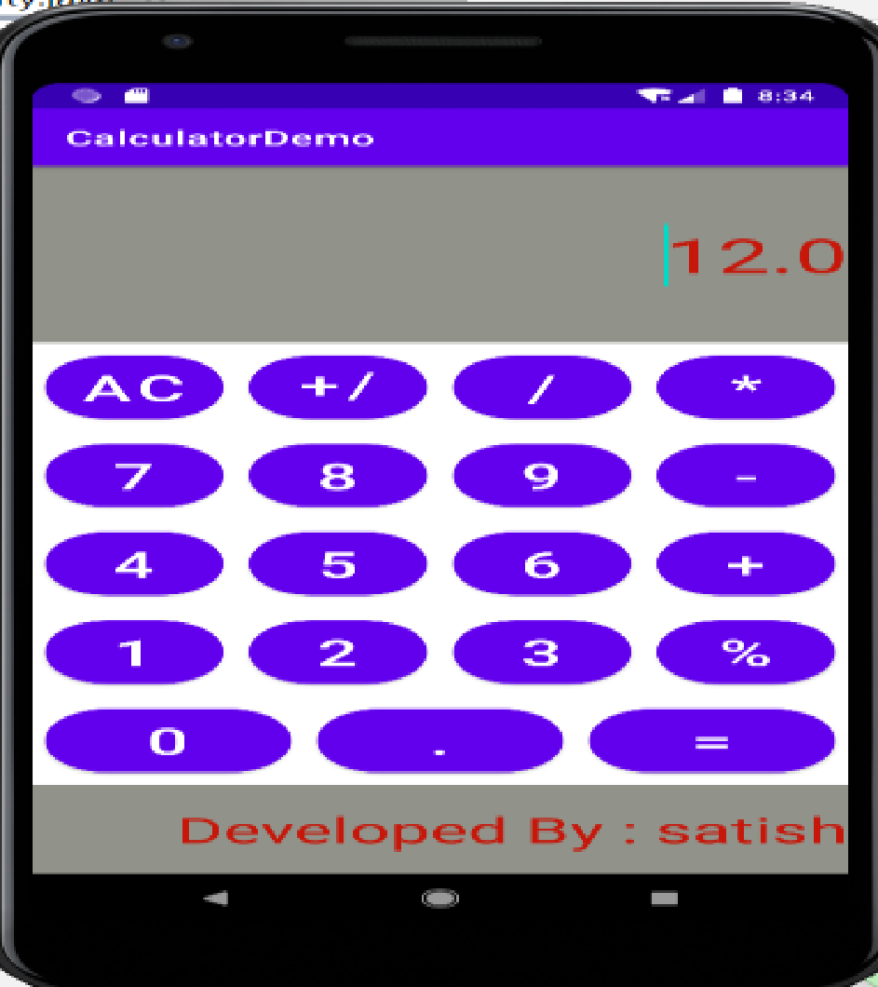

Q.4 Viva [10 M]

Q.5 Lab Book [10 M]

Q.1. **Advance Java:**

Q1. Write a Multithreading program in java to display all the alphabets from A to Z after 3 seconds. [15 M]

Q2. Write a java program to display sales details of products between two dates in JTable(use database). Consider product table (pid, pname, amount) [15 M]

**Q2. Node JS:**

A) Using Node.js create a department store portal. [25 M]

**OR**

**Advance PHP:**

A)Write a simple PHP program which implements AJAX for addition of two numbers.

[25 M]

**Q.3 Android:**

A) Write an Android Application to Change the Image Displayed on the Screen [25 M]

Q.4 Viva [10 M]

Q.5 Lab Book [10 M]

Q.1. **Advance Java:**

A) Write a JDBC program to delete the details of given employee (ENo EName Salary). Accept employee ID through command line. [15 M]

B) Write a Multithreading program in java to create an applet that contains a TextField to show time. The time should be displayed in the hh:mm:ss format. The thread should start when the user clicks the Start button and stop when the user clicks the stop button. Initialize the values to current time. [15 M]

**Q2. Node JS:**

A)Create an Node.js Application that contain the Student Registration details and write a JavaScript to validate DOB, Mobile Number, and email address. [25 M]

**OR**

**Advance PHP:**

A)Write a simple PHP program which implements AJAX for factorial of a number.[25 M]

**Q.3 Android:**

A) Create an Android Application to perform following string operation according to

user selection of radio button. [25 M]

1. Upper Case

2. Lower Case

Q.4 Viva [10 M]

Q.5 Lab Book [10 M]

Q.1. **Advance Java:**

A) Write a JSP program to check whether given number is Armstrong or not. (Use Include directive). [15 M]

B) Write a java program to display the selected employee details in JTable. (use database, combo box for employee selection ) Employee having fields eno, ename, sal, desg. [15 M]

**Q2. Node JS:**

A)Using Node.js create a matrimonial portal. [25 M]

**OR**

**Advance PHP:**

A)Write an Ajax program to display list of games stored in an array on Clicking OK button.

[25 M]

**Q.3 Android:**

A) Write an Android Program to Demonstrate Date Picker Dialog in Android [25 M]

Q.4 Viva [10 M]

Q.5 Lab Book [10 M]

Q.1. **Advance Java:**

A) Write a JSP program to accept Name and Age of Voter and check whether he is eligible for voting or not. [15 M]

B) Write a menu driven java program for the following:

* Insert
* Update
* Delete
* Search
* Display
* Exit

Consider Student (rno, sname, per) table for this.

**Q2. Node JS:**

A)Create a Node.js Application that uses user defined module circle.js which exports the functions area () and circumference () and display the details on console. [25 M]

**OR**

**Advance PHP:**

A)Write a PHP script using AJAX concept to develop a user friendly and interactive search engine (like a google search engine) [25 M]

**Q.3 Android:**

A) Create a Simple Application Which Shows Greeting information to User. [25 M]

Q.4 Viva [10 M]

Q.5 Lab Book [10 M]

Q.1. **Advance Java:**

A) Write a JSP program to display all the prime number’s between 1 to n in “Blue” Color. [15 M]

B) Write a SERVLET program to display the details of Product (ProdCode, PName, Price) on the browser in tabular format. (Use database) [15 M]

**Q2. Node JS:**

A)Write Node.js application containing an event handler to open and read the contents of a file.. [25 M]

**OR**

**Q.2 Advance PHP:**

A)Write a PHP program to create a simple distance calculator that accepts distance in meters from user. Convert it to centimetres or kilometres according to user preference. Use radio button and AJAX. [25 M]

**Q.3 Android:**

A) Create an Android Application that Demonstrate Custom ListView which shows

the BookName and Author Name [25 M]

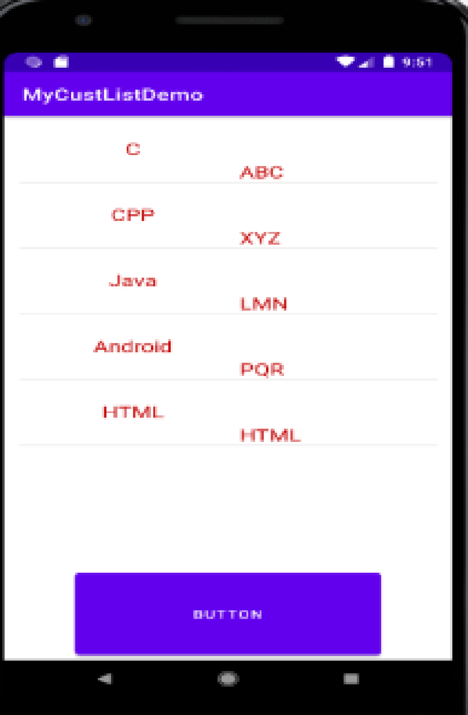

Q.4 Viva [10 M]

Q.5 Lab Book [10 M]