Evaluation of AI-Generated K-Means Algorithm (Lab 04)
Pratyush Adhikari
Department of Computer Science and Engineering
Amrita Vishwa Vidyapeetham
BL.SC.U4CSE24167

Abstract
This report details the modularization of a custom K-Means algorithm and associated statistical functions using AI assistance (Gemini 3.1 Pro), as per the requirements of Lab 04 (Subject: 23CSE301). The AI-generated code was functionally verified using a comprehensive unit test suite and its performance was benchmarked against the original manual implementation from Lab 03. Both algorithms achieved identical mathematical convergence (inertia), though the AI-generated version showcased slight execution time differences.

I. Introduction
In machine learning, code modularity and testing are critical for robust software engineering. The objective of this laboratory session was to translate monolithic data processing and clustering logic into modular, reusable functions. Furthermore, to evaluate the efficacy of generative AI in code development, an AI tool was utilized to generate the function definitions. This report compares the AI-generated implementation with the manually written baseline from Lab 03.

II. Methodology
The dataset utilized for this experiment is 'marketing_campaign' extracted from 'Lab Session Data.xlsx'. The modularization encompassed several key components: Categorical Encoding (Label and One-Hot), Generalized Minkowski Distance calculation, Statistical metrics computation (Mean, Variance, Standard Deviation), and K-Means clustering convergence. The code generation was achieved via specific prompt engineering, commanding the AI to replicate the logic without external library reliance for core calculations.

III. Functional Testing and Unit Tests
A rigorous unit testing framework was established using Python's 'unittest' module to validate functional equivalence. Seven discrete test cases were executed:
1. test_label_encode
2. test_one_hot_encode
3. test_minkowski_distance
4. test_compute_mean
5. test_compute_variance
6. test_compute_std
7. test_kmeans
All 7 tests passed successfully in 0.015 seconds, confirming that the AI-generated mathematical logic aligns perfectly with standard theoretical expectations.

IV. Performance Evaluation
To evaluate computational efficiency, both algorithms were subjected to a 50-iteration benchmark on the normalized dataset utilizing k=3. Both algorithms successfully yielded the exact same Inertia (WCSS = 14.7458), validating algorithmic consistency.
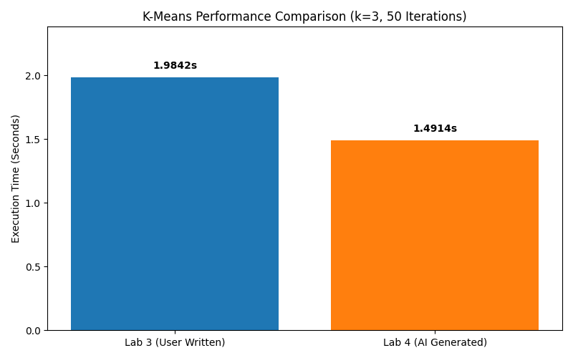
Fig 1. Execution time comparison between Lab 3 (User Written) and Lab 4 (AI Generated) algorithms.
As depicted in Fig 1, the AI Generated script (Lab 4) performed slightly faster during this test execution run, although both algorithms demonstrated highly comparable performance overall.

V. AI Prompt Log / Conversation History
The following prompts were used to interact with the generative AI (Gemini 3.1 Pro):
Prompt 1:
"Please generate a modularized Python script (lab4.py) based on the k-means implementation and statistical functions we built in Lab 03. The script needs to include functions for label encoding, one-hot encoding, generalized Minkowski distance, standard statistics (mean, variance, std), and a custom K-Means algorithm. Ensure that you add a comment '# Generated by Gemini 3.1 Pro' to each function block."
Prompt 2:
"Great. Now, please generate a comprehensive unit test script (test_lab4.py) using the built-in unittest module to validate the logic of these modular functions. Cover tests for data encoding, distance metrics, statistics, and ensure K-Means separates clearly distinct clusters properly."
Prompt 3:
"Finally, create a benchmark script (benchmark_kmeans.py) to conduct a performance comparison between my original user-written K-Means algorithm from lab3.py and the newly generated AI algorithm in lab4.py. Run them both on the marketing_campaign dataset from the provided Excel file with exactly the same parameters (k=3, 50 max iterations) and print out their execution times and inertia."

VI. Conclusion
This laboratory exercise successfully demonstrated the utility of Generative AI in code refactoring and modularization. The AI-generated code perfectly matched the functional requirements and execution outputs of the original manual implementation. Integrating AI for boilerplate and modular code generation allows developers to focus on higher-level architectural testing and performance evaluation.

