**LIFE LINE**

**INTRODUCTION**

This paper presents an easiest way to give out necessary things as a charity to the people. This is implemented using an Android application. In the present situation some people may not be able to afford the price of their necessities (by some causes like flood etc...) and the people who are willing to help them will not be known about them. The application mentioned here, makes the people who are willing to give the necessary things to a man (cash, blood, medicines, clothes, food) access and register what they have. The people who really need those things can access the application and can gain the materials they need through the services we provide for delivery.

**SOFTWARE REQUIRMENTS**

* Operating system : Windows 7 or Above, Android
* Technology used : Python
* IDE : PyCharm, Eclipse/Android Studio
* Framework : Flask
* Database : MySQL

**HARDWARE REQUIRMENTS**

* Processor : 64 bit
* RAM : Min 3 GB
* Hard Disk : 10 GB

**MODULES**

1. ADMIN
2. DONOR
3. DELIVER SECTION
4. USER

Admin

* Login
* Add donors
* Manage donors
* View delivery agent
* View user
* View feedback
* View report

Donor

* Login
* Add delivery agent
* Manage delivery agent
* Add item details
* Manage item details
* View request
* Assign work to agent
* View status
* Add report
* Manage report

Delivery agent

* Login
* View work
* Update status

User

* Register
* Login
* View items
* Request items
* Add feedback

**EXISTING SYSTEM**

In the current scenario, there is no existing system to replace our concept. There is no facility to record the whole donors and to give the detail information surrounds the poor people. It is very difficult to inform the people about the donors without any verified source. And the donors will not know the right person who is in need of particular item. So our application introduces a new way for charity and social service to the people.

**PROPOSED SYSTEM**

* In the proposed system, we are making the donors to register their details and the materials they have. The complete details they registered up there are stored in the database and updated to the donors list according to the items they are provided
* The users in need of the items register their details, what they need and they are visualized the details that the donor had uploaded. They confirm the items and make a bid with the donor.
* The donor and admin will be notified with this bid. When the donor confirms the bid, the admin notifies the deliver section for the delivery. After the deliver section completes their work the admin will be notified and the current database will be updated.

**SCOPE OF THE SYSTEM**

The system has the capability of ensuring the necessities are given to the people. This makes the people to know who are in need of the necessary items. It makes the people to feel that the item is delivered to the right person. Throughout this project we can ensure that any more people are suffering without any deficiency for their daily needs in any situation.

**DFD**

LEVEL - 0

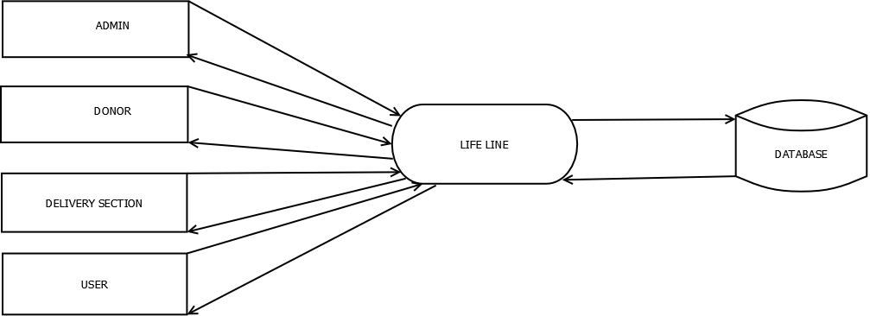.

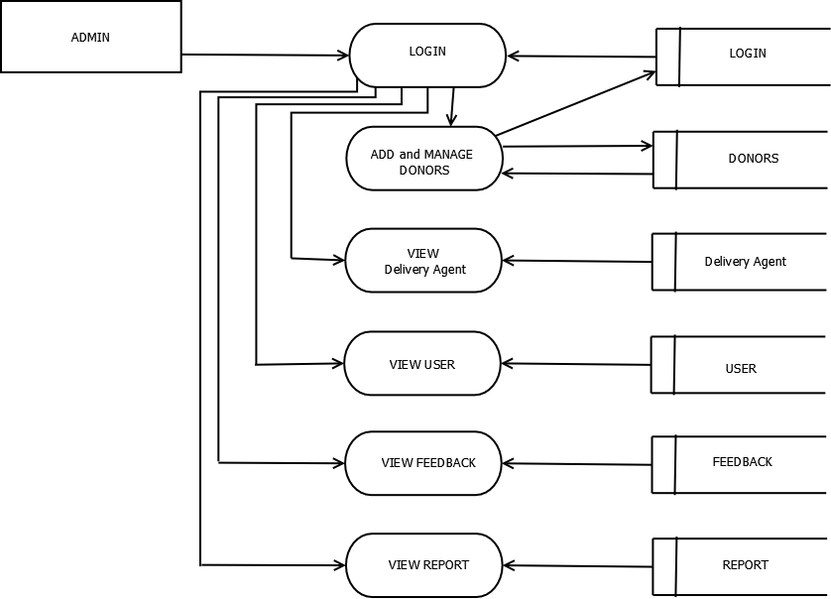LEVEL :1.1

LEVEL : 1.2

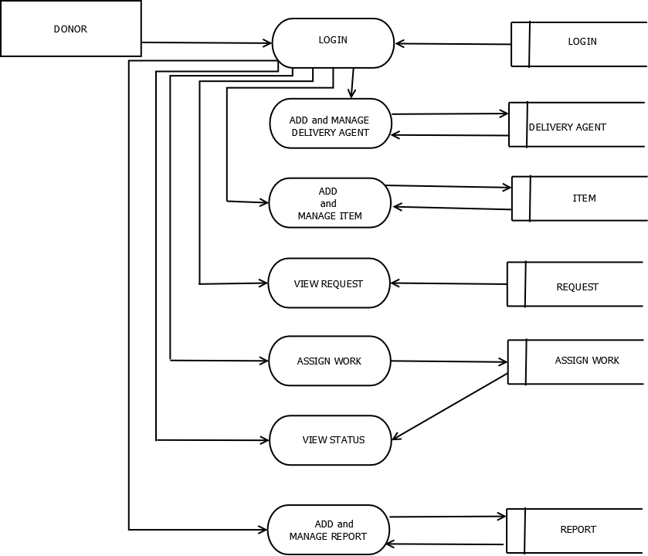

LEVEL : 1.3

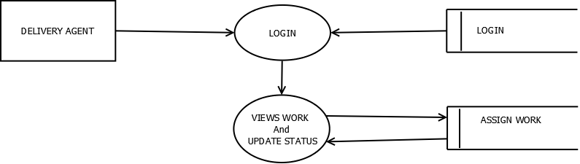

LEVEL : 1.4

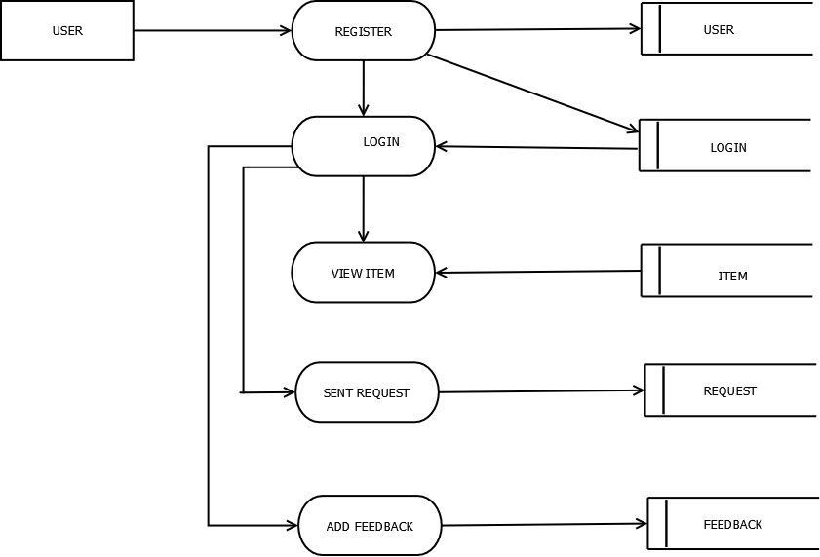

TABLE DESIGN

**TABLE NAME : LOGIN**

|  |  |  |  |
| --- | --- | --- | --- |
| COLUMN NAME | DATA TYPE | SIZE | CONSTRAINTS |
| Login_id | Int | 10 | Primary Key |
| Username | Varchar | 50 | Not NULL |
| Password | Varchar | 50 | Not NULL |
| User_type | Varchar | 50 | Not NULL |

**TABLE NAME : DONOR**

|  |  |  |  |
| --- | --- | --- | --- |
| COLUMN NAME | DATA TYPE | SIZE | CONSTRAINTS |
| Donor_id | Int | 10 | Primary Key |
| Login_id | Int | 10 | Foreign Key |
| First Name | Varchar | 50 | Not NULL |
| Last Name | Varchar | 50 | Not NULL |
| DOB | Date | 08 | Not NULL |
| Place | Varchar | 50 | Not NULL |
| Post | Varchar | 50 | Not NULL |
| Pin | Int | 10 | Not NULL |
| Email | Varchar | 50 |  |
| Phone | Bigint | 10 | Not NULL |

**TABLE NAME : AGENT**

|  |  |  |  |
| --- | --- | --- | --- |
| COLUMN NAME | DATA TYPE | SIZE | CONSTRAINTS |
| Agent_id | Int | 10 | Primary Key |
| Login_id | Int | 10 | Foreign Key |
| First Name | Varchar | 50 | Not NULL |
| Last Name | Varchar | 50 | Not NULL |
| Gender | Char | 10 | Not NULL |
| Place | Varchar | 50 | Not NULL |
| Email | Varchar | 50 |  |
| Phone | Bigint | 10 | Not NULL |

**TABLE NAME : USER**

|  |  |  |  |
| --- | --- | --- | --- |
| COLUMN NAME | DATA TYPE | SIZE | CONSTRAINTS |
| User_id | Int | 10 | Primary Key |
| Login_id | Int | 10 | Foreign Key |
| First Name | Varchar | 50 | Not NULL |
| Last Name | Varchar | 50 | Not NULL |
| Place | Varchar | 50 | Not NULL |
| Post | Varchar | 50 | Not NULL |
| Pin | Int | 10 | Not NULL |
| District | Varchar | 50 | Not NULL |
| Phone | Bigint | 10 | Not NULL |
| Email | Varchar | 50 |  |

**TABLE NAME : FEEDBACK**

|  |  |  |  |
| --- | --- | --- | --- |
| COLUMN NAME | DATA TYPE | SIZE | CONSTRAINTS |
| Feedback_id | Int | 10 | Primary Key |
| Login_id | Int | 10 | Foreign Key |
| Feedback | Varchar | 200 | Not NULL |
| Date | date | 10 | Not NULL |

**TABLE NAME : REPORT**

|  |  |  |  |
| --- | --- | --- | --- |
| COLUMN NAME | DATA TYPE | SIZE | CONSTRAINTS |
| Report_id | Int | 10 | Primary Key |
| Login_id | Int | 10 | Foreign Key |
| date | date | 12 | Not NULL |
| Report | Varchar | 200 | Not NULL |

**TABLE NAME : REQUEST**

|  |  |  |  |
| --- | --- | --- | --- |
| COLUMN NAME | DATA TYPE | SIZE | CONSTRAINTS |
| Request_id | Int | 10 | Primary Key |
| Login_id | Int | 10 | Foreign Key |
| Item_id | Int | 10 | Foreign Key |
| Description | Varchar | 200 | Not NULL |
| Donor_id | Int | 11 | Foreign Key |
| Status | varchar | 200 | Not NULL |
| Date | date |  | Not NULL |

**TABLE NAME : ASSIGN**

|  |  |  |  |
| --- | --- | --- | --- |
| COLUMN NAME | DATA TYPE | SIZE | CONSTRAINTS |
| Assign_id | Int | 10 | Primary Key |
| Login_id | Int | 10 | Foreign Key |
| Agent_id | Int | 11 | Foreign Key |
| Request_id | Int | 10 | Foreign Key |
| Status | Varchar | 200 | Not NULL |

**TABLE NAME : TEM**

|  |  |  |  |
| --- | --- | --- | --- |
| COLUMN NAME | DATA TYPE | SIZE | CONSTRAINTS |
| Item_id | Int | 10 | Primary Key |
| Login_id | Int | 10 | Foreign Key |
| Item_type | Varchar | 60 | Not NULL |
| Item_name | Varchar | 100 | Not NULL |
| Quantity | Int | 11 | Not NULL |