***Machine Learning Assignment 1***

**1)Fisher’s Linear Discriminant Analysis**

Linear Discriminant Analysis can be used for both Classification and Dimensionality Reduction.

The basic idea is to find a vector w which maximizes the separation between target classes after projecting them onto w.To find w we incorporate the following idea

a)Maximize the distance between projected means.

b)Minimize the sum of the projected scatter (Covariance).

**2)Steps taken to implement Algorithm**

1)Compute the d-dimensional mean vectors for the different classes from the dataset.

2)Find the difference of the mean vectors of different classes.

3)Find deviation of the dataset from the mean for both the classes and add them to get within class scatter matrix

3)The vector w is proportional to the difference of means multiplied by the inverse of within class scatter matrix.

4)Then project the data set in d dimension to 1 dimension by taking projection from vector w.

5)Draw the normal curves for both the classes and their intersection point is the threshold point.

**Output**

1)F Score of Dataset a1_d1 is .945

2)F Score of Dataset a1_d2 is .994

**FLDA**

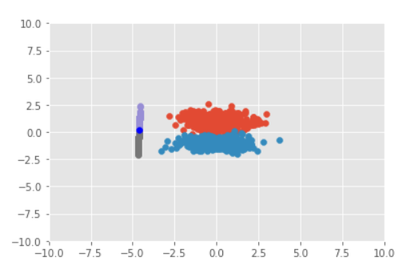

For Dataset a1_d1

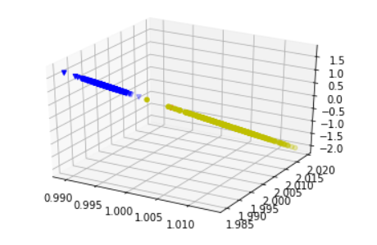

For Dataset a1_d2