1. INNER JOINS

SELECT Students.student_ID,Students.student_Name,Students.student_Address,Course.course_Name,Faculty.faculty_Name FROM Students

JOIN Course ON Course.student_ID = Students.student_ID

JOIN Faculty ON Faculty.student_ID = Students.student_ID ;

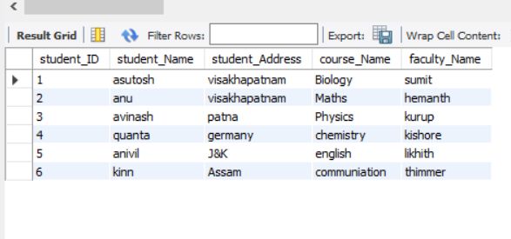

SELECT Students.student_Name , Course.course_Name FROM Students

JOIN Course

WHERE Students.student_ID = Course.student_ID ORDER BY Students.student_Name;

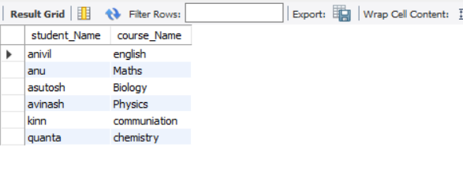

SELECT Students.student_Name , Students.student_Address, Faculty.faculty_Name FROM Faculty

JOIN Students

WHERE Students.student_ID = Faculty.student_ID GROUP BY Students.student_Address HAVING Students.student_Address = 'patna' ;

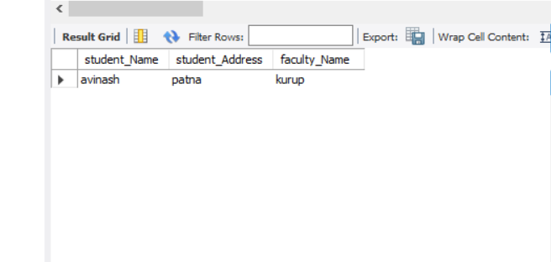

LEFT OUTER JOINS

SELECT Students.student_Name , Students.student_Address , Course.course_Name FROM Students

LEFT OUTER JOIN Course

ON Students.student_ID = Course.student_ID ;

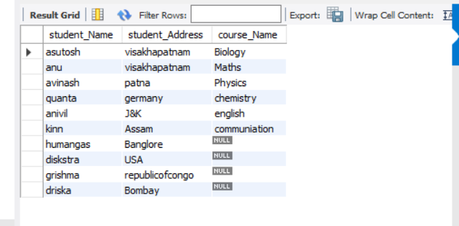

SELECT Faculty.faculty_Name , Faculty.faculty_Address , Students.student_Name FROM Faculty

LEFT OUTER JOIN Students

ON Faculty.student_ID = Students.student_ID WHERE Faculty.faculty_Name LIKE '%a';

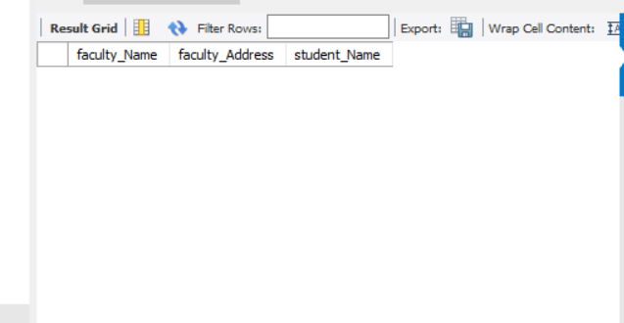

SELECT Students.student_ID ,Students.student_Name , Students.student_PhoneNumber , Course.course_Name , Faculty.faculty_Name FROM Students

LEFT OUTER JOIN Course

ON Students.student_ID = Course.student_ID

LEFT OUTER JOIN Faculty

ON Students.student_ID = Faculty.student_ID ORDER BY Faculty.faculty_Name ;

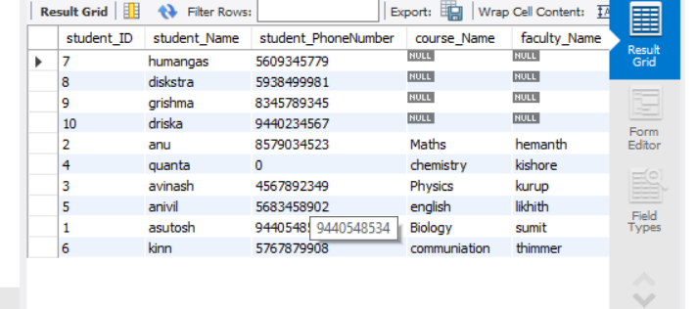

RIGHT OUTER JOINS

SELECT Students.student_Name , Course.course_ID , Course.course_Name FROM Course

RIGHT OUTER JOIN Students

ON Students.student_ID = Course.student_ID WHERE Students.student_Name LIKE 'a%';

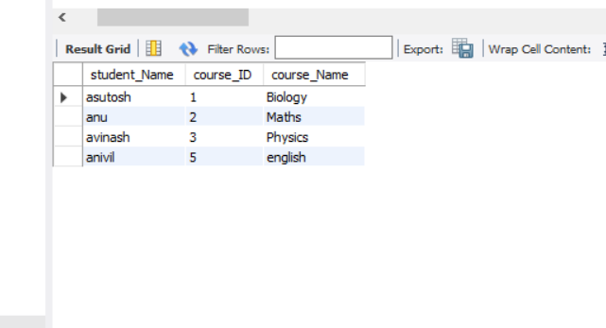

SELECT Students.student_Name , Faculty.faculty_Name , Faculty.faculty_MailID

FROM Students

RIGHT OUTER JOIN Faculty

ON Students.student_ID = Faculty.student_ID GROUP BY Faculty.faculty_MailID HAVING Faculty.faculty_MailID = '[this@gmail.com](mailto:this@gmail.com)';

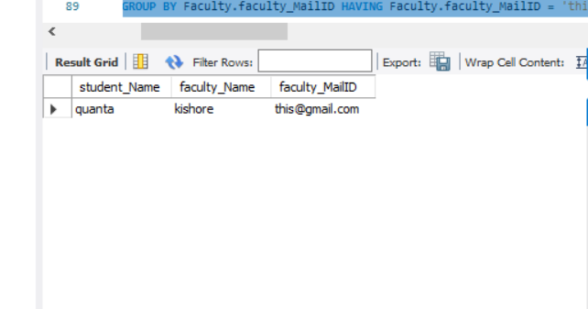

SELECT Students.student_Name , Faculty.faculty_ID , Faculty.faculty_Name , Course.course_Name FROM Students

RIGHT OUTER JOIN Faculty

ON Students.student_ID = Faculty.student_ID

RIGHT OUTER JOIN Course

ON Students.student_ID = Course.student_ID ;

