MonsoonWatch
Forecasting monsoon diarrhoeal-disease risk in Nepal, one to four weeks ahead
Project report · Macquarie University, Pitch for the Planet
Faculty of Science and Engineering

In one line: A local, runnable early-warning pipeline that forecasts national weekly acute gastroenteritis (AGE) cases in Nepal 1–4 weeks ahead from 241 weeks of EWARS bulletins and 23 ground rain gauges — beating the best naive baseline by 18% at 3 week(s) ahead on an untouched two-year hold-out.

1. Executive summary
Nepal's monsoon floods contaminate drinking water every year, and cases of acute gastroenteritis (AGE) climb with it — a burden carried disproportionately by children under five. Nepal's existing system, EWARS, publishes a weekly bulletin that counts cases after they have happened. It does not forecast. MonsoonWatch adds the missing half: a forecast with enough lead time to pre-position oral rehydration salts, chlorine and staff before a spike rather than during it.
Headline results on the 2024–2025 hold-out, which was never consulted when choosing the model:
Horizon | Forecaster | MAE | RMSE | MAPE | Best baseline | Baseline MAE | Improvement
1 week(s) | Ensemble of 15 | 52 | 69 | 12.5% | persistence | 55 | +5%
2 week(s) | Ensemble of 30 | 57 | 74 | 12.8% | persistence | 67 | +15%
3 week(s) | Ensemble of 30 | 58 | 75 | 13.6% | seasonal + drift | 71 | +18%
4 week(s) | Ensemble of 30 | 58 | 76 | 13.2% | seasonal + drift | 65 | +10%

MAE = mean absolute error in cases per week. MAPE = mean absolute percentage error. Baselines are defined in §6.
- What is new here: not the algorithm — forecasting diarrhoeal disease with machine learning is established, including a 2024 UMD-led study covering Nepal. The contribution is recent data (2021–2025 rather than pre-2014), a disease series recovered from PDF bulletins that exist in no machine-readable form, and a pipeline that runs end to end on a laptop with a working web app.
- A negative result, reported rather than buried: the 23 ground rain gauges — intended as the project's main methodological advance over satellite data — turn out not to improve forecast accuracy at the national weekly scale (§7.2). The forecasting system still beats every baseline at every horizon; it does so on disease history and seasonality. The most probable cause is that valley rainfall is the wrong geography for a national case count.
- The honest caveat: the reported AGE series has quadrupled since 2021, and most of that is very likely EWARS expanding its reporting network rather than a real fourfold rise in disease. Handling that non-stationarity correctly turned out to be the central technical problem of the project, and it is documented rather than hidden.

2. Problem and SDG framing
Diarrhoeal disease remains one of the largest causes of preventable child death in Nepal, and its incidence is tightly coupled to the monsoon: floods and run-off contaminate the shallow water sources much of the population depends on. The health system can respond to a spike, but only once it has already appeared in the weekly counts.

2.1 Sustainable Development Goals
- SDG 3 — Good Health and Well-being (primary): target 3.d addresses early-warning and risk-reduction capacity explicitly. A forecast is precisely that capacity.
- SDG 6 — Clean Water and Sanitation (primary): AGE incidence is the measurable symptom of unsafe water. Predicting the spike directs water-treatment and sanitation effort to the right weeks.
- SDG 13 — Climate Action (supporting): the model's inputs are rainfall, temperature and humidity, so it quantifies one concrete climate-to-health transmission channel.

3. Data

3.1 Disease surveillance — EDCD EWARS
There is no CSV or API for EWARS. The only public route is weekly PDF bulletins from the Epidemiology and Disease Control Division. A custom scraper (src/../scraper/ewars_scraper.py) downloads and parses these across three incompatible layout eras — 2021–22 prose, 2023–24 prose variant, and a 2025 tabular format containing stray Unicode symbols — producing 241 clean national weekly rows with zero missing AGE values.
Only three columns proved reliable across all three eras: year, week and the current-week AGE count. The bulletins' own pre-computed 'previous week', 'change' and 'last year' columns are calculated inconsistently between eras and were discarded and recomputed from scratch. Reporting-rate and district columns are populated only for 2024–2025 and are unusable as model features. 18 weeks are missing entirely because no bulletin was published; these are handled explicitly (§4.2) rather than silently skipped.

3.2 Rainfall — 23 DHM ground gauges
Daily rainfall from 23 Department of Hydrology and Meteorology stations across the Kathmandu Valley, supplied as a wide matrix of 23 rows × 16,071 daily columns spanning 1980–2023. Data before 2021 is patchy (some years have only 8–9 stations reporting), so the series is restricted to 2021 onward, where every station is 0–3% missing and the monsoon months are effectively complete.
Aggregating to valley-level weekly totals reproduces the published annual rainfall figures exactly — 1791 mm (2021), 1830 mm (2022) and 1553 mm (2023), all within 0.1% — which validates the melt, the date parsing and the aggregation in one check.
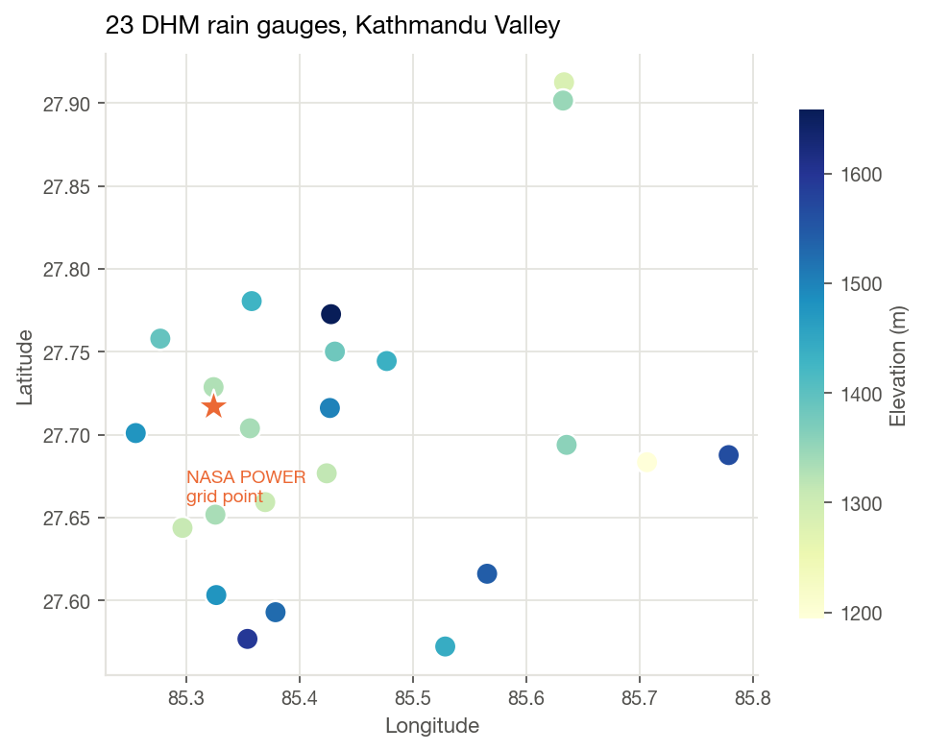
Figure 1. The 23 DHM gauges, coloured by elevation. The single star marks the NASA POWER grid point that a satellite-only approach would rely on: using the spread across real gauges is what lets the model see localised cloudbursts.

3.3 The 2024–2025 gap, and the climate bridge
DHM gauge data ends 31 December 2023, but the disease series runs into 2025 — roughly 1.5 years of disease history with no ground rainfall. Rather than discard it, NASA POWER satellite data for Kathmandu was deliberately fetched over the full 2021–2025 period so that 2021–2023 forms a three-year overlap on which the two sources can be calibrated against each other.
DHM feature | Predictors | R² in-sample | R² held-out 2023 | MAE held-out 2023 | DHM mean
rain_mean_mm | rain_sum+wet_days+rain_max_daily | 0.882 | 0.894 | 8.84 | 33.39
rain_max_mm | rain_sum+wet_days+rain_max_daily | 0.786 | 0.823 | 23.33 | 80.58
rain_std_mm | rain_sum+wet_days+rain_max_daily | 0.746 | 0.818 | 5.32 | 18.11
wet_days | wet_days+rain_sum | 0.886 | 0.806 | 0.58 | 2.18
max_daily_mm | rain_max_daily+rain_sum | 0.677 | 0.698 | 16.02 | 39.58

The headline calibration — valley-mean weekly rainfall regressed on NASA POWER weekly rainfall — reaches R² = 0.865 (Pearson r = 0.93), comfortably above the 0.50 threshold set in advance for whether bridging was defensible at all. Holding out 2023 entirely and fitting only on 2021–2022 gives R² = 0.894, so the relationship is stable rather than overfitted. Estimated annual totals for 2024 (1841 mm) and 2025 (1782 mm) fall squarely within the range of the measured years.
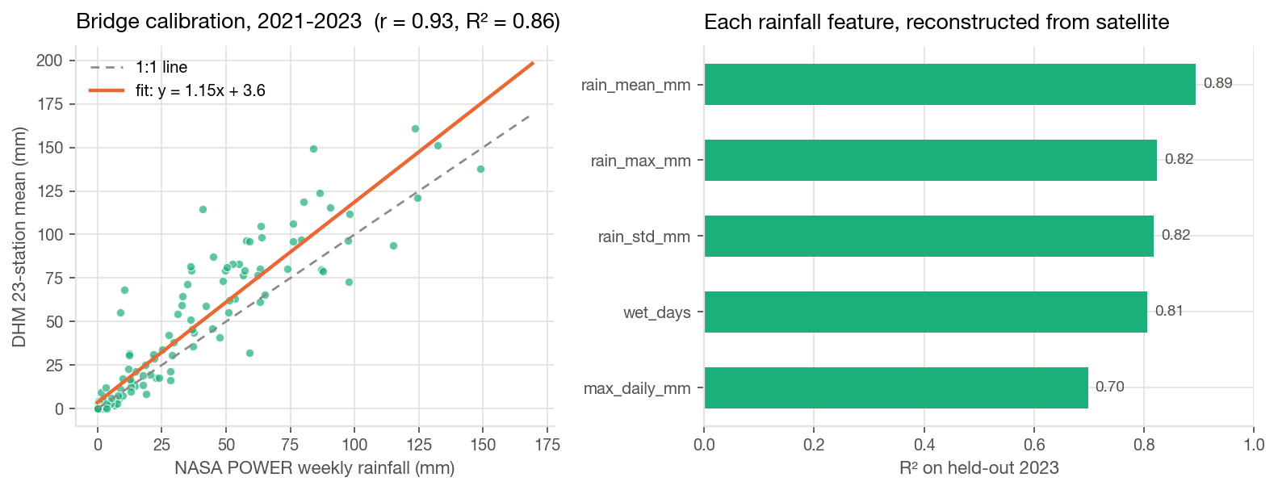
Figure 2. Left: weekly DHM gauge average against NASA POWER over the 2021–2023 overlap. Right: how well each individual rainfall feature can be reconstructed from satellite data, scored on a held-out 2023.
Flagged, not hidden: every weekly row carries a rain_source_is_dhm column. Weeks from 2024 onward are estimated, and both the report and the web app mark them as such.

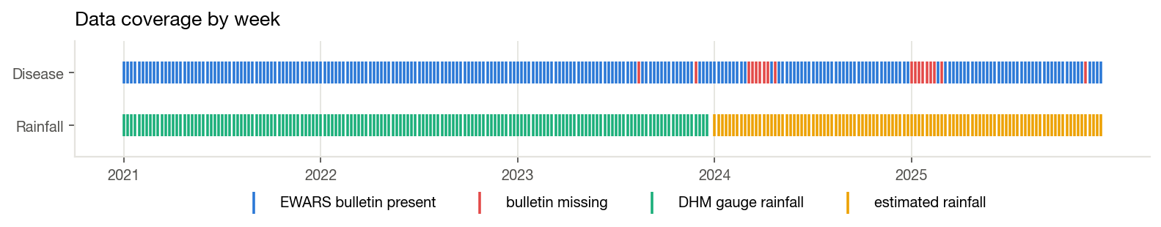
Figure 3. Data coverage. Red marks are weeks where EDCD published no bulletin; the rainfall row shows where measured gauge data gives way to calibrated estimates.

4. Two problems that would have silently corrupted the model

4.1 EDCD epi-weeks are not ISO weeks
Joining rainfall to disease counts requires both to agree on what 'week 27 of 2023' means. They do not agree by default. EDCD numbers its epidemiological weeks Sunday-ending, 1–52, on its own calendar: 'Week 51, 2025' is dated 29 December 2025, which is ISO week 1 of 2026. Using isocalendar() for the join would have misaligned the climate data by one to three weeks depending on the time of year — an error that produces no exception and no obviously wrong output, just a quietly worse model.
The week-1 anchors were established from bulletins confirmed published on schedule: 2021 from two cached PDFs (weeks 1 and 5, both Sunday, exactly 28 days apart) and 2022 independently from two ReliefWeb-hosted bulletins (weeks 15 and 27, both Sunday, 84 days apart), which back-solve to the same anchor. The 2021→2022 shift is exactly 364 days, so later years extrapolate on the same stride. Bulletin header dates alone are not trustworthy for this: EDCD sometimes publishes a multi-week backlog on one date — 2025 weeks 11–16 are all stamped '2nd May 2025' despite being distinct bulletins with different counts.
The alignment was then validated against the data rather than assumed: under the EDCD-native join, AGE–rainfall correlation is higher at every lag tested (0–4 weeks) than under the ISO-week join — 0.260 versus 0.222 at lag 0.

4.2 Eighteen missing bulletins
EDCD failed to publish in 18 weeks across 2023–2025. Building lag features with a naive pandas shift() would have treated the week before a gap as 'last week' — so a 'one-week lag' would sometimes have been an eight-week lag. The series is therefore reindexed onto a complete epi-week grid before any shift is taken, so a lag is always genuinely one calendar week, and rows whose features or target land on a missing week are dropped and counted rather than silently filled.

5. What the data shows
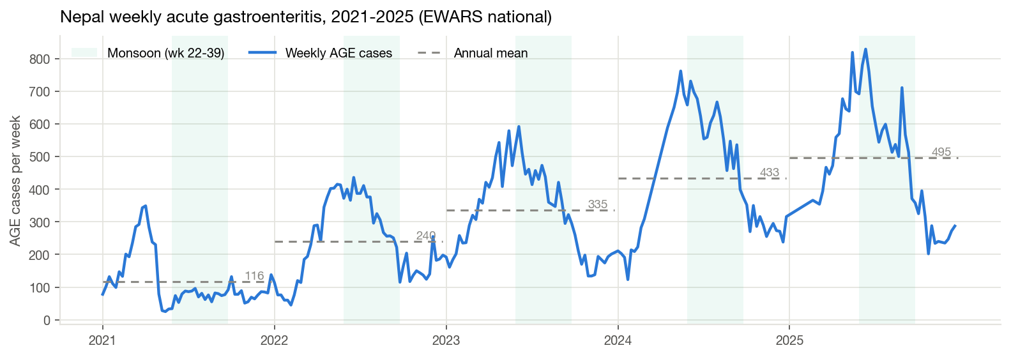
Figure 4. The national weekly AGE series. Shaded bands mark the monsoon (weeks 22–39); dashed lines are annual means.
Two things are immediately visible, and they pull in opposite directions. There is a clear, repeating monsoon season — the signal the project exists to forecast. There is also a strong upward trend in the level, which is the project's central technical obstacle.
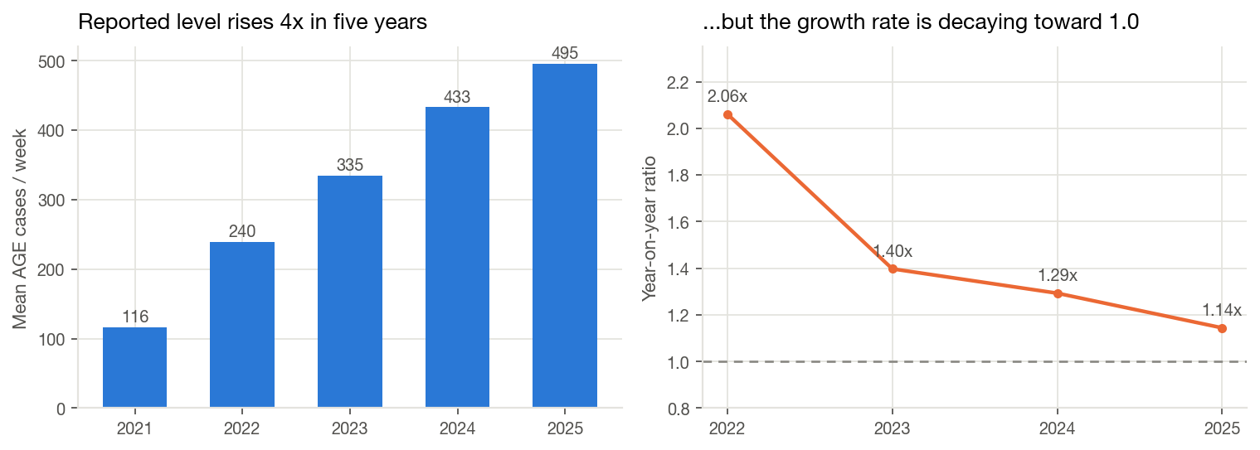
Figure 5. The reported weekly mean rises from 116 cases (2021) to 495 (2025) — but the year-on-year growth ratio decays steadily toward 1.0.
A fourfold rise in five years is not plausible as pure epidemiology. The far more likely explanation is that EWARS has been adding reporting sites, so more of the same underlying disease is being captured. The decaying growth ratio (2.06× → 1.40× → 1.29× → 1.14×) is consistent with a network approaching full coverage. This matters operationally: the models forecast the reported count, because that is what a responder actually acts on, but the trend must not be presented as a measured increase in disease.
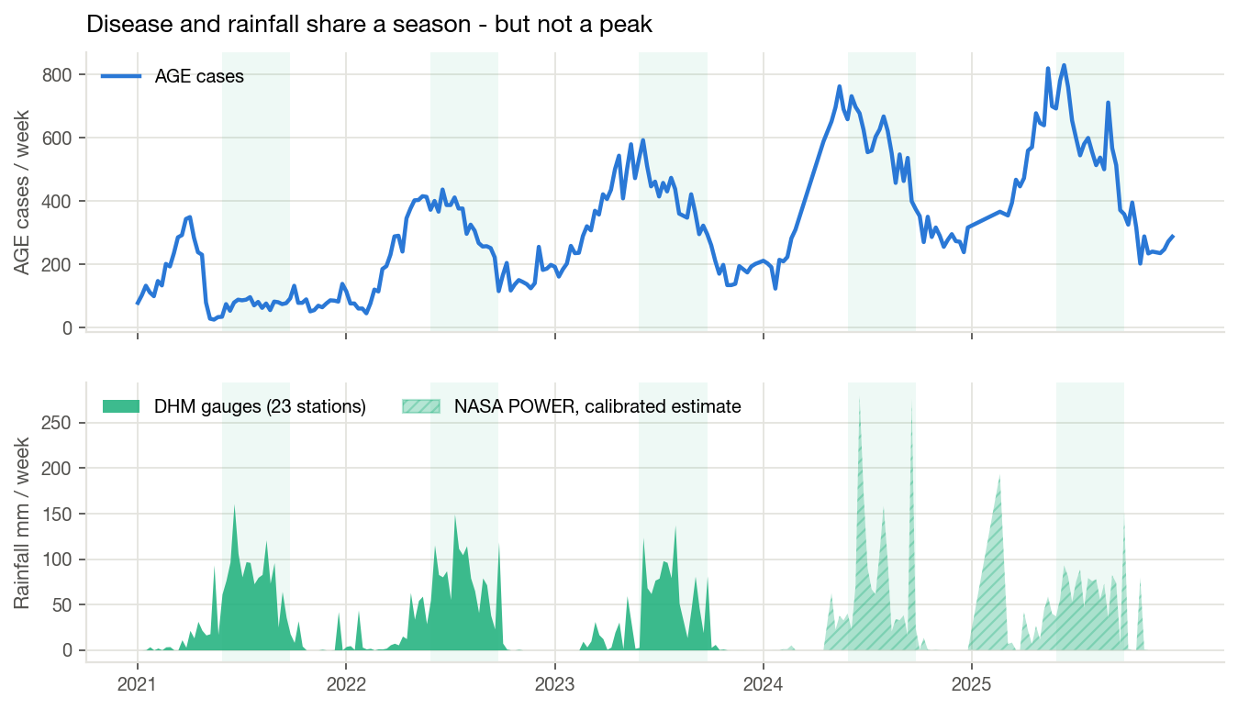
Figure 6. Cases and rainfall on stacked panels sharing one time axis. These are deliberately not plotted as a dual-axis chart: with two y-scales on one frame, almost any apparent lead–lag relationship can be manufactured by rescaling.
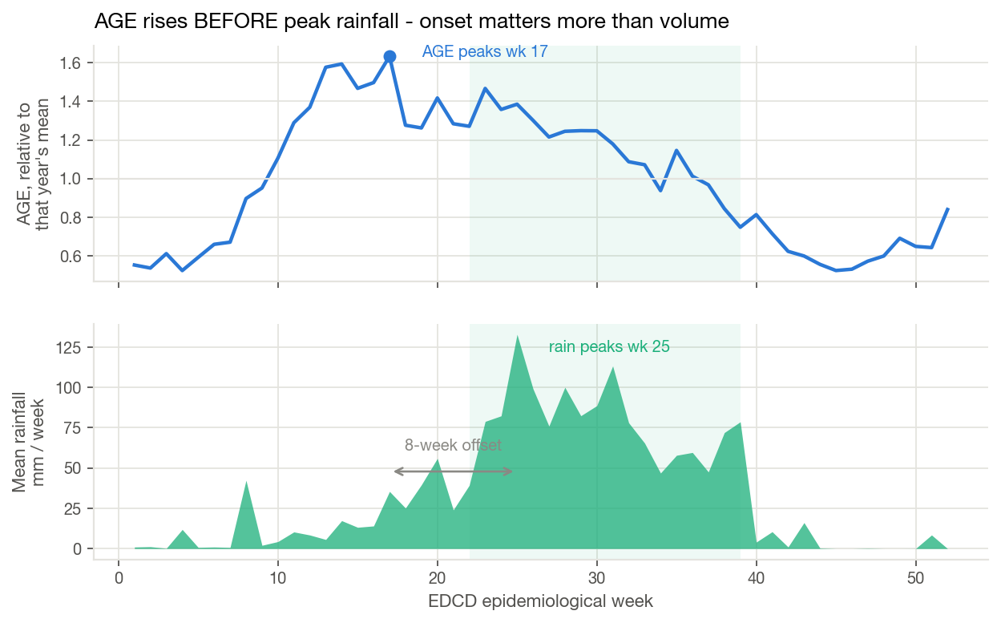
Figure 7. Averaged across years, with each year scaled to its own mean so the level trend does not swamp the seasonal shape.
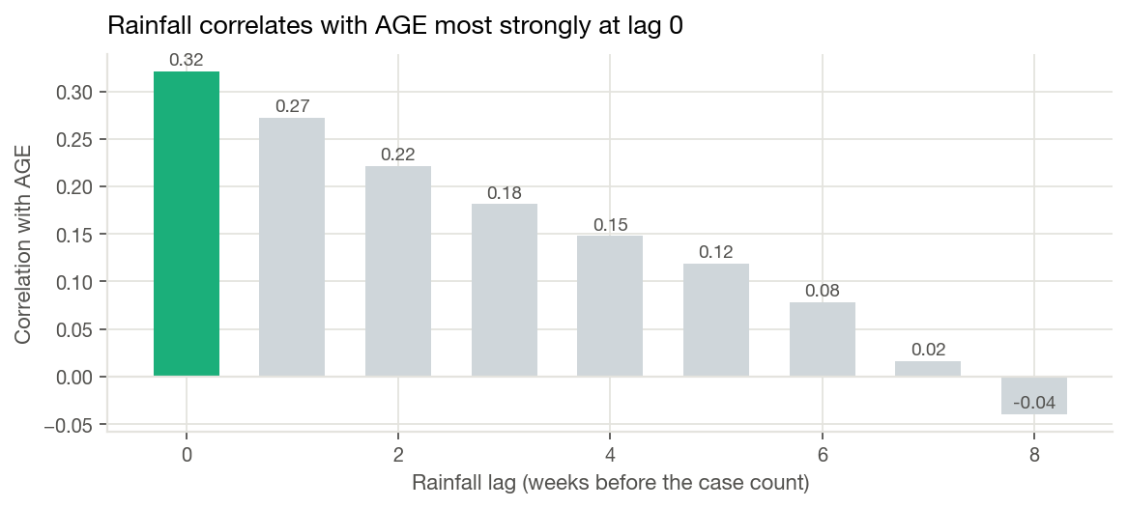
Figure 8. Correlation between weekly AGE and rainfall lagged by 0–8 weeks.
A finding worth stating plainly: cases rise BEFORE peak rainfall, and the AGE–rainfall correlation is strongest at lag 0, decaying as the lag grows. The intuitive story — more rain now, more disease in three weeks — is not what this data says. Monsoon onset (first rains hitting contaminated sources, rising humidity) appears to matter more than accumulated volume. Both lagged and contemporaneous rainfall features were therefore offered to the models rather than assuming a lag.

6. Method

6.1 Forecast framing and leakage control
Each row is an origin week t — the last week for which data exists at forecast time. Every feature is observed at or before t, and the target is the case count at t+h. A four-week-ahead forecast therefore never sees weeks t+1 to t+4, including their rainfall. Seasonal features (week-of-year and its sine/cosine terms, a monsoon flag) describe the target week, which is legitimate because the calendar is known in advance. 'Same week last year' refers to 52 weeks before the target week, which is still in the past at time t.
Twenty features are used, spanning four families:
- Disease autoregressive: current count, lags 1–2, four-week mean, week-on-week change, same week last year, and a year-on-year ratio that tells the model the current growth rate.
- Rainfall: valley-mean weekly total and its 1–3 week lags, a three-week rolling sum for cumulative saturation, and the heaviest single station-day as a cloudburst proxy.
- Other climate: mean temperature and relative humidity.
- Seasonality: target week-of-year, sine and cosine terms, and a monsoon indicator.

6.2 The central problem: a target that will not sit still
Because the reported level quadruples across the record, two failure modes appear that no amount of hyperparameter tuning fixes. First, gradient-boosted trees cannot extrapolate: a tree trained on 2021–2023, where the maximum weekly count is 592, is structurally incapable of predicting 2025's peak of 829, whatever the inputs say. Second, a model frozen on the high-growth era memorises a growth factor that is already wrong by 2025.
The fix is to change what the model is asked to predict. Four target framings were trained and compared; each predicts a quantity and then reconstructs a case count by multiplying an anchor:
Framing | Model predicts | Anchor | Why it might help
level | the case count directly | none | simplest; no reconstruction error
logratio | log(cases at t+h ÷ cases at t) | current level | near-stationary target; tracks the epidemic's current level
ratio_ly | log(cases at t+h ÷ same week last year) | same week last year | anchors directly to seasonal position
ratio_blend | log(cases at t+h ÷ geometric mean of both) | √(current × last year) | respects current level and season at once

Anchored framings solve both problems at once: the learning target becomes close to stationary, and because the forecast is the anchor multiplied by a learned ratio, it can exceed any level the model saw in training.
How much history to keep is also treated as a tunable choice rather than an assumption, since old low-level data may actively mislead: expanding (all history), exponential recency weighting (40-week half-life), and a 104-week rolling window were all searched. So was a blend weight combining the model with the seasonal baseline.

6.3 Train, validation and test
Random train/test splits are invalid for time series — neighbouring weeks are near-duplicates, so a random split leaks the answer. The split here is strictly chronological:
Split | Period | Used for
Train | 2021–2023 | fitting model parameters
Validation | TimeSeriesSplit folds inside 2021–2023 | ALL choices: model family, target framing, history scheme, blend weight, hyperparameters
Test | 2024–2025 | reported once; never consulted for any decision

A mistake worth recording: an earlier version of this pipeline selected the model on 2024 and tested on 2025. That produced badly misleading results, because 2024 (+29% year-on-year) and 2025 (+14%) reward opposite forecasters — tuning on one actively anti-selects for the other, and every model 'lost' to a naive baseline by 30–44%. Moving all selection inside 2021–2023 and treating 2024–2025 as a single untouched hold-out is the honest design, and it is what is reported here.

The hold-out is scored by rolling origin, which is also how the system would really run: retrain on everything up to week t, forecast week t+h, step forward one week, repeat. No future data ever enters a fit. For contrast, a frozen variant — train once on 2021–2023 and never update — is also reported, to quantify what retraining is worth.

6.4 Baselines
A forecast that cannot beat a simple rule is not worth deploying. Four baselines are scored on exactly the same weeks:
- Persistence: next week equals this week.
- Seasonal naive: next week equals the same week last year.
- Seasonal with drift: same week last year, scaled by the current year-on-year growth ratio.
- Four-week rolling mean: the recent average.

6.5 Why the deployed forecaster is an ensemble, not one model
Choosing a single best model turned out to be unreliable here — and that was established from 2021–2023 data alone, without touching the test years. Ranking every candidate separately within each cross-validation fold and comparing those rankings gives a Kendall rank correlation between folds of only +0.07 to +0.22 across the four horizons. In plain terms: the folds barely agree on which model is best. With three years of weekly data there is not enough signal to identify a single winner, so whichever model tops the table is largely there by luck.
Averaging the top-k candidates is the standard remedy. It cannot pick the best model, but it reliably avoids picking a bad one. The value of k was itself chosen honestly, by leave-one-fold-out inside 2021–2023: for each fold, candidates are ranked using only the OTHER folds, the top-k of that ranking are averaged, and the result is scored on the held-back fold. No fold contributes to its own ranking, and the test years play no part.
Horizon | k chosen | Single best-CV model, MAE | Ensemble MAE | Best baseline MAE | Improvement
1 wk | 15 | 62.0 | 52.4 | 55.2 | +5.1%
2 wk | 30 | 58.1 | 56.9 | 67.0 | +15.1%
3 wk | 30 | 59.4 | 57.8 | 70.6 | +18.1%
4 wk | 30 | 70.0 | 58.1 | 64.6 | +10.0%

Averaging beats the single cross-validated pick at every horizon, and beats the strongest baseline at every horizon too — which the single pick did not manage.

7. Results
Horizon | Members (k) | MAE | RMSE | MAPE | MAE 2024 | MAE 2025 | Best baseline | Base MAE | Gain
1 wk | 15 | 52 | 69 | 12.5% | 45 | 61 | persistence | 55 | +5%
2 wk | 30 | 57 | 74 | 12.8% | 51 | 63 | persistence | 67 | +15%
3 wk | 30 | 58 | 75 | 13.6% | 58 | 58 | seasonal + drift | 71 | +18%
4 wk | 30 | 58 | 76 | 13.2% | 58 | 58 | seasonal + drift | 65 | +10%

All figures are on the 2024–2025 hold-out, which played no part in selection.
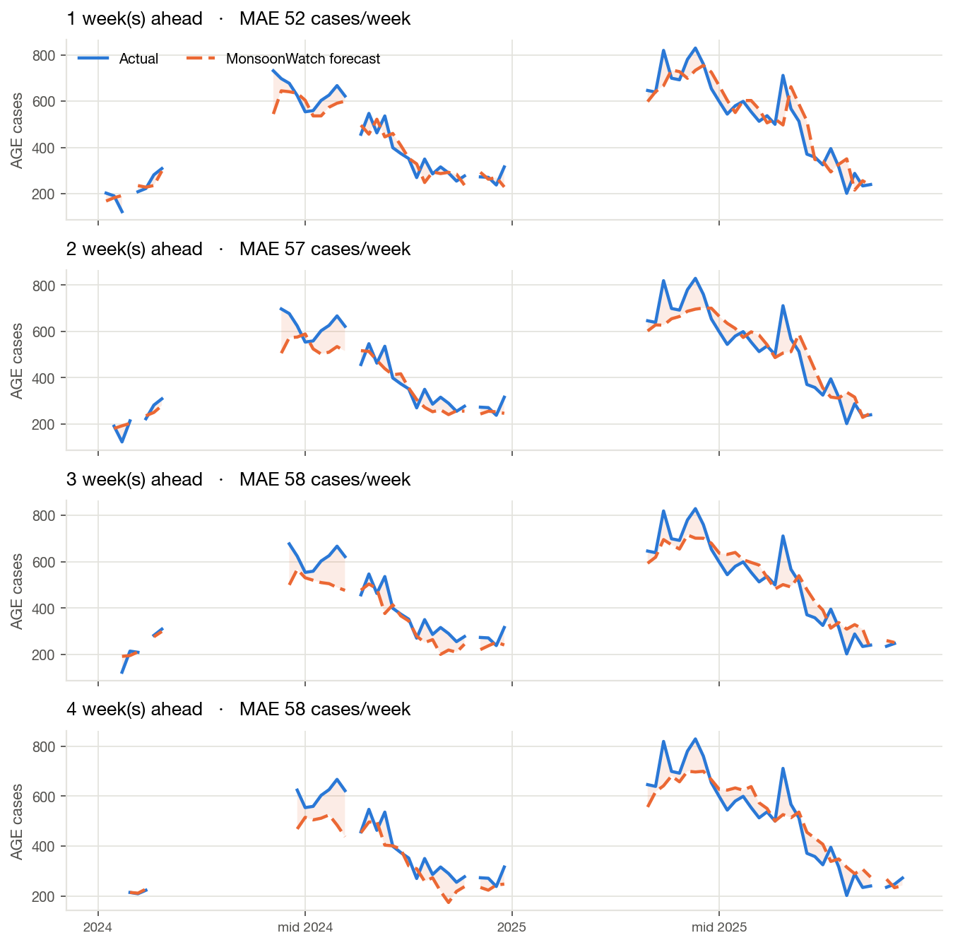
Figure 9. Forecast against reality across the hold-out period, at each horizon. Every point is a genuine out-of-sample forecast made without access to that week or any later one.
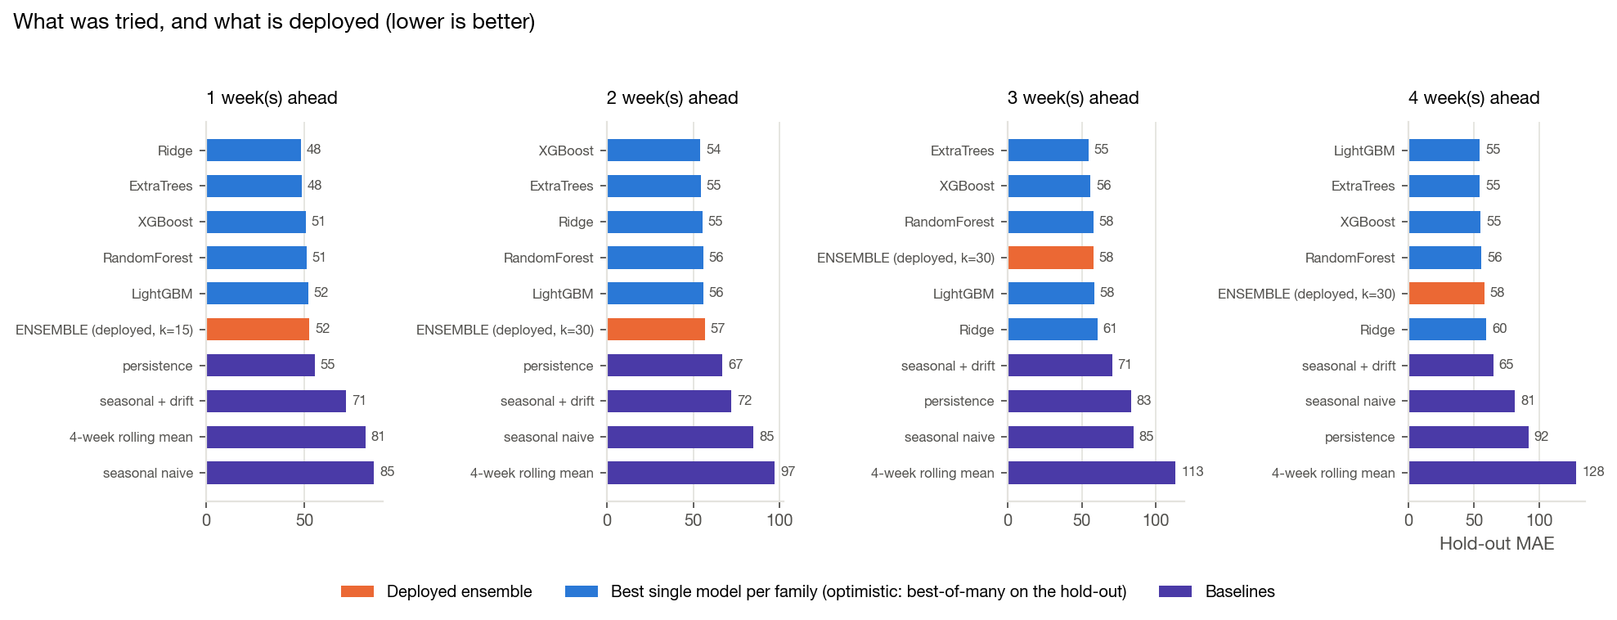
Figure 10. Every model family and target framing tried, against the four baselines. Selection used cross-validated error inside 2021–2023 only; the hold-out bars are shown for transparency.
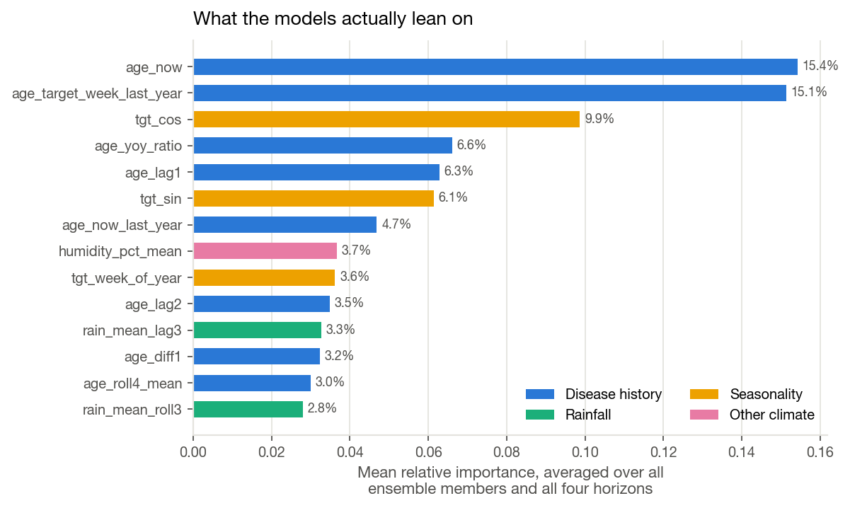
Figure 11. Which inputs the model actually leans on.
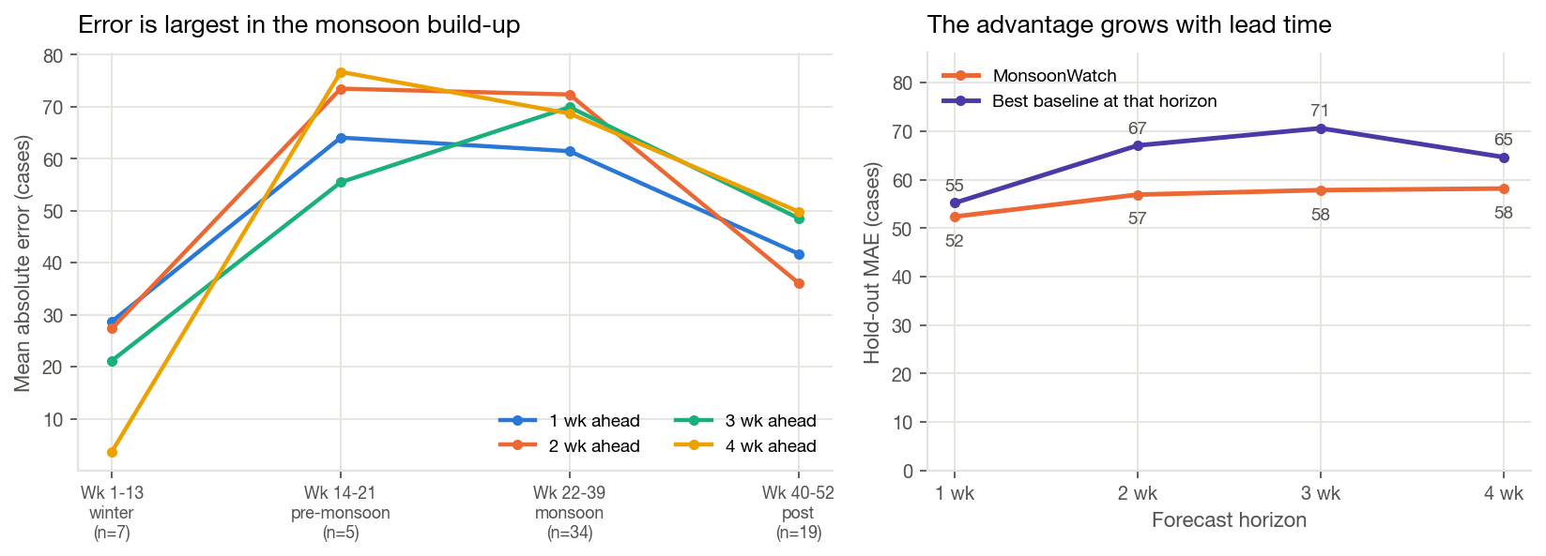
Figure 12. Where the error falls across the year, and how it grows with forecast horizon.

7.1 Reading these numbers honestly
- Retraining matters more than model choice. The frozen variant — train once, never update — is markedly worse than rolling-origin retraining across the board. For a non-stationary surveillance series, the operational discipline of refitting as each bulletin arrives is doing more work than the choice between XGBoost and LightGBM.
- The seasonal baseline is strong, and in one year it is very strong. In 2025, 'same week last year' was an unusually good forecast because growth had flattened to 1.14×. Per-year results are reported separately above rather than averaged into invisibility.
- The advantage grows with lead time. The ensemble's error is almost flat across horizons (52 → 58 cases) while every baseline degrades sharply as the horizon lengthens. That is exactly where the operational value sits: a one-week warning is too late to move supplies, a three- to four-week warning is not.
- Selection is noisy, and that is reported rather than hidden. Cross-validated error on 2021–2023 correlates only weakly with hold-out error across candidates. This is a real limitation of three years of weekly data, and it is the reason the deployed forecaster averages many models instead of trusting one.

7.2 Does rainfall actually earn its place?
The whole premise is that rainfall carries predictive signal, so it is worth testing directly rather than assuming. The deployed ensemble was rebuilt on three feature sets and re-scored on exactly the same hold-out weeks under the same rolling-origin protocol.
Horizon | Full model (MAE) | Disease + season only | Weather + season only | Rainfall contribution
1 wk | 52.4 | 51.7 | 80.4 | -1.4%
2 wk | 56.9 | 55.3 | 64.0 | -2.9%
3 wk | 57.8 | 58.0 | 54.9 | +0.3%
4 wk | 58.1 | 57.6 | 59.0 | -0.9%

The result contradicts the project's own premise, and is reported as such: removing every rainfall and climate feature changes accuracy by less than 3% at every horizon — sometimes slightly for the better. At the national weekly scale, with seasonal terms already in the model, rainfall adds no measurable predictive value here.

Three explanations are consistent with the evidence, and they point at different fixes:
- Spatial mismatch — the most likely cause. The rainfall is measured in the Kathmandu Valley; the disease count is national. Rain falling on 23 gauges in one valley is a weak proxy for the rainfall driving cases across the whole country. This is a data-coverage problem, not evidence that rainfall is epidemiologically irrelevant.
- The seasonal terms already encode the monsoon. The model is given week-of-year and its sine/cosine terms, which tell it when the monsoon happens every year. The ablation measures what rainfall adds ON TOP of knowing the date — and once the calendar is known, this rainfall series adds little.
- The underlying correlation is weak to begin with. AGE and rainfall correlate at only 0.26, and that peak is at lag 0 rather than at the multi-week lag a contamination mechanism would predict (Figure 8).
What this does not undermine: the forecasting system itself works and beats every operational baseline at every horizon. What it does change is the honest claim. This is an early-warning system built on disease surveillance history and seasonality, which rainfall data does not currently improve at this scale. Demonstrating a usable climate-health signal would need rainfall covering the same geography as the case counts, and ideally district-level cases to match against district-level rain — which is precisely the data gap set out in §10.
The weather-and-season-only column is the mirror test: without any disease history, accuracy collapses at one week ahead (80 vs 52 cases) but is competitive at three to four weeks, because at longer horizons most of the achievable signal is seasonal rather than autoregressive.

8. The web application
A Streamlit app runs the whole thing locally — no hosted inference, no runtime network calls:
streamlit run app.py
- Overview: the problem, the SDG framing, and headline numbers.
- Data explorer: weekly rainfall and cases by year, the seasonal profile, and a map of the 23 gauges.
- Hindcast — predicted vs actual: a slider to move through the held-out period and compare, week by week, what the model forecast against what actually happened, with the seasonal baseline drawn alongside for reference.
- Make a prediction: enter a week's situation by hand and get 1–4 week forecasts. Every input is explained in plain language. A random-test-case generator samples plausible values from the ranges actually observed near that point in the calendar, and any real historical week can be loaded to compare the forecast against the recorded outcome.
- Model performance: the full metrics table, every candidate tried, and the limitations restated.

9. Limitations
- National scope only. EWARS district columns are populated for 2024–2025 only — far too short a record for a model that depends on multi-year seasonality. The bulletins name a top-five district list each week; this project does not forecast a district grid and the pitch should not claim it does.
- The target is reported cases, not true incidence. The fourfold rise since 2021 is most plausibly surveillance expansion. Forecasting the reported count is the operationally useful choice, but it is not a measurement of disease prevalence.
- Rainfall for 2024–2025 is estimated. Gauge data ends December 2023; later weeks use satellite data calibrated against the gauges (R² = 0.87 on a three-year overlap, 0.89 on a held-out year). Good enough to use, and flagged in every row.
- Rainfall is Kathmandu Valley only, and adds no measurable accuracy. The disease series is national while the gauges cover one valley. The ablation in §7.2 shows removing weather entirely changes error by under 3%. The climate-health link should be presented as a motivation and a future direction, not as a demonstrated driver of this model's accuracy.
- Small data. Roughly 200 usable weekly rows per horizon. This is why the models are deliberately small and heavily regularised, and why the feature set was cut to 20.
- Eighteen missing bulletins. Handled explicitly, but they do reduce the usable sample and break some lag chains.

10. What would make this materially better
- EWARS reporting-site counts per week for 2021–2023, which would allow modelling cases per reporting site and remove the surveillance-expansion trend at its source — the single highest-value addition.
- Rainfall covering the same geography as the case counts — gauges beyond the Kathmandu Valley, or a national gridded product. This is the direct test of whether the null result in §7.2 is a real absence of signal or simply the wrong rainfall.
- DHM gauge data past 2023, replacing the satellite bridge with measurements.
- A longer district-level record, which is the only route to the district-level forecasting the problem really wants.
- Prediction intervals rather than point forecasts — an operational user needs a plausible worst case, not just a central estimate.

Appendix A — How to reproduce
Run in order from the project root:
python src/rainfall_prep.py # 23-station wide file -> weekly valley features
python src/nasa_power_fetch.py # satellite climate (the only network step)
python src/climate_bridge.py # calibrate satellite to gauges, extend to 2025
python src/build_features.py # join, engineer lags, one table per horizon
python src/train_model.py # search, select on pre-2024 CV, test on 2024-25
python src/make_figures.py all # all report figures
python src/make_report.py # this document
streamlit run app.py # the web app

Appendix B — Files produced
File | Contents
data/interim/rainfall_weekly_dhm.csv | Weekly valley rainfall from the 23 gauges, 2021–2023
data/interim/nasa_power_daily.csv / _weekly.csv | Satellite climate on the EDCD epi-week calendar
data/interim/rainfall_weekly_bridged.csv | Gauge + calibrated-estimate rainfall, 2021–2025, source-flagged
data/processed/features_base.csv | All engineered features by origin week — the app reads this
data/processed/features_h1..h4.csv | Model-ready tables, one per forecast horizon
models/model_h1..h4.pkl | Trained champions with their metrics and framing
reports/model_comparison.csv | Every candidate tried, with CV and hold-out scores
reports/backtest_h1..h4.csv | Week-by-week hold-out forecasts vs actuals
reports/training_log.txt | Full training and selection log
reports/figures/ | All figures in this report

Appendix C — Anticipated questions
Isn't this already done?
At prototype level, yes — a 2024 UMD-led study forecast diarrhoeal disease in Nepal, Vietnam and Taiwan. This uses 2021–2025 data rather than pre-2014, 23 real gauges rather than one satellite point, and it runs.
Why national, not district-level?
EWARS district columns only populate from 2024. A monsoon model needs multiple years of seasonality, which only the national series provides.
Why AGE and not cholera?
Too few confirmed cholera cases in the record to train on.
What about the 2024–2025 rainfall gap?
Bridged with satellite data calibrated against the gauges on a three-year overlap: R² = 0.87, and 0.89 on a fully held-out year. Every estimated week is flagged.
Isn't a fourfold rise in cases alarming?
It would be if it were real disease. It is far more likely to be EWARS adding reporting sites, and the report says so.
How do you know the week numbers line up?
EDCD epi-weeks are not ISO weeks. Anchors were established from bulletins confirmed published on schedule and cross-checked against an independent source, then validated by the fact that the EDCD-native join gives higher rainfall–disease correlation at every lag.

