Hi, I have used Pycharm to write and execute the code:

# task 1:2 ###########  
i = 2000  
a = ""  
while i <= 3200:  
 if i % 7 == 0 and i % 5 != 0:  
 a += (str(i) + ",")  
 i += 1  
print(a)

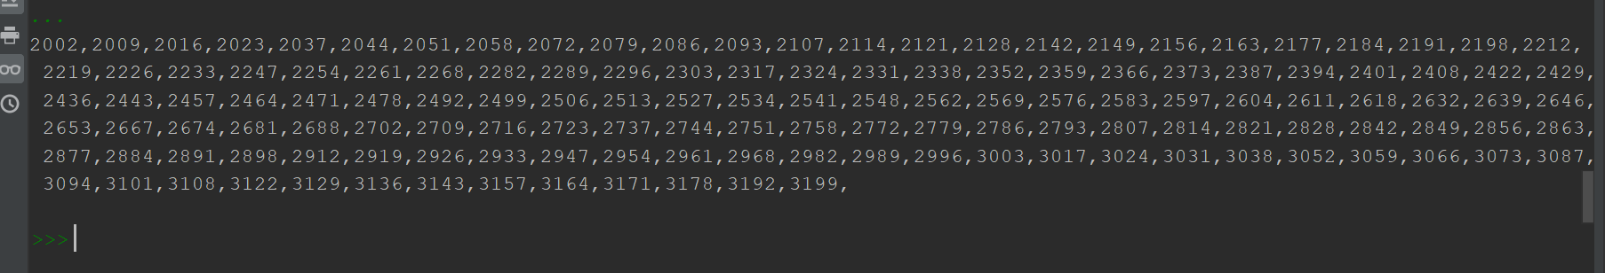  
  
# task 1:2 alternate ################  
i = 2000  
a = []  
while i <= 3200:  
 if i % 7 == 0 and i % 5 != 0:  
 a.append(i)  
 i += 1  
print(a)

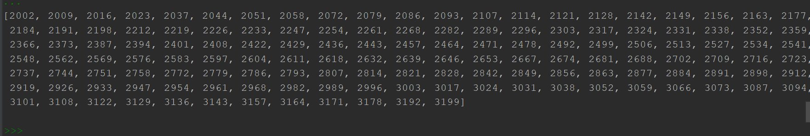  
  
# task 1:3 #############################  
x = input("your first name: ")  
y = input("your last name: ")  
  
print(y + " " + x)

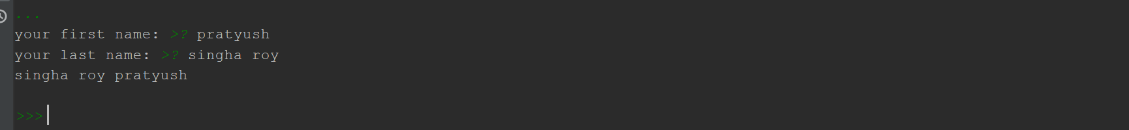

# task 1:4 #############################  
# V=4/3 * π * r 3  
pi = 3.14  
r = 12  
V = 4/3 * 3.14 * (r ^ 3)  
print("volume is: " + str(V))

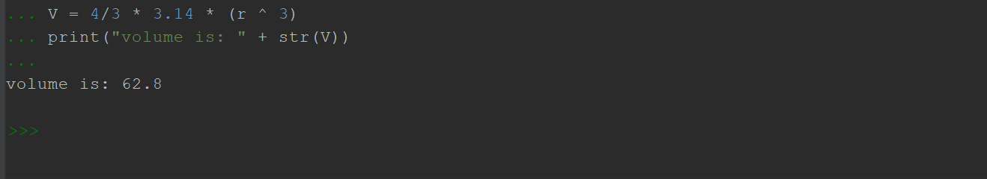  
  
# task 2:1 #############################  
  
y = input("enter comma separated numbers: ")  
  
numbers = y.split(',')  
print(numbers)

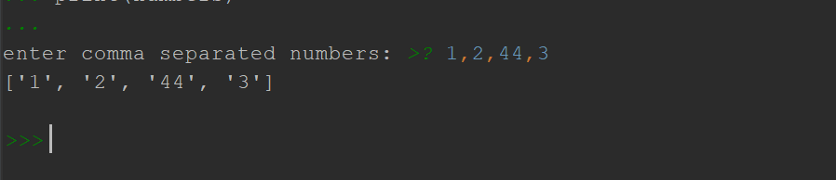  
# task 2:2 ##############################  
  
n = 5  
for i in range(n):  
 # print(i)  
 for j in range(i):  
 print('* ', end="")  
 print('')  
  
for i in range(n, 0, -1):  
 for j in range(i):  
 print('* ', end="")  
 print('')

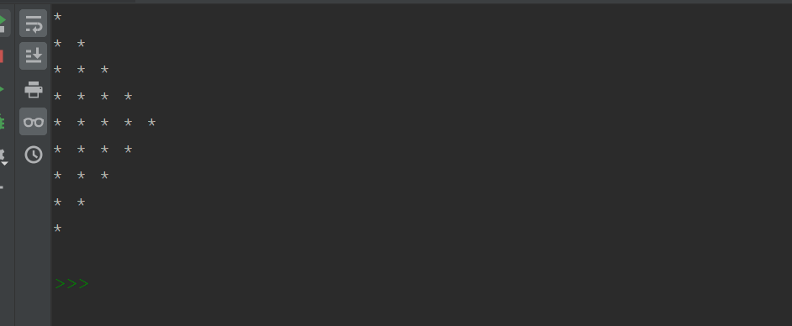  
  
# task 2:2 ##################################################  
  
n = 5  
for i in range(n):  
 # print(i)  
 for j in range(i):  
 print("", end='* ')  
 print('')  
  
for i in range(n, 0, -1):  
 for j in range(i):  
 print("", end='* ')  
 print('')

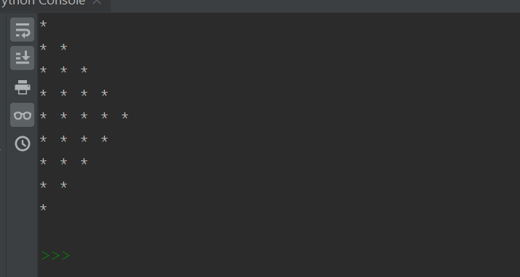  
  
# task 2:3 ######################################  
i = 0  
y = ""  
x = input("enter the word: ")  
z = len(x)  
while i < z:  
 y += x[z-1]  
 z -= 1  
print(y)

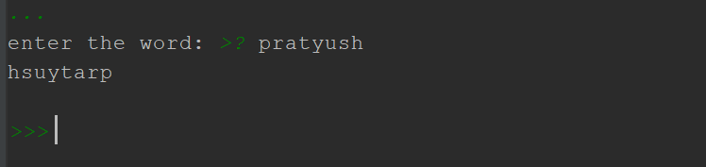  
  
# task 2:4 ###########################################  
  
print("""WE THE PEOPLE OF INDIA, \t \t \t \t \t  
\t \t having solemnly resolved to constitute India into a SOVEREIGN, !  
\t \t \t SOCIALIST, SECULAR, DEMOCRATIC REPUBLIC  
\t \t \t \tand to secure to all its citizens""")

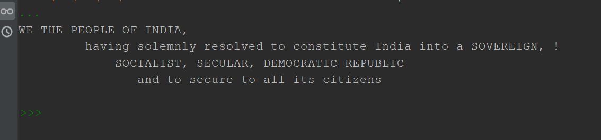  
  
# task 2:4 ###########################################