*# Task 1 : 1***def** divide_five(a, b):  
 c = a / b  
 **try**: print(**"the division value: "**, c)  
 **except** ZeroDivisionError **as** e:  
 print(**"INFO: error captured!"**)  
 print(e)  
 **finally**:  
 print(**"finally the operation is done"**)  
  
x = int(input(**"enter the dividend:"**))  
y = int(input(**"enter the divisor:"**))  
divide_five(x, y)

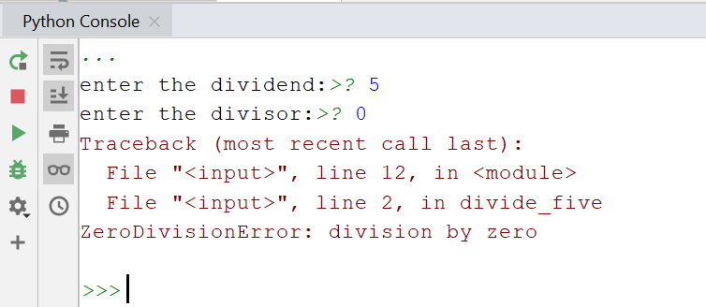  
  
*# TASK 1: 2 #######################*subjects = [**"Americans "**, **"Indians"**]  
verbs = [**"play"**, **"watch"**]  
objects = [**"Baseball"**, **"Cricket"**]  
  
**for** x **in** subjects:  
 **for** y **in** verbs:  
 **for** z **in** objects:  
 print(x + **" "** + y + **" "** + z)  
  
*# TASK 2: 1 ##########################  
  
# column of the output matrix are power of the input vector***import** numpy **as** np  
  
x = np.array([1, 2, 3, 4, 5])  
N = 4  
print(np.vander(x,N))

