Low Level Design (add product module)

Project Code | Group 4
Project Name | University Admission System

Prepared/Modified by | Role | Date of Preparation
Pratyush Das | Software Engineer | 01/02/2018
Reviewed by | Role | Date of Review
Mrunalee Kothari | Software Engineer | 04/1/2018
Approved by | Role | Date of Approval
Uma M Ponniamman | Training Manager
Circulation List | amit.agarwal@igate.com, mrunalee.kothari@igate.com, keerthi.parthasarathy@igate.com, nidhi.shetty@igate.com, nikeeta.menon@igate.com, shrikant.sutar@igate.com, bhagyashree.vedpathak@igate.com | Version Number of the template:1.0
Version Number | 2.0

Table of Contents

1. Description Of The Unit 3
2. References 4
3. Dependencies / Assumptions 5
4. Class Diagrams 6
5. Sequence Diagrams 7
6. Design Components 8
6.1 List Of UI Components 8
6.2 List Of Design Classes 8
7. Re-Usable Routines/Components 9
8. Messages 10
9. Configuration Files 11
10. Crud Matrix Table 12
11. Data Mapping Matrix 13
12. Action Flow Matrix 14
13. Stored Procedures 15
14. Program Specification / Pseudo Code 16
REVISION HISTORY OF THE WORK PRODUCT 17

Description Of The Unit

The add product module allows the admin of the application to add new products into the database. This module can be used only by the admin of the application.

On clicking on the add button in the admin home page, the admin is redirected to a add page. The admin enters all the details of the product like product name, product description, product sub-category, product price, product quantity and product image. If the entered product details are invalid, appropriate error messages are displayed.

After entering all the product details, the details are inserted into the database on clicking the add button. The admin can also cancel the add product functionality by clicking on the cancel add button.

References

Reference | Description
Repository reference | https://IGTEBLRSVNTNG.igatecorp.com/svn/oct3_Team1
Class Diagram | /Project Documents/Design Documents/HLD/Class Diagrams
URS | /Project Documents/Requirements/Case Study/Ecommerce-grp1 and grp3.doc
UTP | /Project Documents/Test Plan/UTP/Test Cases/AddProduct /UTP_AddProductModule.xlsm
DB Design | /Project Documents/Design Documents/HLD/DB Design/E-Commerce_GROUP_DBDESIGN.xls

Dependencies / Assumptions

Dependencies:
- The MAC should be logged in.
- Any program scheduled should be selected.
- Any valid applicant should be either Accepted or Confirmed.

Assumptions:
- MAC data should be stored in Data Base.
- Valid data should be there in program_scheduled & program_offered table in Data Base.

Class Diagrams

Class Diagram

Sequence Diagrams

Sequence Diagram
NA

Design Components

List Of UI Components
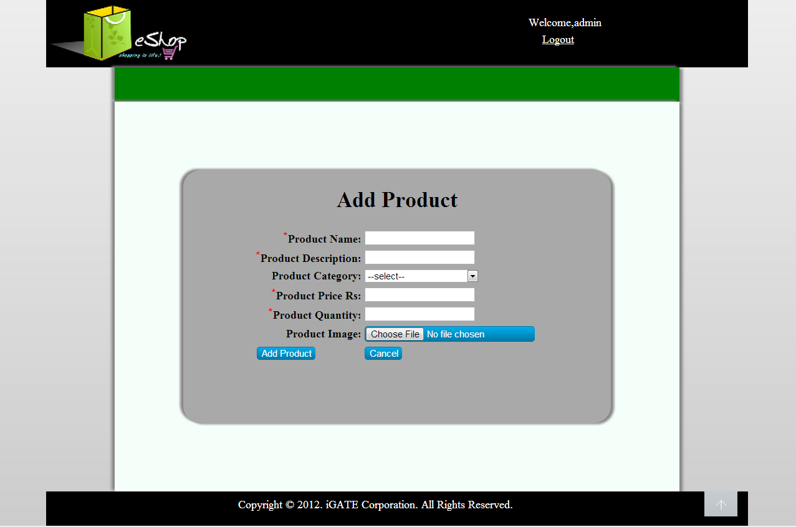

List Of Design Classes
Sr. No. | LLD Name | Class Name | Method Name | Method Description
1 | Add Interview Date

Re-Usable Routines/Components

Re-Usable Routines/Components

- CSS files
- Javascript files
- DataAccessException class
- Database properties files
- Logger properties files

Messages

#. | Type | Message Text
M1 | Error | Enter a valid MAC ID
M2 | Error | Enter a valid MAC Password
M3 | Error | No Applicant Details Found
M4 | Error | Cannot Update / Rejected Applicant

Configuration Files

File Name | Path | Description
oracle.properties | /Development/Source | To configure database connection.
Web.xml | /Development/Source | To configure the bean properties.
Dispatcher-servlet.xml | /Development/Source | To configure the request mapping and view resolver.
Eshop_logger.properties | /Development/Source | To configure the logger.
Eshop_error.properties | /Development/Source | To configure error messages.

Crud Matrix Table

# | Table Name | Create | Read | Update | Delete
1. | Product | Y | N | N | N
2. | Product_Image | Y | N | N | N
3. | Product_Sequence | N | Y | N | N
4. | Sub_Category | N | Y | N | N

Data Mapping Matrix

Sr. No. | Screen Label | Field Source | Field Type | Data Type | Max Length | Data Flow | Mandatory
1 | Product Name | NA | Label | NA | NA | UI | NA
2 | txtProductName | Product. Product_Name | TextBox | Varchar2 | 50 | UI→D | Yes
3 | Product description | NA | Label | NA | NA | UI | NA
4 | txtProductDescription | Product. Product_Description | TextBox | Varchar2 | 50 | UI→D | Yes
5 | Product Sub-category | NA | Label | NA | NA | D→UI | NA
6 | optProductSubCategory | Product. Product_Sub_Category | Dropdown | Varchar2 | 50 | UI→D | Yes
7 | Product Price | NA | Label | NA | NA | UI | NA
8 | txtProductPrice | Product. Product_Price | TextBox | Decimal | (8,2) | UI→D | Yes
9 | Product Quantity | NA | Label | NA | NA | UI | NA
10 | txtQuantity | Product. Quantity | TextBox | Number | NA | UI→D | Yes
11 | Product Image | NA | Label | NA | NA | UI | NA
12 | fileProductImage | Product_Image. Image | File | Varchar2 | 50 | UI | Yes
13 | Add | NA | Button | NA | NA | UI | NA
14 | Cancel | NA | Button | NA | NA | UI | NA

Legend
D → UI (Database to User Interface)
UI → D (User Interface to Database)
UI (User Interface Only)

Action Flow Matrix

Sr. No. | Action | Description | Process
1 | On click of Add Button in Admin Homepage | Redirected to the Add page | The admin clicks on the add button in the admin homepage and gets redirected to the add page.
2 | On click of Add Product button in add page | The product details are inserted into the database. | Data is entered in the fields by the admin which gets inserted into the database when add button is pressed.
3 | On click of Cancel button in Add page | The product is not added into the database. | The admin on clicking on the cancel button in add page gets redirected to the home page.

Stored Procedures

# | Stored Procedure Name  (with Description) | Input/Out Parameters | Type | Size
1. | NA | NA | NA | NA

Program Specification / Pseudo Code

<ACTION : >

REVISION HISTORY OF THE WORK PRODUCT

# | Date | Version # | Section Changed | Details of changes made | Approved By
1 | 16/12/2013 | 1.0 | LLD prepared | N/A | Uma M Ponniamman
2 | 17/12/2013 | 1.1 | Reusable components,  Pseudo code | Reusable components added.  The pseudo code is modified as per the specified flow. | Uma M Ponniamman
3 | 18/12/2013 | 1.2 | Reusable components,  References,  Data Mapping Matrix. | Reusable Components added.  File name with relative path is added in the references section.  The name of text boxes(screen label is changed). | Uma M Ponniamman
4 | 24/12/2013 | 1.3 | Configuration files,UI Components | Paths of the configuration files is updated and UI components(Screen Shots) added. | Uma M Ponniamman

