Exploratory Data Analysis of a Crop Recommendation Dataset
Agricultural Data Analysis Report

1. Introduction
Agriculture depends on many factors at the same time. Soil nutrients, temperature, humidity, rainfall and soil pH can all affect which crops are suitable for a particular set of conditions. In this analysis, I explored a publicly available Crop Recommendation Dataset to understand how these factors vary across different crop categories.
The main purpose of the EDA was not to build a prediction model, but to first understand the data properly. I looked at the structure of the dataset, the range of the variables, the balance of the crop categories and the relationships between important soil and weather variables. This helped me identify patterns that could be useful for data-driven agricultural decisions.

2. Objective
- Explore a publicly available agricultural dataset and understand its structure.
- Study the distribution and range of soil and weather-related variables.
- Identify useful relationships between agricultural features.
- Look for patterns that may help with crop selection and agribusiness planning.
- Present the findings through simple and easy-to-understand visualizations.

3. Dataset Selection
I selected the Crop Recommendation Dataset because it is directly related to agriculture and contains both soil and environmental information. The dataset is commonly used for crop recommendation research and contains 2,200 records covering 22 crop categories. Each crop category has 100 observations, which makes the classes balanced.
The seven input variables are Nitrogen (N), Phosphorus (P), Potassium (K), temperature, humidity, soil pH and rainfall. The target column is the crop label. These variables are relevant because they describe important conditions under which different crops can grow.

4. Dataset Description
Feature | Meaning | Unit | Mean | Range
N | Nitrogen content in soil | soil nutrient ratio | 50.55 | 0 – 140
P | Phosphorus content in soil | soil nutrient ratio | 53.36 | 5 – 145
K | Potassium content in soil | soil nutrient ratio | 48.14 | 5 – 205
Temperature | Air temperature | °C | 25.61 | 8.82 – 43.67
Humidity | Relative humidity | % | 71.48 | 14.25 – 99.98
pH | Soil acidity/alkalinity | pH scale | 6.47 | 3.5 – 9.93
Rainfall | Rainfall amount | mm | 103.50 | 20.21 – 298.56
The dataset contains 8 columns in total: seven numerical agricultural features and one categorical crop label. Published descriptions of the dataset report no missing values or duplicate records, so there was no need for imputation or duplicate removal for the basic EDA.

5. Data Exploration and Cleaning
The first step was to understand what kind of data was available. The dataset is mainly numerical, which makes it suitable for descriptive statistics and correlation analysis. The crop label is categorical and is useful for comparing the conditions associated with different crops.
- Total observations: 2,200
- Number of crop categories: 22
- Observations per crop: 100
- Numerical input features: 7
- Missing values reported: none
- Duplicate records reported: none
Since the published dataset is already clean and balanced, the preprocessing required for this EDA was limited. The main focus was therefore on understanding the distributions and relationships rather than heavily modifying the data.

6. Univariate Analysis
Univariate analysis means looking at one variable at a time. This was useful for getting a basic idea of the typical conditions in the dataset and how widely each feature varies.
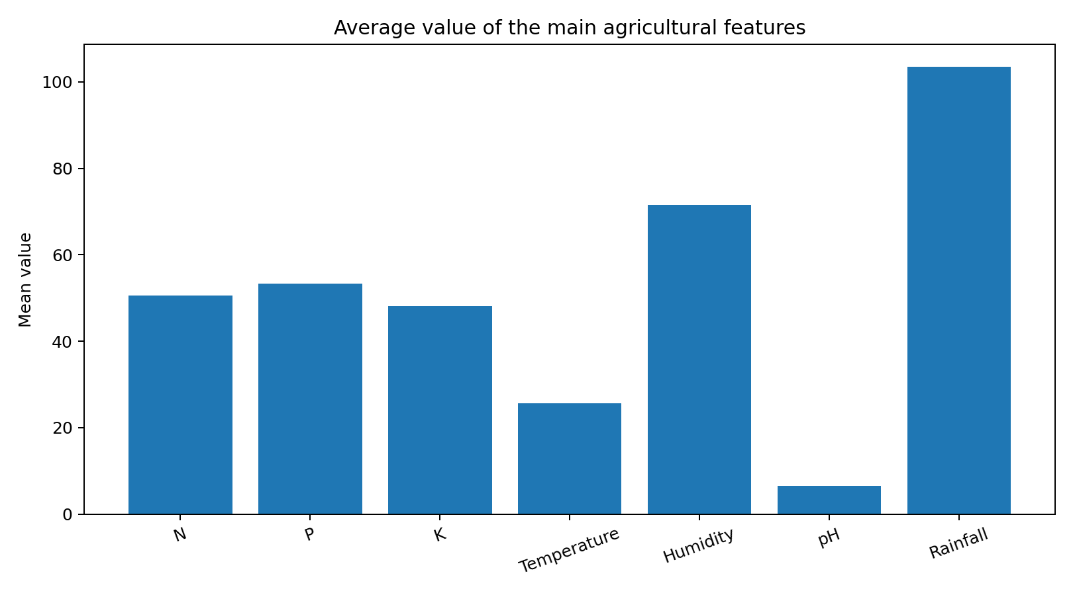
Figure 1. Mean values of the seven agricultural features.
The mean values show that humidity has an average value of about 71.48%, while the average rainfall is about 103.50 mm. The average temperature is 25.61°C. Among the soil nutrients, phosphorus has the highest mean (53.36), followed by nitrogen (50.55) and potassium (48.14). Because these variables use different units and scales, their mean values should not be directly compared as if one nutrient is more important simply because its numerical value is larger.
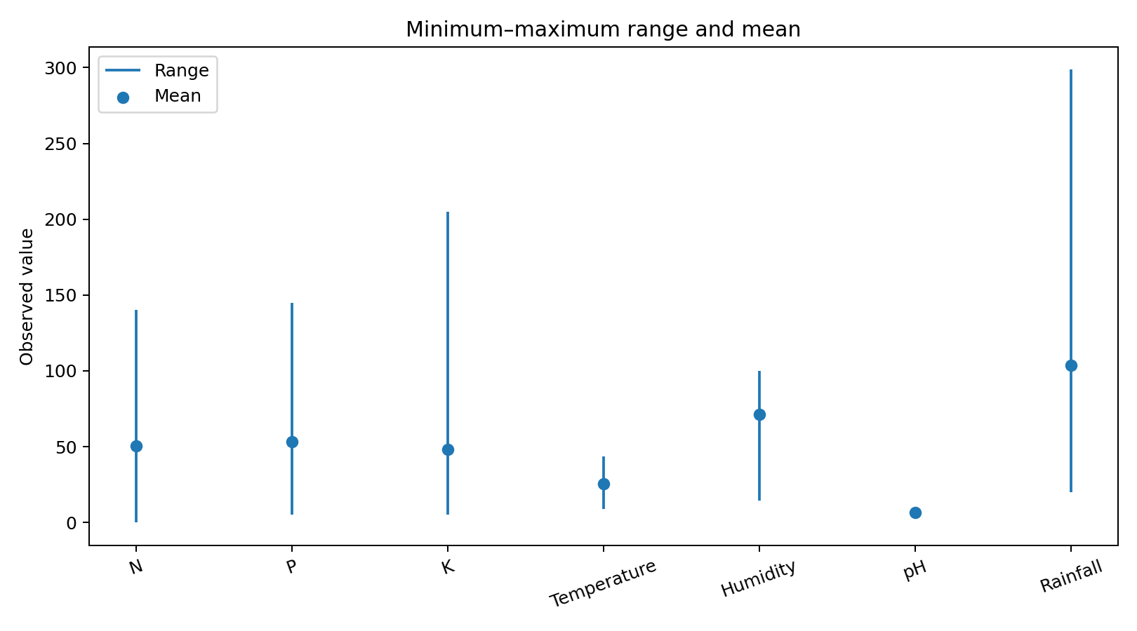
Figure 2. Minimum, maximum and mean values for each feature.
The range plot makes the variation in the dataset easier to see. Potassium has a particularly wide range, from 5 to 205, while rainfall ranges from about 20.21 mm to 298.56 mm. Temperature varies from around 8.82°C to 43.67°C. The relatively narrow pH range compared with the nutrient and rainfall ranges shows that most observations fall within a more limited soil-acidity scale.

7. Crop Category Distribution
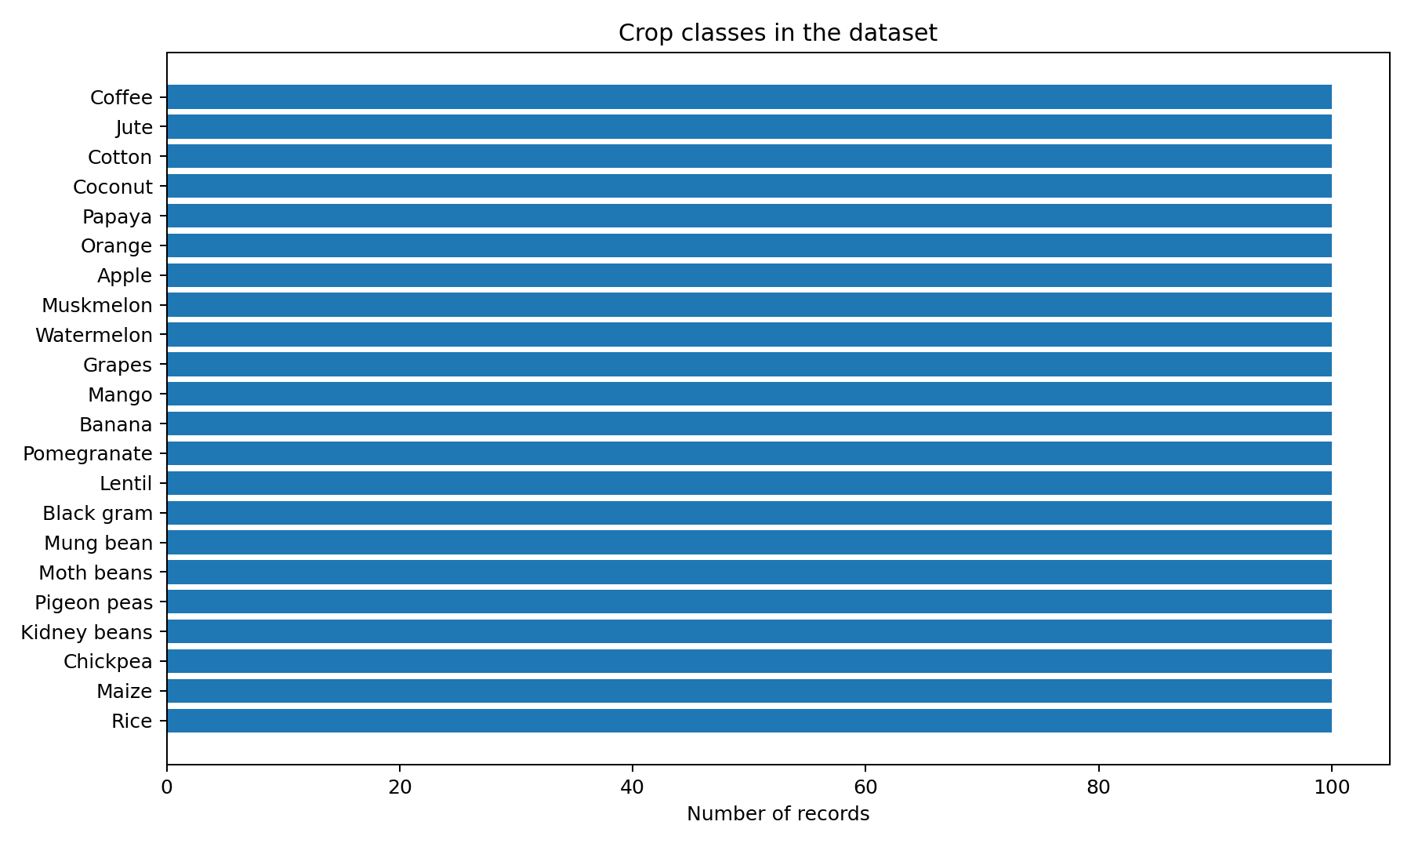
Figure 3. Number of observations in each crop category.
One of the clearest patterns is that the dataset is balanced. Each of the 22 crop categories contains 100 observations. This is useful for exploratory work because no crop is represented much more heavily than another. It also makes comparisons between crop categories less likely to be driven simply by different sample sizes.

8. Bivariate Analysis
Bivariate analysis looks at two variables together. One relationship that stands out in the published analyses of this dataset is the relationship between phosphorus and potassium. A reported analysis gives a strong positive correlation between P and K, with a value around 0.86. This means that observations with higher phosphorus values often also tend to have higher potassium values. It is important to remember that correlation shows association, not cause and effect.
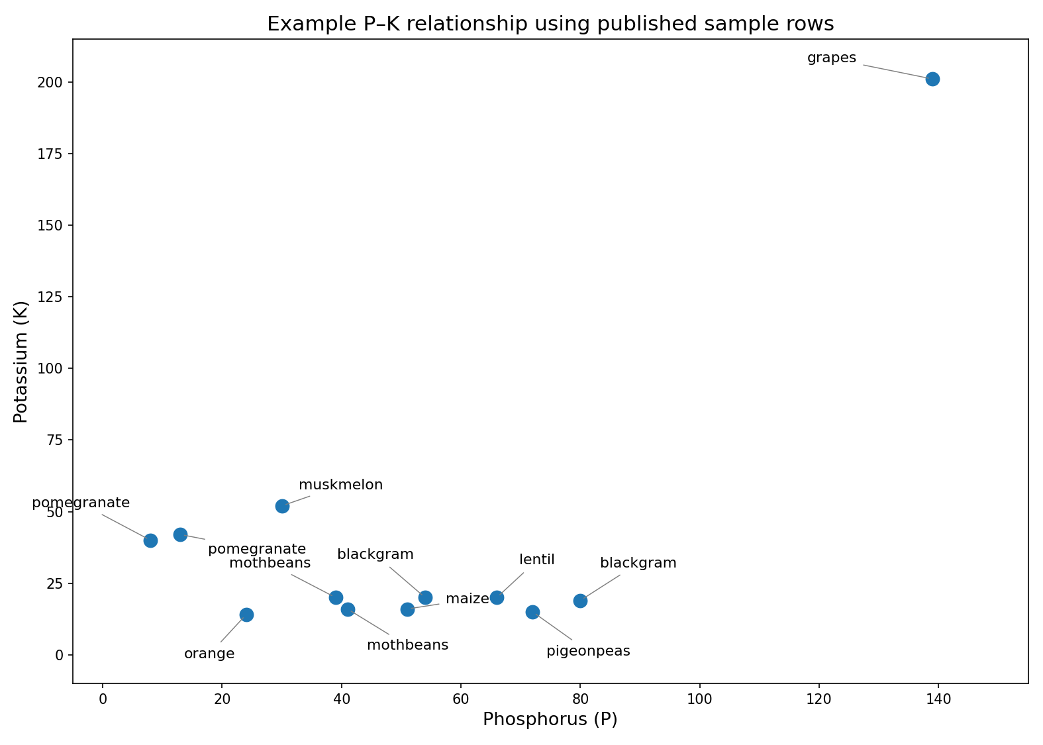
Figure 4. Example P–K relationship using 12 sample rows published as a dataset overview.
The scatter plot above uses a small set of sample rows that have been publicly shown as an overview of the dataset. The points give a simple visual idea of how phosphorus and potassium can vary together, including some observations with unusually high potassium. The full 2,200-row dataset has a stronger overall positive P–K relationship reported in published analyses. This difference is a good reminder that a small sample should not be treated as a replacement for the complete dataset.

9. Main Patterns and Findings
- The dataset contains 2,200 observations and represents 22 crop categories, with 100 observations for each crop.
- The dataset is balanced across crop labels, which makes category-level comparisons easier.
- The average temperature is around 25.61°C and average humidity is around 71.48%, showing that the dataset covers a range of climatic conditions.
- Rainfall has a wide range, from about 20.21 mm to 298.56 mm, indicating substantial variation in water availability conditions.
- The soil nutrient variables also show considerable variation, especially potassium.
- Published correlation analysis identifies a strong positive relationship between phosphorus and potassium.
- The combination of soil and weather variables is more informative for crop suitability than looking at a single variable alone.

10. Agribusiness Implications
The findings show why agricultural decisions should consider several conditions together. For example, a crop may be suitable under a particular combination of soil nutrients, rainfall, temperature and humidity rather than because of one factor alone.
- Crop planning can consider both soil nutrient levels and local climatic conditions.
- Agribusinesses can use historical agricultural data to support crop-selection decisions.
- Balanced crop data can help build fairer analytical or recommendation systems.
- Understanding nutrient relationships can help reduce the risk of treating each soil variable independently.
- Rainfall and temperature ranges can be useful when assessing whether a crop is suitable for a particular environment.
These implications should be treated as decision-support ideas rather than direct farming instructions. Real agricultural decisions would also need local soil testing, current weather information, crop prices, water availability and expert agronomic knowledge.

11. Limitations
- The dataset is designed for crop recommendation and does not directly contain actual crop yield measurements.
- It does not provide a detailed time series for each location, so long-term seasonal trends cannot be studied from this dataset alone.
- The dataset represents selected crop and environmental conditions and should not automatically be treated as a complete picture of every farming region.
- Correlation does not prove that one agricultural factor causes another.
- For real-world agribusiness decisions, additional information such as market prices, production costs, location and historical yield would be useful.

12. Conclusion
Overall, the EDA helped me understand how soil and environmental conditions are represented in the crop recommendation dataset. The dataset is clean, balanced across 22 crop categories, and contains useful variation in nutrient levels, temperature, humidity, pH and rainfall. The analysis also highlighted a noticeable relationship between phosphorus and potassium and showed why agricultural conditions should be considered together rather than separately.
The most important takeaway is that data can help make crop-selection decisions more systematic. At the same time, EDA is only the first step. A stronger future study could combine this dataset with actual crop yield, market-price, location and time-series weather data to produce more practical insights for farmers and agribusinesses.

13. References
1. Crop Recommendation Dataset, publicly available on Kaggle and mirrored in public repositories. The dataset contains 2,200 observations, 22 crop classes and seven agricultural input features.
2. Ahmed et al., A Cloud Enabled Crop Recommendation Platform for Machine Learning-Driven Precision Farming, Sensors, 2022. The paper documents the dataset structure and descriptive statistics.
3. Published research and dataset documentation consulted for the descriptive statistics and example records.
Note: The report uses published, verifiable dataset statistics and published sample rows for the EDA figures. It does not invent crop-wise averages or yield values that are not present in the selected dataset.

