SkillSpector –
Topics -Architecture, Analysis, Scoring & Reporting
Complete Findings | Medium-Level Technical Detail
A practical, evidence-oriented explanation of how an Agent Skill moves through context building, four independent analyzer families, meta analysis, inspection finalization, scoring and reporting.
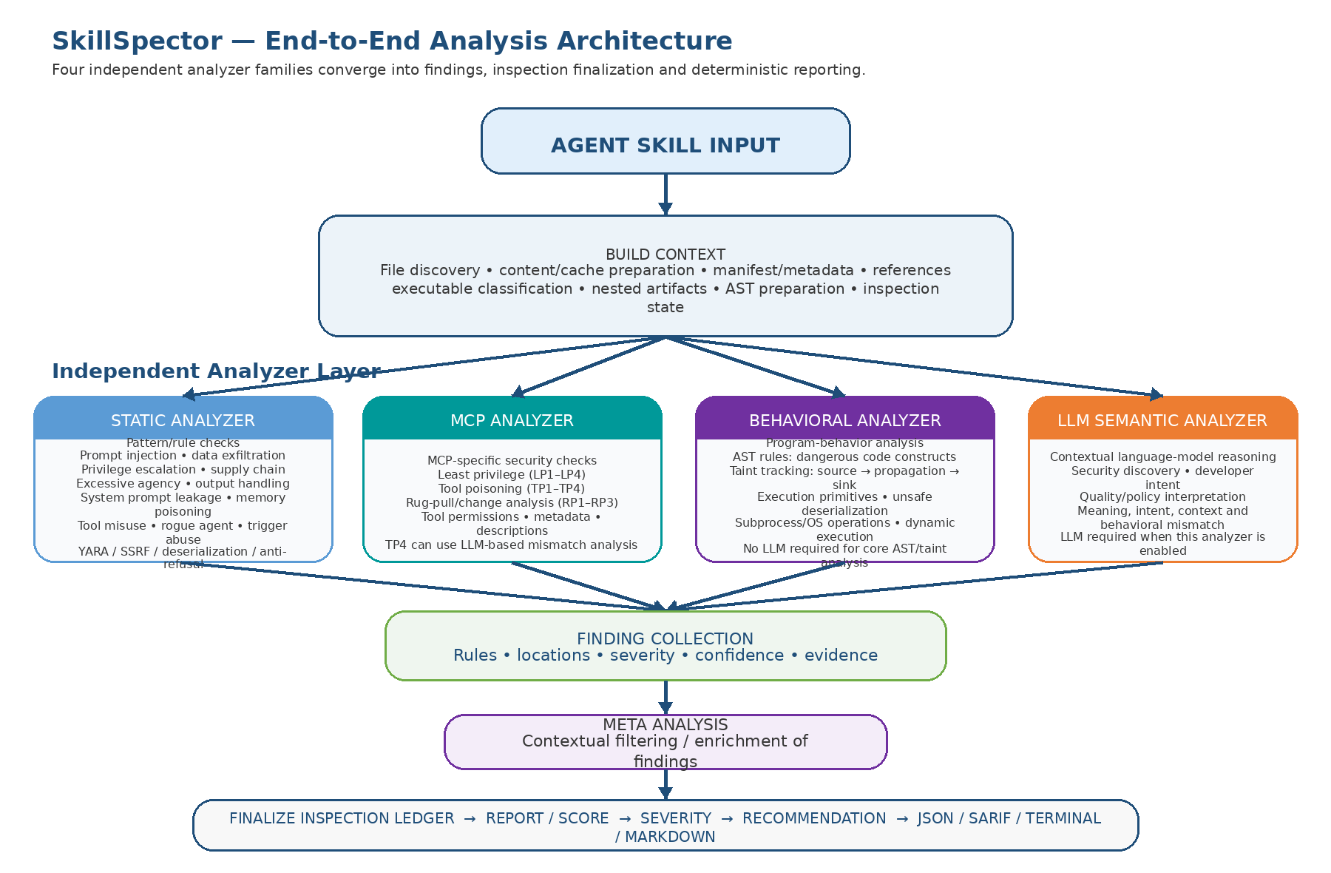
Figure 1. SkillSpector high-level architecture. The four analyzer families are shown as independent branches after build_context.

1. Executive Summary
SkillSpector can be understood as a staged security-analysis pipeline. It first converts the raw Agent Skill into structured scan context, then sends that context into four distinct analyzer families: Static, MCP, Behavioral, and LLM Semantic. Their findings converge into a common finding set, are further contextualized by meta analysis, and are then used by the reporting pipeline to produce inspection-completeness information, a deterministic 0–100 risk score, severity and recommendation.
A critical distinction is that build_context is preparation, not the security verdict, and the inspection ledger is primarily a record of what was and was not successfully inspected. The numerical risk score is calculated later from the final active findings.
The repository also supports both deterministic analysis and model-backed analysis. The exact set of analyzers and rules can change by SkillSpector version, so conclusions should always be tied to the version/commit used for the scan.

2. High-Level Architecture
The most useful mental model is:
Agent Skill → Build Context → four independent analyzer families → finding collection → Meta Analysis → Finalize Inspection Ledger → Report/Scoring → Severity → Recommendation → Output.
The four analyzer families are independent branches. MCP and LLM Semantic are not sub-branches of Static Analysis. Each branch consumes the scan context and contributes its own evidence/findings.
Analyzer family | Main question | LLM involvement
Static | Does the artifact match a known security pattern, risky declaration, signature, dependency condition, or other deterministic rule? | No for the core rule checks
MCP | Are MCP/tool permissions, metadata, descriptions, or changes unsafe? | Mostly deterministic; TP4 is LLM-powered for description/behavior mismatch
Behavioral | Does executable code contain dangerous structures or does data flow from risky sources to dangerous sinks? | No for core AST/taint analysis
LLM Semantic | What does the skill mean, intend, or imply in context, and is the behavior semantically suspicious? | Yes when enabled

3. What build_context Means
In SkillSpector, “context” is the structured scan state/evidence that downstream analyzers need. It is broader than an LLM prompt. build_context does not decide whether the skill is malicious; it prepares the material on which later analyzers operate.

3.1 File and artifact discovery
- Discovers the files and artifacts that are within the scan scope.
- Applies traversal and resource boundaries so the scanner has a defined analysis universe.
- Records relevant exclusions, unsupported or unreadable artifacts, and other inspection limitations.

3.2 Content and cache preparation
- Reads relevant artifact content into analyzer-ready representations.
- Maintains raw/local/LLM-oriented content paths where required by the implementation.
- Prepares safer external-model representations when sensitive material requires redaction.

3.3 Manifest, metadata and references
- Parses skill metadata/manifest information such as name, description, triggers and declared capabilities where present.
- Captures component metadata such as type, size, lines and executable classification.
- Resolves or records references so related files can be included in the analysis context.

3.4 Structural preparation
- Prepares Python AST information for code-aware behavioral analysis.
- Inspects nested artifacts within defined resource limits where applicable.
- Tracks inspection status and limitations so later reporting can distinguish a clean result from incomplete inspection.
Bottom line: build_context answers “What is this skill, what is inside it, what can be analyzed, and what evidence is available?” The analyzers then answer “What security issues does that evidence indicate?”

4. Static Analyzer
The Static Analyzer is the deterministic/content-oriented branch. It inspects files, text, metadata, declarations, signatures, dependency information and other detectable patterns without executing the skill. The current repository defines a broad set of security-pattern categories.

4.1 Prompt Injection
Looks for instructions that attempt to override system or prior instructions, bypass safety controls, or otherwise manipulate the instruction hierarchy. The core pattern layer can identify known phrases/patterns; contextual judgment may later involve the LLM semantic/meta stages.

4.2 Data Exfiltration
Looks for patterns associated with collecting sensitive information and sending or exposing it through network, file, logging or other output mechanisms.

4.3 Privilege Escalation
Looks for behaviors or declarations that increase access or execution privilege beyond the intended scope, including dangerous execution or privileged infrastructure patterns covered by the implemented rules.

4.4 Supply Chain
Checks dependency and packaging risk such as known-vulnerable dependencies, abandoned/typosquatting-like dependencies, untrusted container image settings and shipped Python bytecode. The SC4 path can consult OSV.dev for live vulnerability information.

4.5 Excessive Agency
Looks for capabilities that permit broad or autonomous actions beyond the stated purpose, including unrestricted tool access, autonomous decision-making, scope creep and unbounded resource access.

4.6 Output Handling
Checks whether model/tool output is used unsafely, crosses trust boundaries without validation, or is left unbounded in ways that can enable injection, leakage or resource exhaustion.

4.7 System Prompt Leakage
Detects direct instructions to reveal system prompts/internal rules, indirect extraction attempts, and tool-based exfiltration of system instructions.

4.8 Memory Poisoning
Detects persistent context injection, context-window stuffing/padding, and attempts to manipulate agent memory or stored state.

4.9 Tool Misuse
Detects dangerous tool parameter choices, unsafe tool chaining and permissive defaults such as disabled TLS verification or missing authentication.

4.10 Rogue Agent
Detects self-modification and unauthorized persistence mechanisms such as runtime changes, cron jobs or startup persistence.

4.11 Trigger Abuse
Detects overly broad triggers, triggers that shadow commands/other skills, and generic keyword baiting designed to increase unwanted activation.

4.12 Other implemented pattern families
- YARA signatures for known suspicious artifacts/payloads.
- Server-side request forgery indicators, including cloud/internal-network request patterns.
- Insecure deserialization patterns.
- Anti-refusal/jailbreak-style statements.
- Agent-snooping patterns involving sensitive agent configuration or MCP configuration access.
The exact rule IDs, severity defaults and category membership should be taken from the SkillSpector version used for the scan.

5. MCP Analyzer
MCP means Model Context Protocol. In this analyzer family, SkillSpector looks at MCP/tool-oriented security properties rather than treating MCP as a child of static analysis.

5.1 MCP Least Privilege (LP1–LP4)
- Underdeclared capability: code or behavior uses a capability that is not properly declared.
- Wildcard permission: permission scope is broader than necessary, such as “*”, “all”, “full” or equivalent.
- Missing permission declaration: no clear permission declaration exists while detectable capabilities are used.
- Overdeclared permission: a permission is declared but there is no corresponding observed capability.

5.2 MCP Tool Poisoning (TP1–TP4)
- TP1 — hidden instructions in tool/skill metadata.
- TP2 — Unicode deception such as homoglyphs, RTL overrides or invisible characters.
- TP3 — injection patterns in parameter descriptions or default values.
- TP4 — description/behavior mismatch. The current repository identifies TP4 as LLM-powered because it requires semantic comparison between declared purpose and observed behavior.

5.3 MCP Rug Pull (RP1–RP3)
Compares MCP/tool definitions across scans or versions and looks for security-relevant changes that can alter the trust relationship established by an earlier definition.
Therefore, “MCP analysis ran” does not automatically mean “an LLM was called.” Most MCP checks are deterministic; TP4 is the notable model-backed mismatch analysis in the current implementation.

6. Behavioral Analyzer
The Behavioral Analyzer focuses on executable behavior rather than only matching text. The core branch contains AST-based analysis and taint/data-flow analysis.

6.1 AST Analyzer
The AST analyzer parses Python into a structured syntax tree and checks actual code constructs. This allows it to distinguish real calls/expressions from a plain text occurrence of a keyword.
- Dynamic execution: exec(), eval(), compile() and related execution primitives.
- Dynamic imports/reflection: dangerous import or reflective execution patterns.
- Process execution: subprocess-related calls and operating-system execution primitives.
- Dangerous execution chains where individually less-suspicious operations combine into a higher-risk path.
- Unsafe deserialization and reflective/dynamic call patterns covered by the implemented AST rules.

6.2 Taint Analyzer
The taint analyzer asks a different question: does data from a risky source flow through the program to a dangerous sink?
Concept | Example in the analysis
Source | Environment variable, file input, network response or external/user input
Propagation | Variable assignment or other data-flow steps
Sink | Network output, execution, file write or insecure deserializer
Security meaning | Source → sink relationship may indicate credential exfiltration, file exfiltration, code execution or unsafe deserialization
The repository’s taint rules include direct and variable-mediated flows, credential-to-network flows, file-to-network flows, external-input-to-execution flows, and external-input/file-content-to-insecure-deserializer flows.

7. LLM Semantic Analyzer
The LLM Semantic Analyzer is the branch that uses a language model because some security properties depend on meaning, intent and context rather than a fixed string or syntax pattern.

7.1 Security Discovery
Uses semantic reasoning to discover security-relevant behavior that deterministic rules may not capture reliably from wording alone.

7.2 Developer Intent
Examines the apparent purpose or intent of the skill and whether its instructions/behavior align with that purpose. This is useful for identifying suspicious gaps between what the skill says it does and what it appears designed to accomplish.

7.3 Quality / Policy Interpretation
Evaluates semantic quality and policy-related characteristics that require contextual language understanding rather than only a regex or AST condition.

7.4 What the LLM is doing — and not doing
- It is not the universal scanner: deterministic analyzers can operate without it.
- It can add or interpret contextual findings where semantic reasoning is necessary.
- Its output can differ by provider/model, which is why your multi-model comparisons are valuable.
- It does not directly choose the final 0–100 score; report logic calculates the score from the final active findings.

8. Finding Collection and Meta Analysis
The four analyzer branches contribute findings into a common state. A finding can carry rule ID, severity, confidence, location and evidence-related information.

8.1 Why Meta Analysis Exists
Meta analysis is a separate contextual stage. It can evaluate analyzer findings against file content/context, enrich explanations and help decide which canonical findings remain effective for reporting.

8.2 Typical flow
Analyzer evidence → finding collection → meta analysis → effective finding selection/enrichment → inspection finalization/reporting.
This means an LLM can influence the final set or interpretation of findings without being the component that performs the arithmetic score calculation.

9. Inspection Ledger
The inspection ledger is the scan’s audit trail for execution completeness. It captures what was fully inspected, partially inspected, uninspected, excluded or otherwise limited, along with analyzer status and exceptions.

9.1 Why it matters
A scan with zero findings is not automatically a fully clean scan if important artifacts were never inspected. The ledger provides the second axis of trust: “How complete was the inspection?”

9.2 What to look for
- Per-component status.
- Analyzer execution/completion status.
- Partial or uninspected artifacts.
- Failures, exceptions and resource-limit conditions.
- Degraded analysis, including LLM/API failures where applicable.
- Coverage/completeness information carried into the final report.

10. finalize_inspection_ledger
During execution, different operations can emit inspection events. finalize_inspection_ledger reconciles those events into the final inspection state used by reporting.
1. Collect/reconcile inspection events from the workflow.
2. Determine final status for relevant components/analyzer paths.
3. Derive completeness/coverage and retain limitations or exceptions.
4. Expose the finalized inspection state to the reporting stage.
It does not calculate the risk score. It establishes whether the scan’s evidence is complete enough to interpret the findings responsibly.

11. Final Risk Score
The report stage works from the final active findings. It applies baseline suppression and scoring deduplication, then calculates each finding contribution.
Factor | Current behavior
Severity base | CRITICAL 50; HIGH 25; MEDIUM 10; LOW 5
Confidence | Contribution multiplied by confidence, bounded to 0–1
Repeated rule | 1st ×1.0; 2nd ×0.5; 3rd ×0.25; 4th+ contributes zero
Executable multiplier | Current implementation applies ×1.3 to findings from executable script files
Aggregation | Contributions summed and bounded to 0–100
Conceptually: contribution = severity base × occurrence weight × confidence × executable multiplier.
The exact implementation used for a particular report should be verified against the version/commit that generated the report.

12. Score → Severity
Score | Overall severity
0–20 | LOW
21–50 | MEDIUM
51–80 | HIGH
81–100 | CRITICAL

13. Severity → Recommendation
Severity | Default recommendation
LOW | SAFE
MEDIUM | CAUTION
HIGH | DO_NOT_INSTALL
CRITICAL | DO_NOT_INSTALL
Inspection degradation can affect the recommendation. An important uninspected component or other degradation can prevent a nominal SAFE outcome from being treated as fully safe.

14. Baseline Suppression and Deduplication
Before scoring, effective findings can be compared against a baseline. Suppressed findings remain useful for audit/reporting but are excluded from the active scoring set. The active findings are then deduplicated for score computation.
Therefore, the final score is not simply the number of raw messages produced by all analyzers.

15. Does the LLM Give the Final Score?
No. LLM-driven semantic analysis and meta analysis can influence which findings are present, how they are interpreted, or what confidence is attached. The final numerical 0–100 risk score is calculated deterministically by the report/scoring logic from the final active findings.
This is why the same skill can produce different scores with different models: the model can influence the evidence entering the scoring stage, while the scoring formula itself remains deterministic.

16. Report Generation
The report stage combines the final findings, score, severity, recommendation, component information and inspection-completeness state into the requested output format.
- Risk assessment: score, severity, recommendation.
- Findings: rule IDs, messages/explanations, locations, severity/confidence and evidence-related metadata.
- Component/inspection information: what was analyzed and whether the scan was complete.
- Degradation/LLM status where applicable.
- Supported output representations such as JSON, terminal/Markdown and SARIF.

17. End-to-End Example
Suppose the final active findings are:
- A = HIGH, confidence 1.0, first occurrence, non-executable → 25 points.
- B = HIGH, confidence 0.8, first occurrence, executable → 25 × 0.8 × 1.3 = 26 points.
- C = HIGH, confidence 0.9, second occurrence of the same rule → 25 × 0.5 × 0.9 = 11.25 points.
Total = 62.25 → integer score 62 → HIGH → DO_NOT_INSTALL.
If important artifacts were uninspected or analysis was materially degraded, the inspection state can affect the recommendation even when the numerical score is low.

18. How to Read a SkillSpector Result
1. Start with coverage/inspection completeness: what did the scanner actually inspect?
2. Identify which analyzer family generated each finding.
3. Trace each finding to its file, line, rule and evidence.
4. Check whether LLM analysis was enabled and which model was used when semantic analysis is involved.
5. Check meta-analysis effects if intermediate evidence is available.
6. Recalculate the score from the final active findings when validating report integrity.
7. Compare score → severity → recommendation and then check whether inspection degradation changes the interpretation.

19. Key Findings / Takeaways
- build_context is evidence preparation and scan-state construction, not the final security verdict.
- The four analyzer families are independent branches: Static, MCP, Behavioral and LLM Semantic.
- Static analysis can cover prompt injection, exfiltration, privilege escalation, supply chain, excessive agency, output handling, system-prompt leakage, memory poisoning, tool misuse, rogue-agent behavior, trigger abuse and other implemented static/YARA/security patterns.
- MCP analysis focuses on least privilege, tool poisoning and rug-pull/change detection; TP4 is the current MCP case explicitly described as LLM-powered.
- Behavioral analysis uses AST and taint/data-flow techniques to understand executable behavior and source-to-sink flows.
- LLM Semantic analysis is used for contextual meaning, security discovery, developer intent and quality/policy interpretation.
- Meta analysis sits after the analyzer branches and can filter/enrich contextual findings.
- The inspection ledger answers a different question from the risk score: how complete was the inspection?
- The numerical risk score is deterministic report logic based on final active findings, not an LLM’s direct rating.
- Severity, confidence, repeated-rule diminishing returns and executable-file weighting affect score contribution.
- Baseline suppression and deduplication happen before score aggregation.
- Model-to-model differences should be analyzed by tracing which findings changed before concluding that the scoring engine itself behaved differently.

20. Scope and Evidence Note
This document is an architecture and analysis guide based on the SkillSpector repository behavior examined during this project. Specific rule sets, counts, model defaults and scoring details can change between versions. For any formal evaluation, record the exact SkillSpector version/commit associated with each scan and treat reports/logs plus the source code as the verification chain.
Repository reference: NVIDIA SkillSpector — https://github.com/NVIDIA/SkillSpector

