

**DEPARTMENT OF ARTIFICIAL INTELLIGENCE AND DATA SCIENCE CHAITANYA BHARATHI INSTITUTE OF TECHNOLOGY HYDERABAD – 500075**

# COMMUNITY ENGAGEMENT

RURAL HEALTH CARE

By

**E. Pravalika (1601-22-771-075)**

**K. Shivani (1601-22-771-079)**

**M. Neha Prabha (1601-22-771-082)**

**T. Ramya (1601-22-771-085)**

**V. Sarayu (1601-22-771-087)**



**DEPARTMENT OF ARTIFICIAL INTELLIGENCE AND DATA SCIENCE CHAITANYA BHARATHI INSTITUTE OF TECHNOLOGY HYDERABAD – 500075**

# CERTIFICATE

This is to certify that the project titled **Rural Health Care** is a Bonafide record of the work done by

**E. Pravalika (1601-22-771-075)**

**K. Shivani (1601-22-771-079)**

**M. Neha Prabha (1601-22-771-082)**

**T. Ramya (1601-22-771-085)**

**V. Sarayu (1601-22-771-087)**

in partial fulfillment of the requirements for the award of the degree of **Bachelor of Engineering** in **Artificial Intelligence and Data Science** to the **CHAITANYA BHARATHI INSTITUTE OF TECHNOLOGY,**

**HYDERABAD** carried out during the year 2022-23..

**S. Shoba Rani**

Assistant Professor

Department of

Artificial Intelligence and Data Science

# TABLE OF CONTENTS

1. ABSTRACT 4
2. LIST OF FIGURES… 5
3. INTRODUCTION 6
4. CASE STUDY 7
5. CHALLENGES FACED 9
6. TECHNICAL SOLUTIONS… 10
   1. TELE MEDICINE 10
   2. MEDICAL DRONES 11
   3. ELECTRONIC MEDICAL RECORDS… 12
7. CONCLUSION 13
8. BIBLIOGRAPHY 14

**.**

# ABSTRACT

This report examines the state of rural healthcare, focusing on the challenges faced by rural communities in accessing and receiving quality healthcare services. It delves into the disparities between rural and urban healthcare, including limited healthcare facilities, healthcare workforce shortages, and socioeconomic factors affecting rural health outcomes.

The report also highlights innovative solutions such as telehealth, community health programs, and policy recommendations aimed at bridging the rural healthcare gap. By addressing these issues, we can work towards a more equitable and sustainable rural healthcare system that ensures better health outcomes for all rural residents

# LIST OF FIGURES

* 1. Gram Panchayat Office, 7

Devuni Erravelly

* 1. Ambulance Service 8

(limited availability)

* 1. Anganwadi Centre 8
     1. Telemedicine 10
     2. Medical Drones 11
     3. Electronic Medical Records 12

1. **INTRODUCTON**

Rural health care refers to the provision of medical services, preventive care, and health-related resources in rural or remote areas, where access to healthcare facilities may be limited. It involves addressing unique challenges

such as geographical barriers, limited healthcare infrastructure, and a shortage of healthcare professionals. The goal of rural health care is to ensure equitable access to quality healthcare services and promote the well-being of rural populations. Efforts often focus on mobile clinics, telemedicine, community

health workers, and partnerships with local organizations to improve healthcare outcomes in these areas.

Rural health care faces several challenges, including limited access to medical facilities and specialists, shortages of healthcare professionals, inadequate healthcare infrastructure, difficulties in transportation, and lower funding compared to urban areas. Additionally, there can be challenges in implementing and adopting new technologies, as well as addressing the unique health concerns of rural populations.

The most commonly used methodologies fall into two main camps: population-based factors and geography-based factors. The methodologies used for identifying rural areas include population size, population density, distance from an urban centre, settlement patterns, labor market influences, and postal codes.

The lack of consensus makes it difficult to identify the number of individuals who are in need of rural healthcare services.

# CASE STUDY

## VILLAGE: DEVUNI ERRAVELLY

**Mdl: Chevella , Dist: Rangareddy**

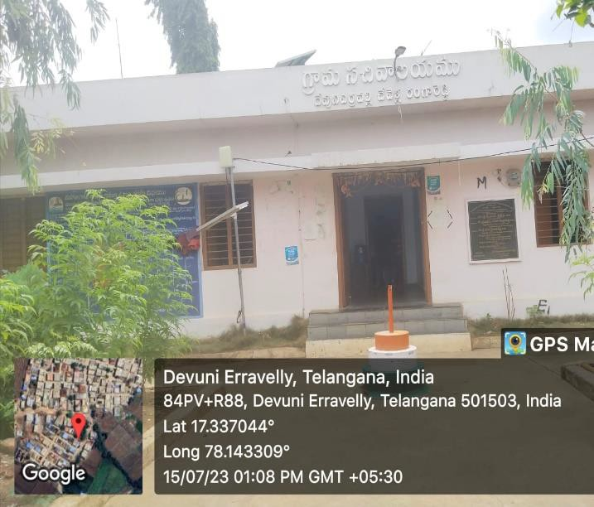

* 1. Gram Panchayat Office, Devuni Erravelly

The village Devuni Erravelly is located in Chevella Mandal of Ranga Reddy

District in the State of Telangana in India. It is governed by Devuni Erravelly

Gram Panchayat. It comes under Chevella Community Development Block. The nearest town is Vicarabad, which is about 32 kilometers away from Devuni Erravelly

## PROBLEMS IDENTIFIED:

People in Devuni Erravelly village are deprived from some of the basic needs like health care. As a part of Rural Health Care development in the country, we identified some challenges faced by the people living in the village

* There is no Primary Health Care Centre (PHC) in the village. In need of medical aid people rush to private hospitals located in mandal Chevella which is 6.1 km away.
* Hospital Staff is not alloted to the village by the government. Though there is a hospital built in the village , its not been used due to absence of doctors and staff
* Ambulance service is scarce (2-3 are available).Most of the villagers use their personal transportation to reach hospitals. People who don’t have personal vehicles need to hire vehicle at high prices .
* Children and Pregnant women get little medication facilities from anganwadis but the staff is irregular.
* ASHA workers are also less in number and not working efficiently

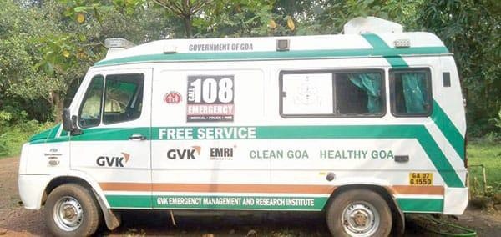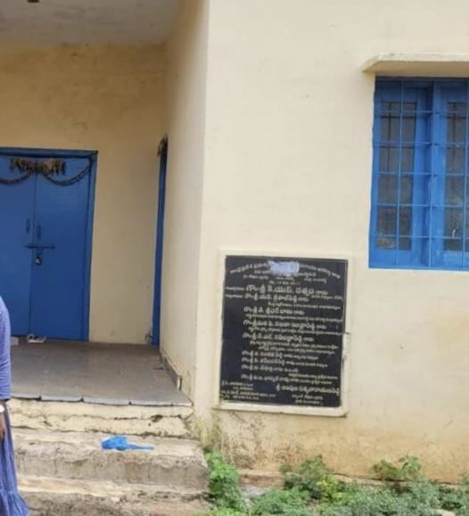

* 1. Ambulance Service 4.3. Anganwadi Centre

(limited availability: only 2-3 ambulances ( closed when visited ,

are found ) found no staff)

This is the state of a single village in India. As most part of our country consists of villages, there is high probability of finding more villages like Devuni Erravelly with lack proper health care. Thus this case study helps us figure out challenges faced by rural people. Consequently, We can develop technical solutions to overcome these challenges and provide better living for rural people.

# CHALLENGES FACED

1. **Limited Access**: Rural areas often have fewer medical facilities, making it challenging for residents to access healthcare services.
2. **Shortages of Healthcare Professionals**: There is a lack of doctors, nurses, and specialists willing to work in rural areas, leading to healthcare workforce shortages.
3. **Inadequate Healthcare Infrastructure**: The healthcare infrastructure in rural areas may be outdated or insufficient to meet the growing demands of the population.
4. **Transportation Difficulties**: Poor transportation networks can hinder

patients from reaching medical facilities promptly, affecting timely healthcare delivery.

1. **Lower Funding**: Rural health care often receives less funding compared to urban areas, limiting resources and services available.
2. **Unique Health Concerns**: Rural populations may face specific health challenges, such as agricultural-related injuries or limited access to preventive care and education.
3. **Technology Implementation**: Integrating and adopting new healthcare technologies can be more challenging in rural settings due to infrastructure limitations.

Addressing these challenges is crucial to improving healthcare outcomes and reducing disparities in rural areas.

# TECHNICAL SOLUTIONS

**Technical ways to provide proper rural health care overcoming the challenges are as follows:**

## TELEMEDICINE:

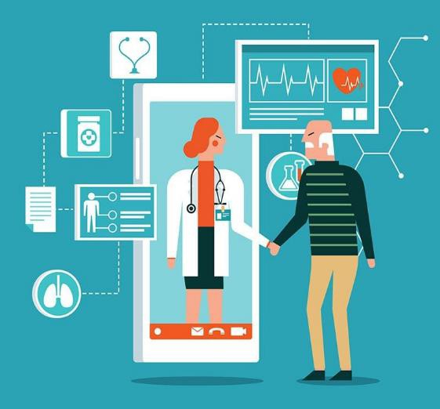It is the use of telecommunication and information technologies to provide remote clinical services to

patients. Physicians use telemedicine for the transmission of digital imaging, video consultations, and remote

medical diagnosis.

Today, individuals no longer have to schedule an in-person visit with a

physician to receive treatment. The 6.1.1. Telemedicine

use of secure video and audio connections makes it possible for

specialists to treat patients who reside in locations with limited access to care.

**Case Study:**

* The first telemedicine Centre in India:

ISRO (Indian Space Research Organization) made a modest beginning in telemedicine in India with a Telemedicine Pilot Project in 2001, linking Chennai's Apollo Hospital with the Apollo Rural Hospital at Aragonda village in the Chittoor district of Andhra Pradesh.

## MEDICAL DRONES:

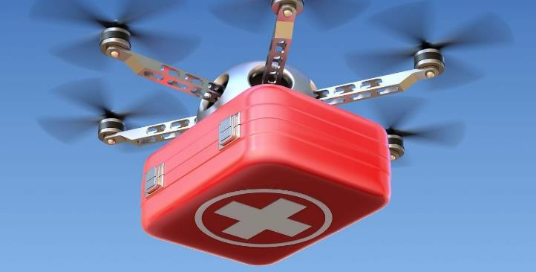Drones make it possible to deliver blood, vaccines, birth control, snake bite serum and other medical supplies to rural areas and have the ability to reach victims who require immediate medical attention within minutes, which in some cases could mean the difference between life and

death. They can transport medicine within 6.2.1. Medical Drone

hospital walls and courier blood between hospital buildings, as well as give elderly patients tools to support them as they

age in place

**Case Study:**

* + - A total of 17,275 units of medical supplies were delivered through the drones in the states of Manipur and Nagaland. The longest drone flight under this project carried 3525 units of medical supplies from Mokokchung to the district Tuensang in Nagaland (approx. 40 km).
    - The Telangana State’s groundbreaking ‘Medicine from the Sky’ initiative, which will use Beyond Visual Line of Sight (BVLoS) flights to deliver payloads of medicine, vaccines and donor blood, was launched with the delivery of a payload from the Vikarabad police Parade Ground to a government health care facility 3 kilometres away. Through this initiative the Telangana government wants to ensure “faster vaccine delivery” and “improved health care access”

## ELECTRONIC MEDICAL RECORDS:

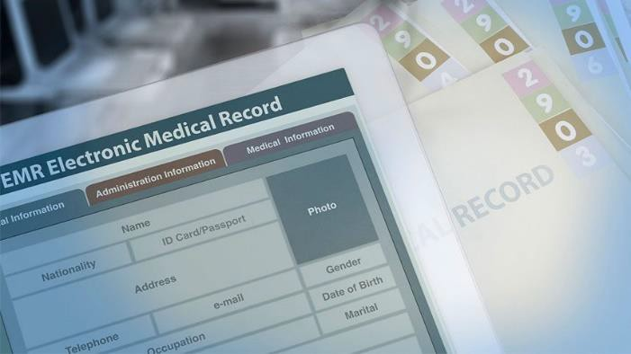

Electronic Medical Record is the systematized collection of patient and population electronically stored health information in a digital format. These records can be shared across different health care settings

EMR help provide better care for their

patients by enabling quick access 6.3.1.Electronic Medical Record

to patient records, resulting in more efficient care. They also help in

treatment effectiveness while

increasing the practice’s operational efficiency.

**Case Study:**

Electronic Medical Records use has been significantly increasing due to their efficiency.

* Electronic Medical registry implementation in hospital, including the Mosoriot Medical Record System in Kenya , PIH-EMR in Peru, HIV- EMR in Haiti, Careware in Uganda and an injury surveillance trauma registry in South Africa.
* U.S. Health Information Technology for Economic and Clinical Health (HITECH) Act called for the creation of a meaningful use incentive program to provide financial support to providers and health systems that adopt electronic medical record (EMR) technologies
* In India , from 2008 to 2014, the percentage of patients who reported that it was very important for them to get their own medical information

electronically increased from 58.3% to 69.1%.

# CONCLUSION:

Good health is not only the wish of an Individual but it is beneficial to the nation. Healthcare system of a nation could be considered as good fit the socioeconomic condition of a nation only if its enable majority of its people ‘to be health’. Health Care market has challenges like asymmetry of

information, supplier induced demand for health care services, legal

restriction on the entry of medical colleges to produce medical professionals which leads to failure of market forces in ensuring socially optimum solutions. Indian health care service market is more of supplier friendly which has neglected the rural segment. Public intervention has also found to

not succeeded in bridging the rural-urban disparities in the health outcomes. Rural areas are in disadvantageous condition in the health care services.

Rural biased health system, shortage of doctors especially in the rural hospitals, absenteeism of medical professional in the rural hospitals increasing out-of-pocket expenditure on the health care are some the problems responsible for poor health outcomes in the rural areas.

# BIBLIOGRAPHY:

Technical Ways for Health Care

Ministry of Family and Welfare, India frontline.thehindu.com

worldwidejournals.com