Terraform:

STeps:

1. Creating the dedicated project for the terraform--->ADO--->New projects.

2. Go to repo--->Try to import the git repository.

3. Go to thegit repo UI-->search for your github reposistories where u have terraform file

https://github.com/CKNAVIN1009/terrformdemo.

4. CLone url: https link for your github terraform demo.

5. Import the repo.

6. Build pipeline-->

a. Classic editor

b. Empty job.

c. Try to rename to agent job name

d. Choose COPY file.

e. Choose Publish build artifact.

f. Created the build pipeline.

g. Artifact is published.

7. Create the release pipeline.

8. Empty job.

9. Choose artifact(generated at build piepline).

10. Marketplace--->install Terraform(By microsoft devlab).

11. Go with your organization..

12. You are good to go with other setup.

13. You need to go to the portal and create the azure storage.

14. You have create the container to store your iac.

13. Edit the release pipeline -->adding the job

a. Terrform tool installer.

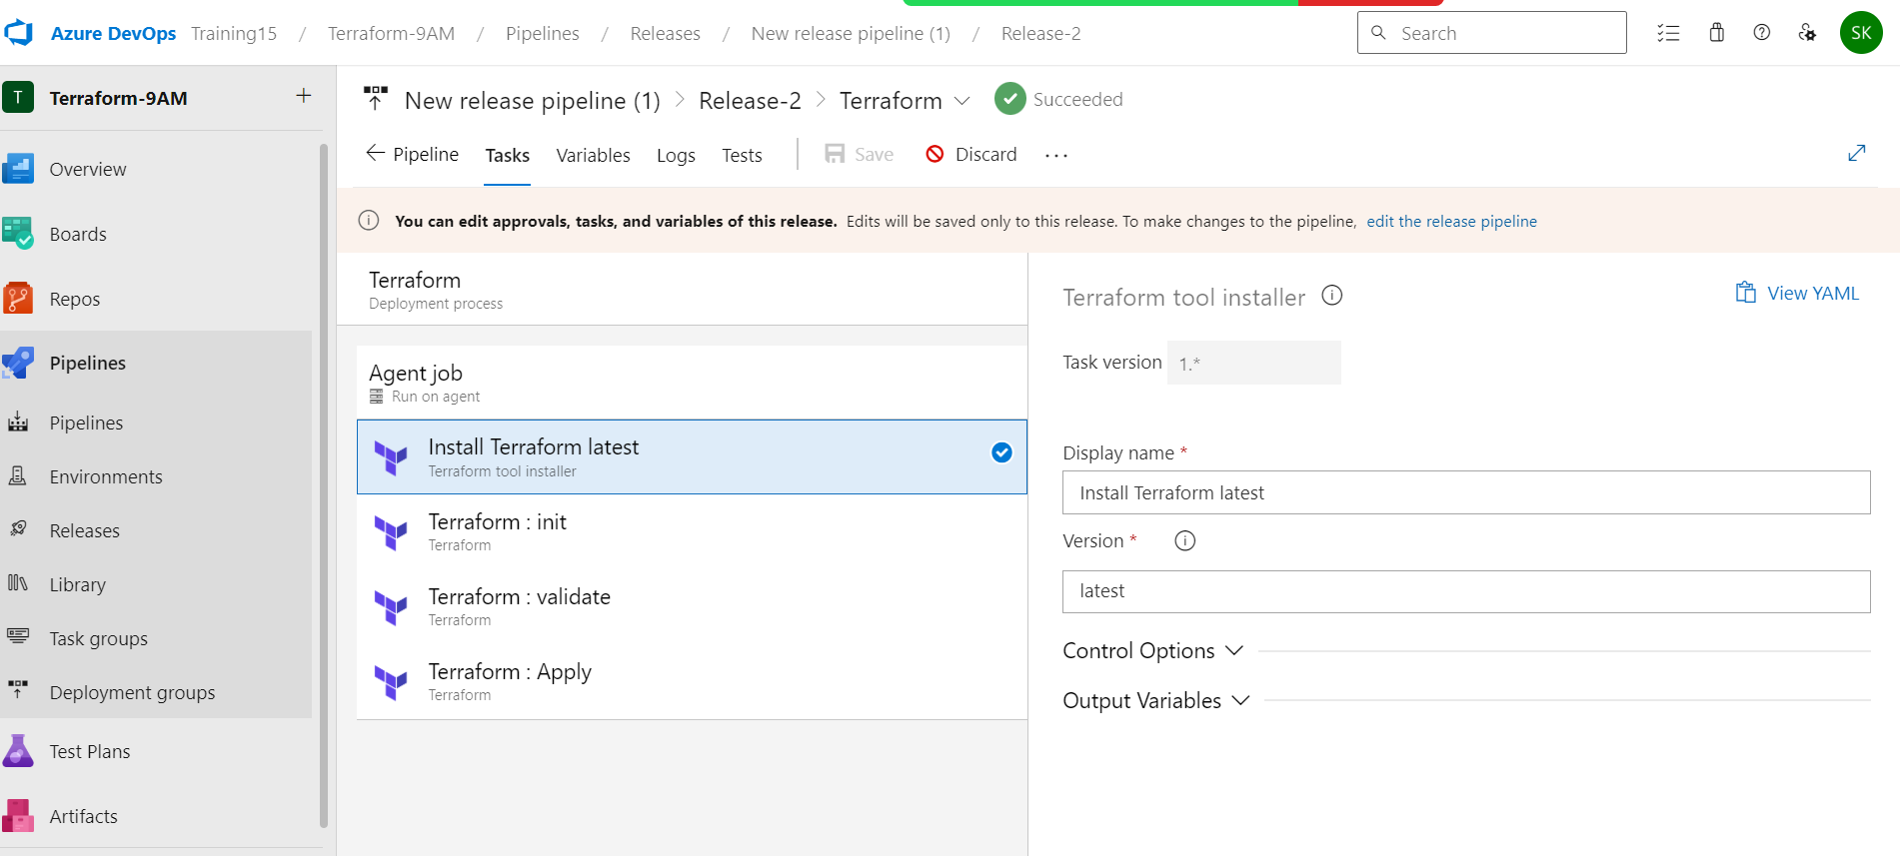

b. Terraform-init

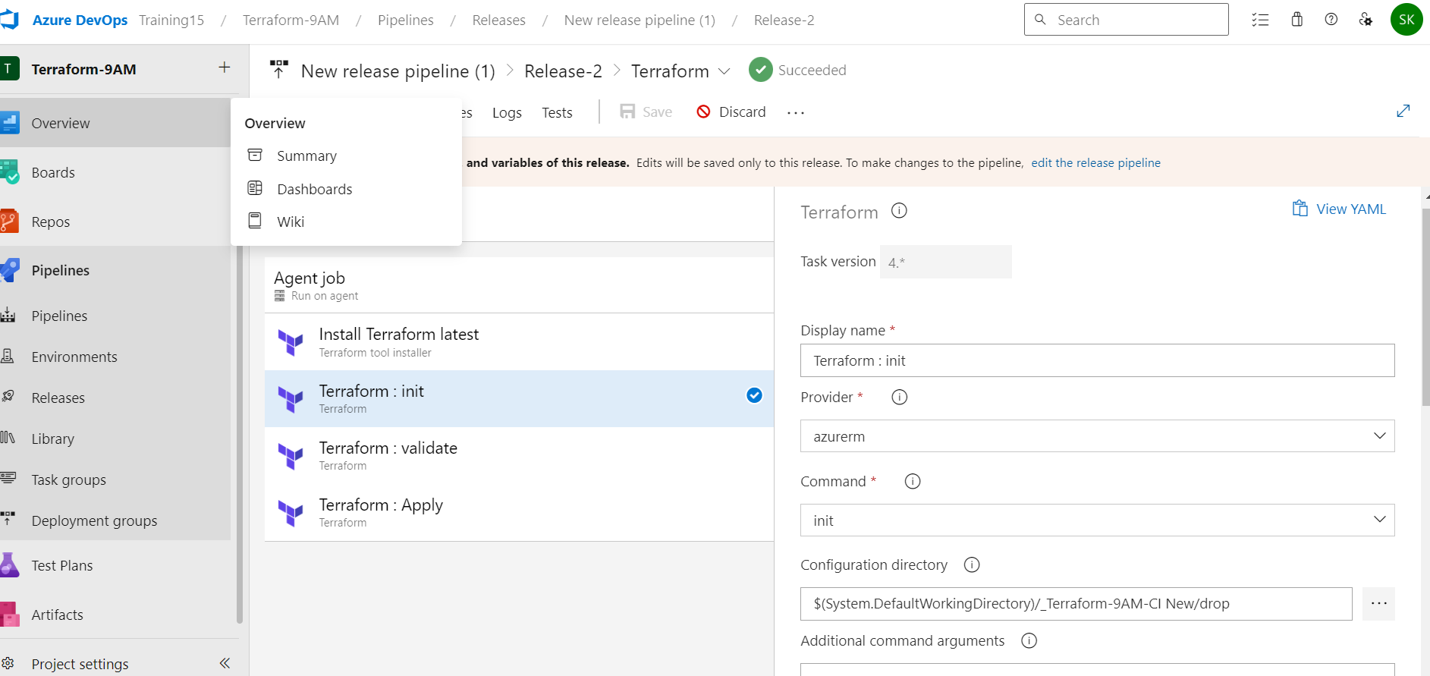

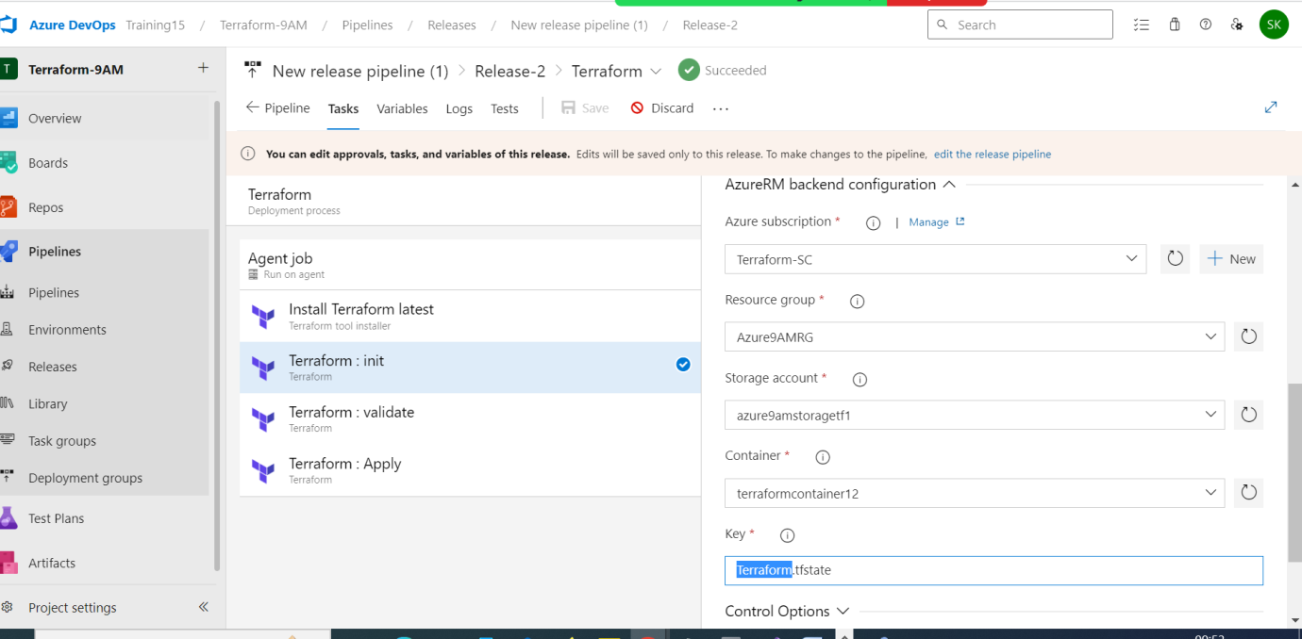

c. Terraform-validate

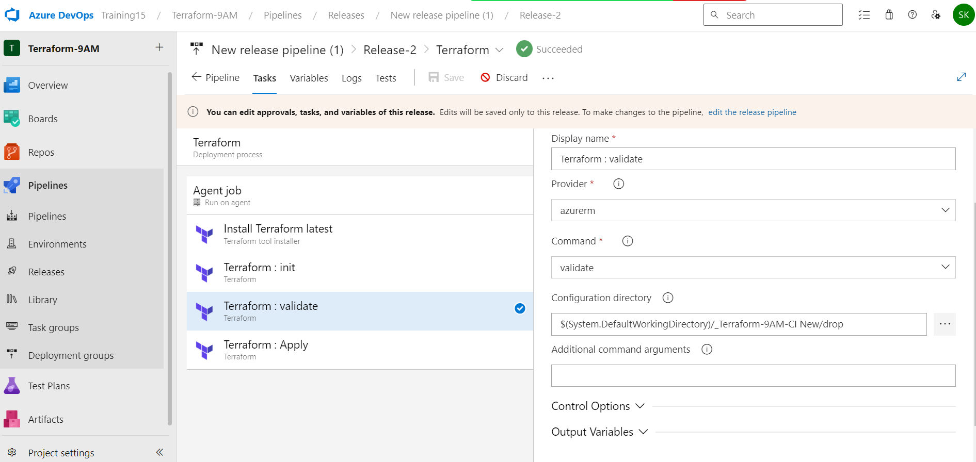

d. Terraform-Apply

