Exp. 8. Simulation of VI Characteristics of FINFET, CNTFET and GFET using NanoHub
(a) FINFET
Case Study 1: Simulate & obtain the current spectrum characteristics for the last bias point of FinFET. Analyze the performance for different Oxide layer thicknesses

Case Study 2: Simulate & obtain the electron density per sheet characteristics of FinFET. Analyze its performance with different Gate region length

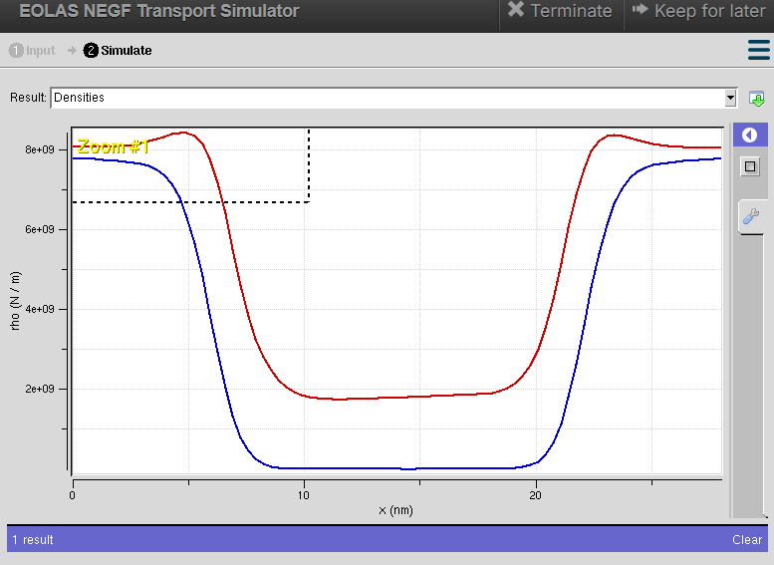

(b) CNTFET
Case study 1: Simulate & Obtain the VI characteristics of CNT-FET by varying Schottky barrier and oxide thickness
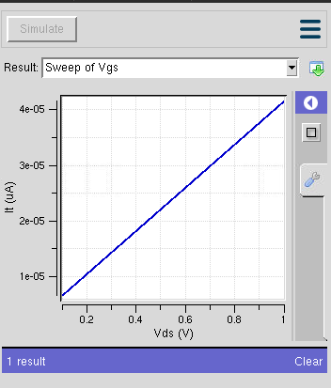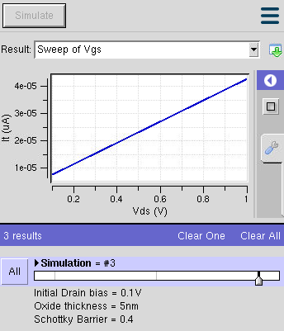
Case study 2: Simulate & Obtain the VI characteristics of CNT-FET by varying CNT diameter
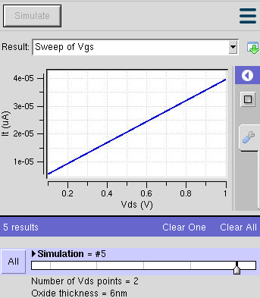
(c) GFET
Case Study 1:How does varying the gate voltage (Vgs) affect the drain current (Ids) in a GFET?
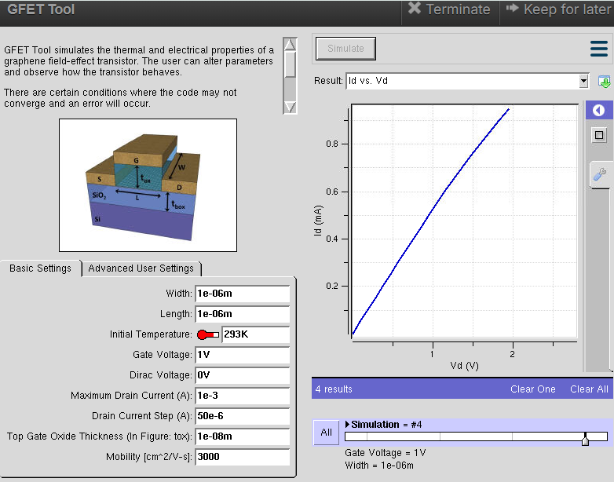
Case Study 2: What factors determine the maximum drain current (Ids,max​ ) in a Graphene Field Effect Transistor (GFET)?

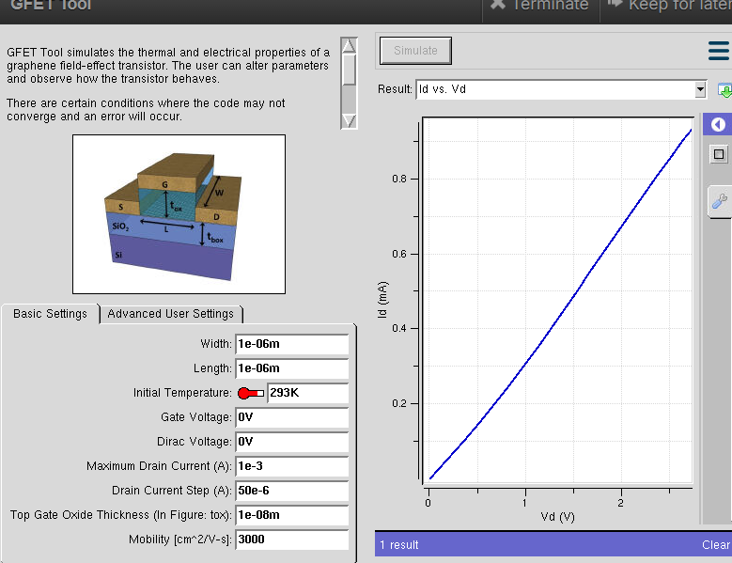
Case Study 3: To investigate how the mobility of charge carriers in a Graphene FieldEffect Transistor (GFET) with a mobility of 2000 cm²/V·s influences its current-voltage (VI) characteristics.
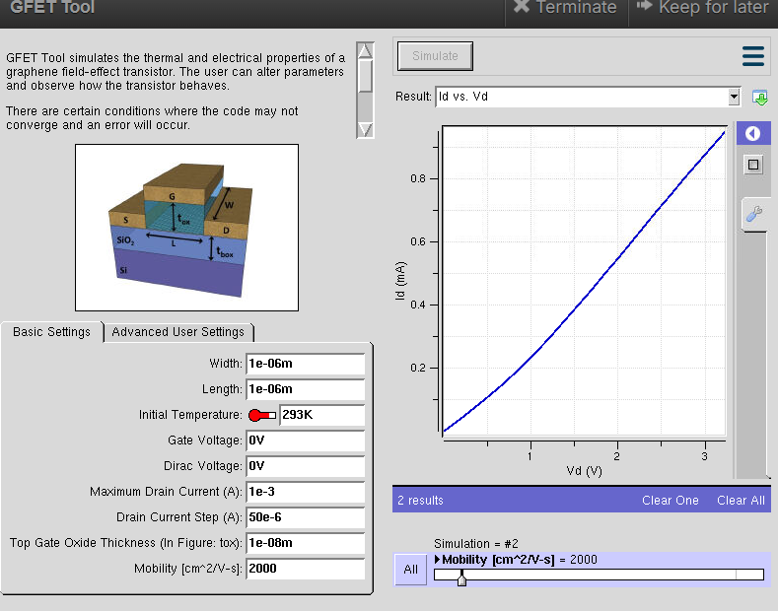
Exp. 9. Simulation of Tunneling Magnetoresistance (TMR) by Varying Barrier Height
using NanoHUB

Case Study 1: Characteristics of TMR with barrier height of 0.85eV

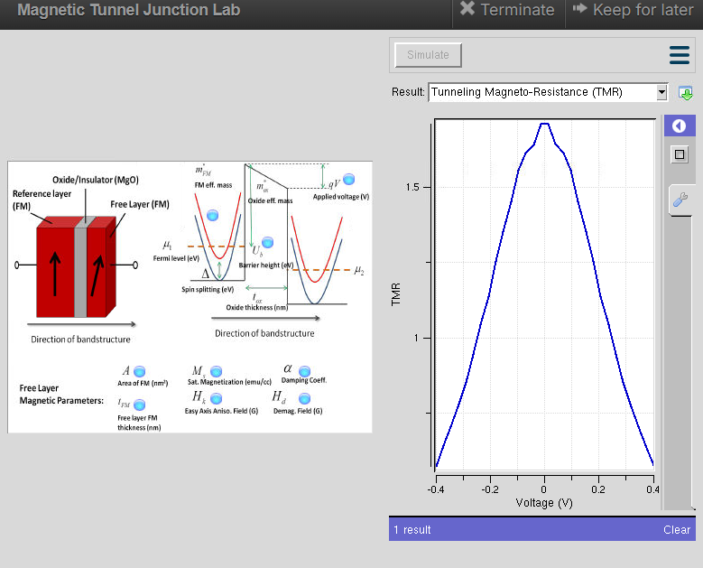

Case Study 2: Characteristics of TMR with barrier height of 1.0Ev
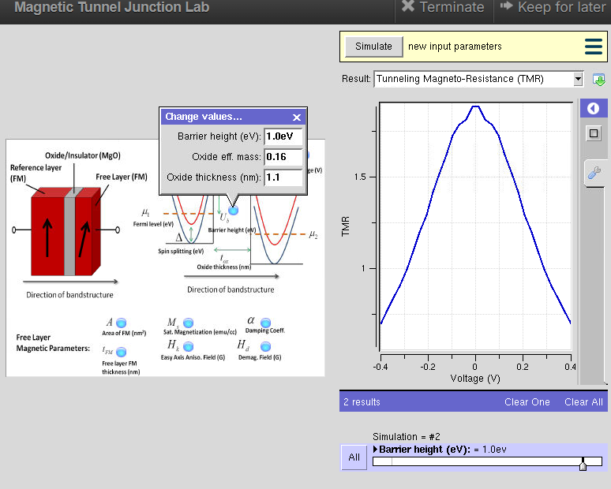

Exp. 10. Biosensor and Bio-FET characteristics using NanoHub
