Exp. 8. Simulation of VI Characteristics of FINFET, CNTFET and GFET using NanoHub
- FINFET
Aim: To Obtain the VI Characteristics of FinFET by varying the Gate Channel length and oxide thickness
Case Study 1: Simulate & obtain the current spectrum characteristics for the last bias point of FinFET. Analyze the performance for different Oxide layer thicknesses

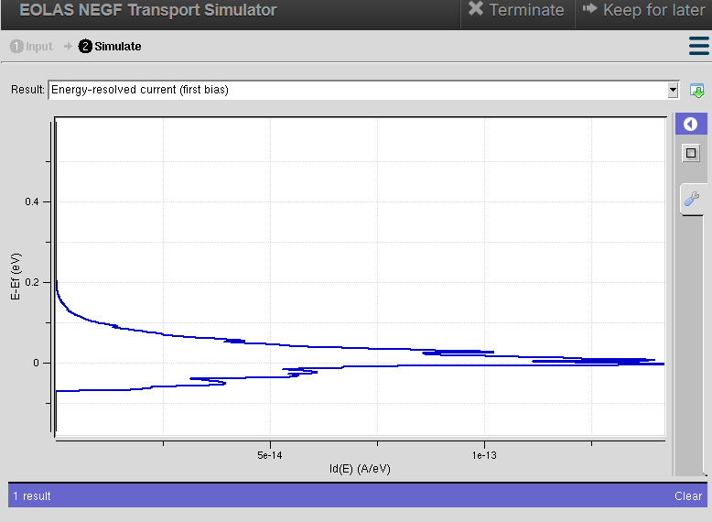

Observation
- The current spectrum (Id(E)) is highest near the Fermi energy (E − Ef = 0 eV) and gradually decreases as the carrier energy moves away from the Fermi level, indicating that most electrons contribute to conduction around this energy.
- Reducing the oxide layer thickness increases the current spectrum, as the gate has stronger electrostatic control over the channel, resulting in improved carrier transport and higher drain current. Increasing the oxide thickness reduces the current spectrum due to weaker gate control.
- The simulation shows that a thinner oxide layer enhances FinFET performance by increasing current conduction and reducing channel resistance, whereas a thicker oxide layer lowers the current spectrum and overall device efficiency.

Case Study 2: Simulate & obtain the electron density per sheet characteristics of FinFET. Analyze its performance with different Gate region length

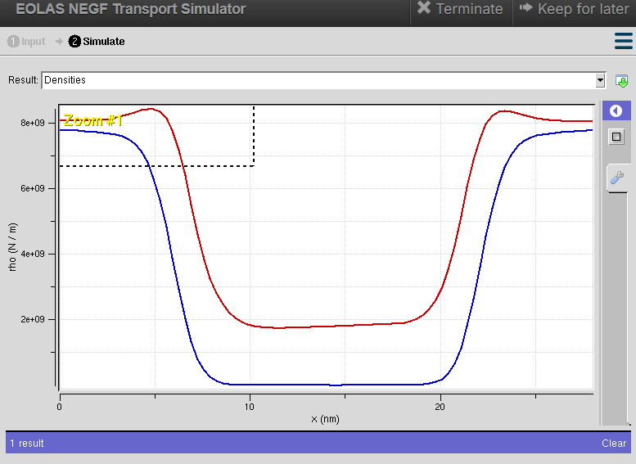
Observation:
- The graph indicates the variation of electron density along the FinFET channel. The x-axis represents the position from the source to the drain, while the y-axis represents the electron density (ρ).
- The high electron density at the source and drain regions and the reduced density in the channel indicate that the gate controls the movement of electrons. The drop in the channel region represents the potential barrier formed by the gate.
- The red curve has a higher electron density than the blue curve in the channel region, indicating better carrier transport, stronger channel inversion, and higher drain current. This shows improved FinFET performance under that simulation condition (such as a shorter gate length or thinner oxide layer).

(b) CNTFET
Case study 1: Simulate & Obtain the VI characteristics of CNT-FET by varying Schottky barrier and oxide thickness
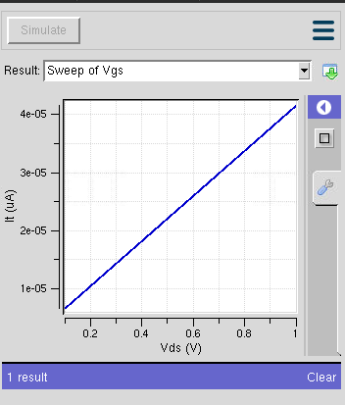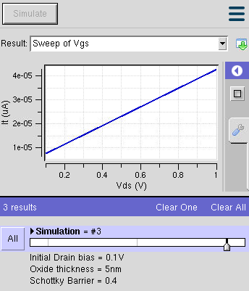

Observation
- The drain current (Id) increases almost linearly with the drain voltage (Vds), indicating normal transistor operation in the applied bias range.
- Reducing the Schottky barrier height improves carrier injection from the source to the channel, resulting in higher drain current, while increasing the barrier height decreases the current.
- Thinner oxide layers provide stronger gate control over the channel, producing higher drain current. Increasing the oxide thickness weakens the gate control and reduces the current conduction.

Case study 2: Simulate & Obtain the VI characteristics of CNT-FET by varying CNT diameter
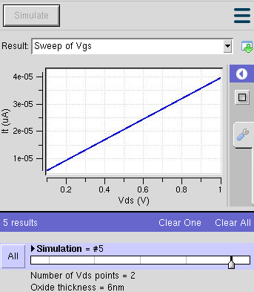

Observation
- The drain current increases with increasing drain voltage, showing the expected V-I behaviour of the CNTFET.
- Increasing the CNT diameter reduces the band gap of the carbon nanotube, allowing more charge carriers to flow through the channel and resulting in a higher drain current.
- Smaller CNT diameters exhibit lower drain current due to the larger band gap and higher channel resistance, whereas larger CNT diameters improve conductivity and overall device performance.

(c) GFET
Case Study 1:How does varying the gate voltage (Vgs) affect the drain current (Ids) in a GFET?
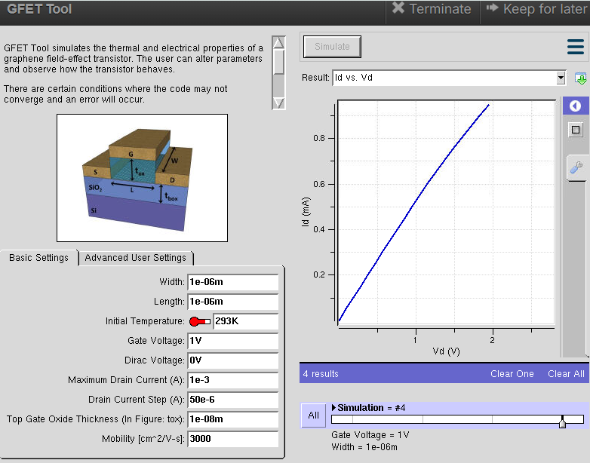

Observation
- The drain current (Ids) increases with increasing drain voltage (Vd) for all gate voltage values.
- Increasing the gate voltage (Vgs) increases the carrier concentration in the graphene channel, resulting in a higher drain current.
- A lower gate voltage produces a smaller drain current due to weaker channel conduction, while a higher gate voltage improves the conductivity and ON-state performance of the GFET.

Case Study 2: What factors determine the maximum drain current (Ids,max​ ) in a Graphene Field Effect Transistor (GFET)?

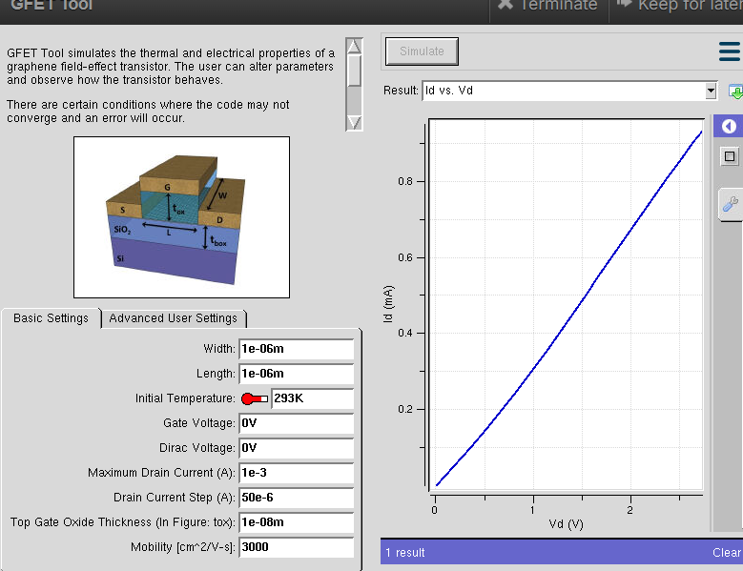

Observation
- The maximum drain current (Ids,max) increases as the drain voltage (Vd) increases, showing enhanced carrier transport through the graphene channel.
- Higher gate voltage, larger carrier mobility, wider channel width, and lower contact resistance contribute to achieving a higher maximum drain current.
- The graph shows a continuous increase in Id with Vd, indicating efficient current conduction and high-performance operation of the GFET.

Case Study 3: To investigate how the mobility of charge carriers in a Graphene FieldEffect Transistor (GFET) with a mobility of 2000 cm²/V·s influences its current-voltage (VI) characteristics.
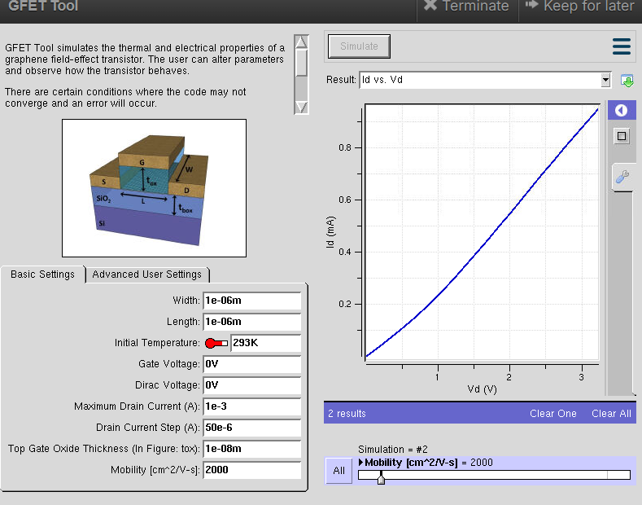

Observation
- At a mobility of 2000 cm²/V·s, the drain current increases almost linearly with the applied drain voltage, indicating stable charge transport.
- The relatively high carrier mobility enables faster electron movement, resulting in low channel resistance and improved current flow.
- Compared with lower mobility devices, a GFET with 2000 cm²/V·s mobility exhibits better conductivity, higher drain current, and improved overall electrical performance.

Conclusion
The NanoHub simulations of FinFET, CNTFET, and GFET demonstrate the influence of key device parameters on transistor performance. In FinFET, reducing the oxide thickness and gate length improves gate control, increases electron density, and enhances drain current. In CNTFET, a lower Schottky barrier height, thinner oxide layer, and larger CNT diameter improve carrier injection and increase the drain current, resulting in better switching performance. In GFET, increasing the gate voltage, carrier mobility, and maximum drain current enhances channel conductivity and overall device efficiency.

Exp. 9. Simulation of Tunneling Magnetoresistance (TMR) by Varying Barrier Height
using NanoHUB

Case Study 1: Characteristics of TMR with barrier height of 0.85eV

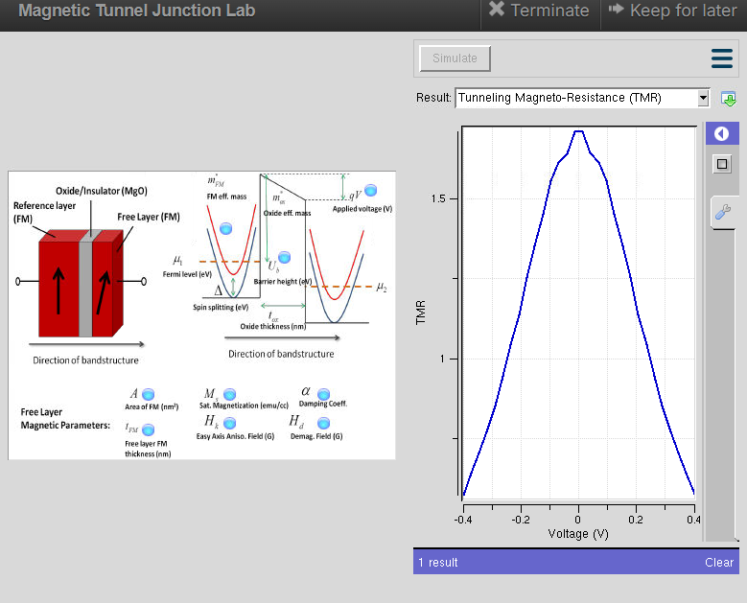
Observation
- The TMR value increases as the applied voltage approaches 0 V, reaches its maximum near zero bias, and then decreases as the voltage increases in either the positive or negative direction.
- With a barrier height of 0.85 eV, electrons tunnel more easily through the insulating barrier, resulting in higher tunneling current and moderate TMR characteristics.
- The graph exhibits a symmetric TMR–Voltage curve, indicating stable spin-dependent tunneling and proper operation of the magnetic tunnel junction.

Case Study 2: Characteristics of TMR with barrier height of 1.0Ev
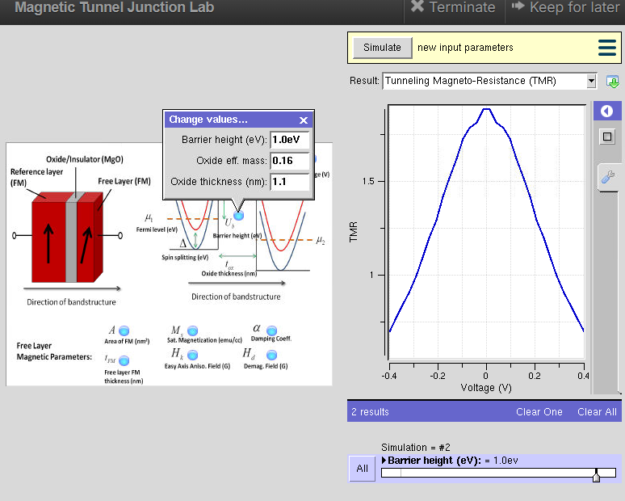
Observation
- The TMR reaches its maximum value near zero applied voltage and gradually decreases as the voltage moves away from zero, similar to the expected behavior of a magnetic tunnel junction.
- Increasing the barrier height to 1.0 eV reduces the tunneling probability of electrons, resulting in lower tunneling current but improved spin filtering, which enhances the TMR effect.
- The graph maintains a symmetrical peak around zero bias, indicating efficient spin polarization and stable magnetic switching characteristics.

Conclusion
The NanoHUB simulation demonstrates that the barrier height significantly influences the TunnelinG Magnetoresistance (TMR) characteristics of a Magnetic Tunnel Junction (MTJ). For both 0.85 eV and 1.0 eV barrier heights, the TMR reaches its maximum near zero bias voltage and decreases as the applied voltage increases in either direction.
A lower barrier height (0.85 eV) allows easier electron tunneling and higher tunneling current, whereas a higher barrier height (1.0 eV) improves spin filtering and enhances.
Exp. 1. Simulation of scattering and absorption of Multi-layer Sphere andCore-Shell Nanoparticle using Mie-Plot tool
Aim: To simulate and analyze the scattering, absorption, and extinction characteristics of multi-layerspheres and core–shell nanoparticles using the Mie-Plot tool.
Scattering and absorption spectra for a core–shell nanoparticle.
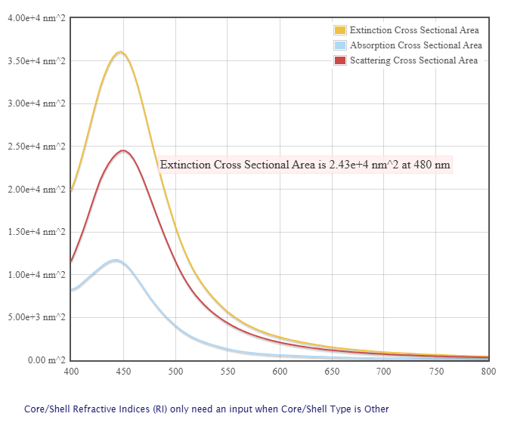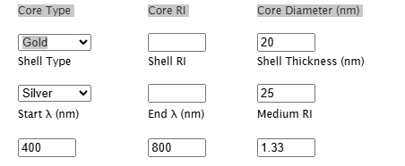
Case Study 1: Scattering and absorption spectra for a single-layer sphere (core only).
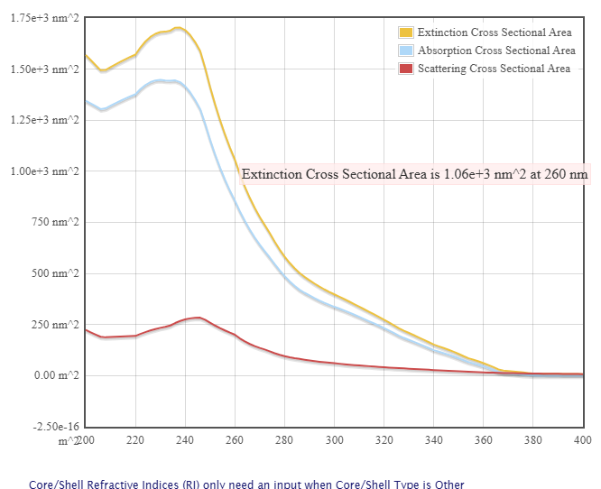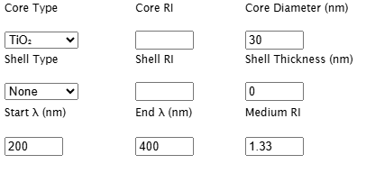
Observations:
- The extinction cross-sectional area shows a strong peak in the UV region, reaching approximately 1.7 × 10³ nm² around 235–245 nm.
- At 260 nm, the extinction cross-sectional area is approximately 1.06 × 10³ nm², as indicated in the graph.
- The absorption cross-sectional area is relatively high and follows a similar trend to the extinction spectrum, with a maximum of about 1.4–1.5 × 10³ nm² near 235–245 nm.
- The scattering cross-sectional area is much smaller than the absorption cross-sectional area, reaching approximately 250–270 nm² near 240 nm.
- As the wavelength increases beyond 250 nm, all three cross-sectional areas decrease gradually.
- Above approximately 360 nm, the extinction, absorption, and scattering cross sections become very small and approach zero.
Case Study 2: Simulate the optical response of a gold (Au) nanoparticle of 50 nmdiameterin water medium.
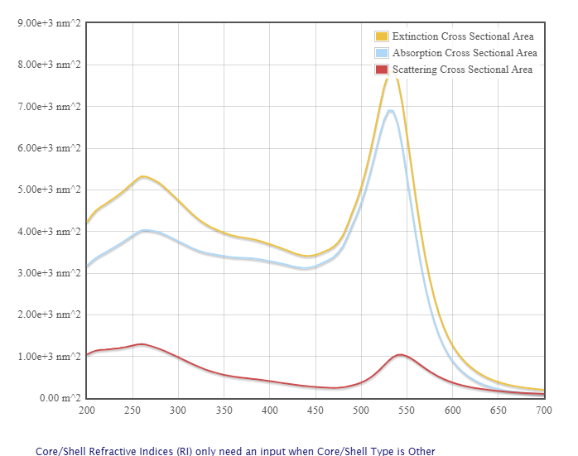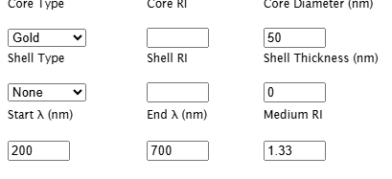
Observations:
- The extinction cross-sectional area shows a broad peak near 260–280 nm, reaching approximately 5.2 × 10³ nm².
- A strong surface plasmon resonance (SPR) peak is observed around 530–550 nm, where the extinction cross section reaches approximately 8.5–9.0 × 10³ nm².
- The absorption cross-sectional area follows the extinction spectrum and reaches approximately 6.8–7.0 × 10³ nm² near 530–550 nm.
- The scattering cross-sectional area is smaller than absorption but increases significantly around the SPR region, reaching approximately 1.0 × 10³ nm².
- The strong peak around 530–550 nm indicates the localized surface plasmon resonance (LSPR) of the 50 nm gold nanoparticle in water.
- Beyond approximately 600 nm, the extinction, absorption, and scattering cross sections decrease rapidly and approach very small values near 700 nm.
Case Study 3: Simulate a core–shell nanoparticle with a gold core (30 nm) and silicashell (10 nm).
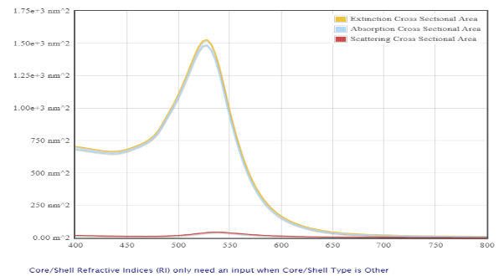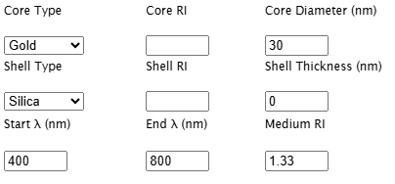
Observations:
- The extinction cross-sectional area shows a strong peak around 520–530 nm, reaching approximately 1.5 × 10³ nm².
- The absorption cross-sectional area follows a similar trend and reaches approximately 1.45 × 10³ nm² near the resonance wavelength.
- The scattering cross-sectional area is much smaller than the absorption cross section, with a maximum of approximately 50–70 nm².
- The strong peak around 520–530 nm represents the localized surface plasmon resonance (LSPR) of the gold core–silica shell nanoparticle.
- The silica shell modifies the optical environment around the gold core and influences the position and strength of the plasmon resonance.
- As the wavelength increases beyond 550 nm, the extinction and absorption cross sections decrease rapidly.

Conclusion
The simulation successfully analyzed the scattering, absorption, and extinction spectra of different nanoparticles using NanoHub. The TiO₂ core-only nanoparticle showed strong optical absorption mainly in the UV region. The 50 nm gold nanoparticle exhibited a strong localized surface plasmon resonance (LSPR) in the visible region around 530–550 nm, with significant extinction and absorption. The Au–SiO₂ core–shell nanoparticle also showed a strong plasmonic response around 520–530 nm, demonstrating that the silica shell influences the optical properties of the gold core.

