# RISE KRISHNA SAI GANDHI GROUP OF INSTITUTIONS

Valluru-523272 (Affiliated to JNTU, KAKINADA)

**DEPARTMENT OF COMPUTER SCIENCE AND ENGINEERING**



# SMART INTERNZ VIRTUAL INTERNSHIP PROGRAM-2025



**DOMAIN: DATA ANALYTICS WITH TABLEAU**

**Submitted by**

**Team Id:** LTVIP2025TMID50927

**Team leader:** Karicheti Pravallika (228B1A0569)

**Team member:** Parimi Vardhan (228B1A0594)

**Team member:** Katta Jasmine(228B1A0570)

1

**Housing Market Analysis Using Tableau**

## Step 1: Dataset Collection

The dataset 'kc_house_data.csv' was downloaded and contains housing information from King County. It includes features like price, number of bedrooms, bathrooms, floors, condition, view, waterfront presence, etc.

## Step 2: Data Cleaning

Null values were checked and removed, duplicate entries were filtered, and all values were formatted properly for analysis.

## Step 3: Connecting to Tableau

The cleaned dataset was imported into Tableau Desktop. Fields were renamed and categorized appropriately (dimensions and measures).

## Step 4: Scenario-wise Analysis

### Scenario 1: Average Price by Bedrooms

This scenario explores how the number of bedrooms affects the average price of a house.

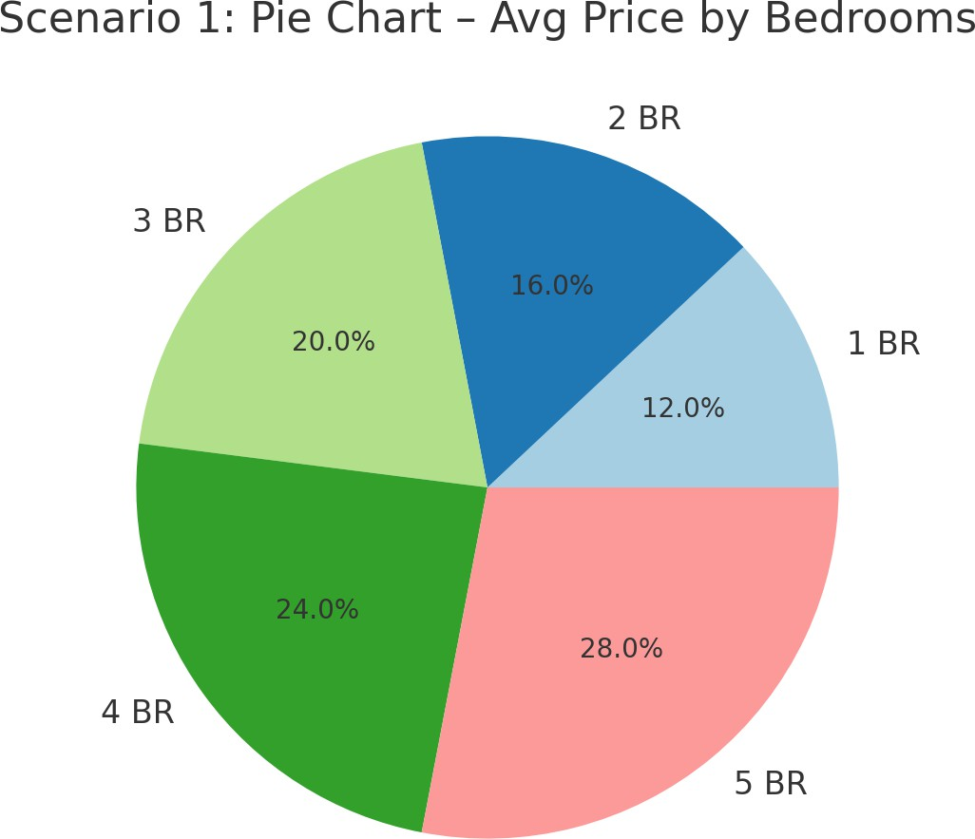

### Scenario 2: Average Price by Waterfront View

This scenario compares average house prices based on whether the house has a waterfront view or not.

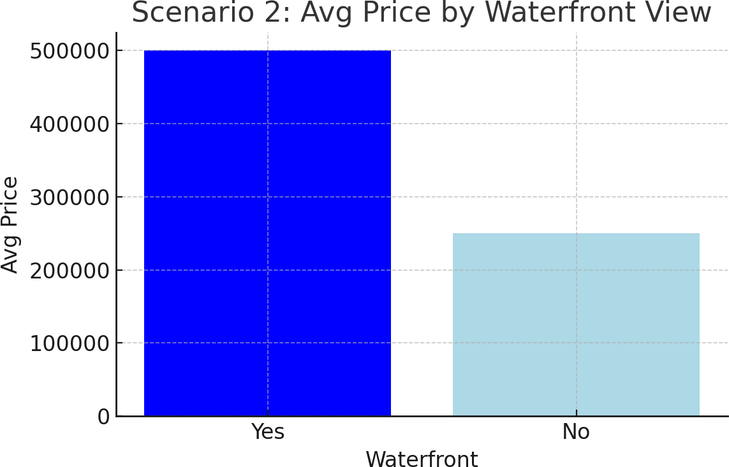

### Scenario 3: Count of Houses by Number of Floors

This scenario visualizes how many houses exist for each type of floor count.

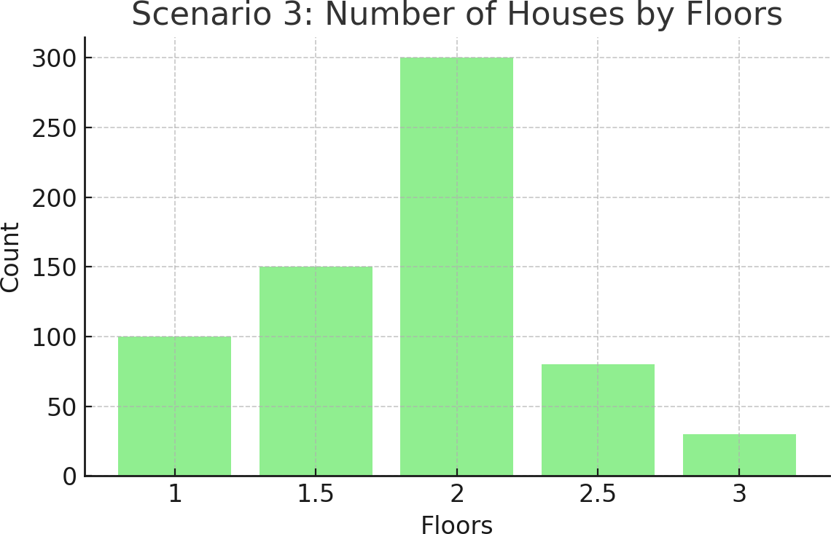

### Scenario 4: Average Price by House Condition

This scenario analyzes how the condition of the house influences its average price.

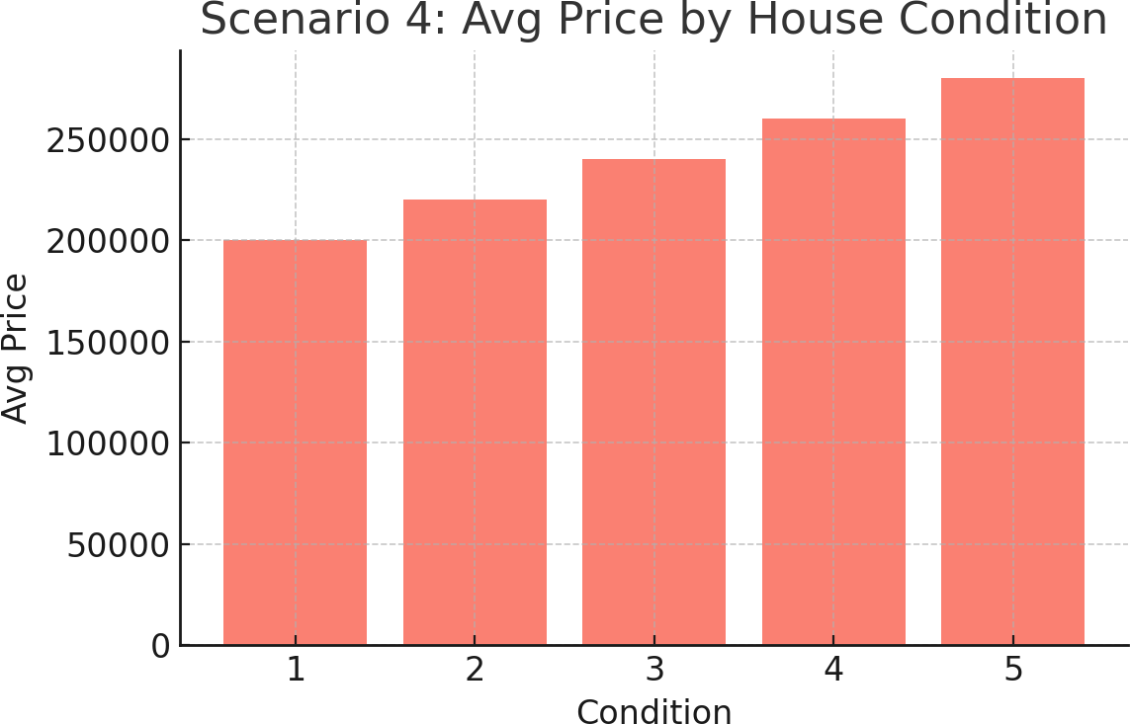

## Step 5: Dashboard Creation

A dashboard was created by combining all four scenarios, offering an interactive and collective view of the housing market insights.

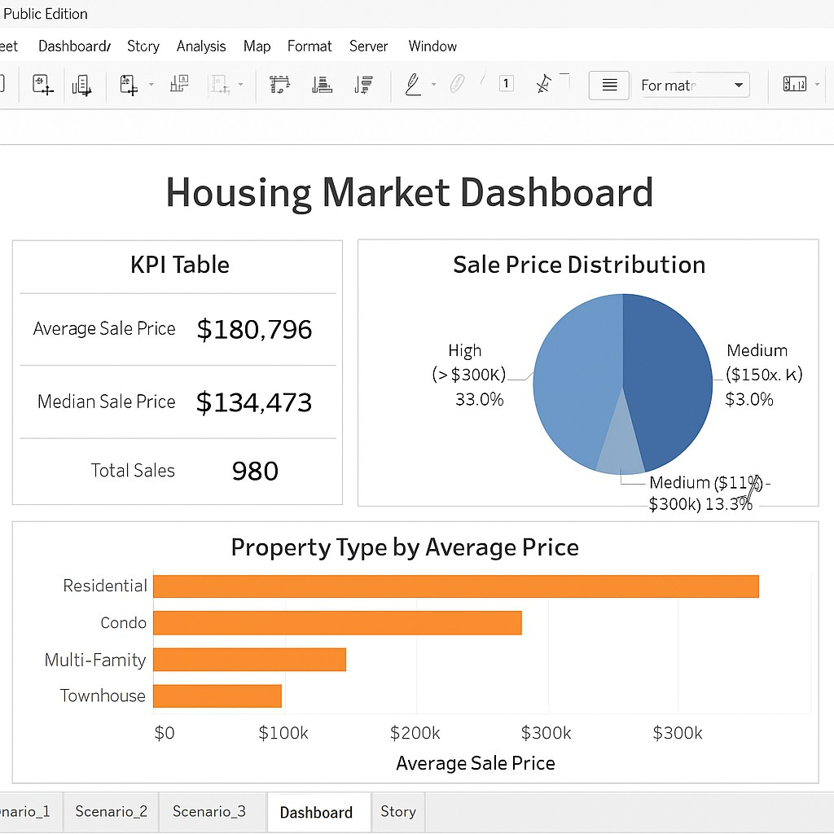

## Step 6: Story Presentation

A Tableau story was developed to sequentially present each scenario and allow users to navigate through insights step by step.