A Knowledge-Based AI Framework for Data-Driven Cost-Aware Classification: Decision Support for Digital Transformation in Entrepreneurial Credit Innovation
Short Communication
Pravallika Nalluri
Independent Researcher, USA
Corresponding author. Email: pravallikanalluri9848@gmail.com
Abstract
Credit decisions need an explicit cost for a missed default, not only a probability. This study states a normalized decision cost and compares two knowledge-based rules that turn probabilities into a yes-or-no action. Both rules are locked on a validation split before the test evaluation. On the UCI credit-card default file (30,000 accounts; 6,636 defaults, 22.12%), four probability models were fit without class weights. On the primary split (seed 42), prediction-first selection kept histogram gradient boosting, the model with the highest validation F1 at threshold 0.50 (0.4682), and then chose a cost-minimizing threshold. Decision-first selection searched every model and threshold for the lowest validation cost. Decision-first selection had the lower test cost at a false-negative cost ratio of 2 (relative difference 0.0406; paired bootstrap 95% interval for the cost difference, 0.0050 to 0.0210). At ratios 5, 10, and 20 that interval included zero, so the strategy difference is not statistically conclusive. Leaving threshold 0.50 reduced test cost at ratios 5, 10, and 20, and those intervals excluded zero; at ratio 2 the threshold contrast was not statistically conclusive. On 20 stratified splits (seeds 42 through 61), tuned test cost was lower than the cost at 0.50 on 19 of 20 splits at ratio 2 and on all 20 splits at ratios 5, 10, and 20. Ranges across splits are not confidence intervals. The public file is not a startup portfolio.
Keywords: Cost-sensitive classification; Decision support; Decision threshold; Knowledge-based system; Credit scoring; Digital transformation
Highlights
• Explicit cost ratios turn default probabilities into thresholds.
• Prediction-first fixes the F1 model, then tunes its threshold.
• Decision-first has a conclusively lower test cost only at ratio 2.
• Strategy gaps at ratios 5, 10, and 20 are not statistically conclusive.
• On all 20 splits, tuning beat threshold 0.50 at ratios 5, 10, and 20.
1. Introduction
Knowledge-based systems support a human decision, not only a ranked score. In credit, a probability of default is not itself an action. When a missed default and a false alarm have different costs, the operating threshold is part of the decision [3,4]. Model comparison is already a large literature [2]. This short communication does not add another accuracy contest. It states a cost ratio as the knowledge a lender writes down, and it turns that ratio into a threshold another person can inspect [1].
The ratio is fixed before any test account is scored. The knowledge is an explicit false-negative cost ratio. It is not a post hoc explanation of a fitted model. Prediction-first selection fixes the model by validation F1 at threshold 0.50, then tunes only the threshold. Decision-first selection chooses the model and the threshold together by validation cost. On each split, the test set is scored once, after both rules are locked. The contribution is Eq. (1), the two selection rules in Eqs. (2) and (3), and the same lock repeated on 20 stratified splits. Section 4 separates the gap between the rules from the move away from threshold 0.50. The study does not claim that decision-first selection is uniformly superior.
The comparison uses the public Default of Credit Card Clients file [5]. It records credit-card accounts, not entrepreneurial startups. The operational question is whether a lender, including a smaller lending venture, can state a cost ratio and publish the threshold that ratio implies.
2. Decision framework
The positive class is default payment next month. A model emits a probability, and the decision predicts default when that probability is at least a threshold t. A false positive is a predicted default that does not occur. A false negative is a missed default. With N cases in the split being scored, the normalized cost per case at false-negative ratio r is
c(r) = (1 · FP + r · FN) / N (1)
The ratio r is a scenario weight, not an estimated monetary loss. The values used here are r ∈ {2, 5, 10, 20}. The threshold grid is T = {0.01, 0.02, …, 0.99}. The models supply probabilities. They do not contain r. The lender states r, and the grid turns it into an action.
Let m index the candidate models, and let F1val be the positive-class F1 on the validation split. Prediction-first selection fixes one model, then one threshold for each r:
m* = arg maxm F1val(m, 0.50),
tA*(r) = arg mint∈T cval(m*, t, r). (2)
If several models share the highest validation F1 at 0.50, the tie is broken by the lower validation cost at that same threshold for the r under consideration, then by model name in alphabetical order. The threshold tie is broken by higher validation F1, then by the lower threshold.
Decision-first selection searches the pairs directly:
(mB*(r), tB*(r)) = arg minm,t∈T cval(m, t, r). (3)
Ties are broken by higher validation F1 at that threshold, then by model name, then by the lower threshold. Class imbalance is not handled with class weights. The grid search is the mechanism that carries both the base rate and the cost ratio. Neither rule may use the test split.
3. Experimental design
The source file is the UCI Default of Credit Card Clients workbook [5,6]. It has 30,000 accounts and 6,636 defaults (22.12%). The identifier column is dropped. The public file contains SEX. SEX is removed before the split because a credit decision policy should not use sex, and this study does not estimate a sex effect. The other 22 predictors are kept as the numeric codes in the file, including education, marriage, age, recent repayment status, bill amounts, and payment amounts.
The split and the bootstrap each use seed 42. The split is stratified. It holds out 6,000 test accounts and then holds out 6,000 validation accounts, leaving 18,000 training accounts. Models are fit only on the training accounts. Selection uses only the validation accounts. Test probabilities are computed after every model and threshold has been chosen.
Four models produce probabilities, with random seed 42 wherever the implementation accepts one, and with no class weight. A logistic regression uses C = 1, after a standardizer, with the library's default L2 penalty. The other models are a random forest (200 trees, depth 10, minimum leaf size 5), histogram gradient boosting (200 iterations, depth 6, learning rate 0.1), and XGBoost (200 trees, depth 5, learning rate 0.1). Thresholds run from 0.01 to 0.99 in steps of 0.01. The decision predicts default when the probability is at least the threshold.
Uncertainty is a paired bootstrap of the test accounts: 1,000 resamples, percentile interval from 2.5 to 97.5, seed 42. The same resamples are used for every contrast. The procedure does not refit models and does not rerun selection, so the interval is conditional on the locked rules. It asks whether the test-cost gap is stable to resampling of this test set. The reported contrasts are the strategy difference, test cost of A minus test cost of B, and, for the prediction-first model only, test cost at threshold 0.50 minus test cost at the tuned threshold. A positive strategy difference means decision-first selection has the lower test cost. The relative difference is that gap divided by the prediction-first test cost. If an interval includes zero, the difference is not statistically conclusive. Seeds 42 through 61 repeat the same stratified sizes, 20 splits in total, with the model random seed held at 42. The bootstrap is not recomputed. The minimum, median, and maximum across those splits are a stability range. They are not a confidence interval.
4. Results
Table 1 is the validation lock. Validation F1 at threshold 0.50 selected histogram gradient boosting. Its F1 was higher than that of the random forest, XGBoost, and logistic regression, and the four values were distinct, so the cost tie-break was not used. On this split the prediction-first model is therefore fixed for every cost ratio. As r increases, the chosen threshold falls. For histogram gradient boosting the validation thresholds are 0.31, 0.16, 0.09, and 0.01. The last of these is the bottom of the grid, so the search could not move lower. That edge is also selected on 6 of the 20 splits. Decision-first selection chooses the random forest at r = 2, r = 10, and r = 20, and XGBoost at r = 5.
Table 1. Validation choice for each false-negative cost ratio. Cost is Eq. (1) on the validation split. F1 is the positive-class F1 at the chosen threshold.
r | Strategy | Model | Threshold | Val. cost | Val. F1
2 | A | histogram GB | 0.31 | 0.3075 | 0.5343
2 | B | random forest | 0.30 | 0.2975 | 0.5502
5 | A | histogram GB | 0.16 | 0.5485 | 0.5050
5 | B | XGBoost | 0.16 | 0.5318 | 0.5126
10 | A | histogram GB | 0.09 | 0.7065 | 0.4414
10 | B | random forest | 0.10 | 0.6982 | 0.4259
20 | A | histogram GB | 0.01 | 0.7728 | 0.3656
20 | B | random forest | 0.06 | 0.7645 | 0.3738
Strategy A uses one model for every r, selected by validation F1 at threshold 0.50: logistic regression 0.3694; random forest 0.4658; histogram GB 0.4682; XGBoost 0.4598. The F1 values were distinct, so the cost tie-break was not used. Strategy B minimizes validation cost over models and thresholds. Histogram GB denotes histogram gradient boosting.
On the locked test split, the strategy gap is small relative to the cost of staying at threshold 0.50 (Table 2 and Figure 2). At r = 2, decision-first selection reaches test cost 0.3035 and prediction-first selection reaches 0.3163. The relative difference is 0.0406. The 95% interval for the cost difference is 0.0050 to 0.0210 and excludes zero, so this difference is statistically conclusive on the present test set. At r = 5, the prediction-first cost is slightly lower (0.5762 versus 0.5788; relative difference −0.0046). The interval includes zero, and the difference is not statistically conclusive. At r = 10 and r = 20 the point estimates favor decision-first selection (relative differences 0.0401 and 0.0077), but both intervals include zero. Those differences are not statistically conclusive. Decision-first selection is therefore not uniformly cheaper on this file.
Table 2. Test cost per case after selection was locked. A positive value of (A−B)/A means strategy B has the lower test cost. The 95% interval is a paired percentile bootstrap of the test-cost difference A−B. It does not refit the models.
r | Strategy | Model | Threshold | Test cost
2 | A | histogram GB | 0.31 | 0.3163
2 | B | random forest | 0.30 | 0.3035
(A−B)/A = 0.0406. Cost difference A−B = 0.0128, 95% CI [0.0050, 0.0210], includes zero: no.
5 | A | histogram GB | 0.16 | 0.5762
5 | B | XGBoost | 0.16 | 0.5788
(A−B)/A = −0.0046. Cost difference A−B = −0.0027, 95% CI [−0.0202, 0.0147], includes zero: yes.
10 | A | histogram GB | 0.09 | 0.7392
10 | B | random forest | 0.10 | 0.7095
(A−B)/A = 0.0401. Cost difference A−B = 0.0297, 95% CI [−0.0023, 0.0655], includes zero: yes.
20 | A | histogram GB | 0.01 | 0.7815
20 | B | random forest | 0.06 | 0.7755
(A−B)/A = 0.0077. Cost difference A−B = 0.0060, 95% CI [−0.0168, 0.0272], includes zero: yes.
For the prediction-first model (histogram GB), test cost at threshold 0.50 versus the cost-tuned threshold: r = 2, 0.3272 versus 0.3163; r = 5, 0.7522 versus 0.5762; r = 10, 1.4605 versus 0.7392; r = 20, 2.8772 versus 0.7815. Paired bootstrap 95% CIs for (cost at 0.50 minus cost at the tuned threshold) are r = 2, [−0.0008, 0.0227], includes zero: yes; r = 5, [0.1370, 0.2147], includes zero: no; r = 10, [0.6297, 0.8035], includes zero: no; r = 20, [1.9144, 2.2858], includes zero: no. Across seeds 42 through 61 (20 splits), prediction-first test cost min, median, and max were r = 2, 0.2917, 0.3052, 0.3175; r = 5, 0.5253, 0.5617, 0.5762; r = 10, 0.6668, 0.7163, 0.7472; r = 20, 0.7673, 0.7792, 0.8660. Cost at threshold 0.50 min, median, and max were r = 2, 0.3122, 0.3196, 0.3300; r = 5, 0.7212, 0.7372, 0.7655; r = 10, 1.4002, 1.4343, 1.4913; r = 20, 2.7552, 2.8276, 2.9430. Decision-first test cost min, median, and max were r = 2, 0.2930, 0.3035, 0.3143; r = 5, 0.5435, 0.5581, 0.5880; r = 10, 0.6625, 0.7038, 0.7457; r = 20, 0.7523, 0.7654, 0.7965. Tuned cost was lower on 19 of 20 splits at r = 2 and on 20 of 20 splits at r = 5, r = 10, and r = 20. Decision-first test cost was strictly lower on 13, 7, 13, and 17 of 20 splits. These ranges are not a confidence interval.
The larger change is the threshold, not the selector. Figure 2 shows the prediction-first threshold moving from 0.50 down to 0.31, 0.16, 0.09, and 0.01. At r = 2, test cost moves from 0.3272 at threshold 0.50 to 0.3163 at the tuned threshold, and that interval includes zero, so the difference is not statistically conclusive. At r = 5, r = 10, and r = 20, the same contrast falls from 0.7522 to 0.5762, from 1.4605 to 0.7392, and from 2.8772 to 0.7815. Those three intervals exclude zero. Once a missed default is several times as costly as a false alarm, publishing a cost-tuned threshold changes the test cost by more than the choice between the two selectors.
Figure 1 is the validation cost curve that produces the prediction-first thresholds on the seed-42 split. The circle is the minimizing threshold, labeled with its value, and the dotted line is 0.50. The curve falls as the threshold leaves 0.50, then rises. The same selection was repeated on seeds 42 through 61. The prediction-first model was histogram gradient boosting on 12 splits, XGBoost on 6, and the random forest on 2. No split used the cost tie-break. Prediction-first thresholds ranged from 0.30 to 0.38 at r = 2, 0.13 to 0.22 at r = 5, 0.05 to 0.10 at r = 10, and 0.01 to 0.08 at r = 20. Decision-first selection chose the random forest on 18, 12, 17, and 18 of the 20 splits. Table 2 gives the min, median, and max of the test costs. The whiskers in Figure 2 are those minima and maxima. They are not a confidence interval. The bootstrap intervals apply only to seed 42.
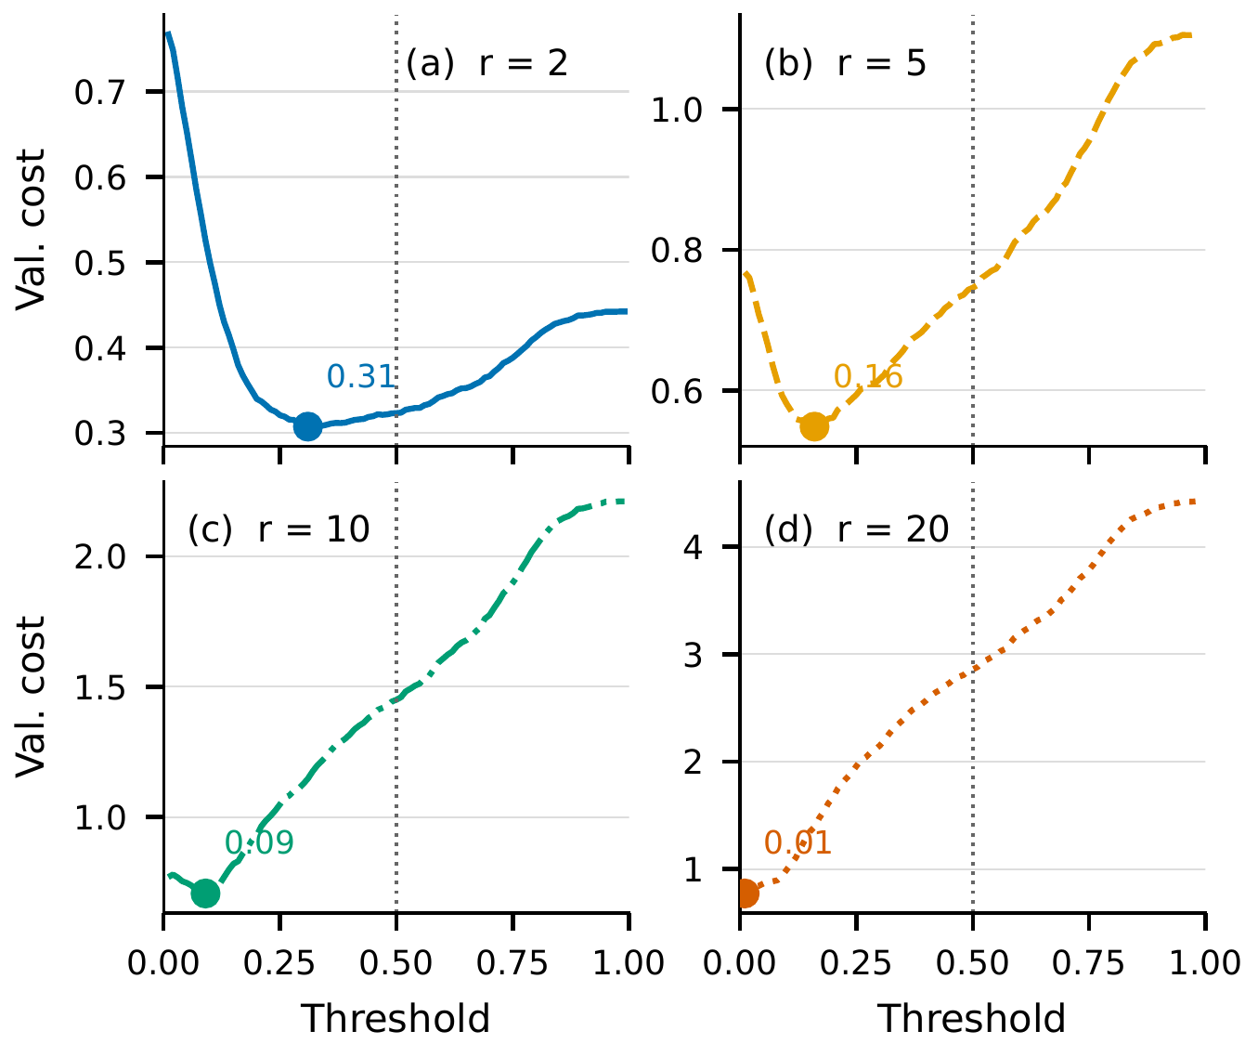
Figure 1. Validation cost per case for the prediction-first model on the seed-42 validation split. Panels (a)–(d) are the cost ratios 2, 5, 10, and 20. The curve is Eq. (1). The circle marks the minimizing threshold and is labeled with its value. The dotted line is threshold 0.50.
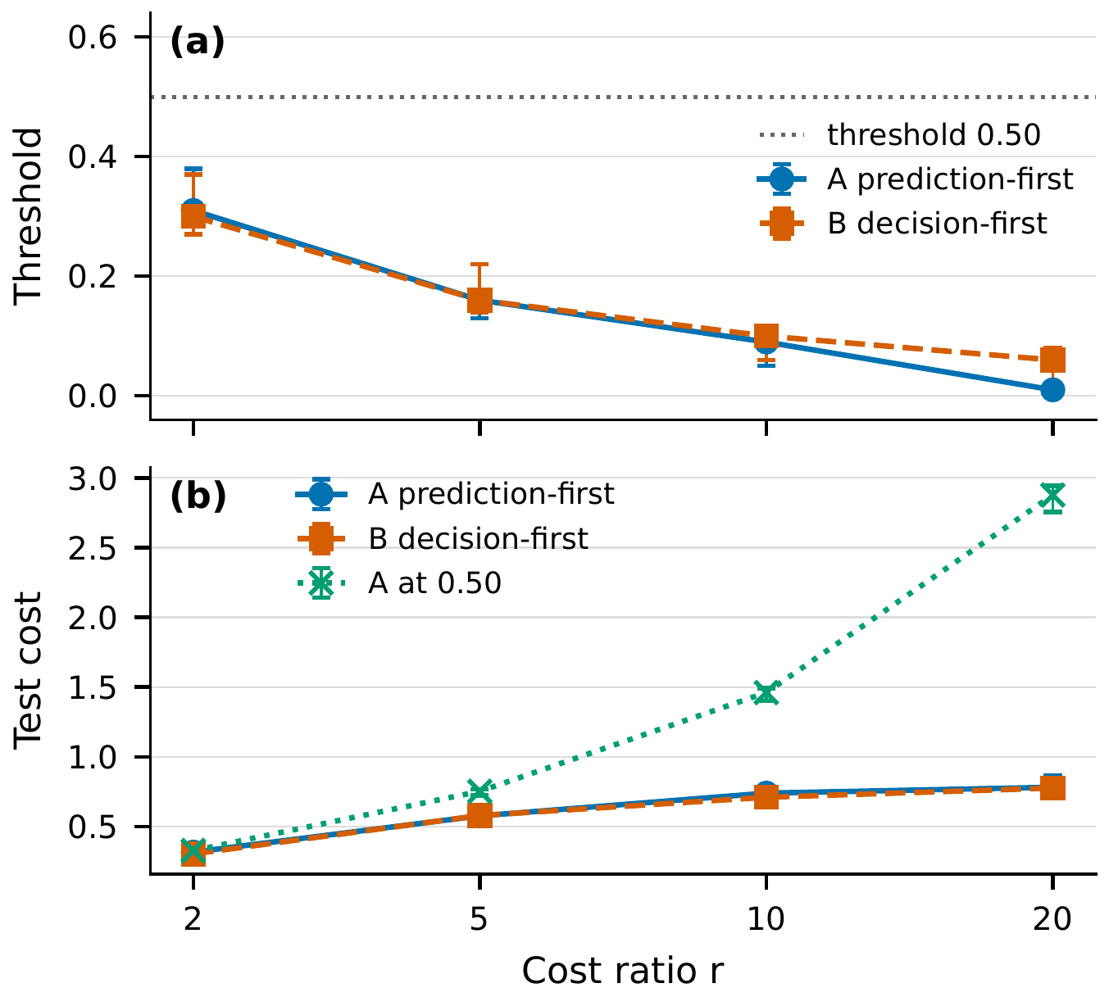
Figure 2. Chosen threshold (a) and test cost per case (b) across false-negative cost ratios. Markers are the seed-42 rules. Circles are prediction-first selection. Squares are decision-first selection. Crosses score the prediction-first model at threshold 0.50. Whiskers run from the minimum to the maximum over 20 stratified splits (seeds 42 through 61). They are not a confidence interval. The dotted line in (a) is threshold 0.50. Model names for seed 42 are in Table 2.
5. Implications for entrepreneurial credit decisions
The practical object is a decision a person can audit. A credit operation writes down r, the relative cost of missing a default, and publishes the threshold returned by Eq. (2) or Eq. (3). A smaller lending venture can do the same on its own book. The auditable object is the pair (r, t). On this file, setting r = 10 moves the prediction-first rule from 0.50 to 0.09. That is a change in the decision process of the sort digital-transformation research describes as organizational, not merely technical [1]. The UCI file contains Taiwanese credit-card clients [5]. It is not a startup portfolio. Product, portfolio, and loss given default will differ in another book, and r here is a scenario weight rather than a measured loss.
6. Conclusion
The useful output is a threshold tied to a stated cost ratio. On the seed-42 split, decision-first selection was conclusively cheaper only at r = 2. At r = 5, r = 10, and r = 20, the strategy difference was not statistically conclusive, and at r = 5 the point estimate favored prediction-first selection. Tuning the prediction-first threshold away from 0.50 changed test cost only modestly at r = 2, where the interval included zero, and by a conclusive margin at the three higher ratios. Across seeds 42 through 61, decision-first selection was not uniformly cheaper, and at ratios 5, 10, and 20 the tuned test cost was lower than the cost at 0.50 on all 20 splits. The bootstrap does not refit the models, and the range across splits is not a confidence interval. The r = 20 prediction-first threshold sits on the lower edge of the grid. SEX was present in the source file, was excluded from the predictors, and was not used to estimate a sex effect. Within those limits, a lender that can state r can publish the threshold that r implies.
Data Availability
The Default of Credit Card Clients file is the UCI Machine Learning Repository dataset introduced by Yeh and Lien [5,6] (https://doi.org/10.24432/C55S3H). The script that regenerates the tables and figures is run.py in https://github.com/pravallika-nalluri-dba/kbs-cost-aware-classification.
Declaration of Competing Interest
The author declares that she has no known competing financial interests or personal relationships that could have appeared to influence the work reported in this paper.
Funding
This research did not receive any specific grant from funding agencies in the public, commercial, or not-for-profit sectors.
CRediT Authorship Contribution Statement
Pravallika Nalluri: Conceptualization, Methodology, Software, Validation, Formal analysis, Writing -- original draft, Writing -- review and editing.
Declaration of Generative AI and AI-Assisted Technologies in the Manuscript Preparation Process
During the preparation of this work the author used Cursor (Grok) to assist with code structure, experiment implementation, and language editing of the manuscript. After using this tool, the author reviewed and edited the content as needed and takes full responsibility for the content of the published article.
References
[1] Gregory Vial, 2019. Understanding digital transformation: A review and a research agenda. The Journal of Strategic Information Systems 28 (2), 118–144. https://doi.org/10.1016/j.jsis.2019.01.003
[2] Stefan Lessmann, Bart Baesens, Hsin-Vonn Seow, Lyn C. Thomas, 2015. Benchmarking state-of-the-art classification algorithms for credit scoring: An update of research. European Journal of Operational Research 247 (1), 124–136. https://doi.org/10.1016/j.ejor.2015.05.030
[3] Charles Elkan, 2001. The foundations of cost-sensitive learning. In: Proceedings of the 17th International Joint Conference on Artificial Intelligence (IJCAI 2001), vol. 2, pp. 973–978. Morgan Kaufmann.
[4] Foster Provost, Tom Fawcett, 2001. Robust classification for imprecise environments. Machine Learning 42 (3), 203–231. https://doi.org/10.1023/A:1007601015854
[5] I-Cheng Yeh, Che-hui Lien, 2009. The comparisons of data mining techniques for the predictive accuracy of probability of default of credit card clients. Expert Systems with Applications 36 (2), 2473–2480. https://doi.org/10.1016/j.eswa.2007.12.020
[6] I-Cheng Yeh, 2009. Default of Credit Card Clients [dataset]. UCI Machine Learning Repository. https://doi.org/10.24432/C55S3H

