**DATA VALIDATION FORM**

**A Report on**

**Industrial Practical Training**

**JAWAHARLAL NEHRU TECHNOLOGICAL UNIVERSITY KAKINADA,**

**KAKINADA**

Submitted to Faculty of Engineering of

**GUDLAVALLERU ENGINEERING COLLEGE**

In partial fulfillment of the requirements for the award of the Degree of

**BACHELOR OF TECHNOLOGY**

In

**COMPUTER SCIENCE AND ENGINEERING**

By

**NUSUM LAKSHMI PRAVALLIKA**

**(15481A05F7)**

Under the guidance of

**Mrs SK.SALMA BEGUM, M.Tech**

Assistant Professor of CSE Department



**DEPARTMENT OF COMPUTER SCIENCE AND ENGINEERING**

**GUDLAVALLERU ENGINEERING COLLEGE**

**(An Autonomous Institute with Permanent Affiliation to JNTUK, KAKINADA)**

**SESHADRIRAO KNOWLEDGE VILLAGE**

**GUDLAVALLERU – 521356**

**ANDHRA PRADESH**

**2018-2019**

**GUDLAVALLERU ENGINEERING COLLEGE**

**(An Autonomous Institute with Permanent affiliation to JNTUK, Kakinada)**

**SESHADRIRAO KNOWLEDGE VILLAGE,GUDLAVALLERU**

**DEPARTMENT OF**

**COMPUTER SCIENCE AND ENGINEERING**



**certificate**

This is to certify that the Industrial practical training report entitled “**DATA** **VALIDATION FORM”** is a bonafide record of work carried out by **N.L.PRAVALLIKA(15481A05F7)** under the guidance and super vision of **Mrs SK.SALMA BEGUM** in partial fulfillment of the requirements for the award of the degree of **Bachelor of Technology** in **Computer Science and Engineering of Jawaharlal Nehru Technological University**, **Kakinada** during the academic year 2018-2019.

**Project Guide Head of the Department**

**(SK.SALMA BEGUM) (Dr. S. NARAYANA)**

**External Examiner**

Certificate on Cloud Infrastructure and Services:

­­

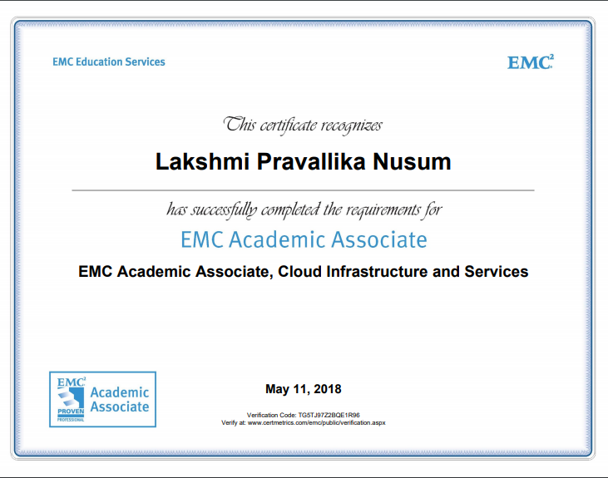

**N**PTEL CERTIFICATE:

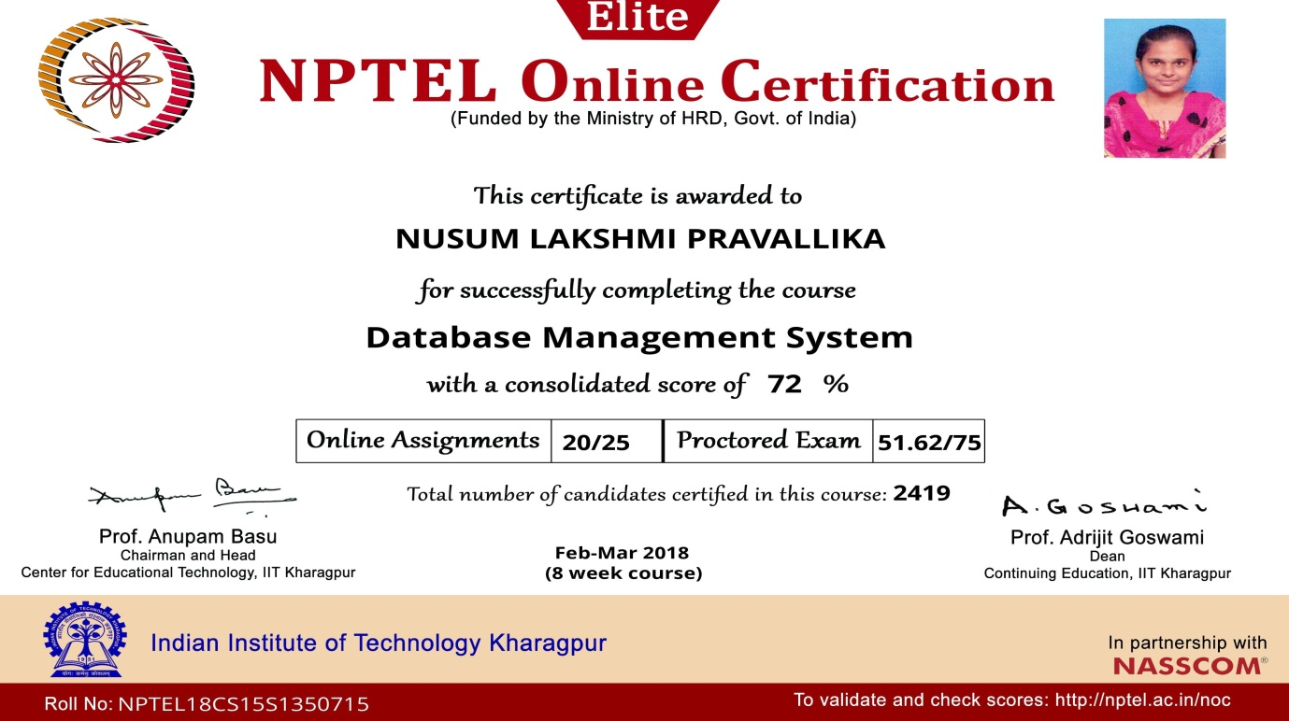

Certificate on Amazon Web Services:

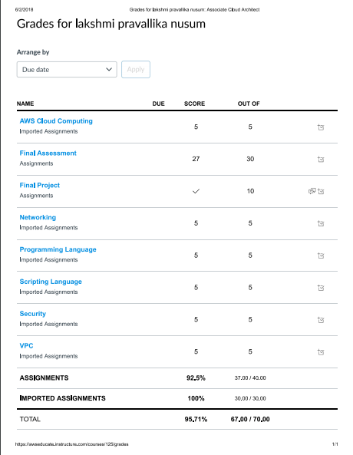

**ACKNOWLEDGEMENT**

The satisfaction that accompanies the successful completion of any task would be incomplete without the mention of people who made it possible and whose constant guidance and encouragements crown all the efforts with success.

I would like to express my deep sense of gratitude and sincere thanks to **Mrs SK.Salma Begum,** AssistantProfessor, Department of Computer Science and Engineering for her constant guidance, supervision and motivation in completing the project work.

We feel elated to express our floral gratitude and sincere thanks to **Dr.S.Narayana**, Head of the Department, Computer Science and Engineering for his encouragements all the way during analysis of the project. His annotations, insinuations and criticisms are the key behind the successful completion of the project work.

We would like to take this opportunity to thank our beloved principal **Dr.P.Ravindra Babu** for providing a great support for us in completing our project and giving us the opportunity for doing project.

Our Special thanks to the faculty of our department and programmers of our computer lab. Finally, we thank our family members, non-teaching staff, attendants and our friends, who had directly or indirectly helped and supported us in completing our project in time.

**By**

**N.L.Pravallika (15481A05F7)**

**ABSTRACT**

GitHub is a web-based hosting service for version control, computer code. Git and GitHub have completely changed the way we work in web development. They provide a centralized, Cloud-based location to store, share, publish, test and collaborate on web development projects. Generally a validation form is which validates the name, password and Gmail, phone number is in the correct form or not. The validation form is developed by using html and JavaScript. And then by using power shell we can directly push into the github or by directly Uploading it into the github which can shared by anyone if they have the link for form.

**INDEX**

**TITLE PAGE NO**

**ABSTRACT**

**CHAPTER 1: INTRODUCTION 1**

1.1 PROBLEM DEFINITION 1

1.2 SCOPE 1

1.3 OVERVIEW 1

1.4 EXISTING SYSTEM 1

1.5 ADVANTAGES 2

**CHAPTER 2: ANALYSIS 3**

2.1 REQUIREMENTS GATHERING 3

2.2 SOFTWARE REQUIREMENT SPECIFICATIONS 3

2.2.1 PURPOSE 3

2.2.2 SCOPE 3

2.2.3 FUNCTIONAL REQUIREMENTS 3

2.2.3.1 INPUT 3

2.2.3.2 OUTPUT 3

2.2.4 NON-FUNCTIONAL REQUIREMENTS 3

2.2.4.1 USABILITY 3

2.2.4.2 PERFORMANCE 3

2.2.4.3 SECURITY 4

2.2.4.4 RELIABILITY 4

2.2.5 TECHNICAL SPECIFICATIONS 4

2.2.5.1 SOFTWARE SPECIFICATIONS 4

**CHAPTER 3: DESIGN 5**

3.1 SYSTEM ARCHITECTURE 5

3.2 UML DIAGRAMS 5

3.2.1 CLASS DIAGRAM 6

3.2.2 ACTIVITY DIAGRAM 7

**CHAPTER 4: IMPLEMENTATION 8**

4.1 INTRODUCTION 8

4.2 BASIC FORM VALIDATION 8

4.3 IMPLEMENTATION STEPS 9

**CHAPTER 5: TESTING 10**

5.1 PURPOSE 10

5.2 TESTING TECHNIQUES 10

5.2.1 WHITE BOX TESTING 10

5.2.2 BLACK BOX TESTING 10

5.3 TEST CASE 11

**CHAPTER 6: RESULTS 12**

6.1 EXECUTION STEPS 12

**CHAPTER 7: CONCLUSION AND FUTURE SCOPE 17**

7.1 CONCLUSION 17

7.2 FUTURE SCOPE 17

**CHAPTER 8: BIBLIOGRAPHY 18**

**LIST OF FIGURES**

**TITLE PAGE NO**

1 ARCHITECTURE 5

2 CLASS DIAGRAM 6

3 ACTIVITY DIAGRAM 7

4 EXECUTION STEPS 12

* STEP-1 12
* STEP-2 12
* STEP-3 13
* STEP-4 14
* STEP-5 14
* STEP-6 15
* STEP-7 15
* STEP-8 16

**LIST OF TABLES**

1 TEST CASE 11

**LIST OF ABBREVIATIONS**

1 UML-UNIFIED MODELING LANGUAGE

2 HTML- HYPERTEXT MARK-UP LANGUAGE