**Abstract**

In most developing countries, the increasing rate of Carbon emissions is considered a major cause of concern. India is leading in terms of CO2 emissions as compared to other countries.The study used descriptive methods. It focuses on finding the main potential parameters that affect the concentration of CO2 emissions based on energy resources. To get predictions here machine learning algorithms will be applied.

**Introduction**

Machine learning algorithms offer several advantages for CO2 emission prediction. They can handle large and complex datasets, capture non-linear relationships between variables, and adapt to changing patterns over time. Moreover, they can incorporate various data sources, including historical emission data, meteorological information, energy consumption data, population statistics, and more, to improve the accuracy of predictions.

**OBJECTIVES**

* To predict the carbon dioxide emissions using ML model.
* To identify the features that are causing more carbon dioxide emissions.
* To reduce their usage in future.

**SYSTEM DESIGN**

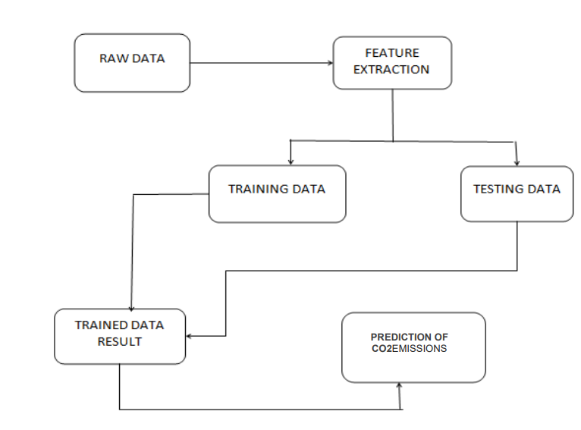

**Raw data:**

Raw information is an exceptionally essential module and it is a beginning stage towards of the project.

**Feature Extraction:**

Extraction is a piece of information mining, which includes new features when mining is done like renewable energy use, energy per kg oil, urban population, rural population etc.

**Training and Testing Data:**

It is utilized to decide the examples in the given RAW information the data is divided into the training and testing data and the data sets which are collected are made to train on various machine learning algorithms.

**CO2Emissions:**

The data sets when trained on different algorithms gives us the final carbon dioxide emissions.

**FEATURES AND FUNCTIONALITIES**

The features and functionalities of CO2 emission prediction using machine learning can vary depending on the specific implementation and goals of the project. However, here are some common features and functionalities that are often incorporated into CO2 emission prediction systems using machine learning:

**METHOD**

**REGRESSION MODEL**

The model is utilized to appraise the consistent qualities. Assessing house costs is one of the most widely recognized instances of relapse given the size of the home, for example, size, cost, and understudy and educator proportion. This is an innovation to be checked. An away from of the sorts of AI and some significant viewpoints is given in my past article.

**OUTPUT**

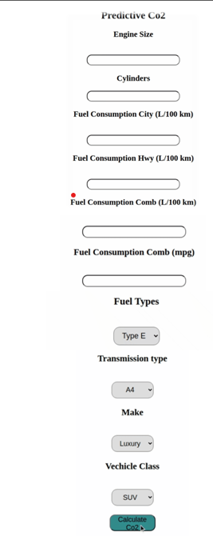

**RESULT**

* Ridge Regression (with alpha = 0.5) has been the most effective in reducing RMSE.
* The exact combination of features responsible for high CO2 emissions cannot be predicted Since all the features are highly correlated.
* Following image shows score table for different models.

