JAVA

package demo1;

public class SwapOfTwoNumbers {

public static void main(String[] args) {

int a=10; int b=20;

a = a+b;

b = a-b;

a = a-b;

System.out.println("The value of A is : " + a);

System.out.println("The value of B is : " + b);

}

}

JAVA

package javaInheritance;

class grandParent {

String property = "Raj Mahal";

String vehicle = "Bajaj Chetak";

public void gdisplay() {

System.out.print("Using Grandpa property : " + property);

System.out.println(" and " + vehicle);

}

}

class parent extends grandParent {

String flat = "My Home Flat 201";

String car = "AUDI A6";

public void pdisplay() {

System.out.print("Using Dad Flat : " + flat);

System.out.println(" and " + car);

}

}

public class child extends parent {

String bike = "Royal Enfield";

public void cdisplay() {

System.out.print("Using my bike : " + bike);

}

public static void main(String[] args) {

*// TODO Auto-generated method stub*

child cp = new child();

parent pr = new parent();

System.out.print("Parent ");

pr.gdisplay();

pr.pdisplay();

System.out.print("Child ");

cp.gdisplay();

System.out.print("Child ");

cp.pdisplay();

cp.cdisplay();

}

}

JAVA

package demoPrograms;

import org.openqa.selenium.By;

import org.openqa.selenium.WebDriver;

import org.openqa.selenium.chrome.ChromeDriver;

public class LoginToERP {

public static void main(String[] args) {

System.setProperty("webdriver.chrome.driver", "D:\\chromedriver.exe");

WebDriver driver = new ChromeDriver();

driver.manage().window().maximize();

driver.get("http://projects.qedgetech.com/webapp/login.php");

driver.findElement(By.id("username")).clear();

driver.findElement(By.id("username")).sendKeys("admin");

driver.findElement(By.id("password")).clear();

driver.findElement(By.id("password")).sendKeys("master");

driver.findElement(By.id("btnsubmit")).click();

String ActualResult = driver.findElement(By.id("ewPageCaption")).getText();

System.out.println("Actual Result is .." + ActualResult);

if (ActualResult.equals("Dashboard") ) {

System.out.println("Login Successful, Test case is passed..");

}

else {

System.out.println("Login Failed, Test case is failed..");

}

}

}

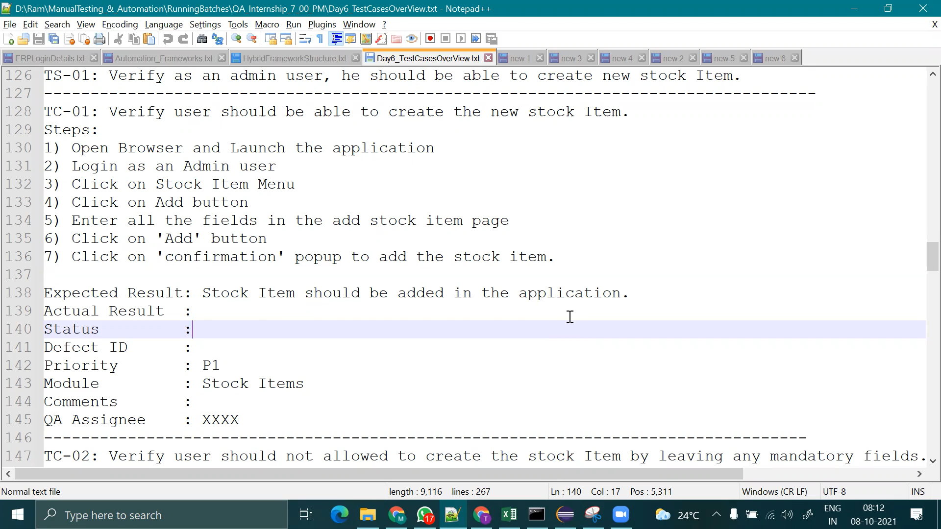

**Test Scenarios to be Automated**

===================================================================

**Live Project - ERP (Test Scenarios to be Automated)**

===================================================================

TS-1: Verify admin user is able to login with valid username and password

TS-2: Verify admin user is able to access the stock items page.

TS-3: Verify admin user is able to add new stock item

TS-4: Verify admin user is able to search the stock items by using search option

TS-5: Verify admin user is able to search the stock items by using Advaced Search option

TS-6: Verify user is able to delete the selected stock item

TS-7: Verify user is able to updated the selected stock item

TS-8: Verify user is able to logout the application

TS-10: Verify user is able to save the search filter

TS-11: Verify user is able to deleted the search filter

TS-12: Verify user is able to export the stock items with the available options.

TS-13: Verify user is able to navigate to the next page.

TS-14: Verify user is able to set the page size

TS-15: Verify user is able to access the stock Categories page

TS-16: Verify user is able to access the Unit of Measurements page.

TS-17: Verify user is able to add new stock Category

TS-18: Verify user is able to add the new Unit of Measurement

------------------------------------------------------------------------