**Industrial Internship Report on**

**”FILE ORGANISER PROJECT”**

**Prepared by:**

**Siddanathi P C L Pravallika,**

**Electronics and Communication Engineering Department,**

**Andhra University College of Engineering for Women.**

**Internship duration: 1st June to 15th July.**

**Date of Submission: 15-07-2023**

|  |
| --- |
| *Executive Summary* |
| This report provides details of the Industrial Internship provided by upskill Campus and The IoT Academy in collaboration with Industrial Partner UniConverge Technologies Pvt Ltd (UCT).  This internship was focused on a project/problem statement provided by UCT. We had to finish the project including the report in 6 weeks’ time.  My project was “The File Organizer Project” using Python aims to develop a program that automatically sorts and organizes files based on their file types into designated folders. The motivation behind this project is to simplify the process of file organization, saving time and effort for users. The program will utilize various libraries and modules in Python for file manipulation and directory scanning. It will scan a specified directory and identify all files present in it. Each file will be classified based on its file type, using file extensions or other identification techniques. The program will then move each file to the appropriate folder designated for that file type.  This internship gave me a very good opportunity to get exposure to Industrial problems and design/implement solution for that. It was an overall great experience to have this internship. |

**TABLE OF CONTENTS**

1 Preface 3

2 Introduction 5

2.1 About UniConverge Technologies Pvt Ltd 5

2.2 About upskill Campus 11

2.3 Objective 12

3 Problem Statement 13

4 Existing and Proposed solution 14

5 Proposed Design/ Model 15

6 Performance Test 16

6.1 Test Plan/ Test Cases 17

6.2 Test Procedure 17

6.3 Performance Outcome 17

7 My learnings 18

8 Future work scope 19

9 Conclusion……………………………………………………………………………………………19

# Preface

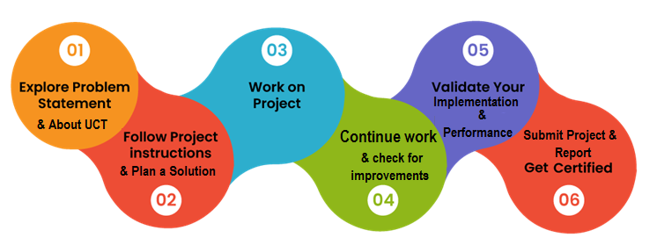Over the past 6 weeks, I have been working on the File Organizer Project using Python. The project aims to develop a program that automatically sorts and organizes files based on their file types into designated folders. This project has provided me with a valuable opportunity to apply my programming skills, enhance my problem-solving abilities, and gain practical experience in file manipulation and organization.

Internships play a crucial role in career development as they provide an opportunity to apply theoretical knowledge to real-world scenarios. This internship has allowed me to work on a practical project, which has not only enhanced my technical skills but also improved my project management, collaboration, and communication abilities. It has given me a taste of the professional environment and prepared me for future challenges in my career.

The problem statement for the project was to develop a file organizer program that automatically sorts and organizes files based on their file type into designated folders. The objective was to simplify the process of file organization and improve efficiency for users. This involved designing an algorithm to scan directories, classify files based on their types, and move them to the appropriate folders.

I am grateful for the opportunity given by UCT to work on this project. It has provided me with a platform to enhance my technical skills, collaborate with fellow interns, and learn from experienced mentors. The guidance and support provided throughout the internship have been invaluable in my learning and growth.

The program was planned by breaking down the project into various milestones and tasks. This included conducting research on file manipulation in Python, designing the program structure, implementing the functionality, and testing the program's performance. Throughout the process, I have learned important concepts such as directory scanning, file classification, error handling, and user interface design. The overall experience has been enriching, allowing me to develop both technical and soft skills.

To my juniors and peers, I encourage you to seize every opportunity for internships and practical projects. Embrace challenges, be proactive in seeking knowledge, and make the most of the learning experiences. Remember to collaborate, seek guidance, and never hesitate to ask questions. Each project is a stepping stone towards your career growth, so make the most of it.

# Introduction

## About UniConverge Technologies Pvt Ltd

A company established in 2013 and working in Digital Transformation domain and providing Industrial solutions with prime focus on sustainability and RoI.

For developing its products and solutions it is leveraging various**Cutting Edge Technologies e.g. Internet of Things (IoT), Cyber Security, Cloud computing (AWS, Azure), Machine Learning, Communication Technologies (4G/5G/LoRaWAN), Java Full Stack, Python, Front end**etc.

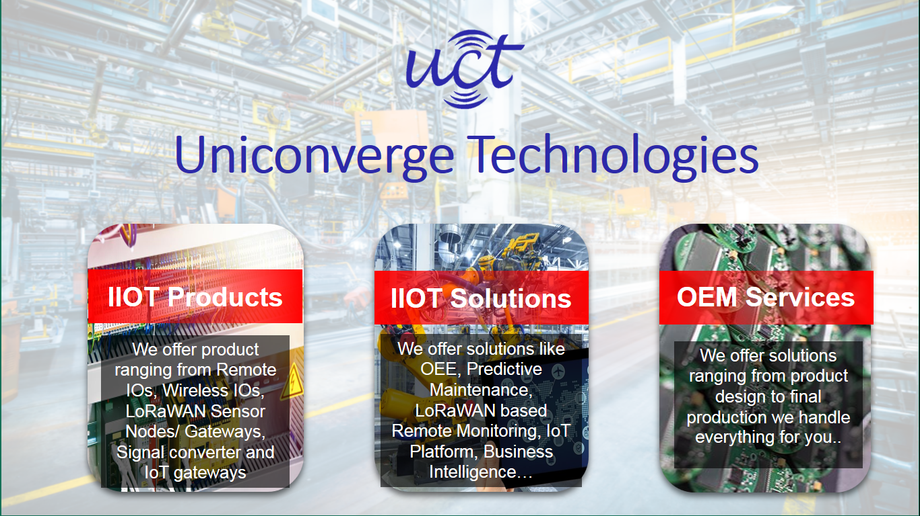

1. UCT IoT Platform **(****)**

**UCT Insight** is an IOT platform designed for quick deployment of IOT applications on the same time providing valuable “insight” for your process/business. It has been built in Java for backend and ReactJS for Front end. It has support for MySQL and various NoSql Databases.

* It enables device connectivity via industry standard IoT protocols - MQTT, CoAP, HTTP, Modbus TCP, OPC UA
* It supports both cloud and on-premises deployments.

It has features to  
• Build Your own dashboard  
• Analytics and Reporting  
• Alert and Notification  
• Integration with third party application (Power BI, SAP, ERP)  
• Rule Engine

 

1. **Smart Factory Platform (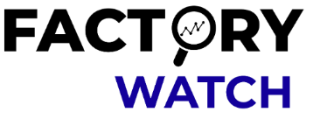)**

Factory watch is a platform for smart factory needs.

It provides Users/ Factory

* with a scalable solution for their Production and asset monitoring
* OEE and predictive maintenance solution scaling up to digital twin for your assets.
* to unleased the true potential of the data that their machines are generating and helps to identify the KPIs and also improve them.
* A modular architecture that allows users to choose the service that they what to start and then can scale to more complex solutions as per their demands.

Its unique SaaS model helps users to save time, cost and money.

 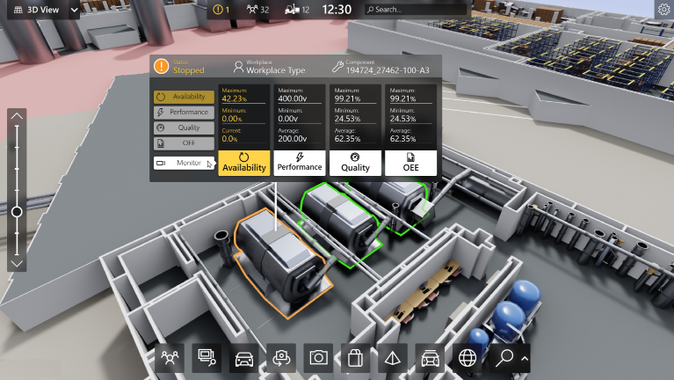

1. 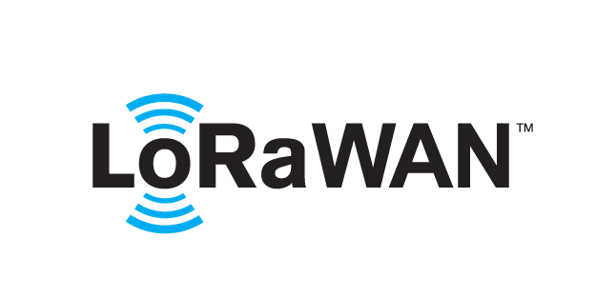 based Solution

UCT is one of the early adopters of LoRAWAN technology and providing solution in Agritech, Smart cities, Industrial Monitoring, Smart Street Light, Smart Water/ Gas/ Electricity metering solutions etc.

1. Predictive Maintenance

UCT is providing Industrial Machine health monitoring and Predictive maintenance solution leveraging Embedded system, Industrial IoT and Machine Learning Technologies by finding Remaining useful life time of various Machines used in production process.



## About upskill Campus (USC)

upskill Campus along with The IoT Academy and in association with Uniconverge technologies has facilitated the smooth execution of the complete internship process.

USC is a career development platform that delivers **personalized executive coaching** in a more affordable, scalable and measurable way.

Seeing need of upskilling in self paced manner along-with additional support services e.g. Internship, projects, interaction with Industry experts, Career growth Services





upSkill Campus aiming to upskill 1 million learners in next 5 year

<https://www.upskillcampus.com/>

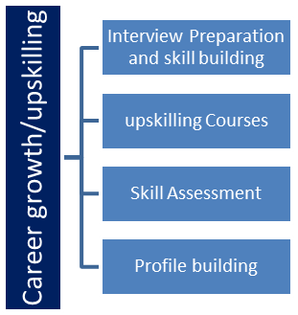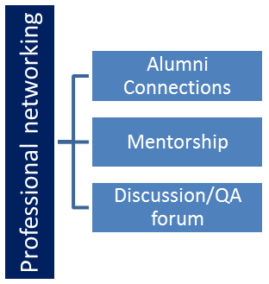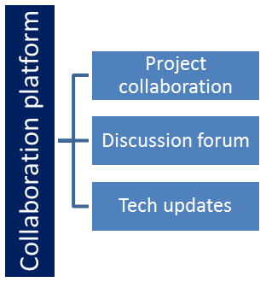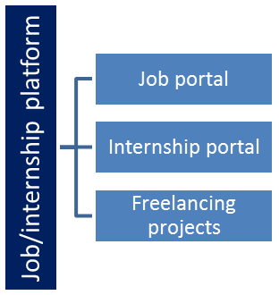

## The IoT Academy

The IoT academy is EdTech Division of UCT that is running long executive certification programs in collaboration with EICT Academy, IITK, IITR and IITG in multiple domains.

## Objectives of this Internship program

The objective for this internship program was to

 ☛ get practical experience of working in the industry.

 ☛ to solve real world problems.

 ☛ to have improved job prospects.

 ☛ to have Improved understanding of our field and its applications.

 ☛ to have Personal growth like better communication and problem solving.

# Problem Statement

The assigned problem statement for the project was to develop a file organizer program that automatically sorts and organizes files based on their file type into designated folders. The goal was to streamline the file organization process and provide users with a convenient and efficient tool.

# Existing and Proposed solution

Existing solutions provided by others were explored during the project. These solutions often involved manual file organization or limited automation. They lacked the ability to handle various file naming conventions and provide a user-friendly interface. Therefore, a proposed solution was developed to automate the file organization process, handle different file types, and provide an intuitive user interface for ease of use.

## Code submission (Github link)

https://github.com/pravallikaspcl/upskillcampus/blob/main/FileOrganiser.py

## Report submission (Github link)

## https://github.com/pravallikaspcl/upskillcampus/blob/main/FileOrganiser_SiddanathiPCLPravallika_USC_UCT.pdf

# Proposed Design/ Model

The proposed design of the file organizer program includes components such as directory scanning, file classification, folder organization, and error handling mechanisms. The program utilizes Python libraries and modules for file manipulation and provides a user-friendly interface for specifying directories and viewing the organization progress.

# Performance Test

Constraints Impact and Recommendations:

Although the identified constraints were addressed and evaluated during the performance testing, it is essential to consider their potential impact on the design. If constraints were not explicitly tested, it is important to acknowledge their potential influence and provide recommendations for handling them:

Memory: As file volumes continue to grow, memory management should be continuously optimized to handle increasing data sizes efficiently. Regular monitoring and optimization efforts are recommended.

MIPS: In scenarios with extremely large file volumes or complex file classification rules, further optimization techniques such as parallel processing or distributed computing can be considered to improve MIPS.

Accuracy: Regular evaluation and updating of file classification rules and algorithms should be undertaken to maintain high accuracy, especially as new file types emerge.

Durability: Regular backups and error handling mechanisms should be implemented to ensure data durability and minimize the impact of unexpected errors or interruptions.

Power Consumption: Continuous optimization of power usage should be pursued to reduce the program's energy footprint and make it more environmentally friendly.

## Test Plan/ Test Cases

A comprehensive test plan was developed to evaluate the performance of the file organizer program. Test cases included scenarios with large file volumes, different file types, and challenging file naming conventions. Test cases were designed to cover edge cases and error scenarios.

## Test Procedure

The test procedure involved executing the file organizer program with different test cases and monitoring its performance. Test results were recorded, including execution time, accuracy of file classification, and proper folder organization.

## Performance Outcome

The performance outcome of the file organizer program was evaluated based on execution time, accuracy of file classification, and successful folder organization. The program aimed to handle large file volumes efficiently and accurately organize files based on their types.

# My learnings

Throughout this project, I have gained valuable insights and learnings. I have deepened my understanding of file manipulation in Python, improved my programming skills, and developed a problem-solving mindset. Additionally, I have learned about project management, collaboration, and effective communication in a professional setting.

# Future work scope

In the future, there are several areas of potential improvement and expansion for the file organizer project. This includes incorporating advanced file classification algorithms, optimizing performance for large file volumes, and adding additional features such as file search and advanced filtering options.

# Conclusion

In conclusion, the File Organizer Project using Python has been a valuable learning experience, providing practical exposure to file manipulation, organization, and project management. It has enhanced my technical skills, problem-solving abilities, and collaboration capabilities. I am grateful for the opportunity and look forward to applying the learnings from this project in my future endeavors.