**LINUX COMMANDS**

1. **Whoami** - my login
2. **Hostname** - name of this computer
3. **echo “Hello, world”** - print characters to screen
4. **echo $HOME** - print environmental variables
5. **Echo my login is $(whoami)** – replace $(xx) with program output
6. **date** – print current time date
7. **cal** – print this month’s calander
8. **shazam** – bad command
9. **awk** – pattern scanning and processing language
10. **cat** – display file
11. **cut** – extract selected fields of each line of a file
12. **diff** – compare two files
13. **grep** – search text for a pattern
14. **head** – display the first part of files
15. **less** – display files on a page by page basis
16. **set** – stream editor(esp search and replace)
17. **sort** – sort text files
18. **split** – split files
19. **tail** – display the last part of life
20. **tr** – translate delete characters
21. **uniq** – filter out repeated lines in a file
22. **wc** – line, word and character count

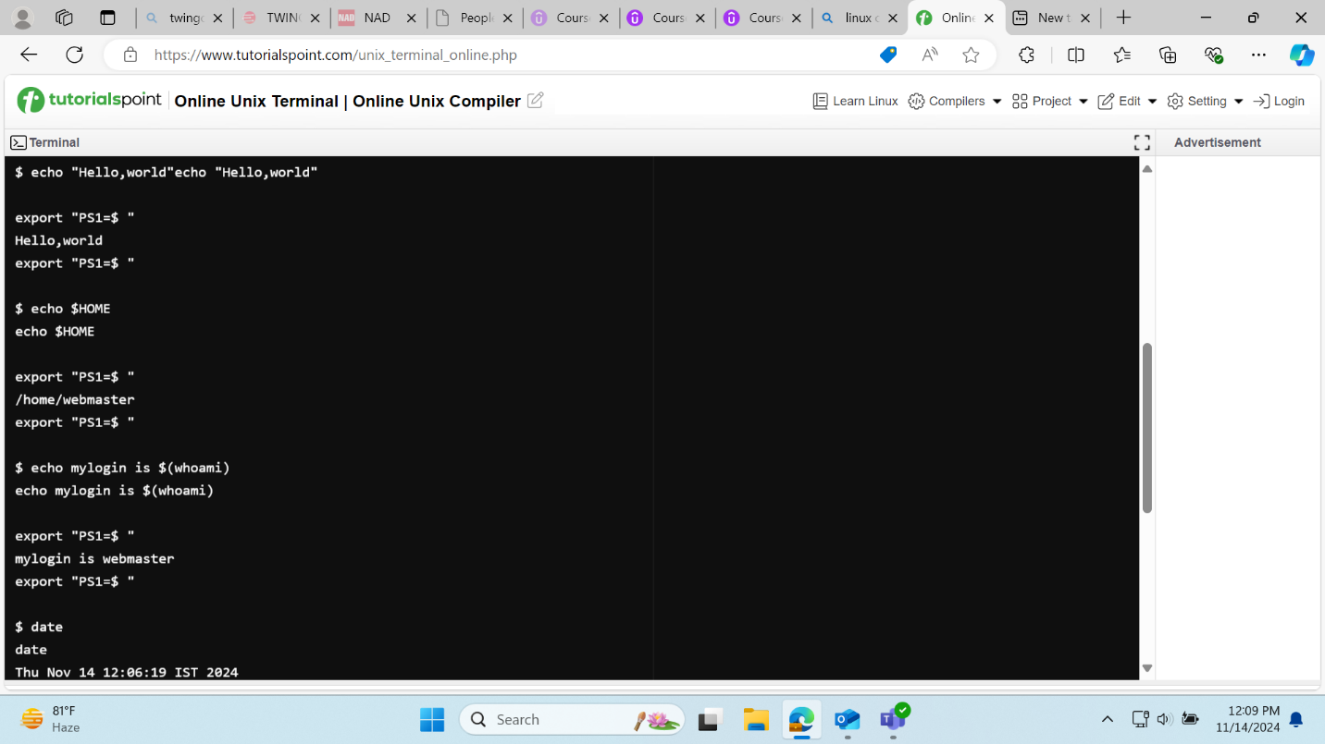

**

**Echo:** used to enter the data in empty file by appending (>>)

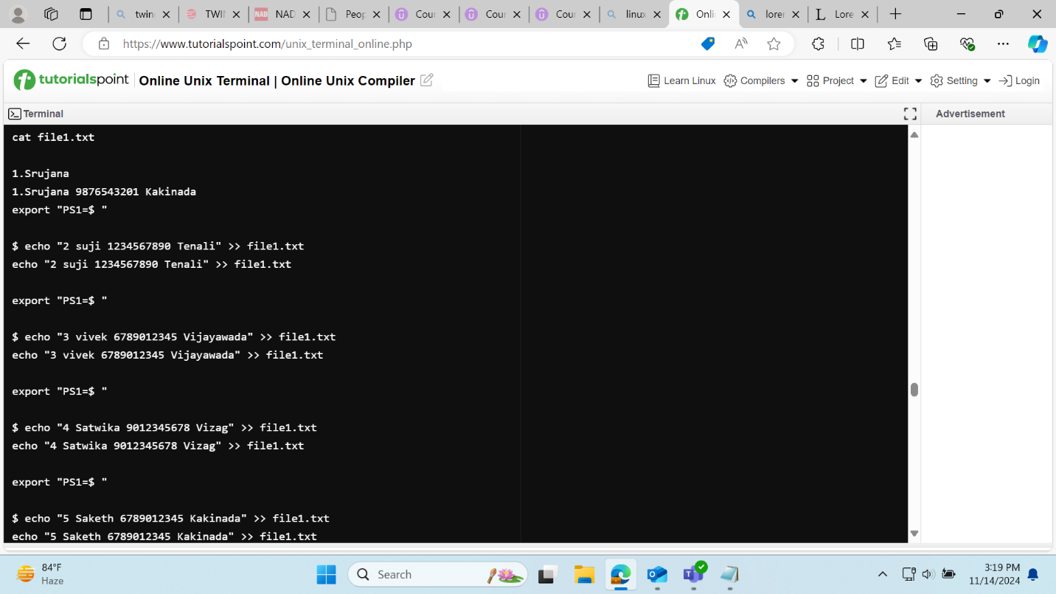

**Copy**: copy the content

**Cat:** Display the content

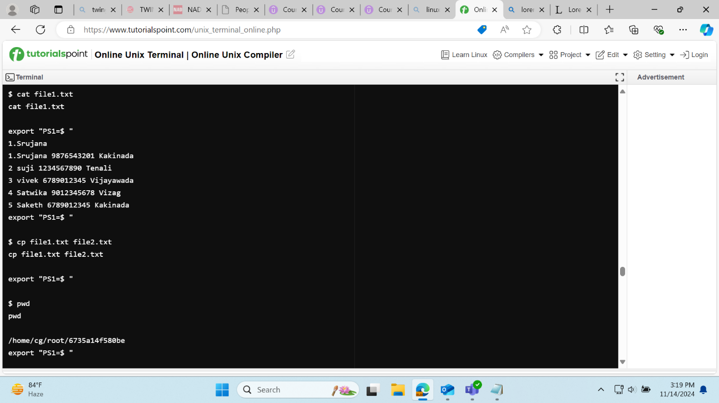

**Move:** move file from one directory to another and rename file

**Split:** split the one file into two different parts

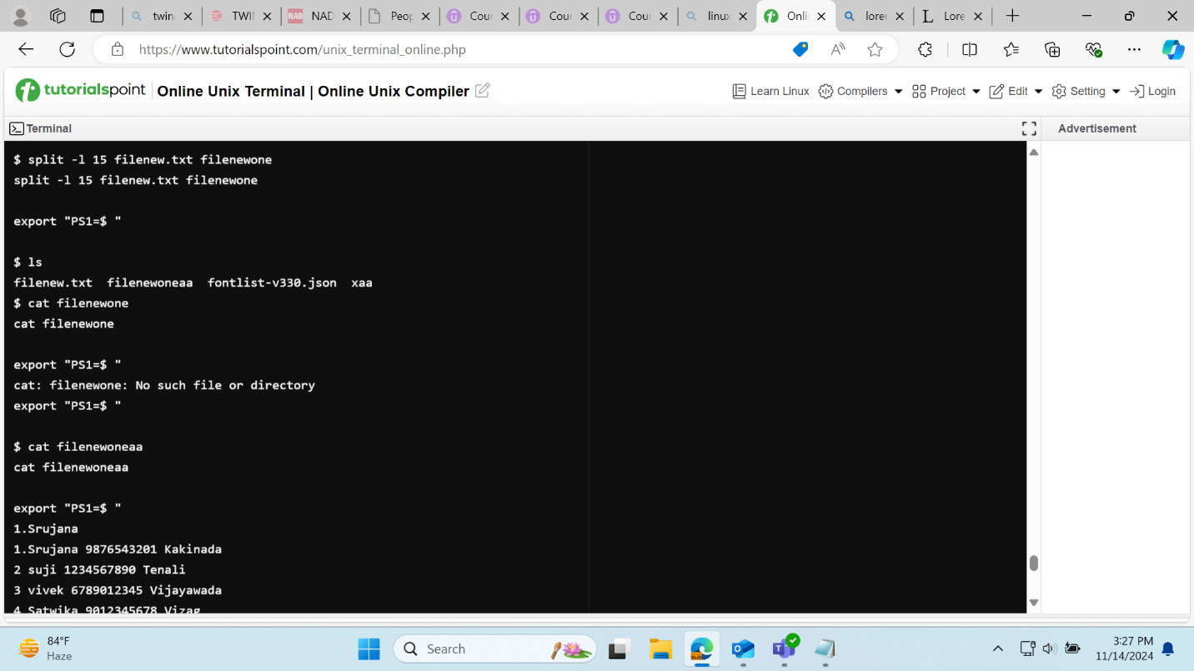

**Wc(word count):** word count

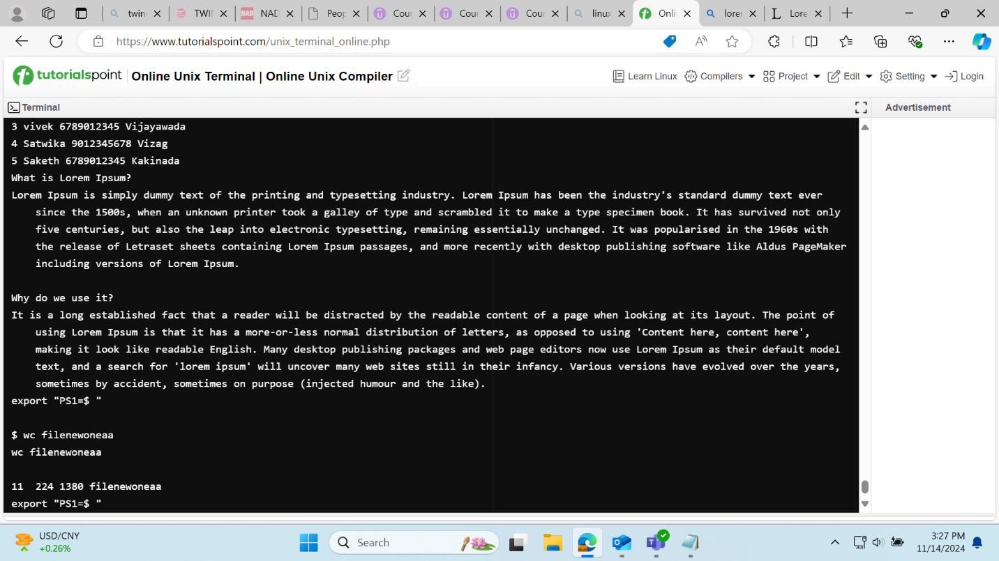

**More**: to view the content page by page

**Tr**: search and replace the text

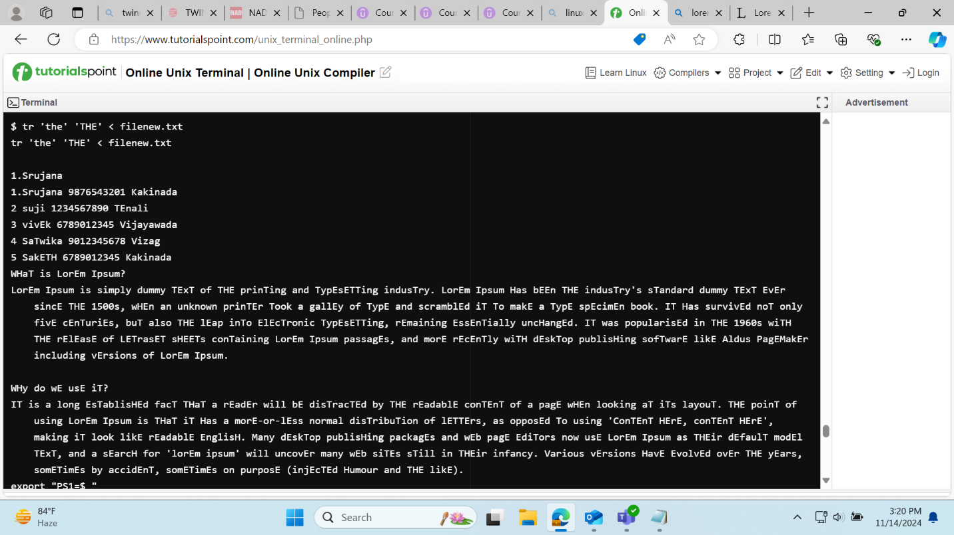

**Head:** to display the top most content in file

**Tail:** to display the bottom content in file.

