# A Summer Internship Project Report

On

**“Insect Detection and Classification using Computer Vision”**

Carried out at the

**Indian Institute of Technology, Indore**



Submitted by

**Pravar More**

**Enrolment:** DE19120

**Bachelor of Engineering**

**Institute of Engineering and Technology -DAVV, Indore**



**Under the Guidance of**

Dr. Puneet Gupta

Discipline of Computer Science and Engineering

Indian Institute of Technology, Indore

June-August, 2022

# CERTIFICATE

This is to certify that the project titled “**Insect Detection and Classification using Computer Vision**”. This project is submitted by **Pravar More** (Institute of Engineering and Technology, Indore) as a **Summer Research Internship Project**. This project was an authentic work done by him under my supervision and guidance **from** **“1 June, 2022” to “31 August, 2022**.

Date:

**(Project Guide)**

Dr. Puneet Gupta

Discipline of Computer Science and Engineering  
Indian Institute of Technology, Indore

|  |  |
| --- | --- |
| **INDEX:** |  |
| **Content** | **Page No.** |
| 1. Abstract……………………………………… | 3. |
| 1. Knowledge………………………………….. 2. Domain………………………………………. 3. Problem Domain 4. Solution Domain 5. Application Domain | 4.  5. |
| 1. Project Details………………………………… 2. YOLOv5 3. CNN 4. Code 5. Result 6. Snap shots 7. F 8. Outcome……………………………………… 9. System Domain………………………………. 10. Conclusion…………………………………..... 11. Appendix……………………………………... 12. References…………………………………….   10. Citation……………………………………….. | 7.  10.  11.  12. |
|  |  |

**Keywords:** Computer Vision, Detection & Classification, Insect, Agriculture

**ABSTRACT**

A formidable challenge faced by farmers around the world is the pests and the insects destroying the crops. These insects are hard to anticipate and detect, leading to increased labor and potential loss for the cultivators. But with the current technological advances in both the hardware and software industry has opened a way to automate and aid in both detection and classification of pest allowing for a faster and more adequate response to ensure the protection of the crops. Object Insect Detection was done by the use of YOLOv5 Model from **git: ultralytics/yoloV5** and Convolutional Neural Network for classification of healthy and infected.

**KNOWLEDGE**  
With new developments in technology, a new opportunity has surfaced to use digital solutions in performing tedious tasks. These solutions allow the farmers to analyze and track the spatial-temporal conditions of the crops using sensors like thermometers, cameras, and aid in decision-making for the cultivators with the data they collect. These technologies allow the decrease in pesticide usage, replacing them with more targeted and optimized methods of pest control. However, these technologies were formally expensive and unaffordable for farmers to apply in their fields. This has changed in the recent past following the development of smaller and cheaper sensors. This paper focuses on one of these technologies useful in basic and elementary pest and insect detection techniques, using a live video capturing device feeding data to a Deep Learning model that can be trained to detect the pests’ infestations on crops.

To Solve this 2 Models were created with the result of Leaf Detection result taken as a input parameter for the other model to detect insect on Leaf.

This was done in order to first distinguish between healthy and infected plant, and then the causing insect on it.

This was.

Shape feature extraction. Shape features are the essential features which are not affected due to scaling, rotation, and translation and applied in computer vision and automatic object recognition systems. Classiﬁcation of insects is performed based on the ﬁnite shape features extracted from the insect images. The insect images in the form of RGB converted to grayscale images for further feature extraction. Image processing techniques are applied to extract the shape features. The nine shape features include area, perimeter, major axis length, minor axis length, eccentricity, circularity, solidity, form factor, and compactness stored in feature vectors and then applied to the classiﬁer models. Computer vision is one of the most remarkable things to come out of the deep learning and artificial intelligence world. The advancements that deep learning has contributed to the computer vision field have really set this field apart.

**Image segmentation** partitions an image into multiple regions or pieces to be examined separately.

**Object detection** identifies a specific object in an image. Advanced object detection recognizes many objects in a single image: a football field, an offensive player, a defensive player, a ball and so on. These models use an X,Y coordinate to create a bounding box and identify everything inside the box.

**Facial recognition** is an advanced type of object detection that not only recognizes a human face in an image, but identifies a specific individual.

**Edge detection** is a technique used to identify the outside edge of an object or landscape to better identify what is in the image.

**Pattern detection** is a process of recognizing repeated shapes, colors and other visual indicators in images.

**Image classification** groups images into different categories. Feature matching is a type of pattern detection that matches similarities in images to help classify them.

**DOMAIN:**

**PROBLEM DOMAIN**

To overcome the overuse of insecticides on agricultural fields, this solution may come useful.  
Crop fields could be monitored by a drone camera or from clicking pictures, and if insect detected can notify at earliest. Along with detecting it would also classify and help to determine which insecticide be used its amount per area of land, and can determine and analyze from the data we may get. Regarding the growth of crops, one of the important factors affecting crop yield is insect disasters. Since most insect species are extremely similar, insect detection on ﬁeld crops, such as rice, soybean and other crops, is more challenging than generic object detection.

Presently, distinguishing insects in crop ﬁelds mainly relies on manual classiﬁcation, but this is an extremely time-consuming and expensive process.

**SOLUTION DOMAIN**

The dataset used has more than 3000 image-set collected and divided into classes was adopted in this work, which contains 4 classes of insects commonly found in with its development phase in crop ﬁelds, such as **Eocanthecona_Bug_A, Larva_Spodoptera_D, Red_Hairy_Catterpillar_C and Tobacco_Caterpillar_B.**  
To improve the generalization ability of this model, more images collected from the Internet were used with a data augmentation technique. Then by using a predefind model LabelImg label-set to create the bounding-boxes was used. This work proposes a **YoloV5 + convolutional neural network model** to solve the **problem of multi-classiﬁcation of crop insects and Healthy Leaf.** The model can make full use of the advantages of the neural network to comprehensively extract multifaceted insect features.

**APPLICATION DOMAIN**

It is being designed for the agricultural fields, but can also be used in Plantation, gardening and nurseries for monitoring.

**Insect classiﬁcation with CNN model**

The CNN model developed to train with RGB insect images dataset. The CNN model comes under the class of deep, feed-forward neural networks applied to analyze visual imagery of insect images and computationally efﬁcient due to automatic feature learning and weight sharing. The CNN model contains ﬁve convolutional layers and three max-pooling layers, a ﬂatten layer, a fully connected layer, and a softmax output layer to classify insect images. The size of the insect image is rescaled to 64x64. The CNN model can run over each insect image pretty fast and reduce the computational operations per layer and memory.

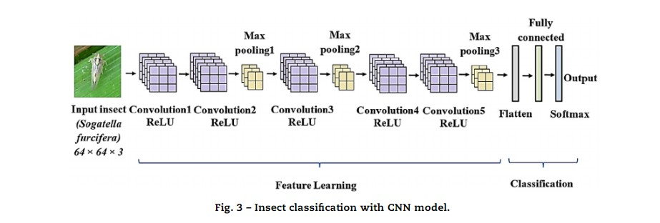

**PROJECT DETAILS:**

**File dataset.yaml –– Model Summary ––**

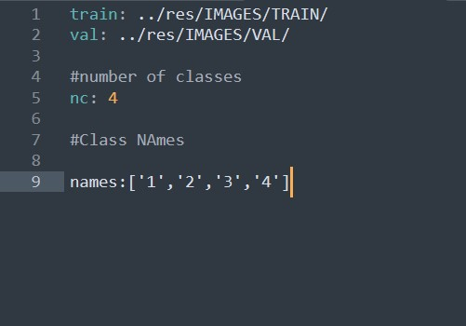 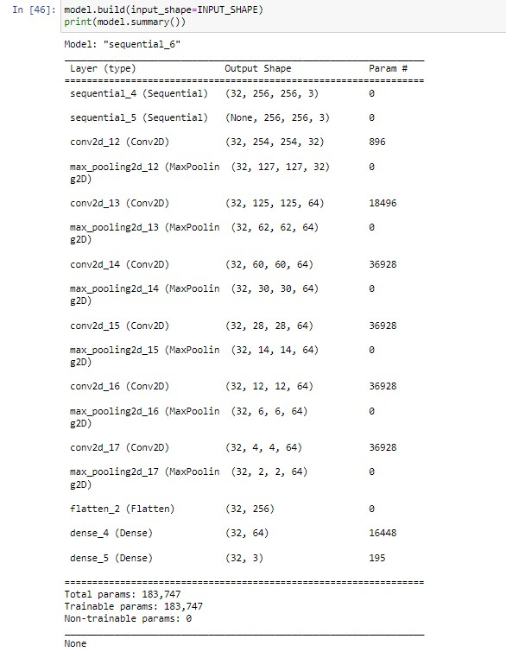

**Flowchart of Project:**

**Deep learning** is a subset of machine learning concerned with the emulation of human brain activities in software programs using layers of artificial neural networks (ANN), which work similar to the human brain at some levels.

––Library Import

––Setting up path for training data

––Data Loading For training

––Data Explorations

––Print Classes present in the data

––Create Model

––Train Model

––Evaluate Model

––Interpret the results

––Prediction Using Trained Model

**CODE:**

**Imports file:**

import tensorflow as tf

from tensorflow.keras import models, layers

import matplotlib.pyplot as plt

from IPython.display import HTML

import os

**trainModel():**

Trained for Constants:

BATCH_SIZE = 32

IMAGE_SIZE = 256

CHANNELS=3

EPOCHS=50

**DataSet Pipeline**

Data pipelines enable the flow of data from an application to a data warehouse, from a data lake to an analytics database,etc. Data pipelines also may have the same source and sink, such that the pipeline is purely about modifying the data set. A machine learning pipeline is a way to codify and automate the workflow it takes to produce a machine learning model. Machine learning pipelines consist of multiple sequential steps that do everything from data extraction and pre-processing to model training and deployment.

- step:

name: preprocess, command: python preprocess.py

inputs:

- name: train-images - name: train-labels

- name: test-images - name: test-labels

- step:

name: train, command: python train.py {parameters}

parameters:

- name: learning_rate, description: Initial learning rate, type: float

default: 0.001

inputs:

- name: train-images

- name: train-labels

- name: test-images

- name: test-labels

- pipeline:

name: Training Pipeline

connections:

- [preprocess.output.train-images, train.input.train-images]

- [preprocess.output.train-labels, train.input.train-labels]

- [preprocess.output.test-images, train.input.test-images]

- [preprocess.output.test-labels, train.input.test-labels]

**Model Architecture:**

n_classes=4

model = models.Sequential([

resize_and_rescale,

data_augmentation,

layers.Conv2D(32, kernel_size = (3,3), activation='relu'),

input_shape=INPUT_SHAPE),

layers.MaxPooling2D((2, 2)),

layers.Conv2D(64, kernel_size = (3,3), activation='relu'),

layers.MaxPooling2D((2, 2)),

layers.Conv2D(64, kernel_size = (3,3), activation='relu'),

layers.MaxPooling2D((2, 2)),

layers.Conv2D(64, (3, 3), activation='relu'),

layers.MaxPooling2D((2, 2)),

layers.Conv2D(64, (3, 3), activation='relu'),

layers.MaxPooling2D((2, 2)),

layers.Conv2D(64, (3, 3), activation='relu'),

layers.MaxPooling2D((2, 2)),

layers.Flatten(),

layers.Dense(64, **activation**='relu'),

layers.Dense(n_classes, **activation**='softmax'),

])

**Model Compiled**

model.compile(

**optimizer** = 'adam',

**loss** = SparseCategoricalCrossentropy(),

**metrics**=['accuracy']

)

**Making Prediction from yolov5 model**

**Execute**: !python detect.py

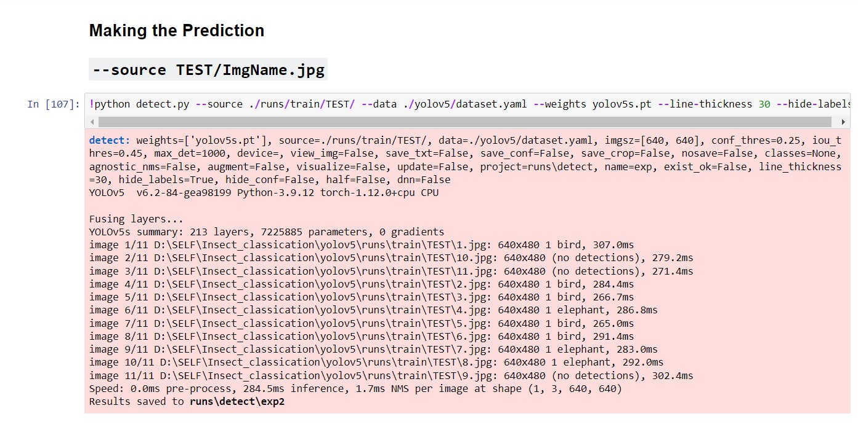

**Making Prediction from CNN Architecture model**

Actual and Predicted Label been printed with the test_image

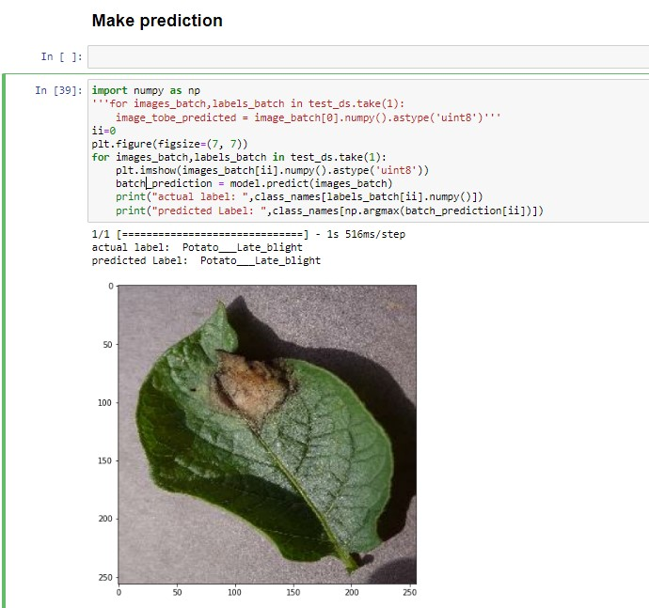

**OUTCOME**

Different insect datasets were classiﬁed and detected by applying the machine learning and insect pest detection algorithm, and the results were compared. All the insect images were rescaled, pre-processed, and augmented to increase the dataset to improve the accuracy. Achieving the insect classiﬁcation with higher accuracy in the real- time ﬁeld is a challenging issue in the presence of shadow, leaves, dirt, branches, and ﬂower buds, etc. in major agriculture ﬁeld crops. The results proved that the CNN model provides the highest classiﬁcation accuracy of > 90% 4 classes of insects from the datasets used. The achieved classiﬁcation accuracy helps to reduce the computation time for better insect recognition.

**Original Test Image:**

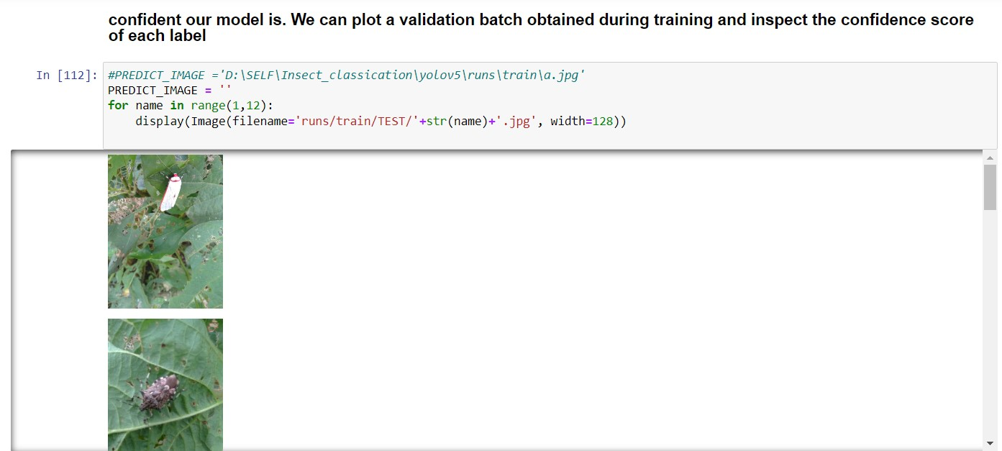

**Predicted Outcome of Test Image:**

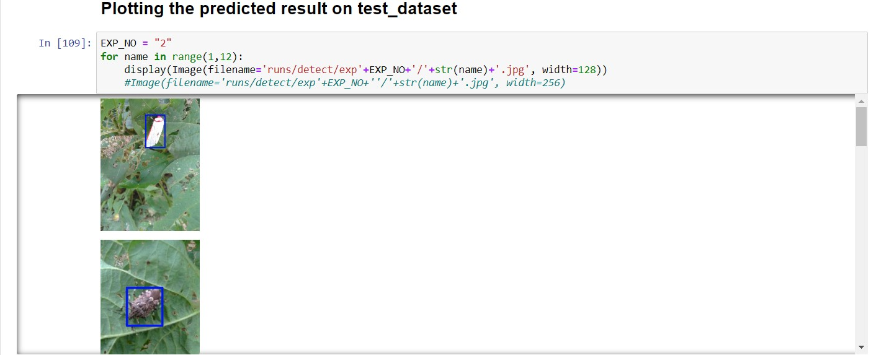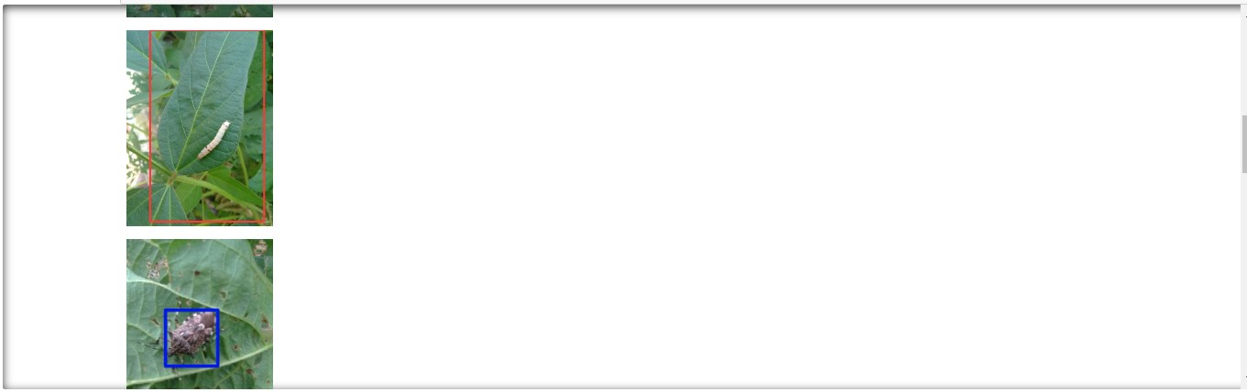

**SYSTEM DOMAIN**

**[1]** Hardware: we may be required a drone or a camera for Real Time Detection  
**[2]** Software: A OS, Utility software to able to run the output snippet after training the model.  
**[3]** Human Resource: A Technician who has skilled in using the software solution and may resolve minor issues like file path, running the train option and similar task.

**CONCLUSION**

Insect datasets were classiﬁed and detected by applying the machine learning and insect pest detection algorithm. All the insect images were rescaled, pre-processed, and augmented to increase the dataset to improve the accuracy. Achieving the insect classiﬁcation with higher accuracy. This model may help to detection for insects in fields for Live detection taking each frames in real-time and processing it to evaluate the model for the test_set resulting in keeping a track on the field and classify the insects and plant condition from the Models as used and provide with information that may be helpful for farmers and the data collected can be used for more research in diagnosing and studying the environmental conditions.

**APPENDIX:**

Image-Set: **[1]** InsectBase: Soybean Crop Insect Raw Image Dataset_V1

Image-Set: **[2]** Potato-Leaf Classification (https://www.kaggle.com/datasets/arjuntejaswi/plant-village)

**REFERENCES:**

**[1]** Insect classification and detection in field crops using modern machine learning techniques. DOI: 10.1016/j.inpa.2020.09.006

Authors: Thenmozhi Kasinathan, Dakshayani Singaraju, U. Srinivasulu Reddy

**[2]** Insect Detection and Classification Based on an Improved Convolutional Neural Network

Authors: Denan Xia,1 Peng Chen,1,2,* Bing Wang,3 Jun Zhang,4,* and Chengjun Xie5

**[3]** A. Tiwari, A. Kumar, and G. M. Saraswat, “Feature extractionfor object recognition and image classiﬁcation,” InternationalJournal of Engineering Research & Technology (IJERT), vol. 2,pp. 2278–0181, 2013

A. Tiwari, A. Kumar, and G. M. Saraswat, “Feature extraction

for object recognition and image classiﬁcation,” International

Journal of Engineering Research & Technology (IJERT), vol. 2,

pp. 2278–0181, 2013.

A. Tiwari, A. Kumar, and G. M. Saraswat, “Feature extraction

for object recognition and image classiﬁcation,” International

Journal of Engineering Research & Technology (IJERT), vol. 2,

pp. 2278–0181, 2013.

A. Tiwari, A. Kumar, and G. M. Saraswat, “Feature extraction

for object recognition and image classiﬁcation,” International

Journal of Engineering Research & Technology (IJERT), vol. 2,

pp. 2278–0181, 2013.

A. Tiwari, A. Kumar, and G. M. Saraswat, “Feature extraction

for object recognition and image classiﬁcation,” International

Journal of Engineering Research & Technology (IJERT), vol. 2,

pp. 2278–0181, 2013.

**CITATIONS:**

**[1]** Tiwari, Vivek; Saxena, Ravi R; Ojha, Muneendra (2020): InsectBase: Soybean Crop Insect Raw Image Dataset_V1 with Bounding boxes for Classification and Localization. figshare. Dataset. https://doi.org/10.6084/m9.figshare.13077221.v4