This project is about Creating Online Pre-registration forms dynamically based on chosen Major and Term.

* **Features**:
* Eliminates the headache for creating a different form for different major and term with different course.
* While selecting course preference (each course), it provides the information about number of student has given the same preference formerly.
* **Technology Used:**
* Programming language used Python 3.6.0, Django framework and SqlLite.
* UI/UX developed using HTML, CSS, Bootstrap, JavaScript and JQuery.
* **Getting stared:**
* Setup environment for python 3.0 or later and Django framework more info at <https://www.djangoproject.com/start/> before getting started.
* To select for which term and major, form will be created.
  + Start the server by going to the manage.py location and run “python anage.py runserverm”
  + Go to link <http://127.0.0.1:8000/admin/>

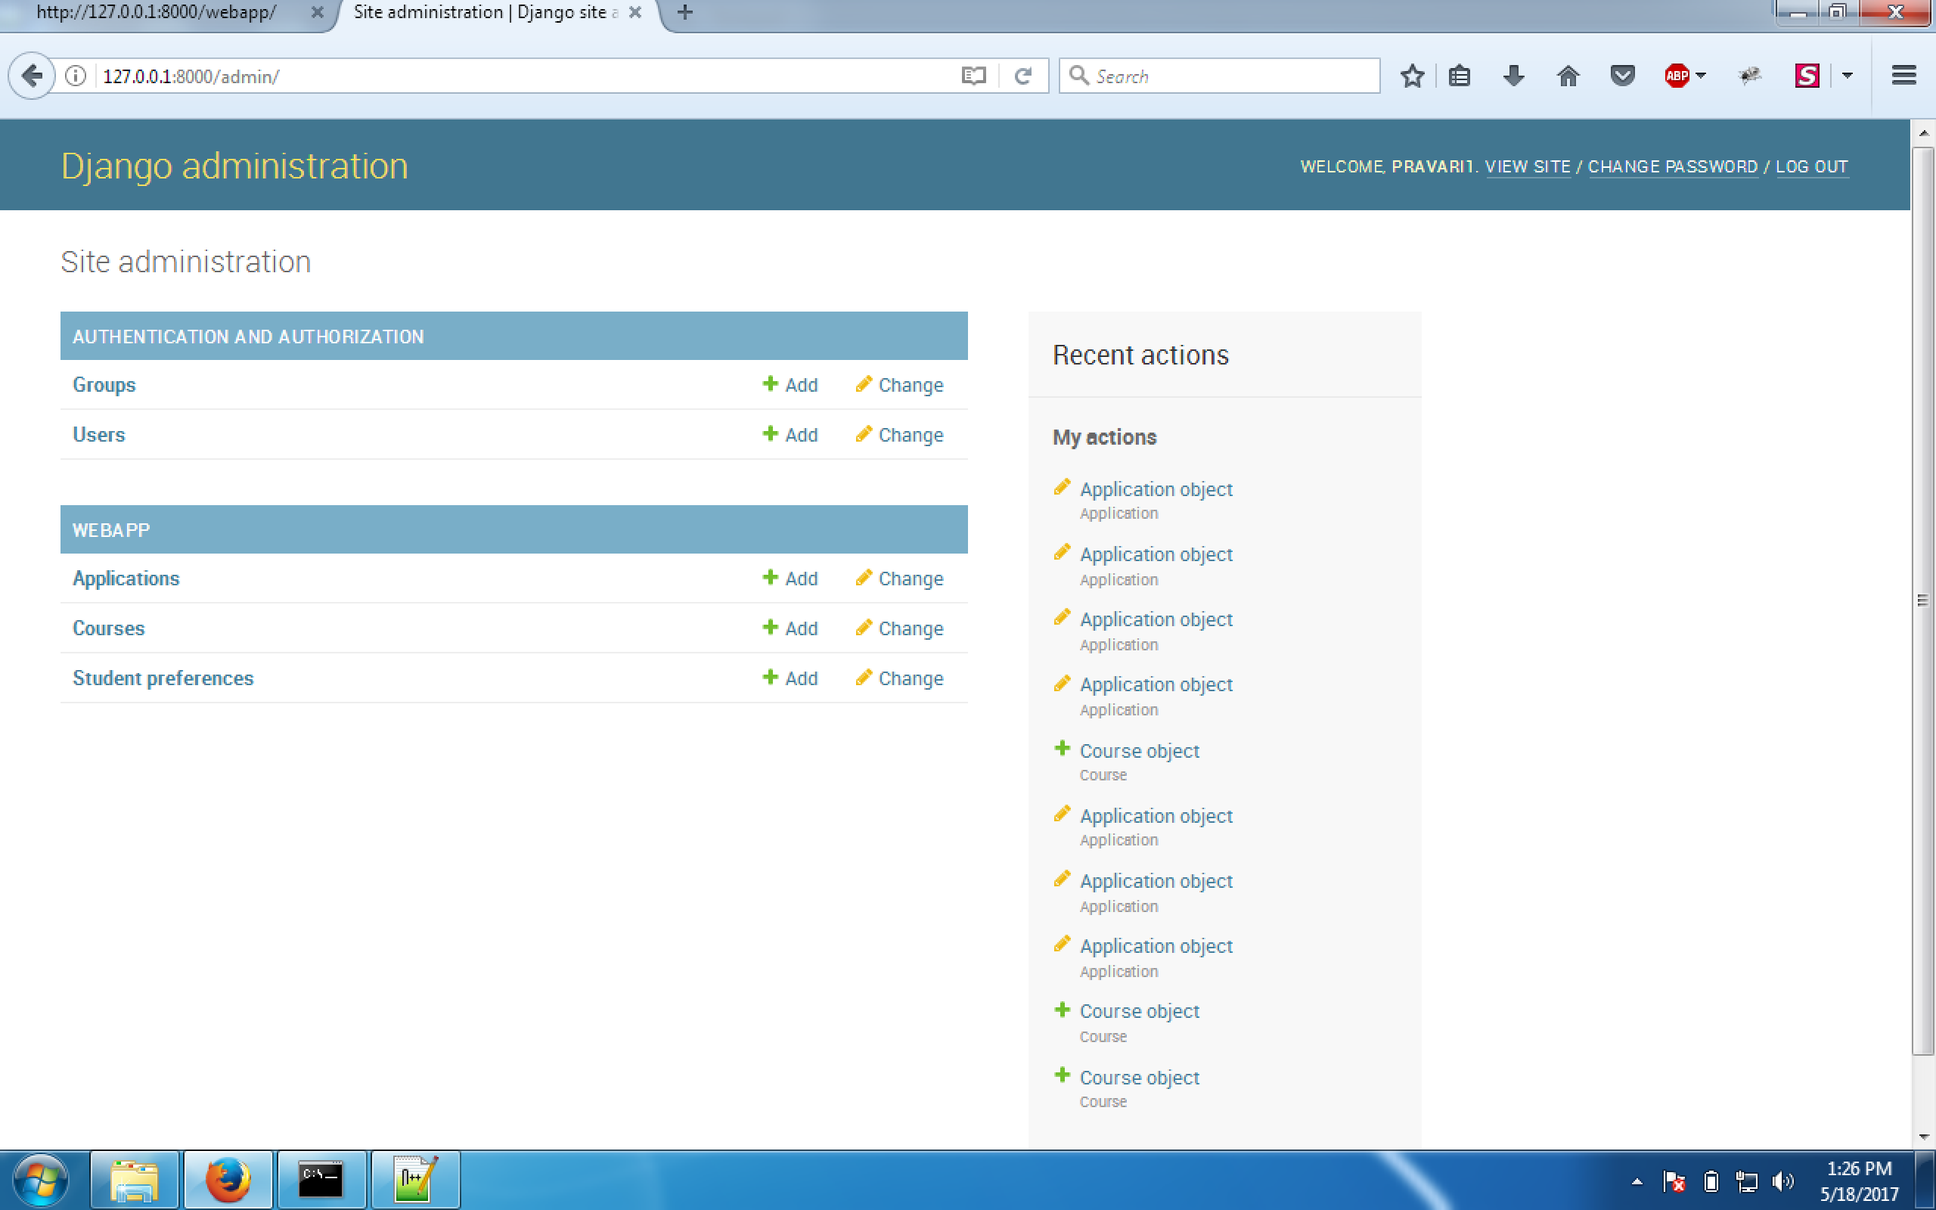

* + Add entry in Application table and activate the application.

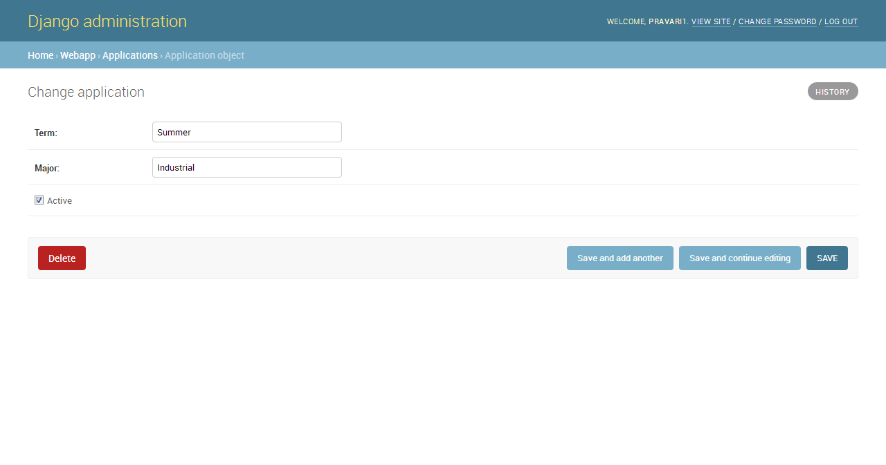

* + Add courses in Course table

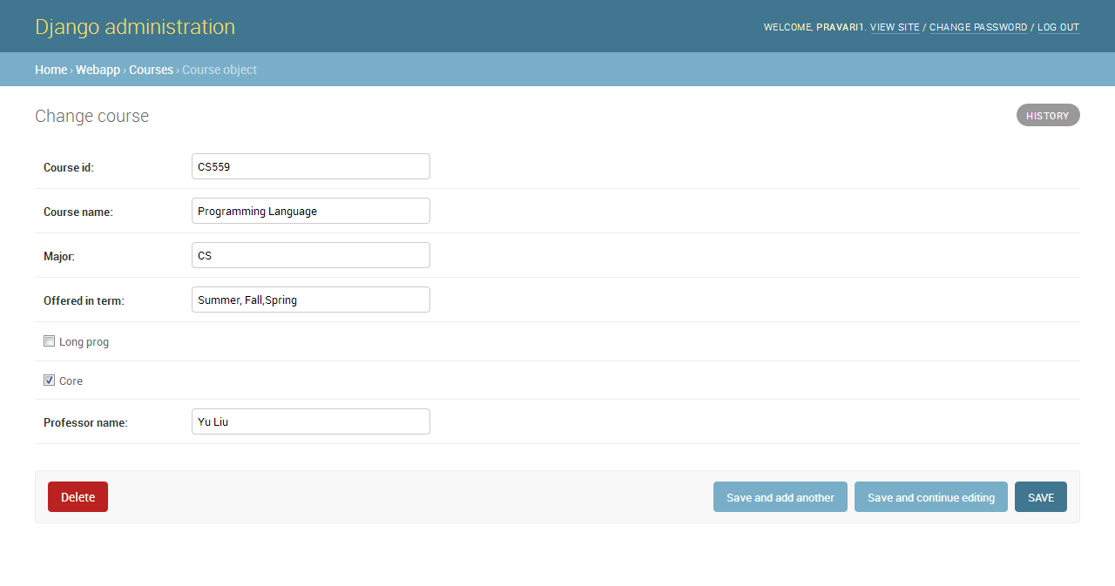

* Accessing and submitting a registration form.
  + Go to link <http://127.0.0.1:8000/webapp/>

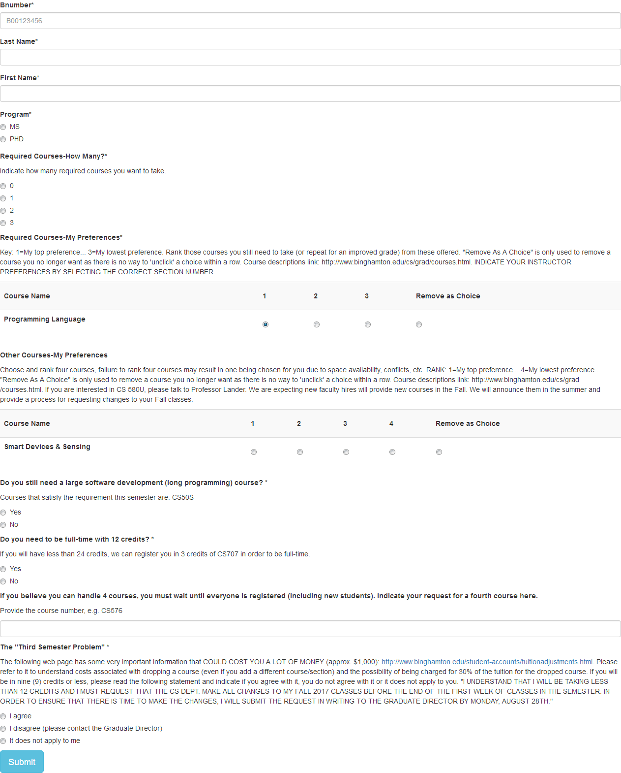

* + Fill the fields accordingly and press button submit (End of Page).
  + The student preference entry will shown in StudentPreferncce table.

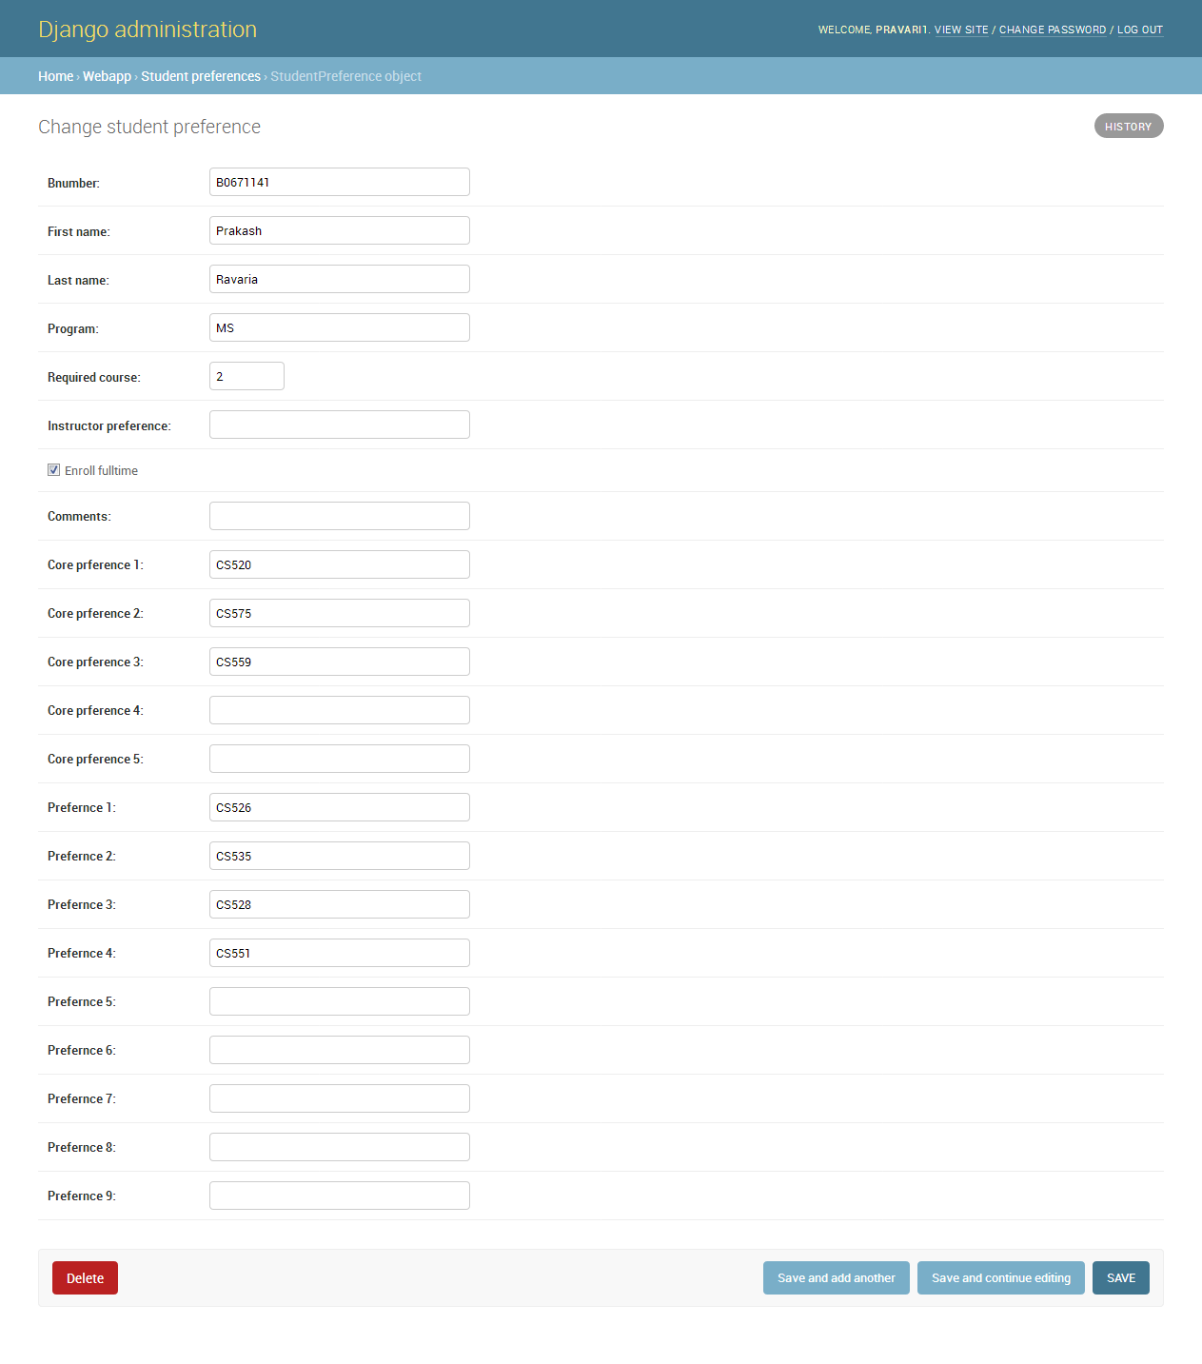

* + Preference count on selecting course.
* When No other student has given a preference for that course.

