Zoho API Token:

1. Log in to https://api-console.zoho.in/

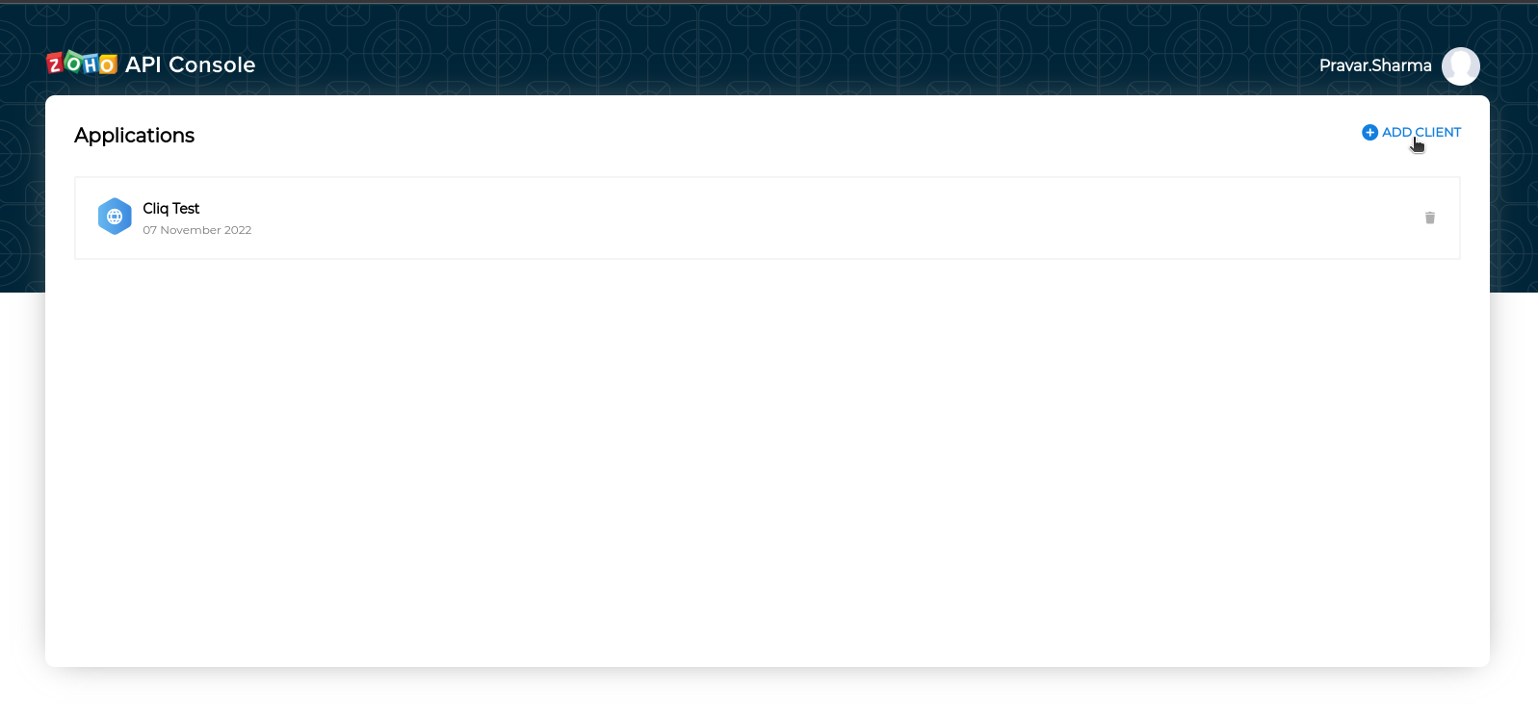
2. Click on add Client

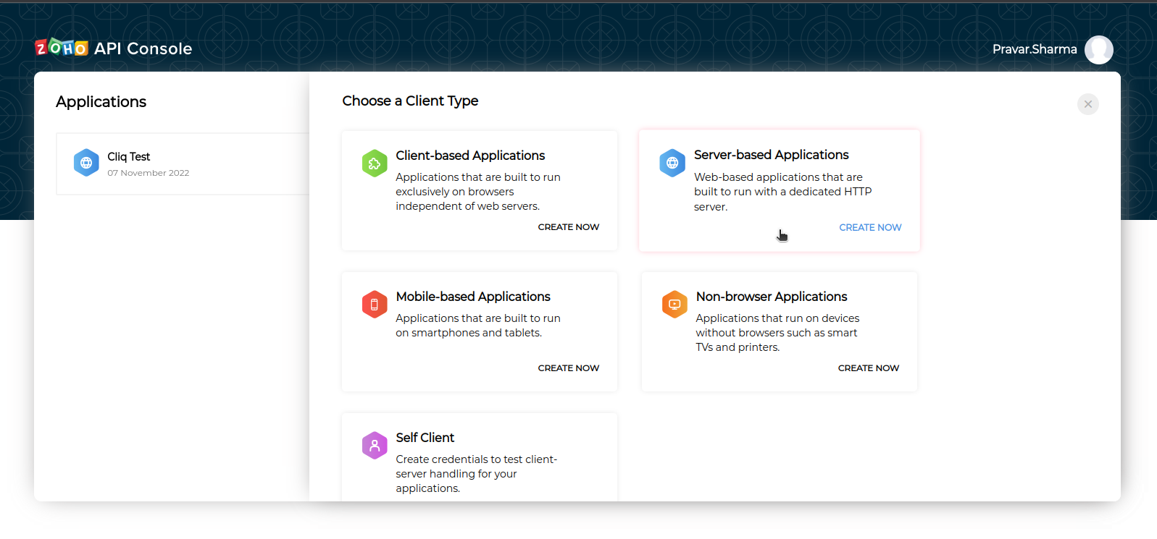
3. Click on server based application.
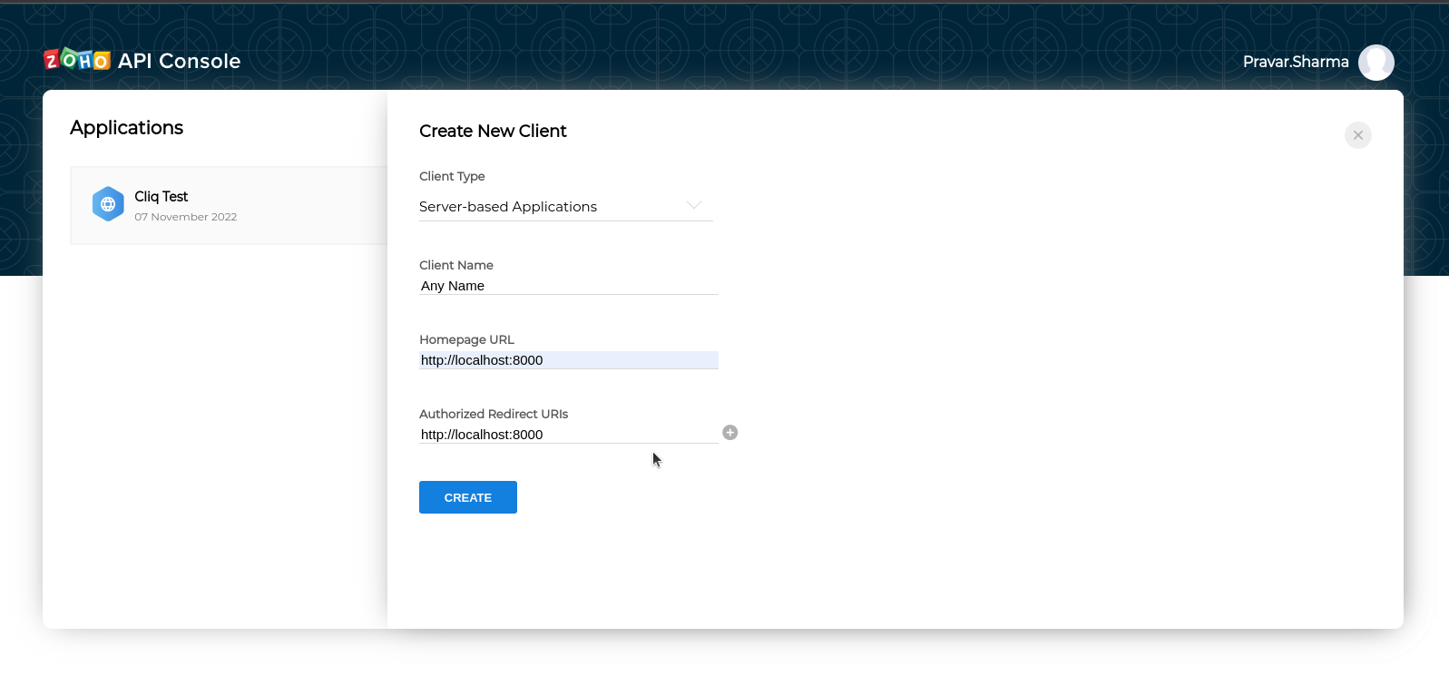
4. Create It. You will get the Client ID and Client Secret.

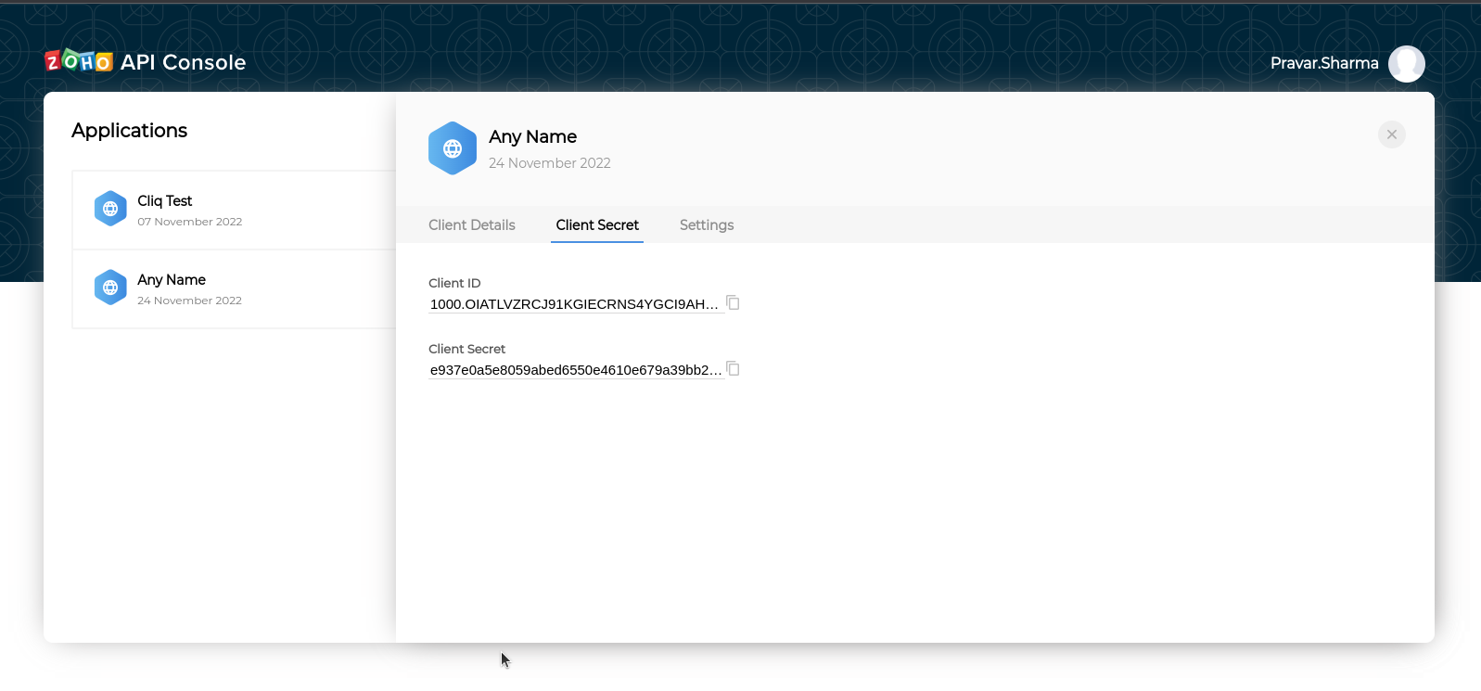
5. https://accounts.zoho.in/oauth/v2/token?code=1000.1627436aa03b9be22364ad0554cb29ed.60b79d436b022215af2324fbbf246925&redirect_uri=http://localhost:8000&client_id=1000.63766CS3T9B47YJMWN8YRRHF8NE55U&client_secret=75fc2fa5769c35065779ed879243fa9d15dc4c9928&grant_type=authorization_code

Change client ID and Client Secret you got in point 4 and POST request of the above link.
The value of code value will get by running below link in the browser.
https://accounts.zoho.in/oauth/v2/auth?scope=ZohoProjects.portals.All,ZohoProjects.projects.ALL,ZohoProjects.users.READ,ZohoProjects.tasks.ALL,ZohoProjects.tasklists.ALL,ZohoCliq.Chats.READ,ZohoCliq.Channels.CREATE,ZohoCliq.Channels.READ,ZohoCliq.Channels.UPDATE,ZohoCliq.Channels.DELETE,ZohoCliq.Users.READ,ZohoPeople.forms.READ,ZohoPeople.employee.READ,ZohoPeople.attendance.READ,ZohoCliq.OrganizationChats.READ,ZohoCliq.Profile.READ,ZohoCliq.Departments.READ,ZohoPeople.employee.READ,ZohoCliq.Channels.ALL,ZohoCliq.Messages.READ,ZohoCliq.OrganizationMessages.READ,ZohoCliq.OrganizationChannels.READ,ZohoCliq.Attachments.READ&client_id=1000.63766CS3T9B47YJMWN8YRRHF8NE55U&state=5466400890088961855&response_type=code&access_type=offline&redirect_uri=http://localhost:8000

this will return
http://localhost:8000/?state=5466400890088961855&code=1000.6d49d1b38d5f4dea84bcb3e46bd21666.9fd0c934947debb108eee5a99cffc16a&location=in&accounts-server=https%3A%2F%2Faccounts.zoho.in

copy the code value and paste it in the POST request and will get the token.

Note – Code is valid for only 2 minutes and the access token is valid for 1 hour.

Add this auth token in .env file along with zoho and mattermost database details.

Also refer README.md in the code.

