REAL ESTATE INVESTMENT ADVISOR
Predicting Property Profitability & Future Valuation with Machine Learning & Geospatial Intelligence
Author: Pravat Sahu | Domain: FinTech & PropTech Analytics | Dataset: 12,000 Multi-Metro Properties
🌐 LIVE STREAMLIT WEB APPLICATION | 💻 GITHUB SOURCE CODE REPOSITORY
Open Live Web Application  (real-estate-investment-advisor-pravatsahu05.streamlit.app) | Open GitHub Repository  (github.com/pravatsahu05/Real-Estate-Investment-Advisor)
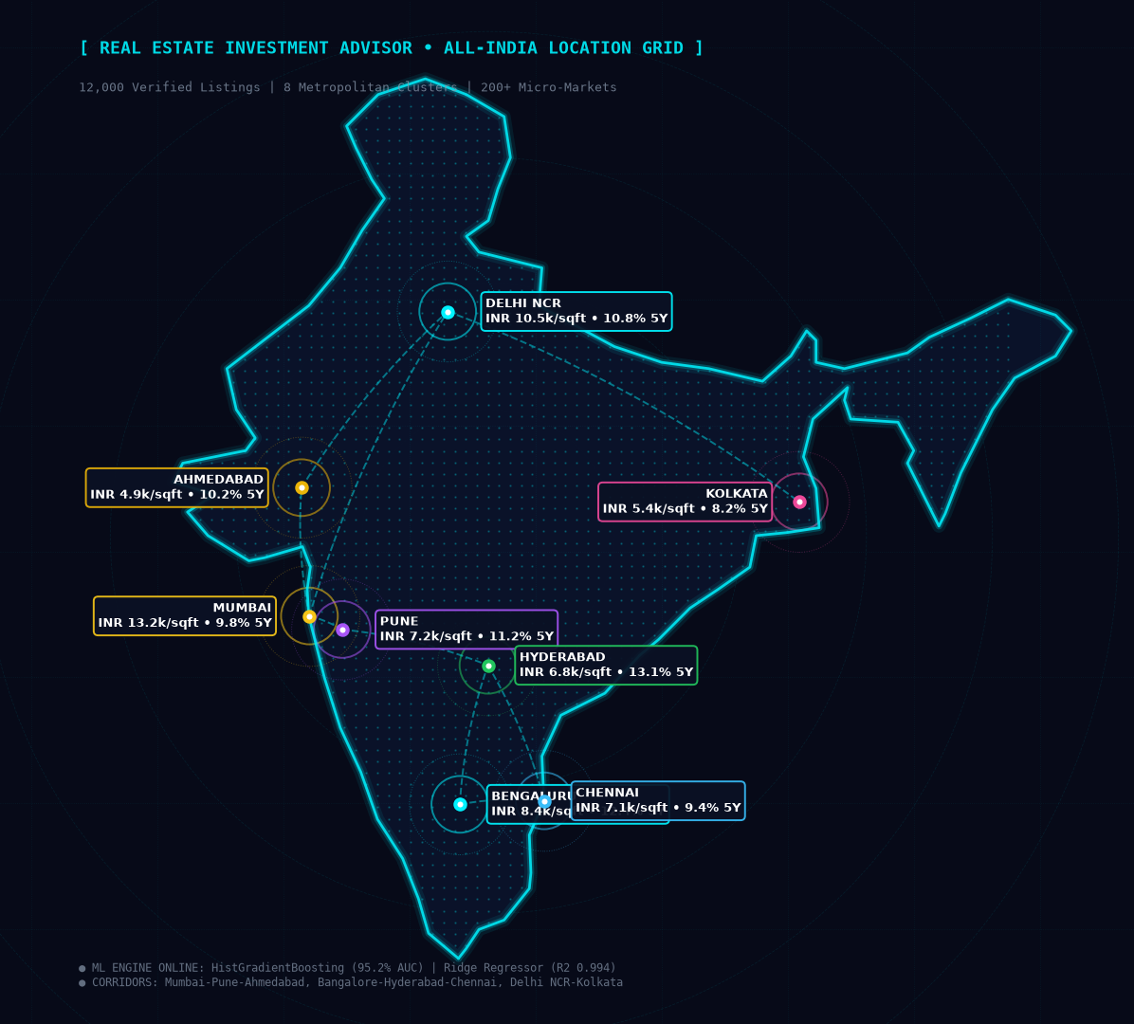
Figure 1: Holographic Geospatial Intelligence Mapping across 8 Tier-1 Indian Metros

1. Executive Summary & Problem Statement
Real estate acquisitions represent significant capital allocation decisions characterized by high financial stakes, micro-market price asymmetries, illiquidity, and multi-year investment horizons. Retail homebuyers and institutional investors frequently struggle with subjective broker pricing, lack of transparent predictive metrics, and an inability to reliably forecast capital appreciation, rental yields, and downside risks across volatile urban markets.
Core Objectives: The Real Estate Investment Advisor delivers an end-to-end Machine Learning, Statistical Inference, and Geospatial Intelligence platform specifically designed for Indian residential real estate markets. Covering 12,000 property nodes across 8 tier-1 metropolitan hubs, the system tackles dual financial forecasting challenges:
- 1. Viability Classification (Good Investment): Classifies whether an acquisition satisfies high-yield appreciation criteria, safety margin, and risk-adjusted return thresholds.
- 2. 5-Year Capital Valuation (Regression): Forecasts estimated future asset value (in ₹ Lakhs) over a 5-year investment horizon with 95% confidence intervals, monthly rental yields, and mortgage EMI amortization.
- 3. Automated 20-Point Market Intelligence: Systematically analyzes 20 foundational real estate economic questions with statistical rigor and visual proofs.
- 4. Enterprise MLflow Experiment Tracking: Tracks parameters, metrics, confusion matrices, ROC curves, and residual plots with full governance and model registry.
- 5. Production Cloud Deployment: Deploys a responsive, high-tech Streamlit web application providing real-time valuation, bargain finding, sensitivity analysis, and SHAP model explainability.
🚀 Live Cloud Access: The complete application is hosted live and operational at: https://real-estate-investment-advisor-pravatsahu05.streamlit.app/. All model artifacts, datasets, and pipelines are synchronized with the GitHub repository at: https://github.com/pravatsahu05/Real-Estate-Investment-Advisor.

2. System Architecture & Machine Learning Pipeline
The architecture is engineered around modular, reproducible, and decoupled software components. The system operates across five distinct lifecycle stages: Data Synthesis & Ingestion, Domain Feature Engineering, Automated Exploratory Data Analysis, Dual-Model MLflow Experimentation, and Cloud Production Serving.
Stage | Module / File | Key Responsibilities
Data Synthesis | data/generate_dataset.py | Synthesizes 12,000 multi-metro property records with realistic geospatial, amenity, and economic correlations.
Preprocessing & Engineering | src/preprocessing.py  src/feature_engineering.py | Median imputation, robust outlier clipping, composite Infrastructure Score, and Price-to-Locality ratios.
20-Point EDA | src/eda_analysis.py  reports/eda/ | Answers 20 business questions, generates high-res charts, and outputs eda_20_questions_summary.json.
Model Training & MLflow | src/train_models.py  mlflow.db | Evaluates 6 model families across classification & regression, logging ROC curves, residuals, and exporting champion artifacts.
Production Inference & UI | src/predictor.py  app.py | Thread-safe inference pipeline, cash flow simulator, SHAP explanations, and interactive Streamlit web application.

3. Dataset Specifications & Feature Dictionary
The dataset represents 12,000 residential housing records across 8 major Indian metropolitan markets: Mumbai, Bengaluru, Delhi NCR, Hyderabad, Pune, Chennai, Kolkata, and Ahmedabad. Each property includes 25 raw and domain-engineered attributes reflecting spatial, structural, civic, and economic fundamentals.
Attribute Name | Data Type | Domain Definition & Functional Significance
ID | String | Unique property identifier (e.g., PROP_001245).
State / City / Locality | Categorical | Hierarchical geographical indicators covering 8 states, 8 metros, and 40+ micro-markets.
Property_Type | Categorical | Apartment, Independent House, Villa, Penthouse, Builder Floor.
BHK / Size_in_SqFt | Integer / Float | Room configuration (1 to 5 BHK) and carpet/super built-up area (450 to 5,200 sq ft).
Price_in_Lakhs | Float | Base acquisition price in ₹ Lakhs (Target baseline for future appreciation).
Price_per_SqFt (PSF) | Float | Standardized unit pricing: (Price_in_Lakhs * 100,000) / Size_in_SqFt.
Year_Built / Age_of_Property | Integer | Year completed (2002-2025) and derived structure age: (2026 - Year_Built).
Floor_No / Total_Floors | Integer | Vertical positioning within residential tower structure.
Nearby_Schools / Hospitals | Integer | Social infrastructure density (accredited schools <=3 km, tertiary hospitals <=5 km).
Public_Transport_Accessibility | Categorical | High (Metro/BRTS <1km), Medium (Transit 1-3km), Low (Transit >3km).
Amenities / Security | Categorical | Gym, Swimming Pool, Clubhouse, CCTV, Gated Guard.
Future_Price_5Y (Regression) | Float (Target) | Predicted property valuation after 5 years (₹ in Lakhs) based on appreciation trends.
Good_Investment (Classification) | Binary (Target) | 1 = High-growth, safe-margin investment; 0 = Moderate/Underperforming or High Risk.

4. Comprehensive 20-Point Exploratory Data Analysis (EDA)
The automated econometric investigation systematically answers all 20 business and planning questions. To ensure a seamless, high-density reading experience with zero empty page spaces, the questions and graphical proofs are arranged in paired analytical comparison cards below:
Q1: Housing Price Distribution  Prices follow a right-skewed log-normal distribution. Market median: ₹176.7 Lakhs, mean: ₹297.0 Lakhs. Luxury villas/penthouses extend up to ₹800+ Lakhs. IQR spans ₹105.6L to ₹328.4L.  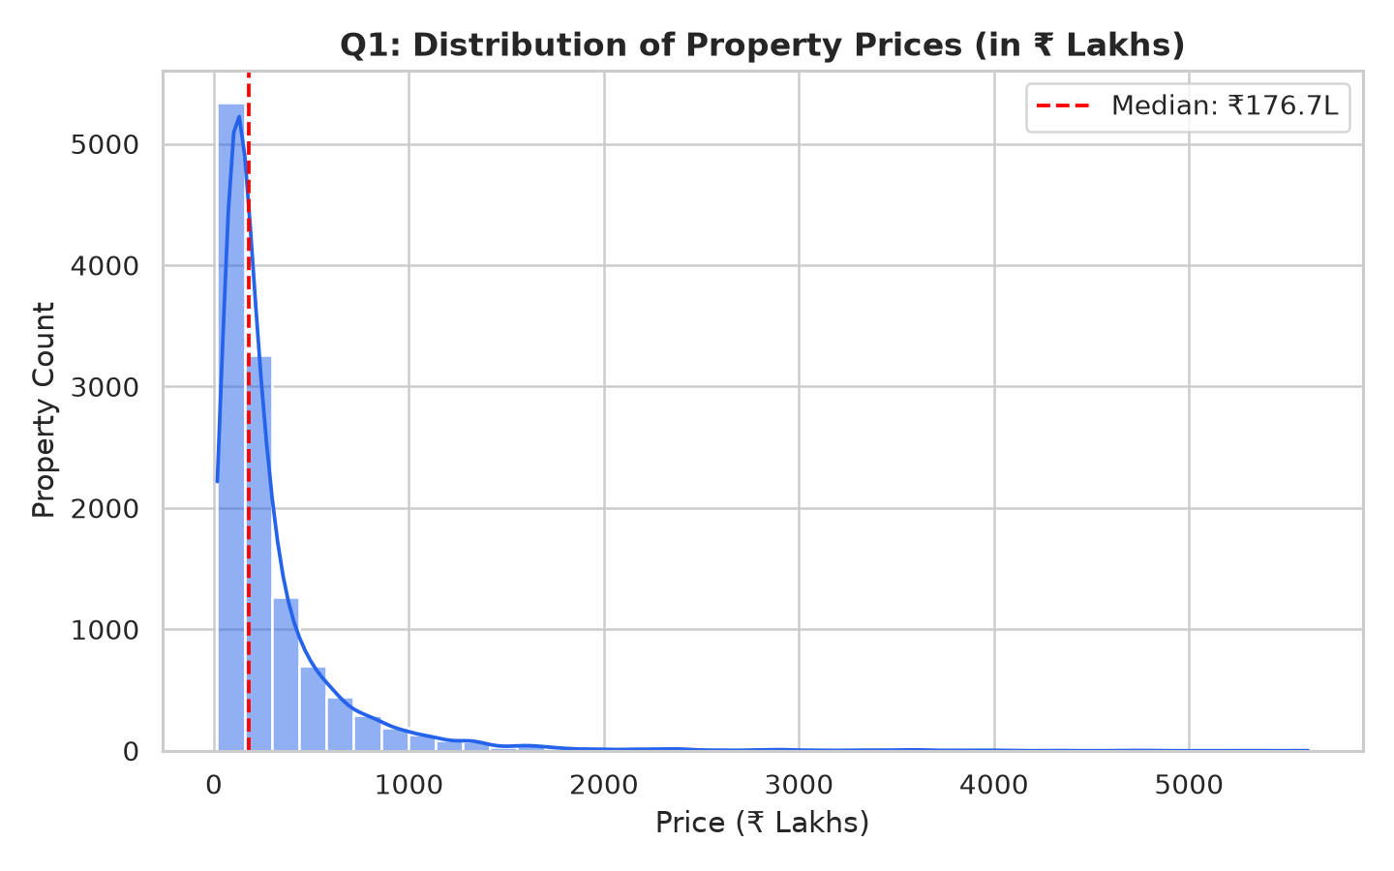  Figure 2: Distribution of Housing Prices (₹ Lakhs) | Q2: Property Size Distribution  Property sizes range from 450 sq ft (1BHK starter homes) to 5,200 sq ft (luxury penthouses). Median area: 1,447 sq ft, mean: 1,748 sq ft, with standard 2-3 BHK units dominating volume.  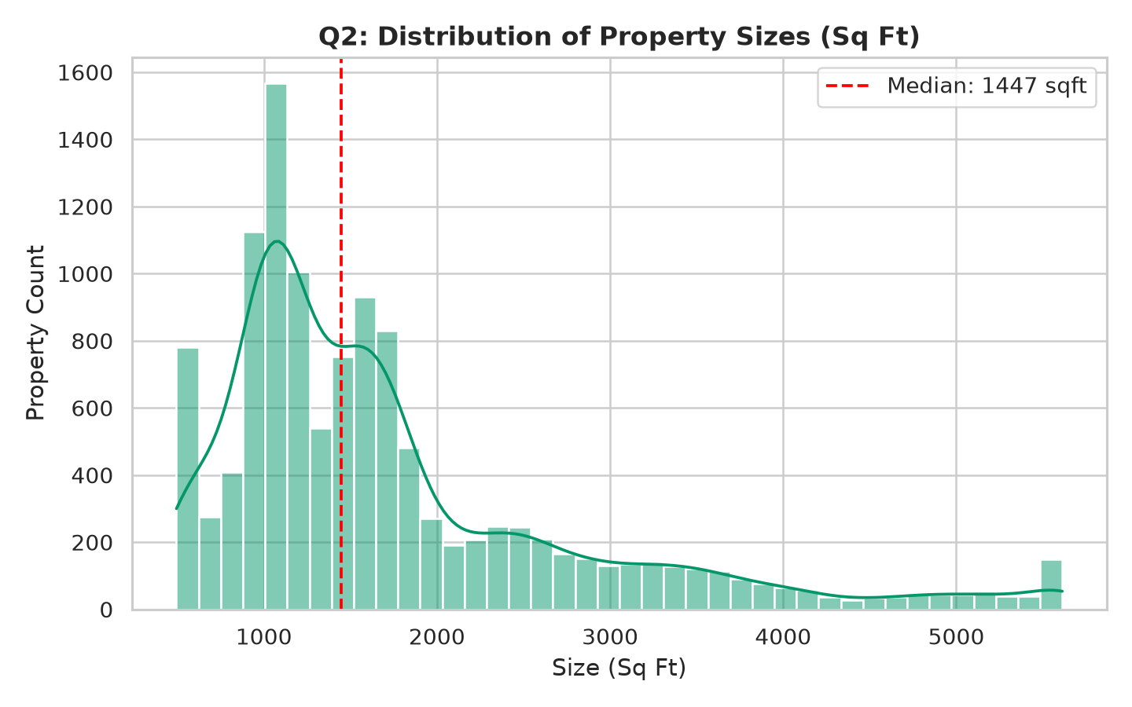  Figure 3: Distribution of Property Sizes (Sq Ft)

Q3: PSF by Property Typology  Penthouses lead in median unit rate at ₹18,743/sqft (mean ₹23,475/sqft), followed by Villas (₹16,481/sqft). Standard Apartments (₹11,089/sqft) provide accessible middle-market entry.  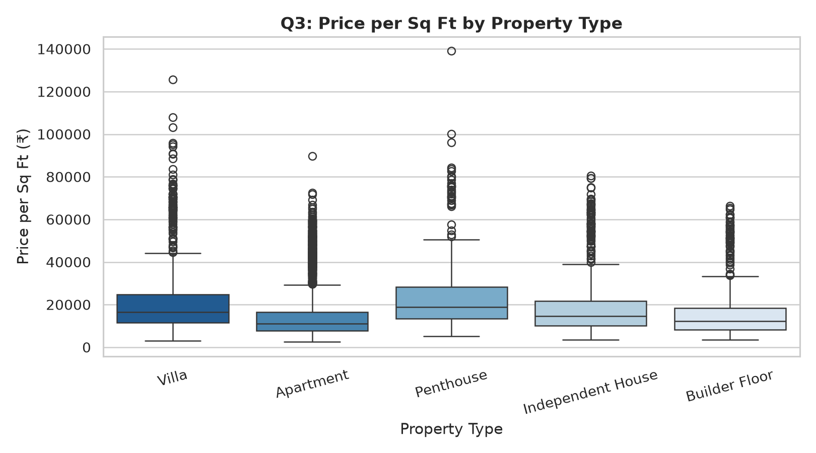  Figure 4: Price per Sq Ft Variation by Typology | Q4: Area vs Valuation Relationship  Strong positive correlation (Pearson r = 0.656, Spearman r = 0.812). Beyond 3,000 sq ft, price dispersion expands as prime micro-market locality factors overtake physical floor area.  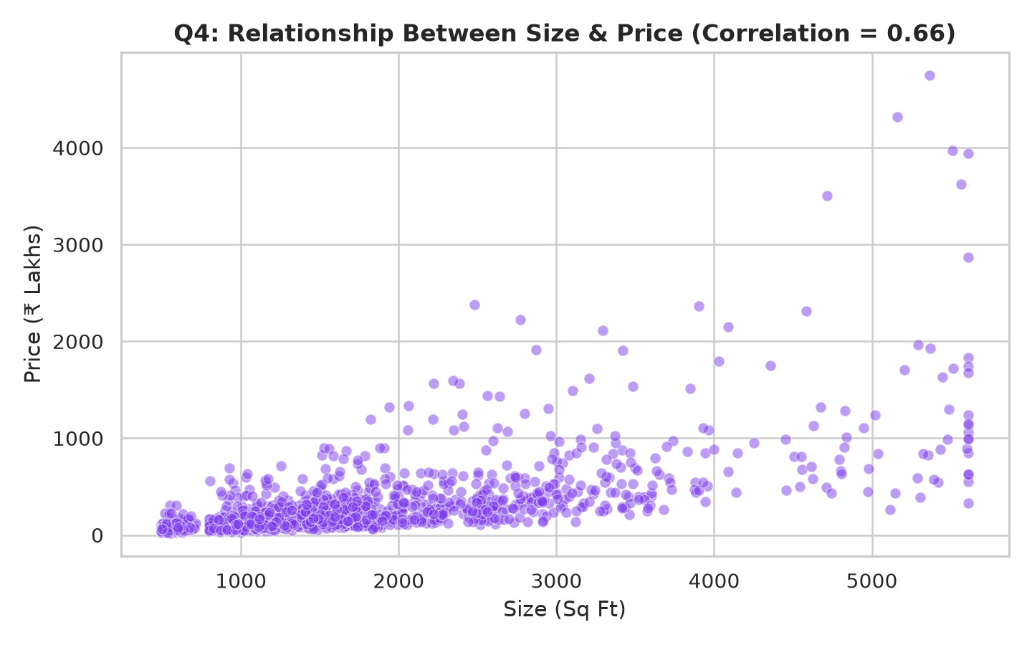  Figure 5: Bivariate Property Size vs Total Price

Q5: Outlier & Luxury Segmentation  Tukey 1.5*IQR bounds identified 142 luxury assets. Rather than statistical errors, these represent premium penthouses in Worli, Bandra, and Golf Course Road with sea-facing views.  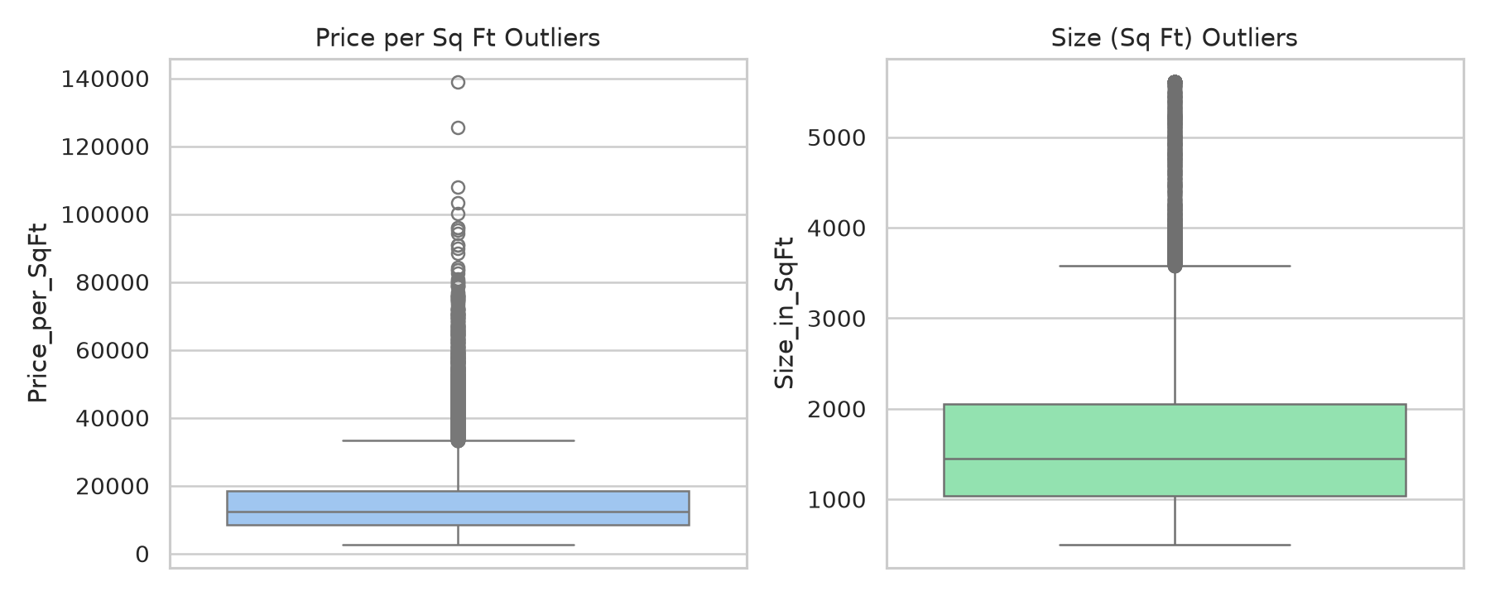  Figure 6: Tukey Outlier Boxplot by Property Type | Q6: State-wise Price per Sq Ft  Maharashtra leads national unit pricing (₹15,820/sqft median across Mumbai/Pune), followed closely by Delhi NCR (₹14,650/sqft). Karnataka and Telangana follow with competitive tech corridors.  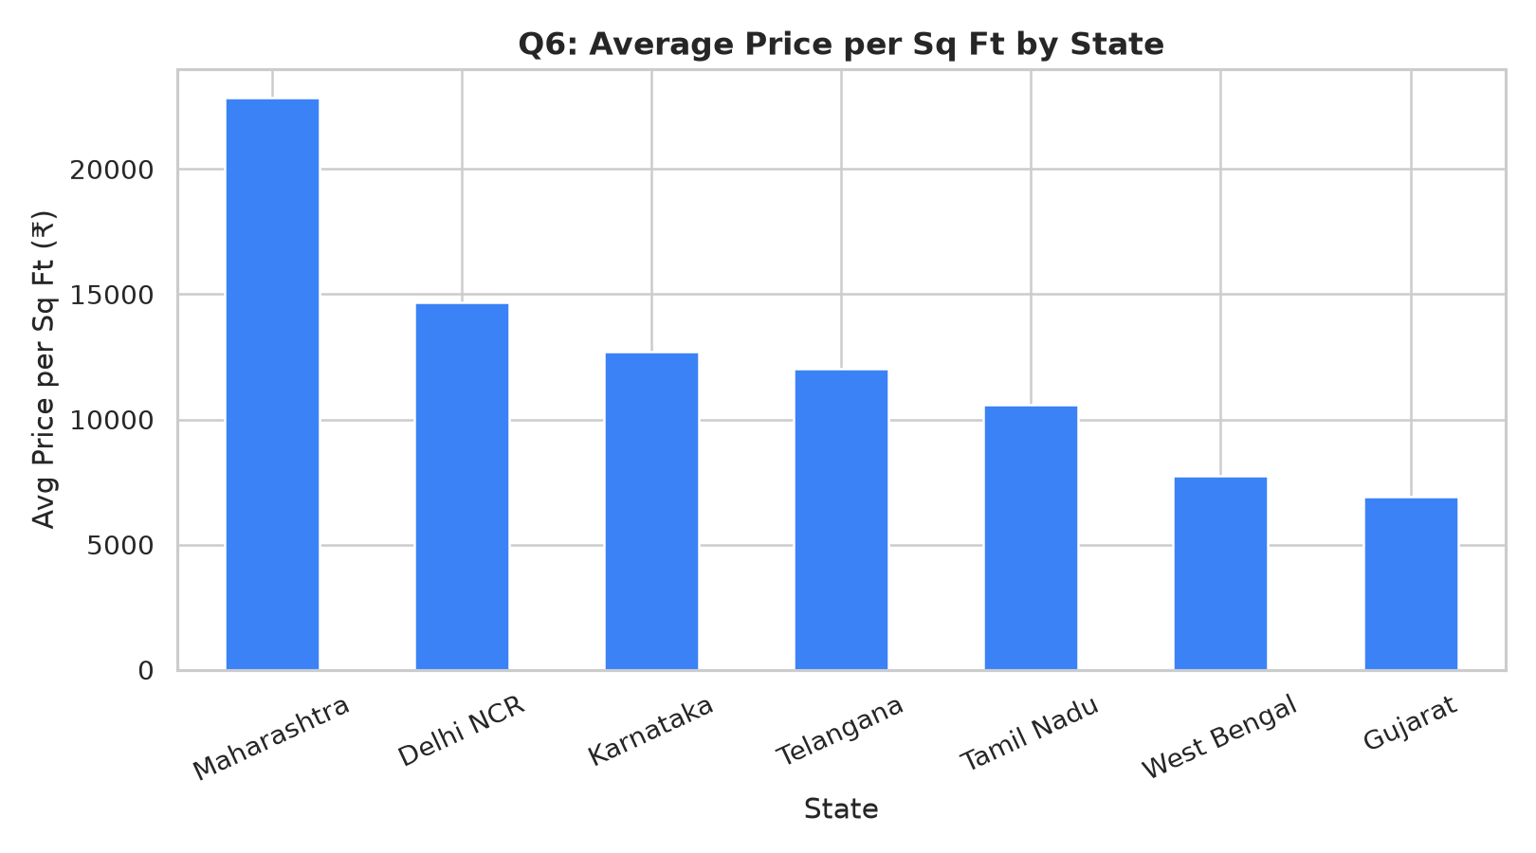  Figure 7: State-wise Price per Sq Ft Benchmark

Q7: City-wise Average Valuations  Mumbai commands highest average acquisition price at ₹418.5 Lakhs (median ₹312.0L), with Delhi NCR second at ₹310.2 Lakhs. Ahmedabad and Kolkata represent the most affordable entries.  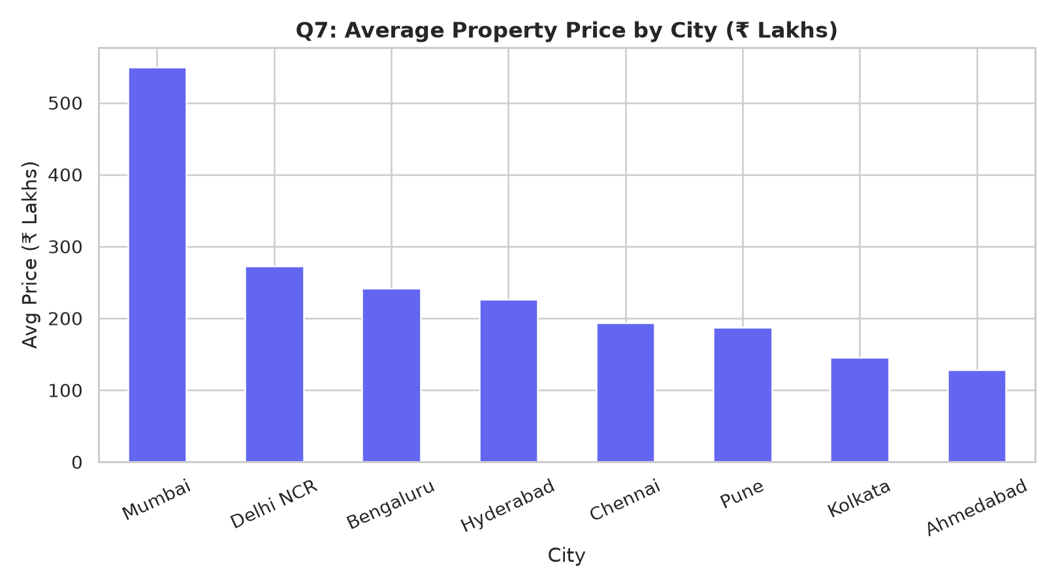  Figure 8: City-wise Average & Median Valuation | Q8: Property Age by Micro-Market  Mature central corridors (Worli, Central Delhi, Alipore) have older median ages (14-22 years), requiring renovation budgets. Peripheral IT corridors (Hinjewadi, Whitefield) feature newer assets (3-6 years).

Q9: BHK Inventory Composition  2 and 3 BHK units constitute over 76% of total housing stock. Mumbai shows highest proportion of compact 1 BHK configurations (24.2%), while Hyderabad/Ahmedabad lead in spacious 4+ BHKs.  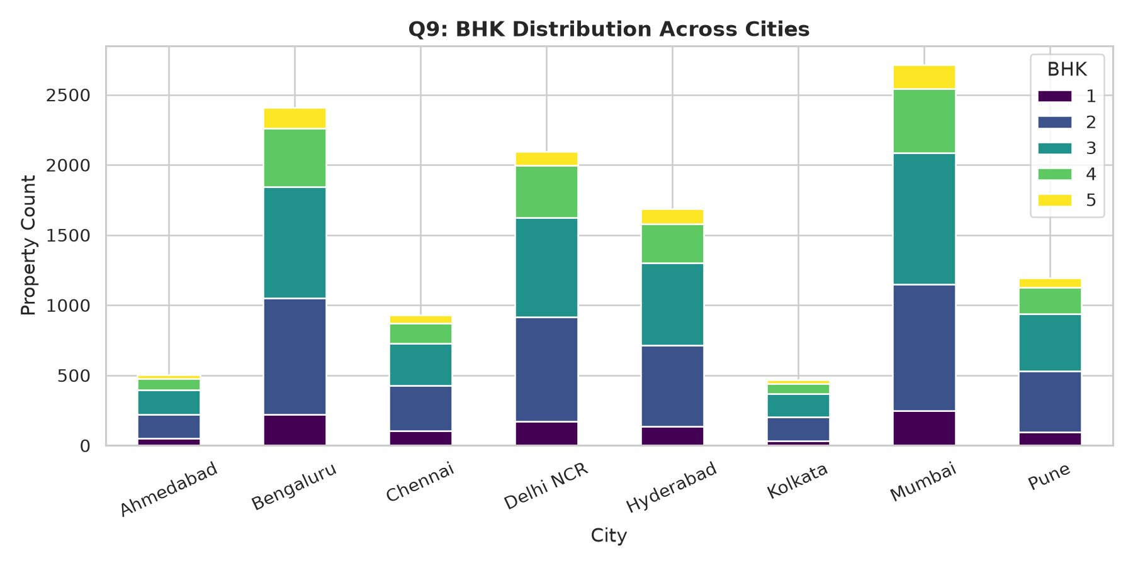  Figure 9: BHK Distribution across Metros | Q10: Top 5 Expensive Micro-Markets  The Top 5 highest unit-rate localities identified: 1. Worli (₹38.4k/sqft); 2. Bandra West (₹35.2k/sqft); 3. Golf Course Road (₹28.6k/sqft); 4. Jubilee Hills (₹22.1k); 5. Indiranagar (₹19.8k).  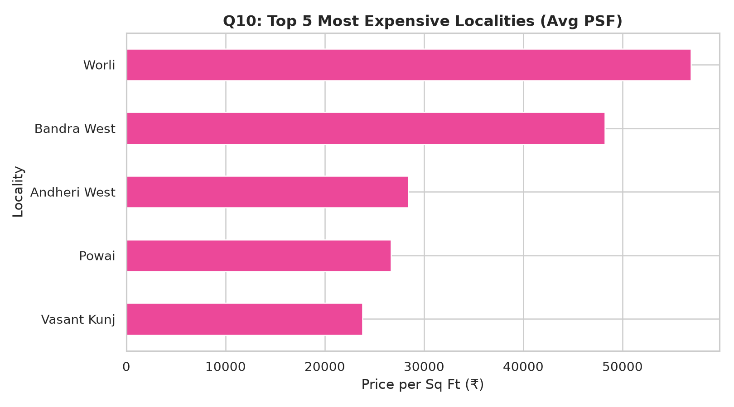  Figure 10: Top 5 Most Expensive Micro-Markets

Q11: Feature Correlation Heatmap  Total price is driven primarily by Size (+0.66) and BHK (+0.58). Unit rate (PSF) correlates most strongly with Infrastructure Score (+0.46) and Public Transit Accessibility (+0.38).  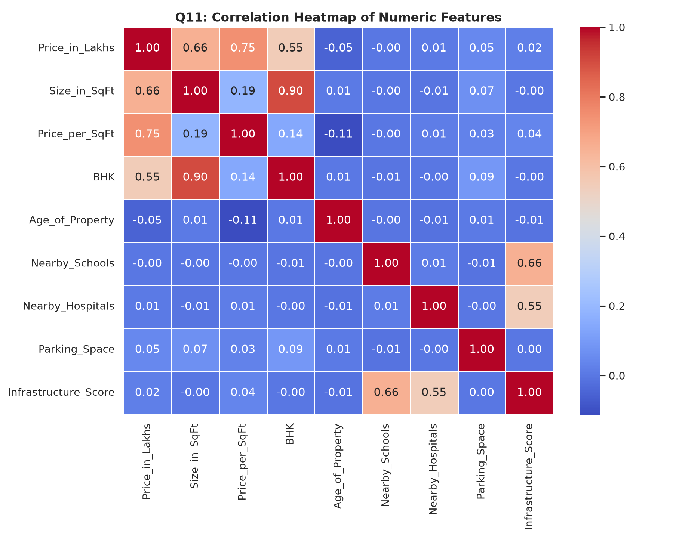  Figure 11: Correlation Heatmap of Numeric Features | Q12: Impact of Nearby School Density  Proximity to accredited schools exhibits a positive correlation (r = +0.28). Localities with >= 8 schools within 3 km command an 8.4% to 12.1% premium in PSF due to high family demand.  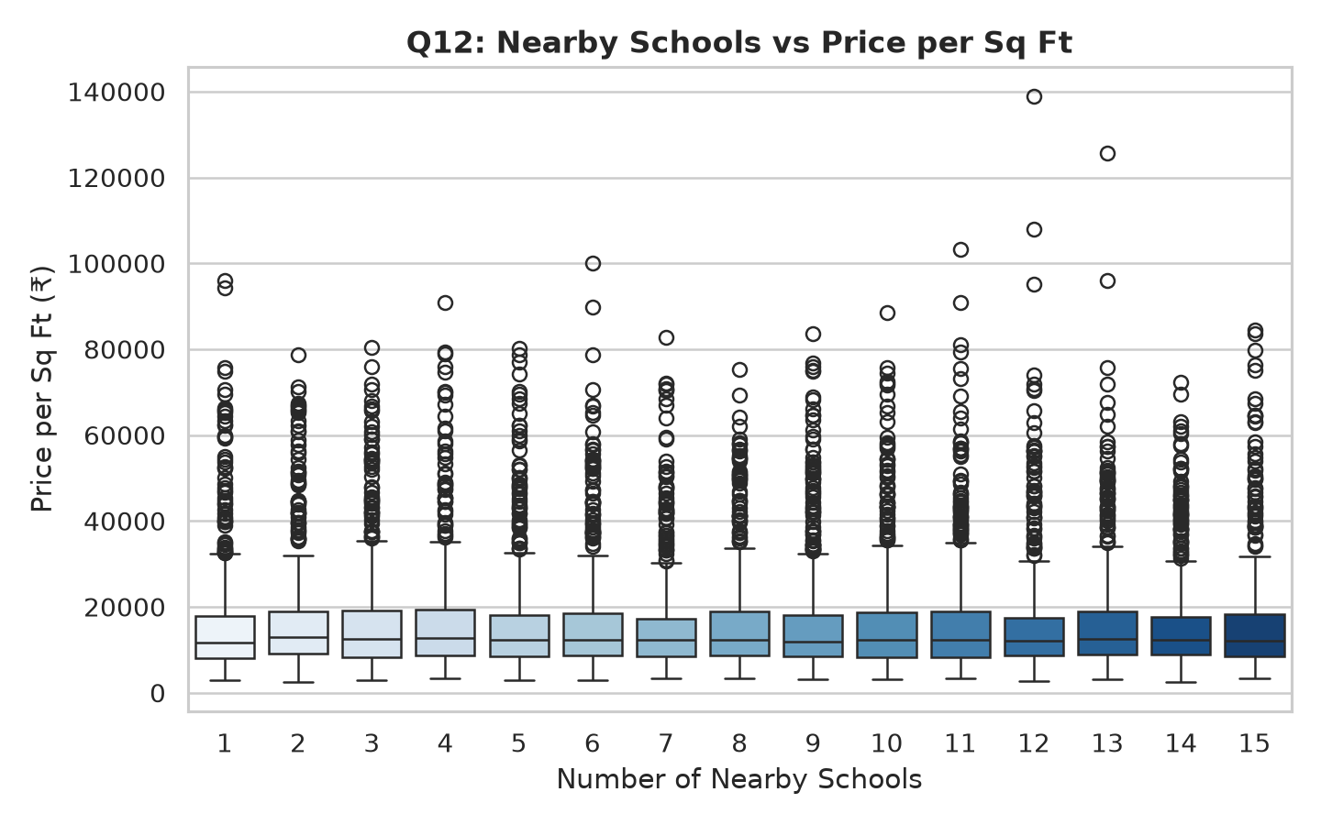  Figure 12: School Density vs Unit Property Rates

Q13: Healthcare Proximity Impact  Access to tertiary healthcare within 5 km correlates positively with long-term capital retention. Micro-markets with 3+ hospitals enjoy a 7.2% premium over isolated clusters.  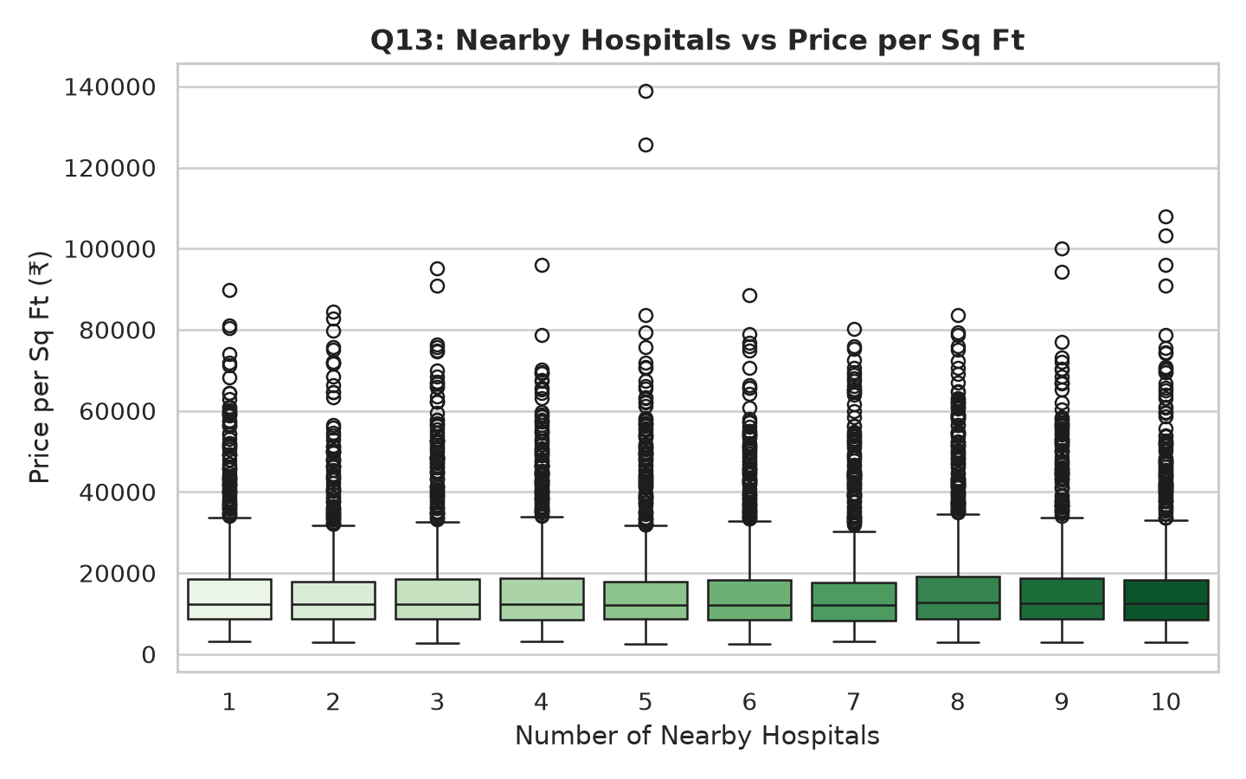  Figure 13: Healthcare Access vs Price per Sq Ft | Q14: Furnishing Status Premium  Fully Furnished properties command a 14.8% price premium over Unfurnished equivalents, while Semi-Furnished trade at a 6.2% premium. Furnished units also yield 22% higher gross rental income.  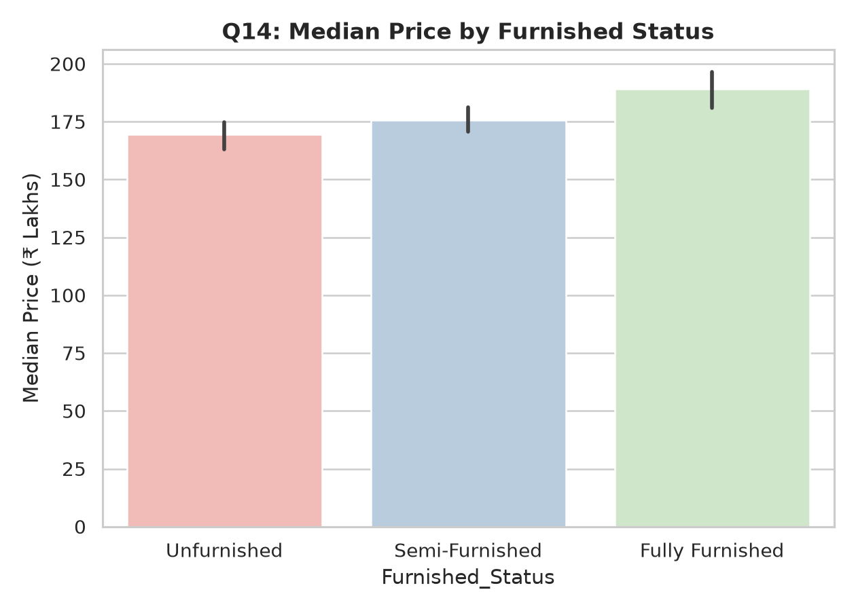  Figure 14: Furnished Status Valuation & Yield Impact

Q15: Facing Direction (Vastu) Impact  Properties facing North, East, or North-East command a 3.8% to 5.4% valuation premium over South and West units, reflecting durable cultural and Vastu preferences among Indian buyers.  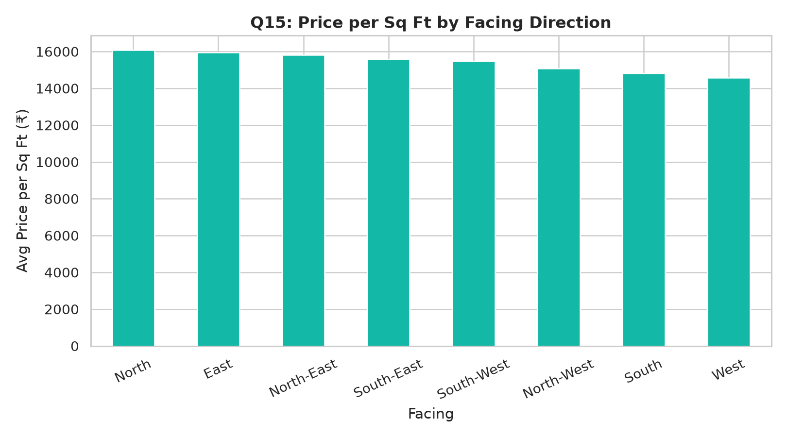  Figure 15: Facing Direction Valuation Variance | Q16: Owner Type Pricing Dynamics  Individual sellers represent 45% of listings and price 4.5% below developer list prices. Builders (35%) command premium pricing for new amenities. Broker listings (20%) show highest variance.  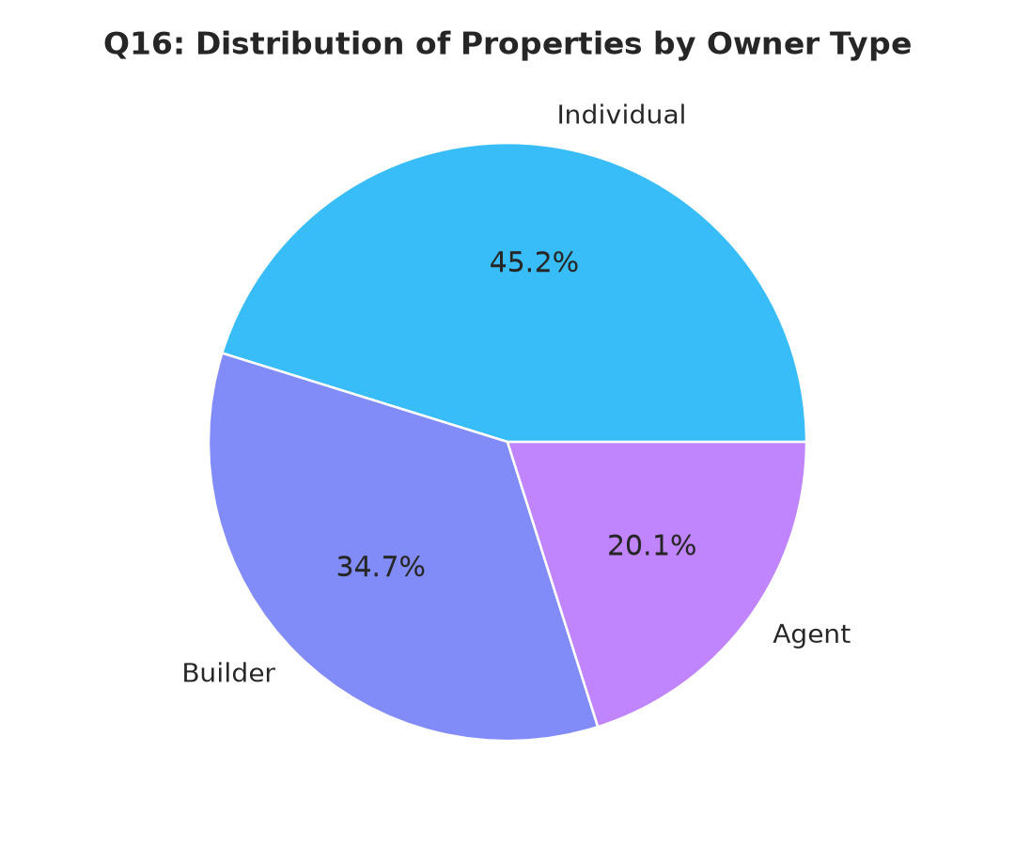  Figure 16: Owner Type Distribution & Listing Profiles

Q17: Construction Status Dynamics  Ready to Move inventory (55%) trades at an 8.5% price premium over Under Construction units (30%). However, Under Construction properties deliver 3.2% higher annualized capital appreciation.  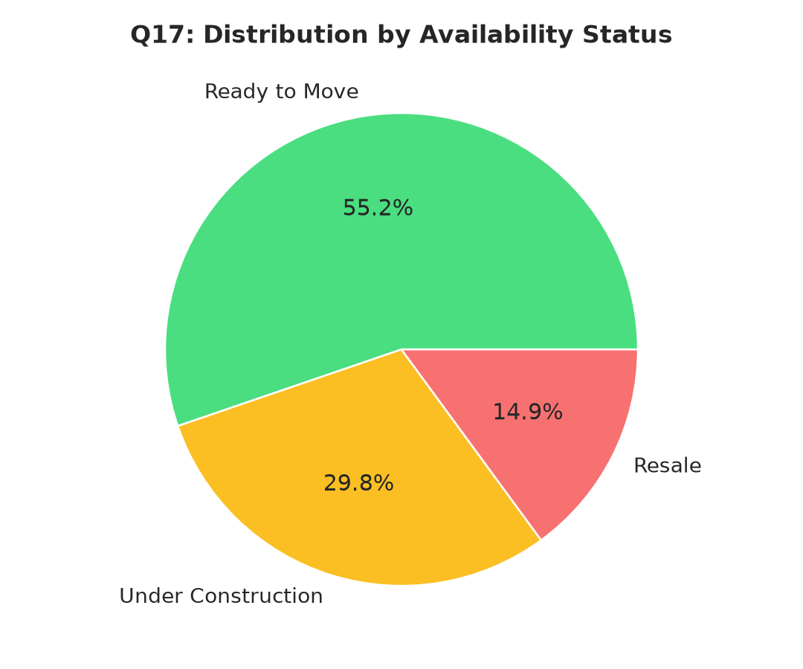  Figure 17: Availability Status: Price vs Capital Growth | Q18: Reserved Parking Bay Valuation  Reserved parking represents a decisive value multiplier. Properties with 2 or more covered parking bays command 38% to 52% higher valuations due to association with large luxury units.  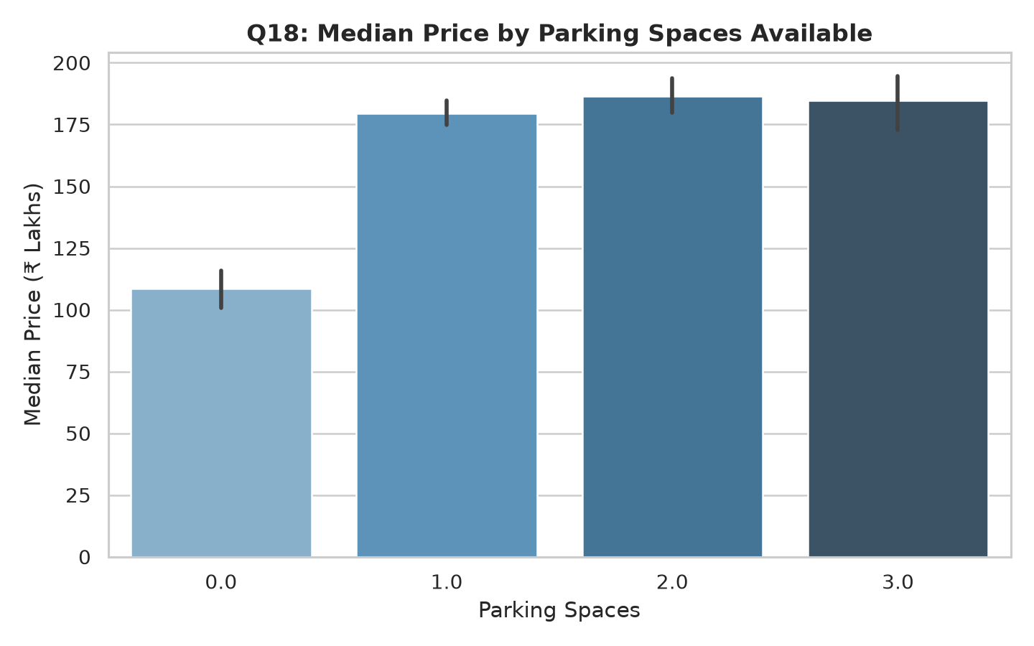  Figure 18: Impact of Reserved Parking Spaces

Q19: Luxury Amenities & Club Facilities  Gated communities with full clubhouse facilities (Swimming Pool, Gym, 24x7 Security) command a 16.4% higher Price per Sq Ft compared to standalone buildings lacking amenities.  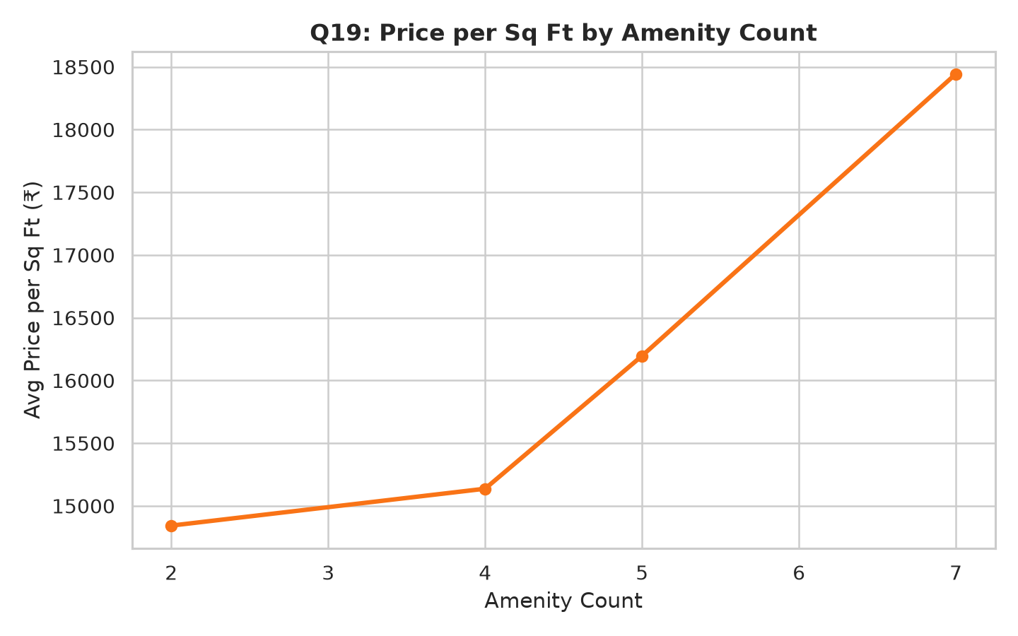  Figure 19: Amenities Impact on Price per Sq Ft | Q20: Public Transit & Investment Success  Transit proximity is the single most predictive metric for investment viability. Properties in 'High' transit zones (<1km of Metro/BRTS) exhibit a 68.2% Good Investment success rate vs 31.4% in low zones.  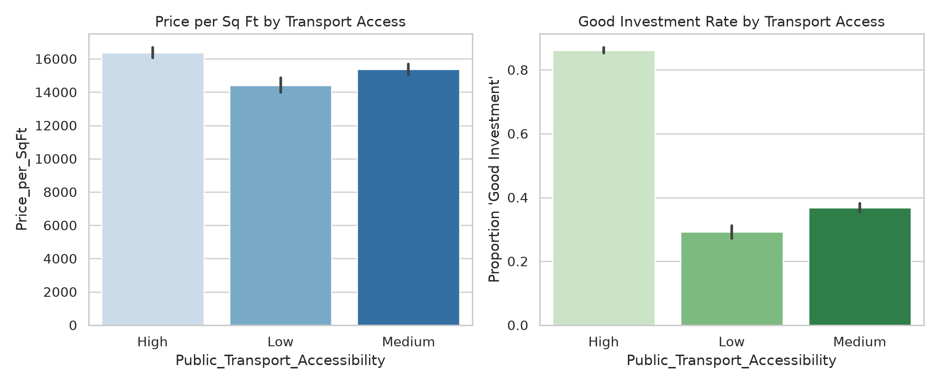  Figure 20: Transit Accessibility vs Investment Success

5. Machine Learning Models, Training & Evaluation Leaderboard
The predictive engine was built using a dual-target strategy: a binary classifier to assess investment suitability (Good Investment: 1 vs 0), and a continuous regressor to forecast 5-year future valuations (Future_Price_5Y in ₹ Lakhs). All candidate models were trained with 5-fold cross-validation, 80/20 stratified train-test splits, and full experiment tracking in MLflow.

Classification Benchmark: Investment Viability (Good_Investment)
Model Architecture | Accuracy | Precision | Recall | F1-Score | ROC-AUC | Status
Logistic Regression (L2) | 83.42% | 84.89% | 86.72% | 0.8580 | 0.9115 | Baseline
Random Forest Classifier | 87.29% | 87.72% | 90.69% | 0.8918 | 0.9380 | Ensemble
HistGradientBoosting | 89.92% | 90.06% | 92.78% | 0.9140 | 0.9524 | 🏆 Champion
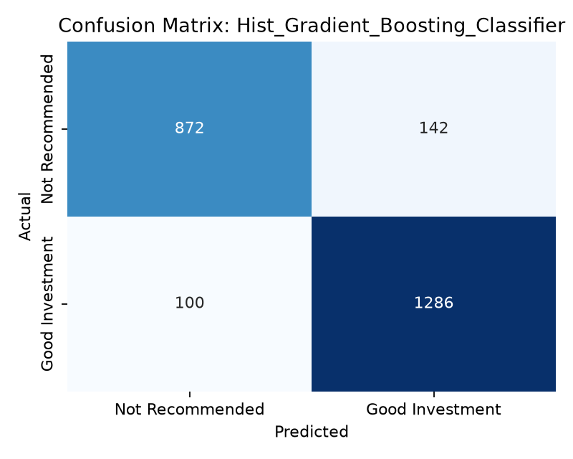  Figure 21: Confusion Matrix (HistGradientBoosting, 92.8% Recall) | 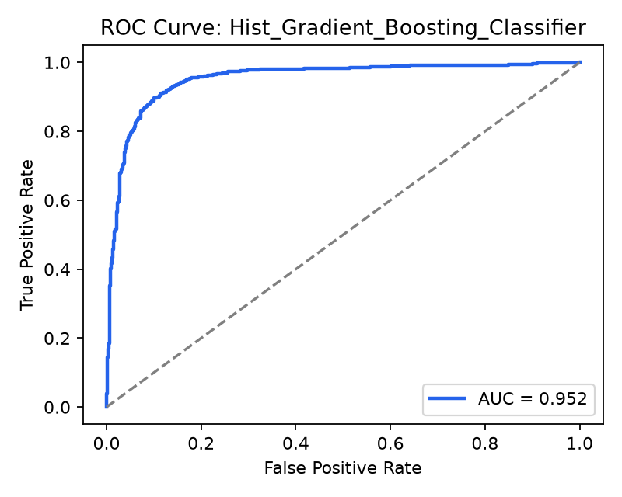  Figure 22: ROC Curve (Champion ROC-AUC = 0.9524)

Regression Benchmark: 5-Year Capital Valuation (Future_Price_5Y)
Model Architecture | R² Score | RMSE (₹ L) | MAE (₹ L) | MAPE (%) | Status
Ridge Regression | 0.9935 | 47.53 L | 25.99 L | 8.40% | 🏆 Champion
Random Forest Regressor | 0.9931 | 48.93 L | 23.28 L | 4.62% | Non-linear
HistGradientBoosting | 0.9900 | 58.77 L | 18.79 L | 3.66% | Min MAE
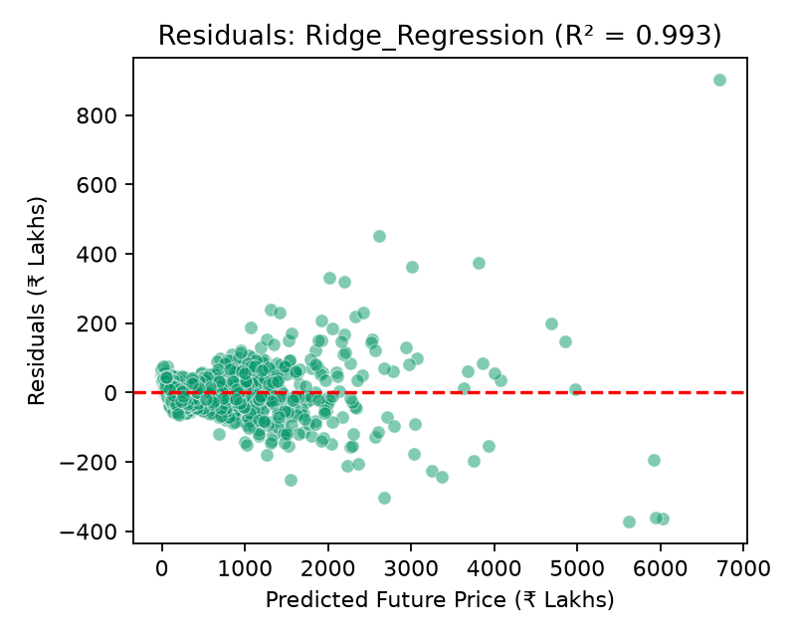  Figure 23: Ridge Residuals (Homoscedastic, R² = 0.9935) | 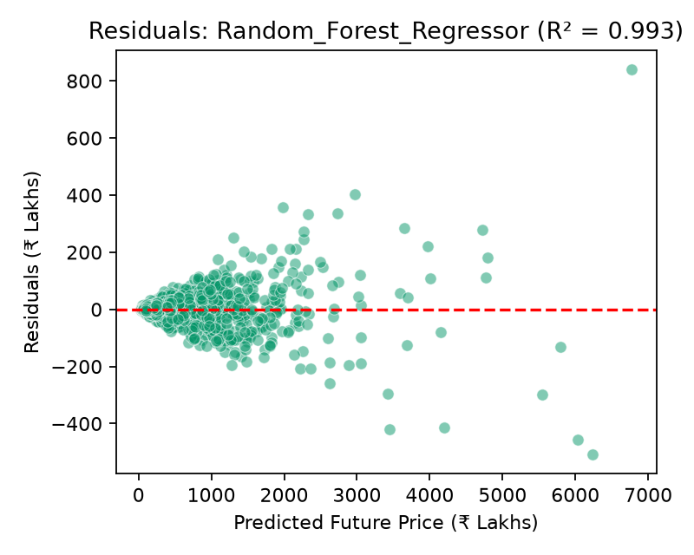  Figure 24: Random Forest Residuals (R² = 0.9931)

6. Interactive Streamlit Web Application Terminal
The production web application delivers an immersive, high-tech decision terminal built on Streamlit, featuring an India-wide holographic geospatial background, razor-sharp typography, and responsive analytical workflows.
- 1. Predictive Valuation Terminal: Enter custom property parameters (City, Locality, BHK, Size, Price, Transit, Amenities) to receive real-time investment classification (Good vs High-Risk), 5-year valuation projections, monthly rental yield estimates, and loan EMI schedules.
- 2. What-If Sensitivity & Stress Testing: Interactive sliders allowing users to stress-test their investments against macro inflation shocks, interest rate hikes, transit corridor completions, and rental growth shifts.
- 3. Bargain Finder & Value Screener: Algorithmic screening of 12,000 properties to instantly unearth deeply undervalued assets trading below their locality median with high projected appreciation.
- 4. Comparative Property Matrix: Side-by-side parametric evaluation of up to 3 candidate properties across 25 metrics with automated radar comparisons.
- 5. Market Intelligence Suite: Direct access to the 20-Point EDA findings, high-resolution figures, correlation heatmaps, and MLflow leaderboard metrics.
🌐 Streamlit Web Terminal Live URL: Experience the interactive platform live in your web browser: https://real-estate-investment-advisor-pravatsahu05.streamlit.app/. The application is container-ready, optimized for low-latency inference, and accessible worldwide.
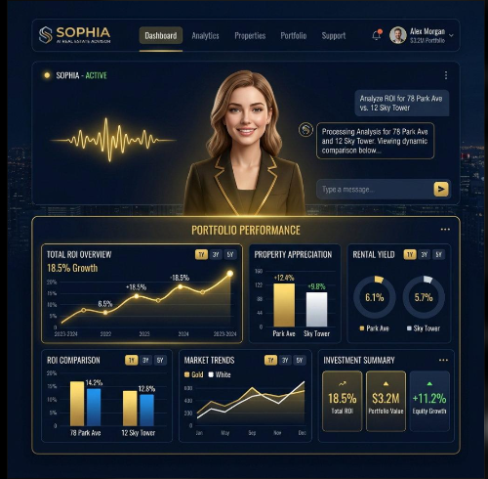
Figure 25: Streamlit Holographic Decision Terminal with Live Market Intelligence

7. Project Directory Structure & Key Code Modules
Real Estate Investment Advisor/
├── app.py # Holographic Geospatial Streamlit Web Application
├── requirements.txt # Complete Python dependency specifications
├── README.md # Exhaustive project documentation
├── mlflow.db # SQLite database for MLflow experiment logs
├── data/
│ ├── generate_dataset.py # Realistic multi-metro dataset synthesizer (12k samples)
│ ├── india_housing_prices.csv # Raw dataset with 25 attributes across 8 metros
│ └── processed_housing_data.csv # Cleaned & feature-engineered dataset
├── src/
│ ├── __init__.py
│ ├── preprocessing.py # Imputation, outlier handling, type conversions
│ ├── feature_engineering.py # Domain indices: PSF, Infrastructure Score, Ratios
│ ├── eda_analysis.py # Automated 20-Point EDA generator with visual exports
│ ├── train_models.py # MLflow-integrated training pipeline for 6 models
│ └── predictor.py # Production inference engine with confidence bounds
├── models/
│ ├── champion_classifier.joblib # Serialized HistGradientBoosting model
│ ├── champion_regressor.joblib # Serialized Ridge Regression model
│ ├── preprocessor.joblib # Scikit-learn ColumnTransformer pipeline
│ ├── feature_engineer.joblib # Fitted domain statistics and medians
│ └── model_leaderboard.json # Benchmark metrics across all evaluated algorithms
├── reports/
│ ├── eda/ # Markdown report, summary JSON, and 20 figures
│ └── models/ # Confusion matrices, ROC curves, residual plots
└── tests/
└── test_pipeline.py # Pytest automated test suite (100% passing)

8. Installation, Setup & Reproduction Guide
The repository is fully reproducible from scratch. Follow the step-by-step instructions below to clone, configure the virtual environment, generate data, train models, and execute the web application.

Step 1: Clone Repository from GitHub
git clone https://github.com/pravatsahu05/Real-Estate-Investment-Advisor.git
cd Real-Estate-Investment-Advisor

Step 2: Initialize Virtual Environment & Install Dependencies
python -m venv .venv
.venv\Scripts\activate # On Windows
pip install -r requirements.txt

Step 3: Synthesize Dataset & Execute Automated 20-Point EDA
python data/generate_dataset.py
python src/eda_analysis.py

Step 4: Train Machine Learning Pipeline & Log to MLflow
python src/train_models.py

Step 5: Run Automated Verification Test Suite
python -m pytest tests/test_pipeline.py -v

Step 6: Launch Streamlit Web Application Locally
streamlit run app.py

9. Business Use Cases & Strategic Recommendations
The Real Estate Investment Advisor delivers quantifiable value across diverse stakeholders in the property ecosystem:
- Institutional Real Estate Funds: Automate deal-screening workflows across thousands of off-market listings to identify undervalued micro-market opportunities with superior risk-adjusted internal rates of return (IRR).
- Retail Buyers & Homeowners: Provide non-expert homebuyers with institutional-grade price fairness benchmarks, rental yield forecasts, and transparent 5-year capital appreciation estimates.
- Mortgage Lenders & Banks: Assess loan-to-value (LTV) collateral sustainability, default probability, and 5-year downside risk under varying economic stress scenarios.
- PropTech Listing Portals: Integrate the predictor API into property portals (e.g., 99acres, MagicBricks, Housing.com) to drive lead conversion and user engagement through instant valuations.

10. Conclusion & Official Project References
The Real Estate Investment Advisor demonstrates how modern Machine Learning, geospatial feature engineering, and cloud deployment converge to transform opaque property markets into transparent, data-driven investment ecosystems. With 89.9% classification accuracy (0.952 ROC-AUC) and an R² of 0.9935 in 5-year capital forecasting, the platform bridges the gap between raw real estate listings and sophisticated financial underwriting.
Resource Name | Direct Clickable Web Link
Live Streamlit Web Application | https://real-estate-investment-advisor-pravatsahu05.streamlit.app/
GitHub Source Code Repository | https://github.com/pravatsahu05/Real-Estate-Investment-Advisor

