

**Web Technology**

**A project report**

**on**

**Titanic**

* A HTML 5 Game

**Submitted by**

**1PI11CS116, Prafulla**

**1PI11CS122, Praveen Chukka**

**1PI11CS138, Rashmi Raghunandan**

**Guide:**

**Professor N S KUMAR.**

Department of Computer Science & Engineering

**PES INSTITUTE OF TECHNOLOGY**

*(An Autonomous Institute under VTU Belgaum)*

**100 Feet Road, BSK III Stage, Hosakerehalli, Bengaluru - 560 085**



**Web Technology**

**A project report**

**on**

**Titanic**

* A HTML 5 Game

**Submitted by**

**1PI11CS116, Prafulla**

**1PI11CS122, Praveen Chukka**

**1PI11CS138, Rashmi Raghunandan**

**Guide:**

**Professor N S KUMAR.**

Department of Computer Science & Engineering

**PES INSTITUTE OF TECHNOLOGY**

*(An Autonomous Institute under VTU Belgaum)*

**100 Feet Road, BSK III Stage, Hosakerehalli, Bengaluru - 560 085**



**PES INSTITUTE OF TECHNOLOGY**

*(An Autonomous Institute under VTU Belgaum)*

**100 Feet Road, BSK III Stage, Hosakerehalli, Bengaluru - 560 085**

Department of Computer Science & Engineering

CERTIFICATE

This is to certify that the project entitled “**Titanic**” has been carried out by

**1PI11CS116, Prafulla**

**1PI11CS122, Praveen Chukka**

**1PI11CS138, Rashmi Raghunandan**

in the partial fulfillment of sixth semester Web Technology [11CS353]

Signature of the Signature of the

**Lab Incharge Head - CSE**

**Name & Signature of the Examiners:**

Examiner 1:

Examiner 2:

**ACKNOWLEDGEMENTS**

The satisfaction that accompanies the successful completion of any task would be incomplete without the mention of the people who made it possible, and whose constant guidance and encouragement helped us in completing the project successfully. We consider it a privilege to express gratitude and respect to all those who guided us throughout the course of the completion of the project.

We would like to express our heartfelt thanks to **Prof. M. R. Doreswamy**, PESIT founder, **Prof. D. Jawahar,** CEO and **Dr. K. N. Balasubramanya Murthy**, Principal, for providing us with a congenial environment for carrying out the project.

We express our gratitude to **Prof.Nitin V. Pujari**, Head of the Department, Computer Science, PESIT, whose guidance and support has been invaluable and for including the project as part of the course.

We extend our sincere thanks to our mentors **Prof. N S Kumar and Prof. Sahana Patil** for their constant guidance, encouragement, support and invaluable advice without which this project would not have been completed.

Last, but not the least, we would like to thank our friends whose invaluable feedback helped us to improve the software by leaps and bounces, and our parents for their unending encouragement and support.

**CONTENTS**

**Acknowledgements………………………………………………………….. 1**

**Introduction…………………………………………………………………. 4**

**Design Details…………………………………………………………………5**

**Test Cases and Results...……………………………………………………..12**

**Conclusion…………………………………………………………………… 14**

**Bibliography…………………………………………………………………..15**

**INTRODUCTION**

**Aim:**  To implement a game based on HTML 5 and gain deeper knowledge on the working of the web.

**Titanic** is an HTML5 game application that can be deployed on both desktops as well as mobile devices.

The aim of the game is to control the movement of a ship in the ocean. The ship is supposed to be manoeuvred such that it does not collide with any ice berg. The user is scored based on the number of ice bergs he manages to cross.

The difficulty of the game is controlled by making use of varying speed and shape of icebergs. There are several effects on the canvas which include waves and a wind based ship manoevring. All these effects have been created to make the game a lot more hard to play, as that was our initial objective. The game was inspired by the popular mobile game, “Flappy Bird” which had gained huge traction in the beginning of 2014.

Scope and Limitations:

1. The game works only on Google Chrome browser. This is because canvas and the other features used are not supported by common browsers like Firefox and Internet Explorer.
2. Since the game is done on a canvas, it can be ported as mobile apps using frameworks like phonegap very easily.
3. Sensors of the phone such as a gyroscope and the touch sensors can be used to maneurvor the ship.
4. Possibility of performance issues occuring during gameplay is higly likely for HTML5 games. But, our team has used neat techniques to overcome most of these problems.

**DESIGN DETAILS**

1. Canvas was used as the base to create the game.

2. Ship and Icebergs were images of the canvas screen.

3. Each object on the screen was made a literal object. Eg. Ship, Stream, Iceberg and Wave.

4. An init method initialises the ship and icebergs are generated at different speeds, positions and sizes using random function.

5. The ship remains at a constant position throughout the game. The screen is redrawn and moved downwards giving an effect that the ship is in motion. This is done by the roll function.

6. Collision between icebergs and ship was detected using the position of ship and icebergs defined in their respective literal objects

7. To redraw the screen, our own logic was used to remove previously existing parts of the screen.

**CHALLENGES**

1. Screen Redraw was a tough task as the movement of the ship should be as smooth as possible. Previous Remnants of the screen should not be retained.
2. Canvas positions are more difficult to deal with when compared to DOM.
3. The varying speed of icebergs was difficult to implement.
4. Perfomance issues might occur when using this in a phone application since it is a HTML5 game.
5. Collision detection is not completely sure shot, since the ship being used has uneven edges.
6. Overwriting the canvas might show certain defects with the layout.

**TEST CASES AND RESULTS**

We have considered several factors for the ship to go overboard and for the ship to be maneuvored appropriately. And here they are,

1. Ship Proceeding Straight (Initially)

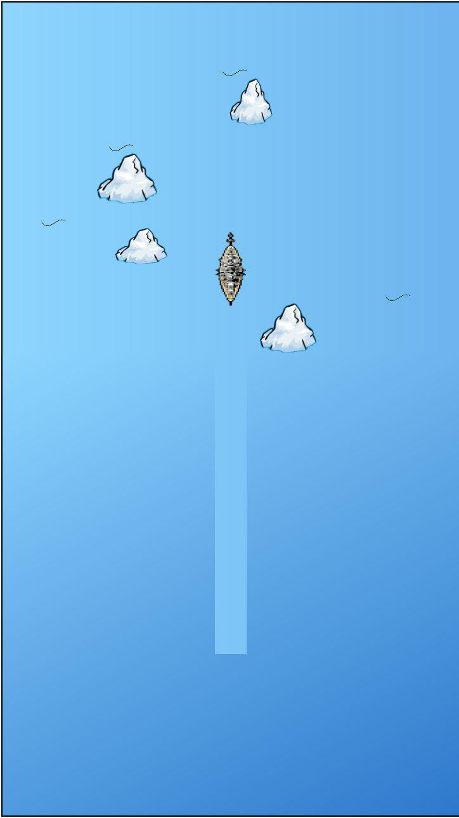

1. Continuous motion of ship

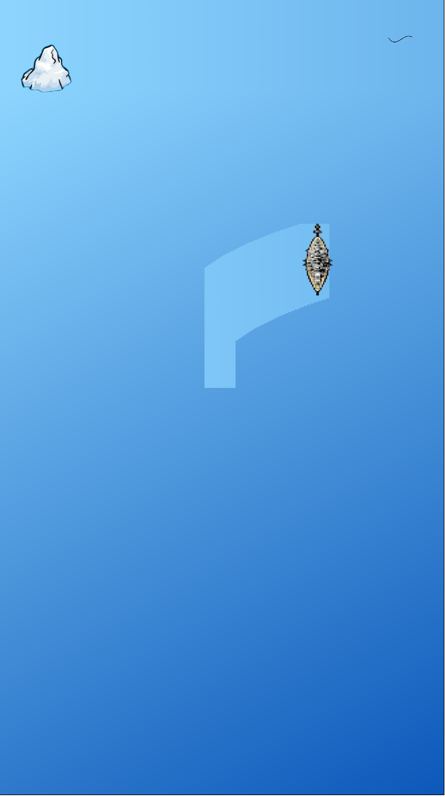

1. Ship Colliding with Ice berg

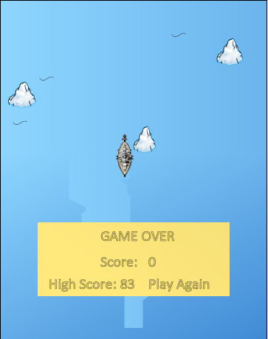

1. Ship Colliding with the edges

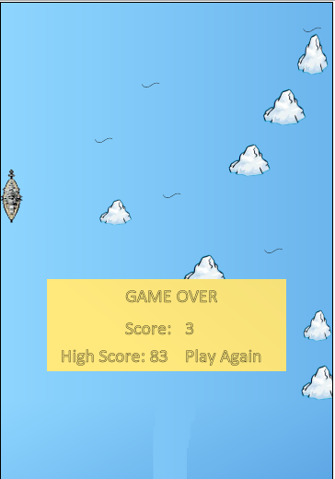

**CONCLUSION**

Implementation of this project made us learn and understand the new and variety of features of HTML 5 and also explore new avenues in Java Script. Creating HTML5 games is not quite similar to a the usual OpenGL games since there are no such vectors of displacement. We liked the idea that a single game can be used in multiple platforms. Performance issues are a major hazzle when it comes to creating games and more specially, creating canvas games. Therefore, it needs a whole new line of thinking.We hope to see more functionality to be provided to developers in the following versions for HTML in the several years to come.

**BIBLIOGRAPHY**

1. [www.w3schools.com](http://www.w3schools.com)
2. [www.stackoverflow.com](http://www.stackoverflow.com)
3. [www.google.com](http://www.google.com)
4. www.wikipedia.com