**IAM**

IAM stands for Identity and Access Management. It's a framework of policies and technologies that ensures the right individuals access the right resources at the right times for the right reason.

**Types of Policies:**

* **AWS Managed Policies**
* **Inline Policies**

**AWS Managed policies:**

There multiple aws managed policies are available in IAM .These policies are managed by AWS .

**Inline Policies:**

These are the customer managed policies.

**Steps to create User in IAM:**

* Go to IAM dashboard and click on users.
* Click on create user and enter the name of user.
* While creating user we can select the “provide user access to aws console” option or we can create this access after creation of user.
* Click on next and select the attach policies directly.
* Select the services which we want to give the access to the user in the permissions policies.
* Click on create user.

**Log Into the new IAM User:**

* Click on the username and click on security credentials.
* Copy the console sign in link on the browser.
* Enter name of the user and password (custom password).If you are not select a “provide user access to aws console” option while creating user you can recreate the new password while sign in into the console as a iam user.
* Now we can login to the new iam use

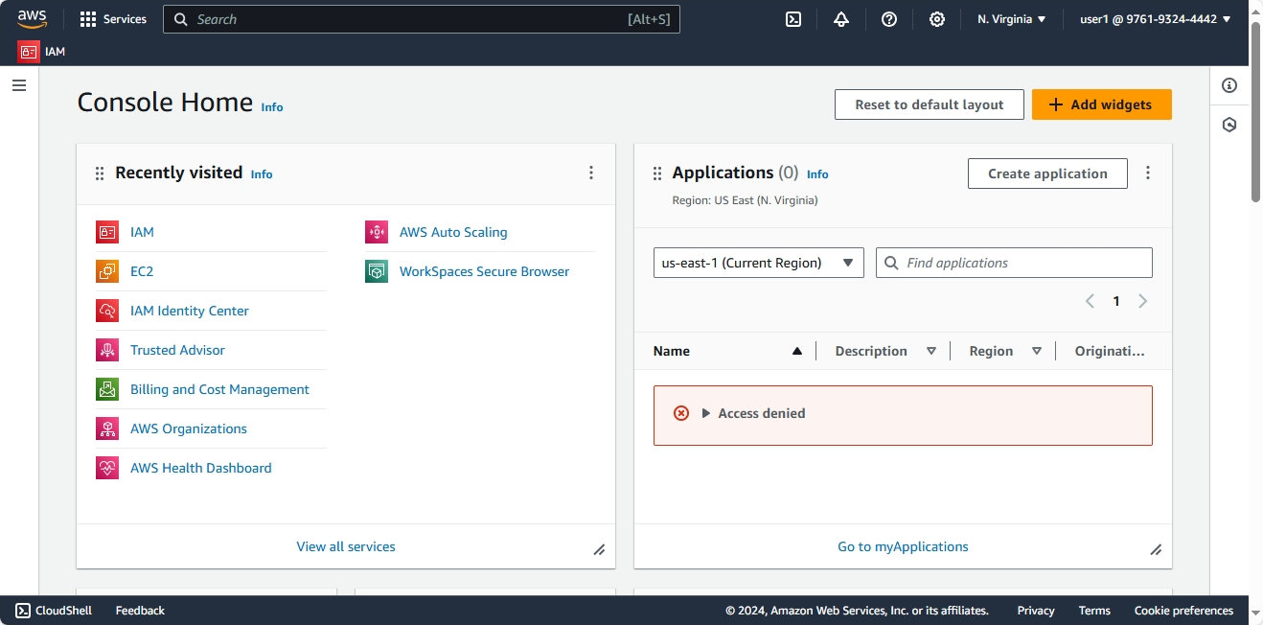

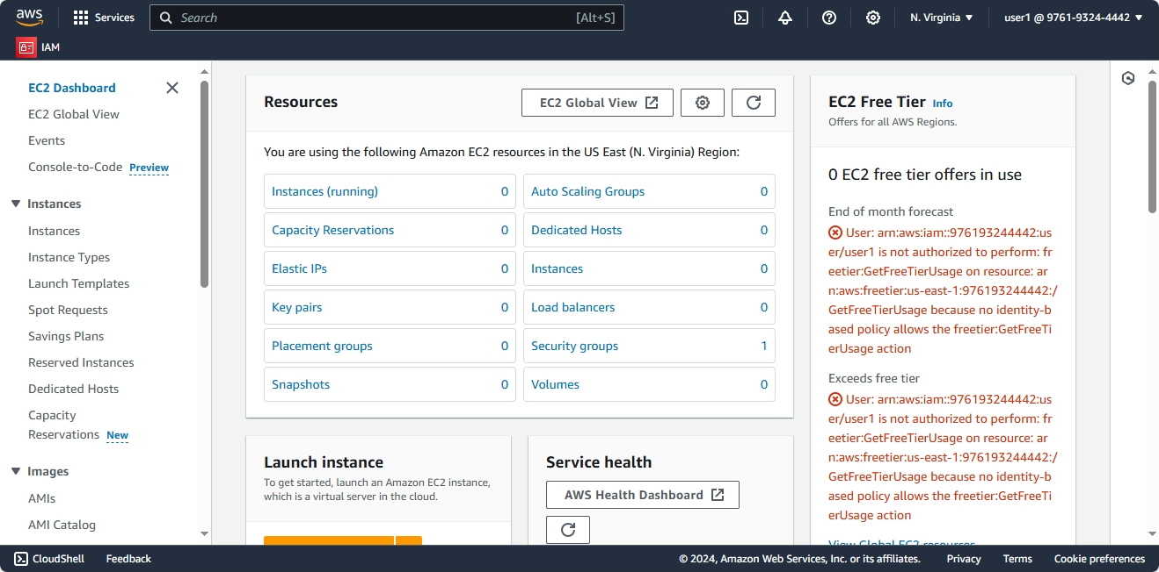

**Steps to create the IAM Role:**

* Click on the roles which is available on iam dashboard.
* Click on create role and select aws service .
* Select the use case or service (To which service we want to add this role).In which I have selected EC2 service.
* Click on next and select the services which services we want to access from above service .(in which I have selected s3 service).
* Enter the name of role and click on create role.

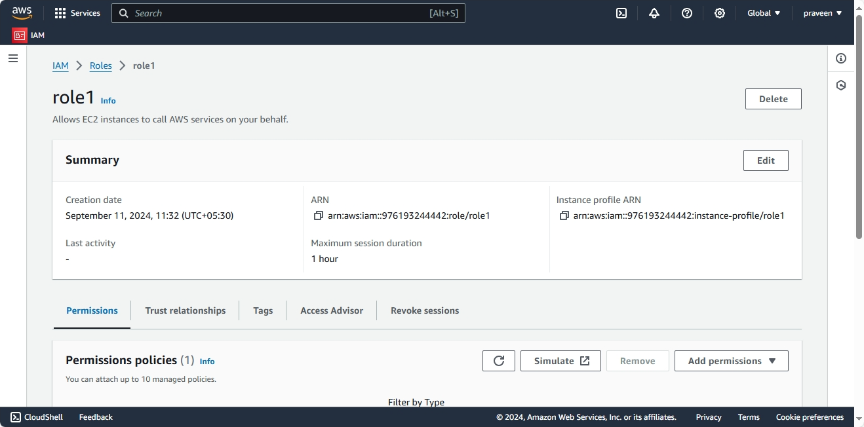

**Groups:**

* Instead of creating and attaching policies to the users individually we can create the group and attach the policies to that group.
* Attach the users to the particular group.
* Users have all the permissions whatever permissions that group has.

**Steps to crete Group:**

* Go IAM dashboard and click on user groups option.
* Click on create group and enter group name whatever we want.
* Add the users to this group or we can add the users to this group after creation of group.
* Attach the policies(to which services we want to give the access to thisgroup) and click on create user group.

