**Installation**

* **Go to downloads**
* **Extract the downloaded file to server**
* **Take it in your web browser**

**In this wizard**

* Click on start -3

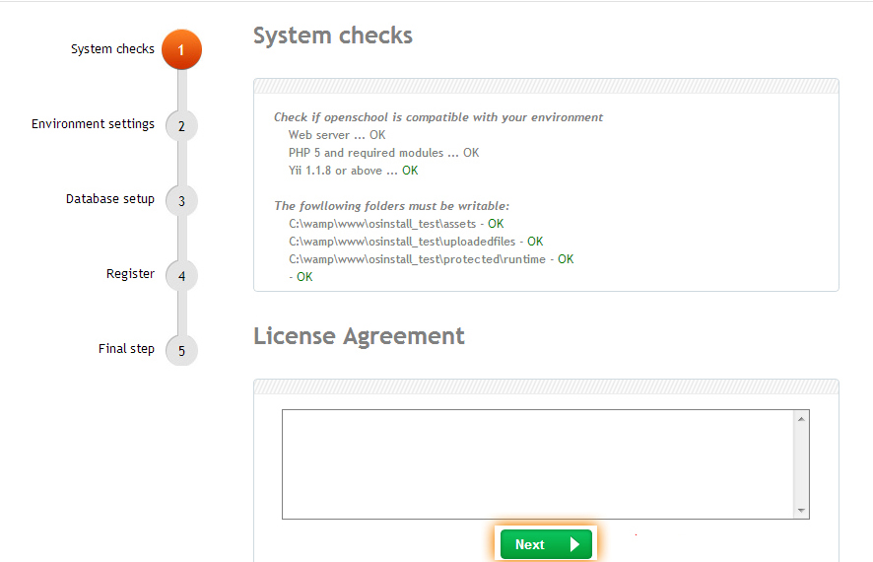

* If **Open-school** is compatible with your environment it displays Ok.
* Read the license agreement and Click on next

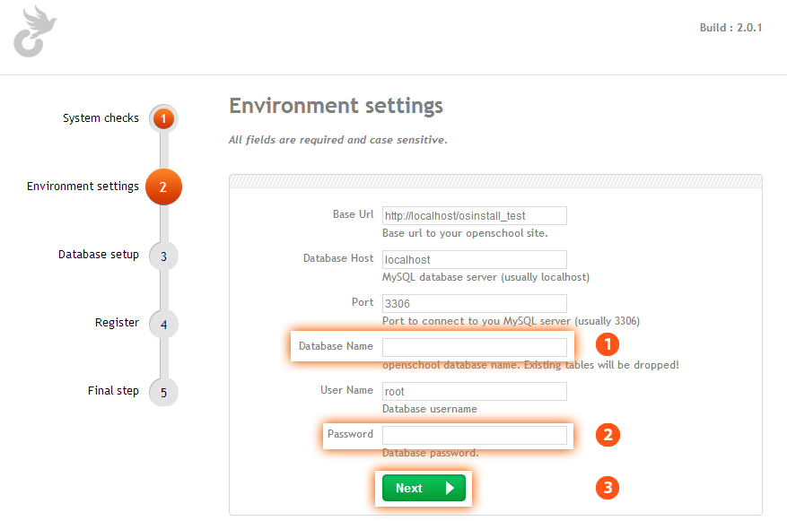

**In this wizard**

* Check the port number is correct or not
* Enter your preferred data base name (ex: **Open-School**) -1
* Enter your preferred password -2
* Security tip: It must contain Lower case character, upper case character and numeric values.
* After fill all the fields click on next. -3

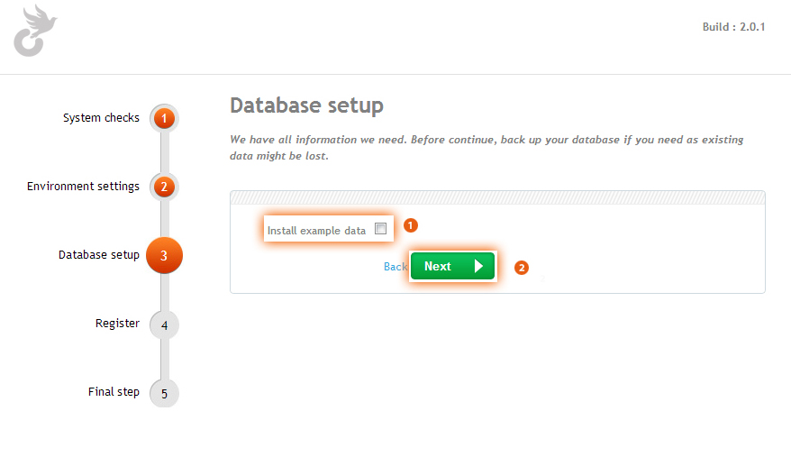

**In this wizard**

* **I you want some sample data’s in application please select install sample data**

**If you don’t want sample data please ignore it -1**

* **After that click on next Button -2**

**In this wizard**

* **Enter your school name -1**
* **Enter Your school address -2**
* **Enter your country name Where school is situated -3**
* **Enter Your State -4**
* **Enter Zip/Pin Code -5**
* **Enter School Url -6**
* **Before clicking register cross check all the details and click on register -7**
* **Enter Email**

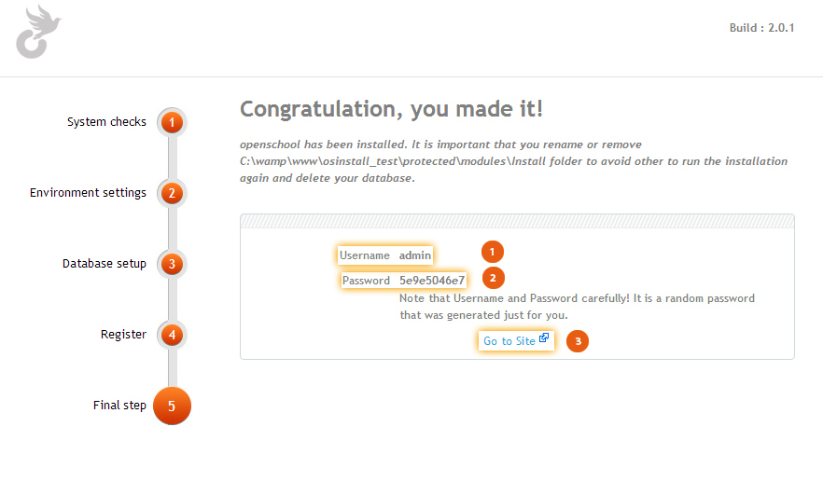

**In this wizard**

* **After finishing registration it displays both the username and password Notice both username and password and click on go to site.**

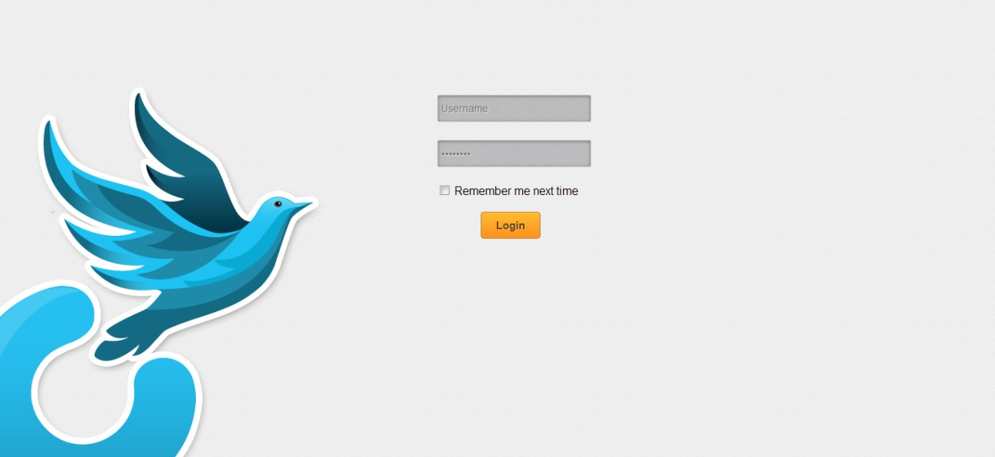

* **Enter you username and password on the both fields And click on login For access**

**Open-School**

**Updating**

**If there are any new updates we will keep in touch with you and sent all the details to your registered Email-id .**

**Checks for Open-School latest updates in** [http://open-school.org/shedule.php#](http://open-school.org/shedule.php)

-------------------------

GNU GPL COPYRIGHT NOTICES

-------------------------

This file is part of Open-School.

Open-School is free software: you can redistribute it and/or modify

it under the terms of the GNU General Public License as published by

the Free Software Foundation, either version 3 of the License, or

(at your option) any later version.

Open-School is distributed in the hope that it will be useful,

but WITHOUT ANY WARRANTY; without even the implied warranty of

MERCHANTABILITY or FITNESS FOR A PARTICULAR PURPOSE. See the

GNU General Public License for more details.

You should have received a copy of the GNU General Public License

along with Open-School. If not, see <http://www.gnu.org/licenses/>.*/

* @author Open-School team <contact@Open-School.org>

* @link http://www.Open-School.org/

* @copyright Copyright &copy; 2009-2013 wiwo inc.

* Matthew George

* Rajith Ramachandran

* Arun Kumar

* Anupama

* Laijesh V Kumar.

* @license http://www.Open-School.org/