Program:

#include<iostream>

using namespace std;

template<typename T>

void Swap(T &x,T &y)

{ T temp;

temp=x;

x=y;

y=temp;

}

int main()

{int a=10,b=20;

float x=1.8,y=2.5;

cout<<"before swapping a&b:"<<a<<"\t"<<b<<endl;

cout<<"before swapping x&y:"<<x<<"\t"<<y<<endl;

Swap(a,b);

Swap(x,y);

cout<<"after swapping a&b:"<<a<<"\t"<<b<<endl;

cout<<"after swapping x&y:"<<x<<"\t"<<y<<endl;

return 0;

}

output:

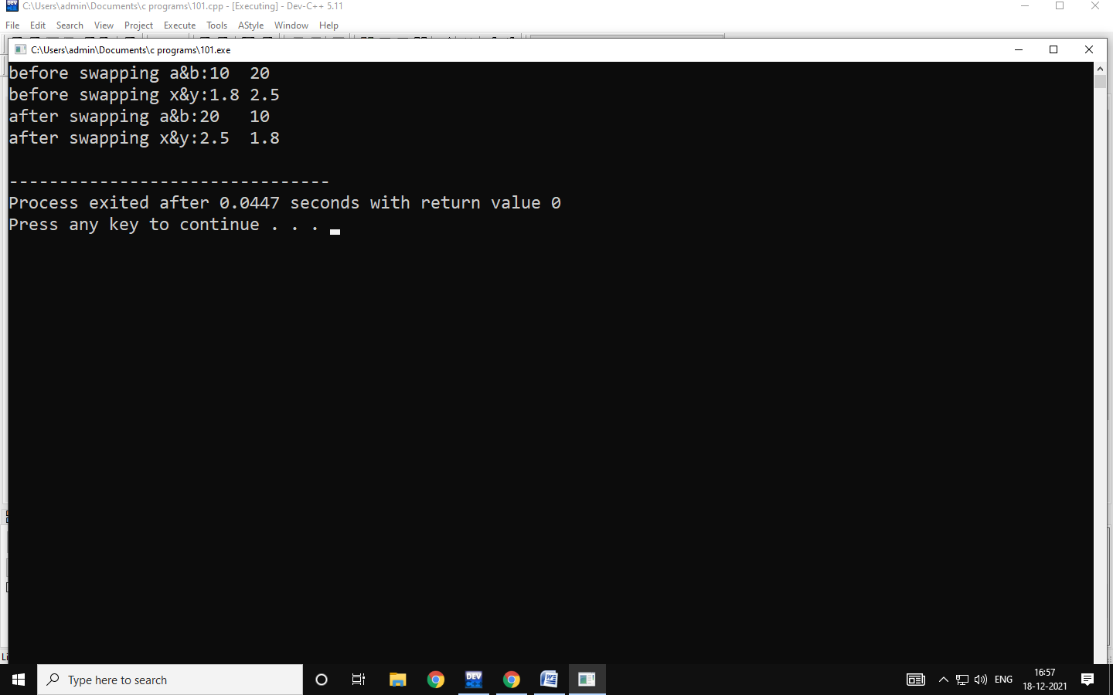

|  |  |  |
| --- | --- | --- |
| |  | | --- | | Program:  https://mail.google.com/mail/u/0/images/cleardot.gif | |  |

#include<iostream>

using namespace std;

template<class t>

class sample

{

                private:

                                t x,y;

                public:

                                void get()

                {

                                cout<<"enter x,y values"<<endl;

                                cin>>x>>y;

                }

                void add()

                {

                                cout<<x+y<<endl;

                }

};

int main()

{

                sample<int>s1;

                cout<<"enter integer values"<<endl;

s1.get();

s1.add();

sampl

Program:

#include<iostream>

using namespace std;

template<class T1,class T2>

class sample

{ private:

T1 a;

T2 b;

public:

void get()

{ cout<<"enter a & b values:"<<endl;

cin>>a>>b;

}

void display()

{ cout<<"display values"<<endl;

cout<<"a="<<a<<endl;

cout<<"b="<<b<<endl;

} };

int main()

{

sample<int,int>s1;

sample<int,char>s2;

sample<int,float>s3;

cout<<"Two integer data"<<endl;

s1.get();

s1.display();

cout<<"Integer and character data"<<endl;

s2.get();

s2.display();

cout<<"Integer and float data"<<endl;

s3.get();

s3.display();

return 0;

}

Output:

