PROGRAM:

#include<iostream>

using namespace std;

int main()

{

try

{

int a,b;

cout<<"enter a,b values";

cin>>a>>b;

if(b==0)

throw b;

else

cout<<a/b;

}

catch(int x)

{

cout<<"DIVIDED BY ZERO ERROR";

}

}

OUTPUT:

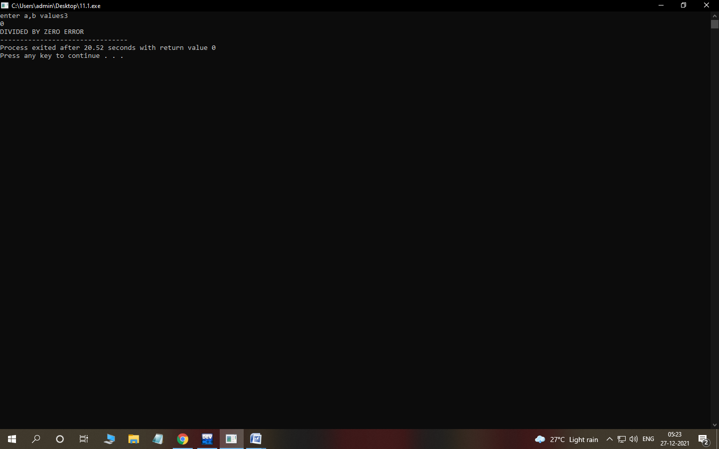

PROGRAM:

#include<iostream>

using namespace std;

int main()

{

try

{

int a[5]={1,2,3,4,5};

int index ;

cout<<"enter index:";

cin>>index;

if(index>=5)

throw index;

else if(index<0)

throw"index should not be negative";

else

{

a[index]=100;

cout<<a[index];

}

}

catch(int x)

{

cout<<"array index out of bounds";

}

catch(const char\*m)

{

cout<<m;

}

}

Output 1:

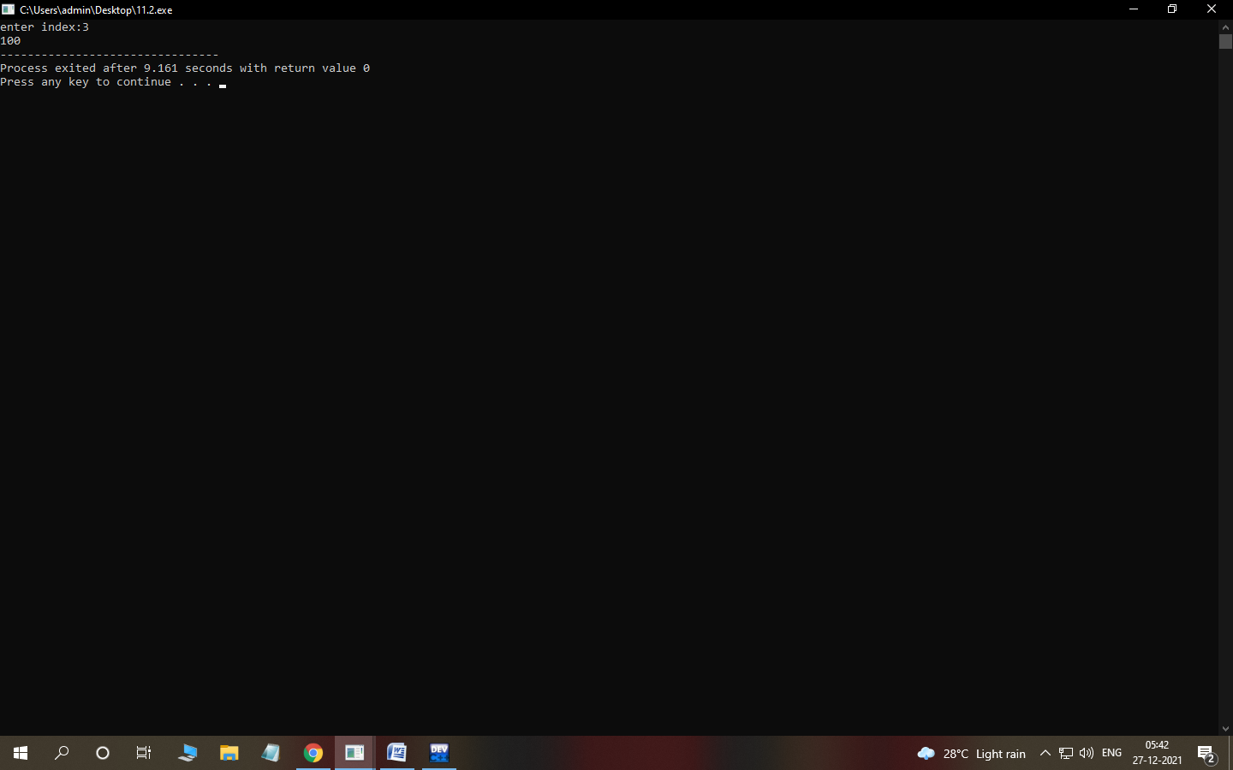

Output2:

