**# REQUIREMENTS**

**#INTRODUCTION:** The Scientific calculator project is the application based mini project, which is used to perform arithmetic operations, trigonometric functions, logarithmic functions, exponential functions, radian to degree conversion, and degree to radian conversion and so on. These calculators are widely used in the field of science, technology and mathematics. The tool used for writing the code in this project is visual studio code. This project has multi file and multiplatform approach (Linux and Windows).

**#RESEARCH**

**Modern scientific calculators generally have many more features than a standard four or five-function calculator, and the feature set differs between manufacturers and models; however, the defining features of a scientific calculator include:**

* scientific notation
* floating-point arithmetic
* logarithmic functions, using both base 10 and base e
* trigonometric functions (some including hyperbolic trigonometry)
* exponential functions and roots beyond the square root
* quick access to constants such as pi and e

In addition, high-end scientific calculators generally include:

* hexadecimal, binary, and octal calculations, including basic Boolean mathematics
* complex numbers
* fractions calculations
* statistics and probability calculations
* programmability — see Programmable calculator
* equation solving
* matrix calculations
* calculus
* letters that can be used for spelling words or including variables into an equation
* Conversion of units.

[https://en.wikipedia.org/wiki/Scientific_calculator]

**Cost Vs Timeline**

This is the plot of cost of the calculators in ($ ) and time in years

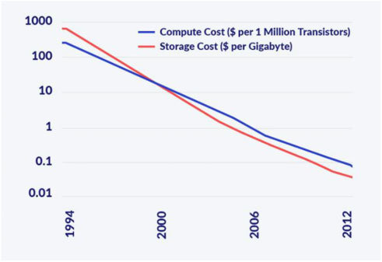

[https://www.researchgate.net/profile/Lili_Liu4/publication/329653747/figure/fig4/AS:723817190137857@1549582874490/Cost-of-computing-over-time-Illustration-by-Naomi-Brierley.jpg]

**Defining System:**

Design and testing mathematical operations of scientific calculator using unit testing algorithm.

**SWOT analysis:**

**Strengths:** Innovative, User-friendly.

**Weakness**: Cost of calculator increases as features added in the calculator increase.

Opportunities: We know that we mostly use scientific calculators in our childhood. So tech based market always attracts the youth.

Threats: Slower growth in an innovation always threat for the company in this dynamic world.

[https://swotindia.wordpress.com/2020/09/03/swot-analysis-of-casio-calculators/]

**4’W and 1’H**

**What:** Scientific calculator

**Where:** School, Science, Mathematics, Technology

**When:** Need for calculation.

**How:** Calculates the user input and gives the output.

**Detail Requirements:**

**High Level Requirements:**

|  |  |  |
| --- | --- | --- |
| **ID** | **Description** | **Status** |
| HL01 | Multiple Arithmetic operation |  |
| HL02 | Multiple Logarithmic operation |  |
| HL03 | Multiple Trigonometric operation |  |
| HL04 | Multiple function operation |  |

**Low level Requirements:**

|  |  |  |
| --- | --- | --- |
| **ID** | **Description** | **Status** |
| LL01_HL01 | Single arithmetic operation |  |
| LL02_HL02 | Single Logarithmic operation |  |
| LL03_HL03 | Single Trigonometric operation |  |
| LL04 | Degree to radian and vice-versa |  |