**Documentation**

1. the total amount spent and the country for the Pending delivery status for each country.

“Customers” table and “Shipping” table are used. Blending field is “Customer id”

Pull status=”Pending” to filter shelf

Pull country ,the total amount spent as {FIXED [Country]:SUM([Amount])},Status to Rows

Pull SUM(Amount) to Marks->Text

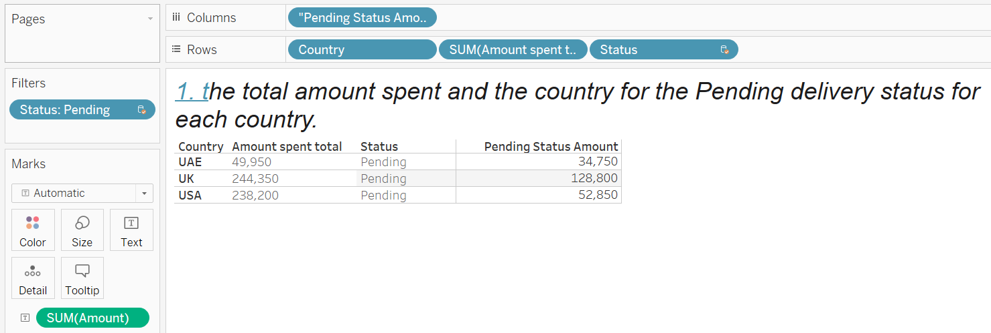

1. the total number of transactions, total quantity sold, and total amount spent for each customer, along with the product details.

“Customers” table and “Orders” table are used. Blending field is “Customer id”

For each customer ID,

Total amount spent as {FIXED [Customer ID]: SUM([Amount])},  
Total number of transactions as {FIXED [Customer ID]: COUNTD([Order ID])}  
Total quantity sold as {FIXED [Customer ID]: COUNT([Item])}

Pull CustomerID, Total amount spent, Total number of transactions, Total quantity sold as Rows

Pull Item to Marks-> Text.

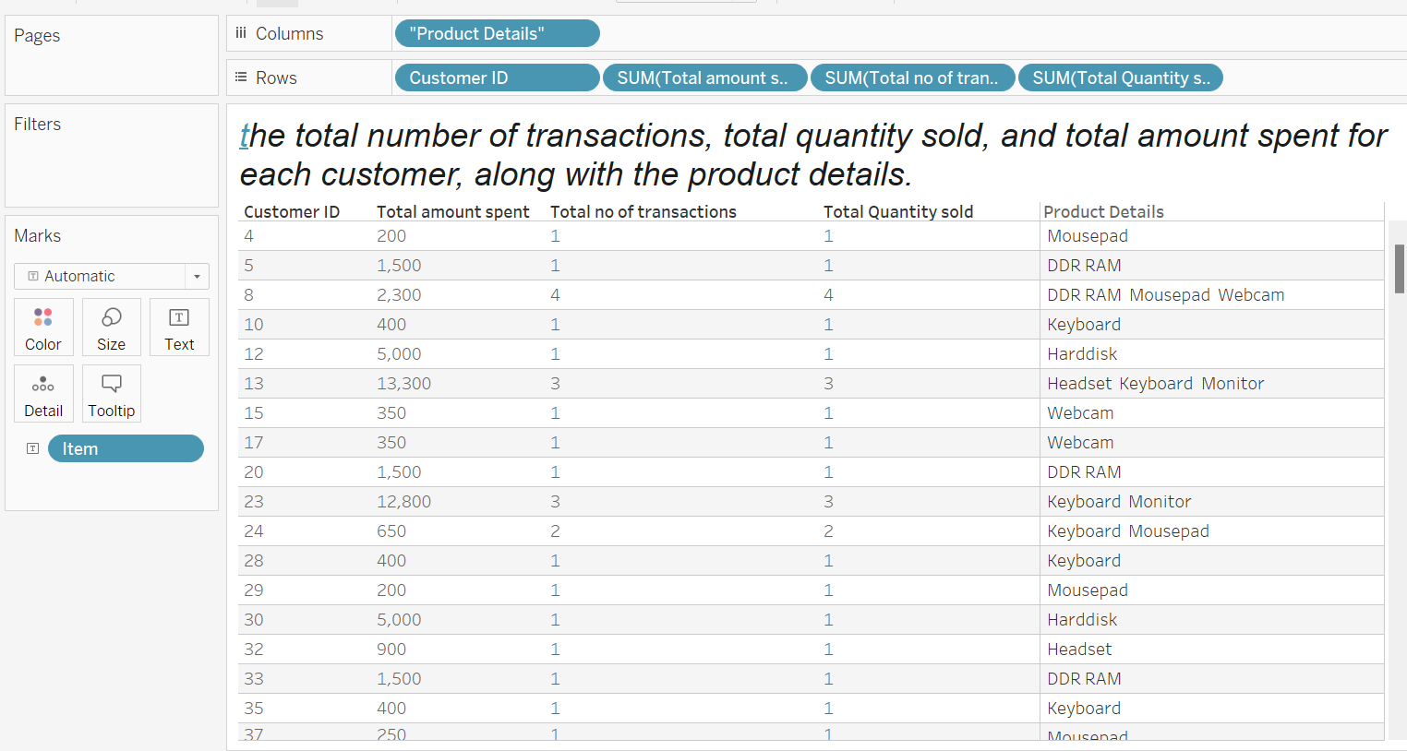

1. the maximum product purchased for each country.

“Customers” table and “Orders” table are used. Blending field is “Customer id”

Create field “Max Product Purchased” as:

COUNTD([Order ID])=

SUM({FIXED [Country]:MAX(

{FIXED [Country],[Item]:COUNTD([Order ID])}

)})

Place the above field on filter and set to “True”.

Pull Country, Item to rows and COUNTD(OrderID) to Marks->Text.

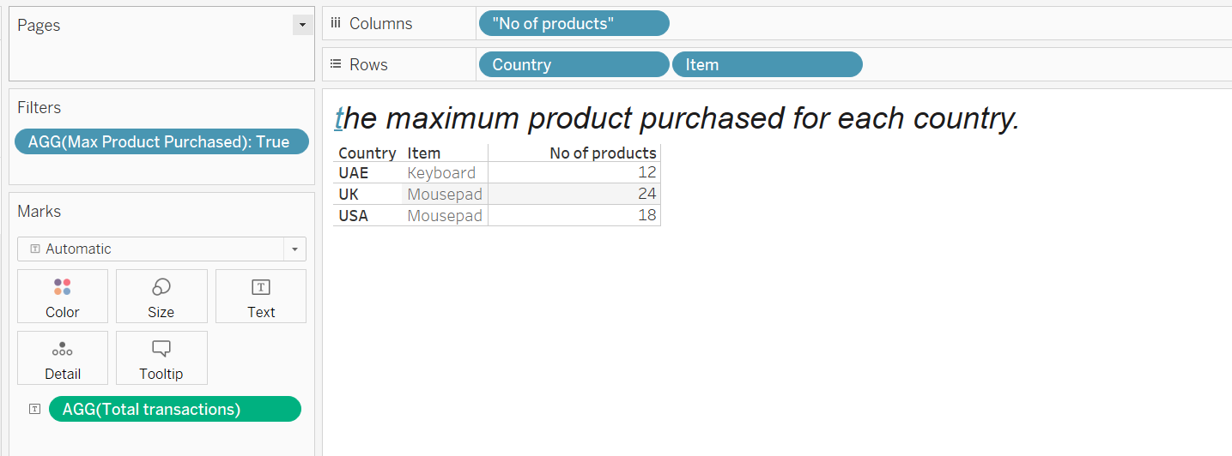

1. the most purchased product based on the age category less than 30 and above 30.

“Customers” table and “Orders” table are used. Blending field is “Customer id”

Created “Most purchased” field as:

COUNTD([Order ID])

=SUM(

{FIXED [Age group]:MAX({FIXED [Age group],[Item]:COUNTD([Order ID])})}

)

Place the above field on Filter shelf and set to “True”.

Created “Age group” field as:

If [Age]<=30 then "Age less than 30"

Elseif Age>30 then "Age greater than 30" END

Pull “Age Group” to Rows and Item to Marks->Text.

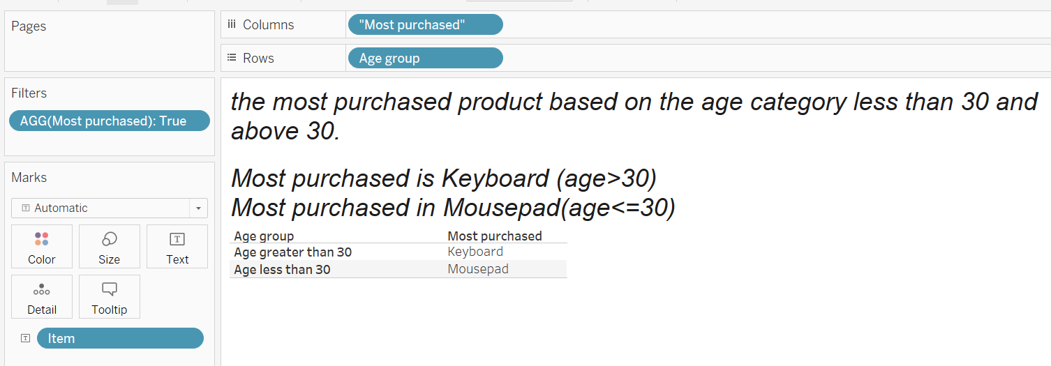

1. the country that had minimum transactions and sales amount.

“Customers” table and “Orders” table are used. Blending field is “Customer id”

Create field “Min Transactions” as:

COUNTD([Order ID])=SUM(

{FIXED :MIN(

{FIXED [Country],[Item]:COUNTD([Order ID])}

)}

)

Place the above field on Filter shelf and set to “True”.

Pull Country, Item, Countd(Order ID) to Rows

Pull SUM(Amount) to Marks-> Text

