WEEK-10

AIM: Implement basic CRUD (Create, Read, Update, Delete) operations on a MySQL database using JDBC in Java.
Explore Spring's stereotype annotations like @Component, @Service, @Repository, and @Controller to define beans with specific roles in the application.
Implement a Spring JDBC Template to interact with a MySQL relational database

CODE:
Application.properties
spring.application.name=spring-crud-jdbc
spring.datasource.url=jdbc:mysql://localhost:3306/studentdb
spring.datasource.username=root
spring.datasource.password=
spring.datasource.driver-class-name=com.mysql.cj.jdbc.Driver

spring.jpa.show-sql=true

JdbcConfig.java
package com.example.demo.config;

import javax.sql.DataSource;
import org.springframework.context.annotation.Bean;
import org.springframework.context.annotation.Configuration;
import org.springframework.jdbc.core.JdbcTemplate;

@Configuration
public class JdbcConfig {

@Bean
public JdbcTemplate jdbcTemplate(DataSource dataSource) {
return new JdbcTemplate(dataSource);
}
}

StudentController.java
package com.example.demo.controller;

import java.util.List;
import org.springframework.beans.factory.annotation.Autowired;
import org.springframework.web.bind.annotation.*;

import com.example.demo.model.Student;
import com.example.demo.service.StudentService;

@RestController
@RequestMapping("/students")
public class StudentController {

@Autowired
private StudentService service;

@PostMapping("/add")
public String add(@RequestBody Student s) {
service.save(s);
return "Student added!";
}

@GetMapping("/get")
public List<Student> list() {
return service.listAll();
}

@GetMapping("/{id}")
public Student get(@PathVariable int id) {
return service.get(id);
}

@PutMapping("/update")
public String update(@RequestBody Student s) {
service.update(s);
return "Student updated!";
}

@DeleteMapping("/delete/{id}")
public String delete(@PathVariable int id) {
service.delete(id);
return "Student deleted!";
}
}

Student.java
package com.example.demo.model;

public class Student {
private int id;
private String name;
private String email;

public Student() {}

public Student(int id, String name, String email) {
this.id = id;
this.name = name;
this.email = email;
}

// Getters & Setters
public int getId() { return id; }
public void setId(int id) { this.id = id; }
public String getName() { return name; }
public void setName(String name) { this.name = name; }
public String getEmail() { return email; }
public void setEmail(String email) { this.email = email; }
}

StudentRepository.java
package com.example.demo.repository;

import java.util.List;
import org.springframework.beans.factory.annotation.Autowired;
import org.springframework.jdbc.core.BeanPropertyRowMapper;
import org.springframework.jdbc.core.JdbcTemplate;
import org.springframework.stereotype.Repository;
import com.example.demo.model.Student;

@Repository
public class StudentRepository {

@Autowired
private JdbcTemplate jdbcTemplate;

public int save(Student s) {
return jdbcTemplate.update(
"INSERT INTO student(name, email) VALUES (?, ?)",
s.getName(), s.getEmail());
}

public List<Student> listAll() {
return jdbcTemplate.query("SELECT * FROM student",
new BeanPropertyRowMapper<>(Student.class));
}

public Student getById(int id) {
return jdbcTemplate.queryForObject(
"SELECT * FROM student WHERE id = ?",
new BeanPropertyRowMapper<>(Student.class),
id
);
}

public int update(Student s) {
return jdbcTemplate.update(
"UPDATE student SET name=?, email=? WHERE id=?",
s.getName(), s.getEmail(), s.getId());
}

public int delete(int id) {
return jdbcTemplate.update(
"DELETE FROM student WHERE id=?", id);
}
}

StudentService.java
package com.example.demo.service;

import java.util.List;
import org.springframework.beans.factory.annotation.Autowired;
import org.springframework.stereotype.Service;
import com.example.demo.model.Student;
import com.example.demo.repository.StudentRepository;

@Service
public class StudentService {

@Autowired
private StudentRepository repo;

public int save(Student s) { return repo.save(s); }

public List<Student> listAll() { return repo.listAll(); }

public Student get(int id) { return repo.getById(id); }

public int update(Student s) { return repo.update(s); }

public int delete(int id) { return repo.delete(id); }
}

OUTPUT:
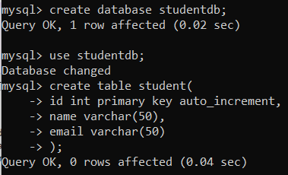
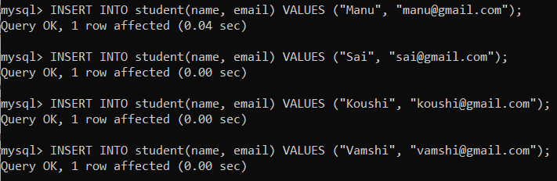

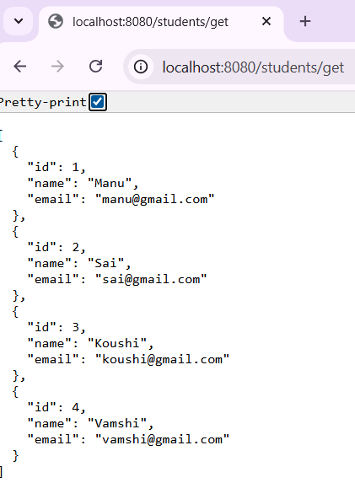
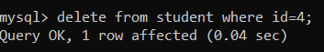
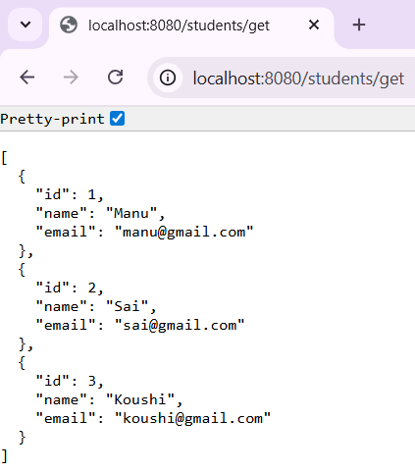
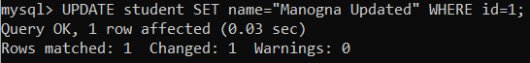
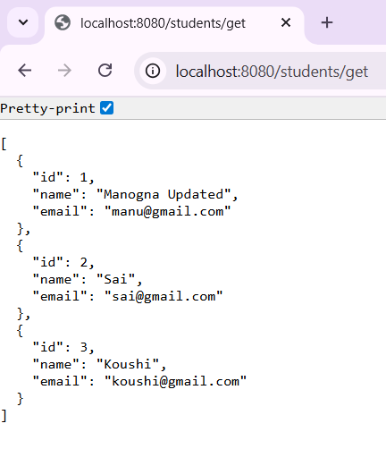

RESULTS:
CRUD Operations are successfully done.
Spring's stereotype annotations @Component, @Service, @Repository, and @Controller are used.
MySQL database is used.

