WEEK-12
SPRING JPA WITH RELATIONAL DATABASE
Dependencies: Spring web, Spring data jpa and mysql drver
- application.properties
spring.application.name=jpamysql
server.port=88

# JDBC - change user/password/db name as needed
spring.datasource.url=jdbc:mysql://localhost:3306/employee_db?useSSL=false&allowPublicKeyRetrieval=true&serverTimezone=UTC
spring.datasource.username=root
spring.datasource.password=
spring.datasource.driver-class-name=com.mysql.jdbc.Driver

# JPA / Hibernate
spring.jpa.hibernate.ddl-auto=update
spring.jpa.show-sql=true

spring.jpa.properties.hibernate.dialect=org.hibernate.dialect.MySQLDialect

2. Create database + sample data (run in MySQL)
CREATE DATABASE IF NOT EXISTS testdb;
USE employee_db;

CREATE TABLE IF NOT EXISTS employee (
id INT PRIMARY KEY AUTO_INCREMENT,
name VARCHAR(100),
department VARCHAR(100)
);

INSERT INTO employee (name, department) VALUES
('Manogna','IT'),
('Keerthi','CSE'),
('Sai','ECE');

3) Entity — Employee.java
src/main/java/com/example/demo/Employee.java
package com.example.demo;

import jakarta.persistence.Entity;
import jakarta.persistence.GeneratedValue;
import jakarta.persistence.GenerationType;
import jakarta.persistence.Id;

@Entity
public class Employee {

@Id
@GeneratedValue(strategy = GenerationType.IDENTITY)
private Integer id;

private String name;
private String department;

public Employee() {}

public Employee(String name, String department) {
this.name = name;
this.department = department;
}

// getters and setters — required for Jackson / JPA
public Integer getId() { return id; }
public void setId(Integer id) { this.id = id; }

public String getName() { return name; }
public void setName(String name) { this.name = name; }

public String getDepartment() { return department; }
public void setDepartment(String department) { this.department = department; }
}

4) Repository — EmployeeRepository.java
src/main/java/com/example/demo/EmployeeRepository.java
package com.example.demo;

import org.springframework.data.jpa.repository.JpaRepository;

public interface EmployeeRepository extends JpaRepository<Employee, Integer> { }

5) Controller — returns JSON and HTML view
src/main/java/com/example/demo/EmployeeController.java
package com.example.demo;

import org.springframework.beans.factory.annotation.Autowired;
import org.springframework.stereotype.Controller;
import org.springframework.ui.Model;
import org.springframework.web.bind.annotation.GetMapping;
import org.springframework.web.bind.annotation.RequestMapping;
import org.springframework.web.bind.annotation.RestController;

import java.util.List;

// REST endpoints
@RestController
@RequestMapping("/api")
class EmployeeRestController {
@Autowired
private EmployeeRepository repo;

@GetMapping("/employees")
public List<Employee> getAll() {
return repo.findAll();
}
}

// HTML (Thymeleaf) controller
@Controller
class EmployeeViewController {
@Autowired
private EmployeeRepository repo;

@GetMapping("/employees")
public String employeesPage(Model model) {
model.addAttribute("employees", repo.findAll());
return "employees"; // maps to src/main/resources/templates/employees.html
}
}
Note: we used two controllers — one @RestController for JSON (/api/employees) and one @Controller for HTML (/employees). They can coexist.

6) Thymeleaf template — employees.html
Create file: src/main/resources/templates/employees.html
<!DOCTYPE html>
<html xmlns:th="http://www.thymeleaf.org">
<head>
<meta charset="UTF-8"/>
<title>Employees</title>
<style>
table { border-collapse: collapse; width: 70%; margin-top: 20px; }
th, td { border: 1px solid #333; padding: 8px; text-align: left; }
th { background: #efefef; }
</style>
</head>
<body>
<h2>Employee List</h2>
<table>
<thead>
<tr><th>ID</th><th>Name</th><th>Department</th></tr>
</thead>
<tbody>
<tr th:each="e : ${employees}">
<td th:text="${e.id}">1</td>
<td th:text="${e.name}">Name</td>
<td th:text="${e.department}">Dept</td>
</tr>
</tbody>
</table>
</body>
</html>

7. pom.xml add these code
<dependency>
<groupId>mysql</groupId>
<artifactId>mysql-connector-java</artifactId>
<version>5.1.49</version>
</dependency>

<dependency>
<groupId>org.springframework.boot</groupId>
<artifactId>spring-boot-starter-thymeleaf</artifactId>
</dependency>

8) Run in STS
- Import project into STS (File → Import → Existing Maven Projects).
- Right-click project → Run As → Spring Boot App.
- Visit:
  - HTML table: http://localhost:88/employees
  - JSON API: http://localhost:88/api/employees
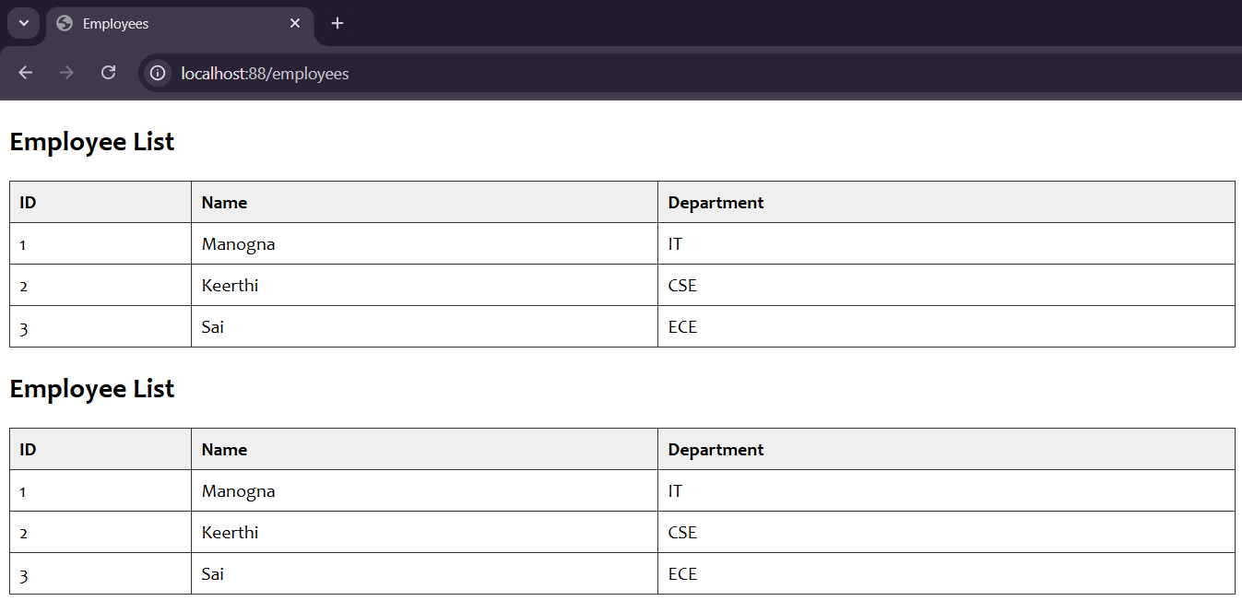
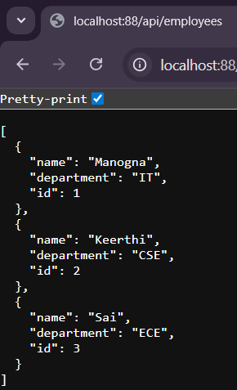

2. Spring jpa with h2
Project name: h2db-jpa
Student.java:
package com.example.mysqldemo;

import jakarta.persistence.Entity;
import jakarta.persistence.GeneratedValue;
import jakarta.persistence.GenerationType;
import jakarta.persistence.Id;

@Entity
public class Student {

@Id
@GeneratedValue(strategy = GenerationType.IDENTITY)
private Long id;

private String name;
private String city;

public Student() {}

public Student(String name, String city) {
this.name = name;
this.city = city;
}

public Long getId() {
return id;
}

public void setId(Long id) {
this.id = id;
}

public String getName() {
return name;
}

public void setName(String name) {
this.name = name;
}

public String getCity() {
return city;
}

public void setCity(String city) {
this.city = city;
}
}

Student Controller.java:
package com.example.mysqldemo;

import org.springframework.beans.factory.annotation.Autowired;
import org.springframework.web.bind.annotation.*;

import java.util.List;

@RestController
public class StudentController {

@Autowired
private StudentRepository repo;

@GetMapping("/")
public String home() {
return "Spring Boot + H2 + JPA Example Running!";
}

@GetMapping("/add")
public String addStudent(@RequestParam String name,
@RequestParam String city) {
repo.save(new Student(name, city));
return "Student Added Successfully!";
}

@GetMapping("/students")
public List<Student> getStudents() {
return repo.findAll();
}
}

Student Repository.java:
package com.example.mysqldemo;

import org.springframework.data.jpa.repository.JpaRepository;

public interface StudentRepository extends JpaRepository<Student, Long> {
}

Application.properties:
spring.application.name=h2db-jpa
spring.h2.console.enabled=true
spring.h2.console.path=/h2-console
spring.datasource.url=jdbc:h2:mem:testdb
spring.datasource.driverClassName=org.h2.Driver
spring.datasource.username=sa
spring.datasource.password=
spring.jpa.hibernate.ddl-auto=update

