WEEK-2

AIM:JAVA &MSACCESS CONNECTIONS WITH OUT DSN.

Procedure:

DATE:28-07-25

- Click the category as java and in projects java application and click on next.
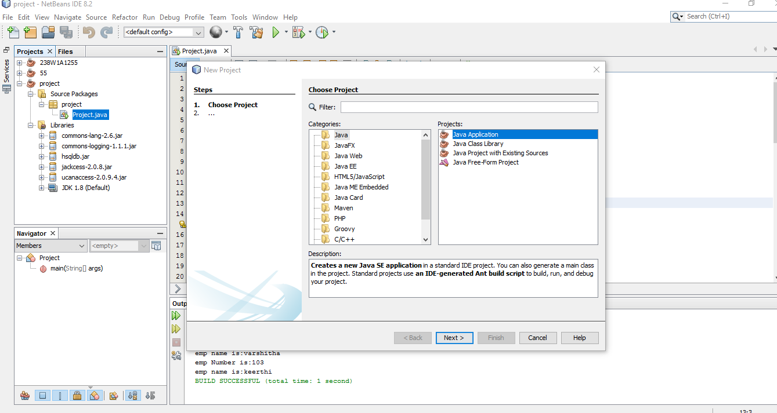

- Enter file name and click finish now your file is setup is completed.

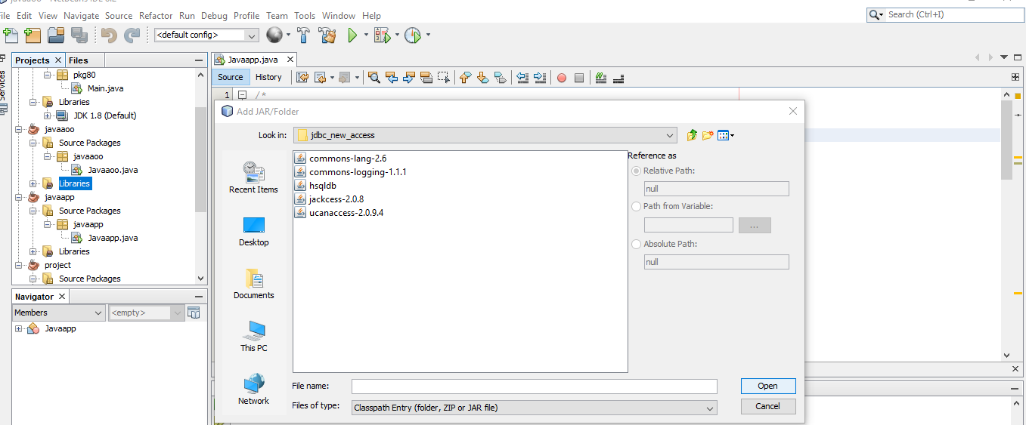
- In your project libraries add the JAR/Folder and choose all drivers that are required and add them.
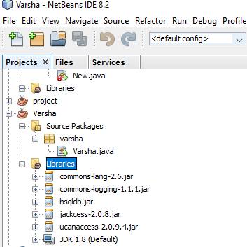
- In files open local disk open vrsec excel sheet to add more records in the database.

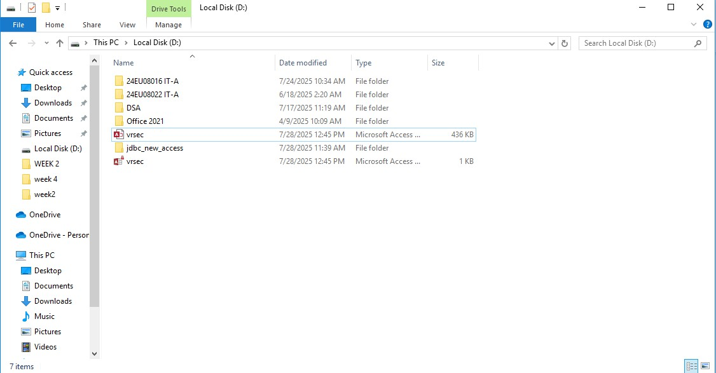
- Adding the records in database it and save the data.After adding the data then close the tab and execute the code.
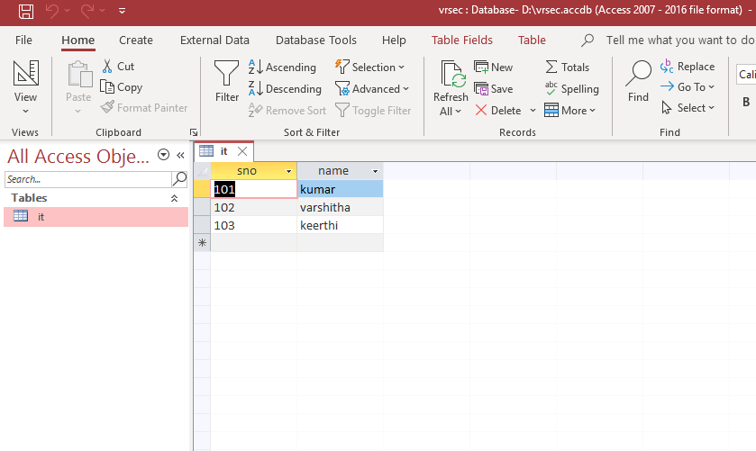

- Run the code then the execution is successful and the output is displayed which are added in the database.
