AIM: JDBC-MYSQL CONNECTION
Procedure:

WEEK-3

DATE:04-08-25

- Click the category as java and in projects java application and click on next.

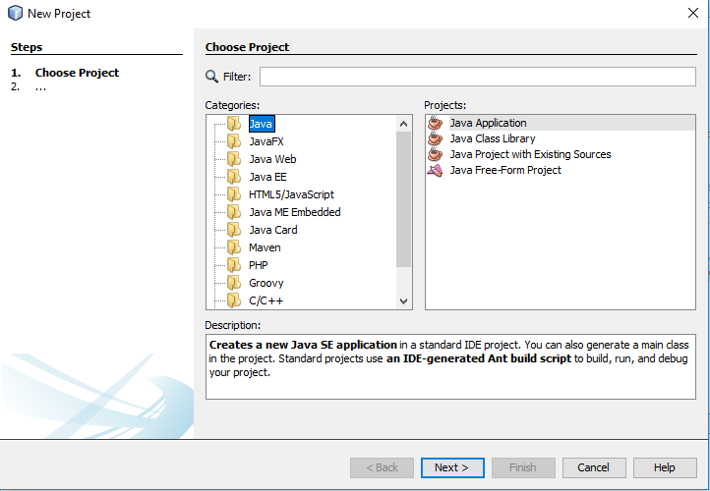
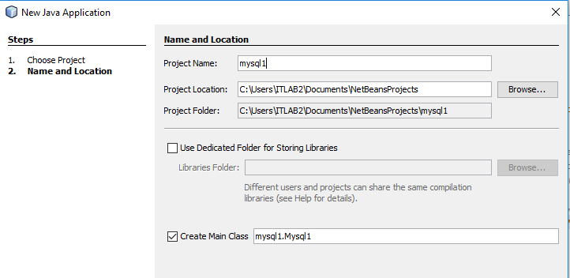
- Enter file name and click finish now your file is setup is completed.

- Code of the Mysql1 of the project and running the code after adding the data.

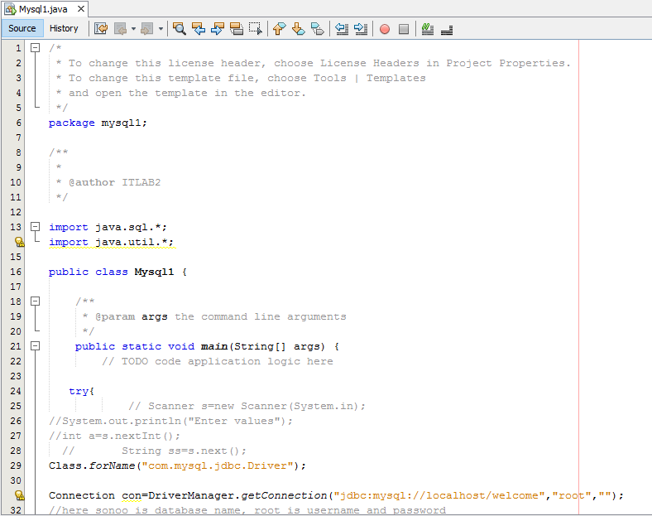

- In your project libraries add the JAR/Folder and choose all drivers that are required and add them

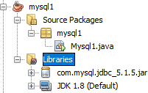

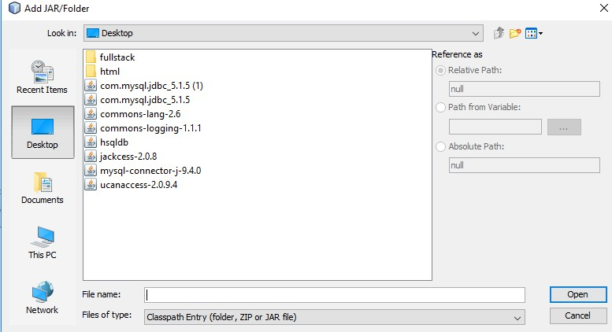

- Open mysql server and create a database welcome. After creation of database, change the database into welcome database. Insert the table with data of some students and run the server.

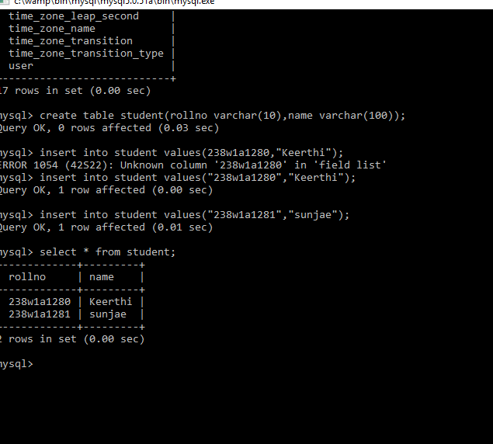

- After running of the mysql server and return to the project mysql1 ,run the program and the output is displayed which are added in the table.

