# MediaWiki Application - Creating Infrastructure with Terraform

1. Pre-requisites Java, Jenkins, Packer, Terraform, AWS Cli should be installed in a Server.
2. Configure AWS CLI:

**aws configure**

AWS Access Key ID [None]:

AWS Secret Access Key [None]:

Default region name [None]:

Default output format [None]:

1. Run Packer with below command to create AMI. Packer having configuration of MediaWiki Apache, PHPand there necessary configuration and software’s.

**packer build ./packer/packer-redhat-httpd-php.json**

1. Mysql UserName and Password added in Environment variables.

# Set secrets via environment variables

export TF_VAR_username=(the username)

export TF_VAR_password=(the password)

1. Created Jenkins pipeline job to run Terraform using Jenkinsfile.
2. Workspace was used in terraform code to create different environments with project selection, using two environment variables as MediaWiki-QA.tfvars, MediaWiki-Staging.tfvars file.
3. Created VPC with 2 Public Subnets, 2 Private Subnets in availability zone 1a and 1b with MediaWiki-QA.tfvars, MediaWiki-Staging.tfvars file.
4. Created 2 Private Instances which contains mediawiki application with Application Load Balancer.
5. Created RDS database.
6. Created Instance with mediawiki application and another instance with MySQL database. This instance is created as an example for standalone application connecting with mysql database in separate instance.
7. Added ALB alias in Route 53 with record type ="A" based on the environment. Ex: For QA: <https://mediawiki-qa.edulakanti.info> and for Staging: <https://mediawiki-staging.edulakanti.info>

**Screen’s shots:**

**Terraform Validate command to verify any errors in terraform script.**

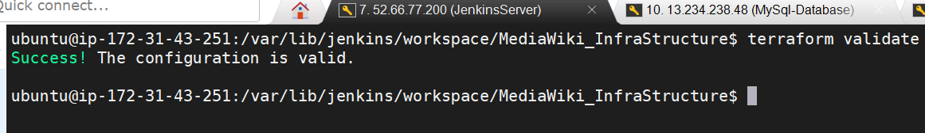

**Jenkins Pipeline Job Parameters screen shot:**

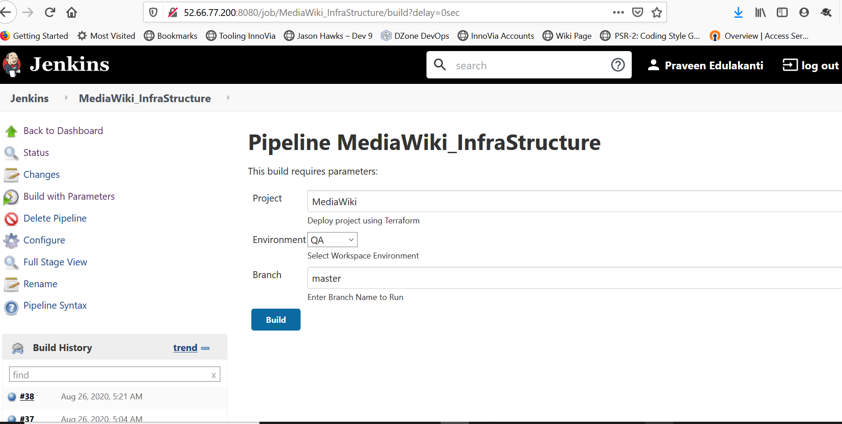

**Jenkins Pipeline configure Page**

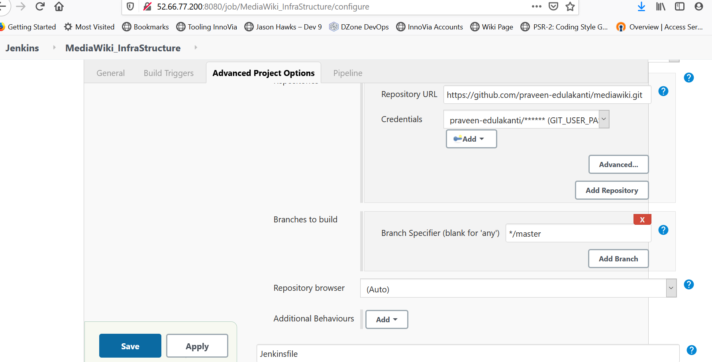

**Jenkins Pipeline Status View Page:**

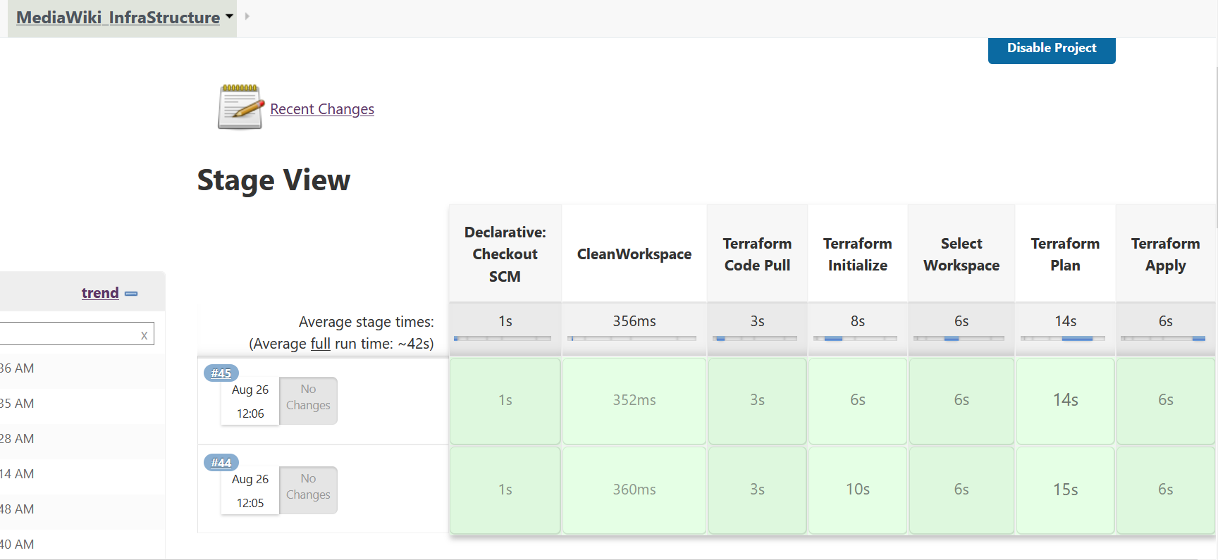

**Build Status for QA Environment:**

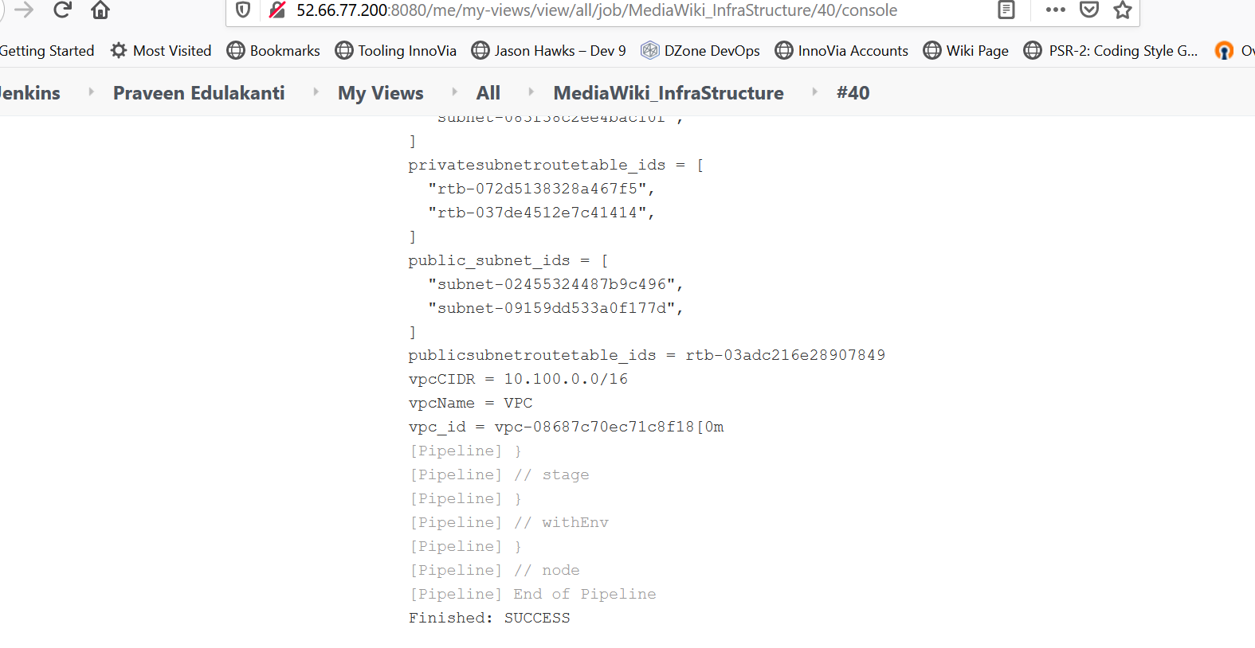

**Application loaded Page in Browser:**

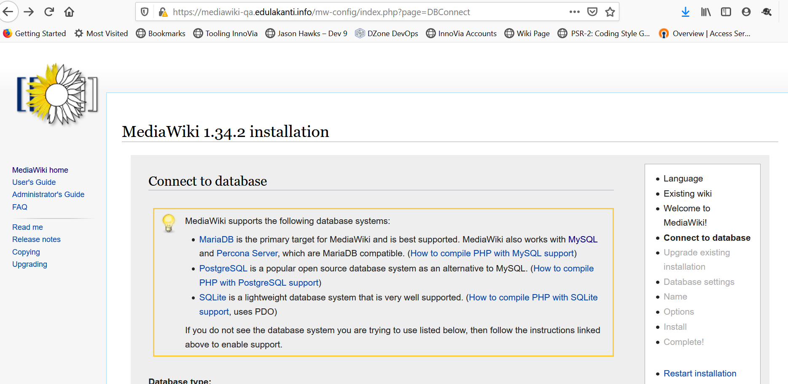

**Mysql Connected Screen shot Page:**

